NURSERY 2 — THIRD TERM
Pupil's book · every subject offered to this class, every teaching week of the term.
11 subjects · 105 lessons · 13 sections. Weeks 7, 10, 11 and 12 are Mid-Term Break, Revision, Examination and Closing: no lesson is written for a week the school keeps for those, except where the school's own table prints a teaching row there.
Each lesson ends with a worksheet and a piece of my own work; each subject ends with the term practice paper — 30 objective, 10 sub-objective and 5 theory questions. The contents page lists every part and every lesson of this book.

CONTENTS
11 subjects · 105 lessons · 13 term practice papers. Each part begins on a fresh page.
Basic Science 3
WEEK 1 — WATER: HOW WE KEEP IT CLEAN AND SAFE 3
WEEK 2 — WATER-BORNE DISEASES: SICKNESS THAT COMES WITH DIRTY WATER 4
WEEK 3 — TECHNOLOGY: SECURITY GADGETS THAT KEEP US SAFE 5
WEEK 4 — ANIMALS AND THE HOMES THEY LIVE IN 6
WEEK 5 — ANIMALS AND THEIR YOUNG ONES 7
WEEK 6 — TECHNOLOGY: SIMPLE MACHINES USED IN THE HOME 9
WEEK 8 — TECHNOLOGY: SIMPLE MACHINES USED IN SCHOOL 10
WEEK 9 — EXPLORING OUR ENVIRONMENT 11
Cultural and Creative Arts (CCA) 13
WEEK 1 — MAKING CARDS: PAPER THAT CARRIES A MESSAGE 13
WEEK 2 — COLOUR SPLASH AND FEATHER ART 14
WEEK 3 — WHAT ART IS AND WHAT WE MAKE IT WITH 15
WEEK 4 — SCRIBBLING, LINES AND SHAPES 16
WEEK 5 — MAKING LETTERS AND NUMBERS BEAUTIFUL 17
WEEK 6 — COLOURS: THE THREE THAT MAKE THE OTHERS 18
WEEK 8 — CRAFTS: MAKING THINGS WITH OUR HANDS 19
WEEK 9 — DECORATION: MAKING PLAIN THINGS BEAUTIFUL 21
Christian Religious Studies (CRS) 23
WEEK 1 — JESUS CHRIST OUR SAVIOUR 23
WEEK 2 — JESUS CALLS US FRIENDS, BROTHERS AND SISTERS 24
WEEK 3 — JESUS COMMANDS US TO LOVE 25
WEEK 4 — JESUS WANTS US TO OBEY GOD'S COMMANDMENTS 26
WEEK 5 — THE MEANING OF PRAYER 27
WEEK 6 — WHEN TO PRAY 28
WEEK 8 — HOW TO PRAY 29
WEEK 9 — PRAYING EVERY DAY 31
Basic Digital Literacy 33
WEEK 1 — HEADPHONES, AND HOW WE CARE FOR A MACHINE 33
WEEK 2 — THE CPU: THE PART THAT THINKS 34
WEEK 3 — RAM: THE MEMORY THAT HOLDS THINGS A LITTLE WHILE 35
WEEK 4 — THE HARD DRIVE: THE BOX THAT KEEPS OUR WORK 36
WEEK 5 — THE MOTHERBOARD: THE FLOOR EVERY PART SITS ON 37
WEEK 6 — POWER SUPPLY: THE PART THAT BRINGS THE MACHINE TO LIFE 38
WEEK 8 — COOLING: HOW A MACHINE KEEPS FROM SWEATING 39
WEEK 9 — HOW THE PARTS WORK TOGETHER 40
Nigerian History 42
WEEK 1 — TRADITIONAL RULERS IN OUR COMMUNITY 42
WEEK 2 — EMIR, OBA, IGWE: DIFFERENT RULERS IN NIGERIA 43
WEEK 3 — TRADITIONAL TITLE HOLDERS 44
WEEK 4 — BAALE, IYALOJA, OTUNBA: THE WORK OF TITLES 45
WEEK 5 — THE LOCAL GOVERNMENT AND ITS CHAIRPERSON 46
WEEK 6 — WHAT A GOOD CHAIRMAN DOES 47
WEEK 8 — WHAT MAKES A GOOD LEADER 48
WEEK 9 — LEADERSHIP IN MY OWN DAY 50
Physical and Health Education (PHE) 52
WEEK 1 — PLACES WE PLAY AND THINGS WE PLAY WITH 52
WEEK 2 — FOOTBALL: KICK IT, KEEP IT, SCORE IT 53
WEEK 3 — BASKETBALL: BOUNCE IT AND THROW IT IN 54
WEEK 4 — TABLE TENNIS: THE BALL THAT MUST NOT DROP 55
WEEK 5 — CHESS: THE GAME PLAYED WITH THE HEAD 56
WEEK 6 — VIDEO GAMES: FUN IN LIMITS 57
WEEK 8 — MOVING OUR BODY PARTS 59
WEEK 9 — MOVING WELL IN EVERYDAY WORK 60
Prevocational Studies (PVS) 62
WEEK 1 — THE TOOLS WE WORK WITH, AND WHERE THEY REST 62
WEEK 2 — WHAT WE MEAN BY SAFETY 63
WEEK 3 — WHY SAFETY MATTERS SO MUCH 64

WEEK 4 — WHAT HAPPENS WHEN A TOOL IS MISUSED 65
WEEK 5 — THE KITCHEN, AND WHY A GROWN-UP IS NEEDED 66
WEEK 6 — THE RULES WE KEEP WHEN TOOLS ARE ABOUT 67
WEEK 8 — CLOTHES AND THINGS THAT PROTECT THE BODY 69
WEEK 9 — PUTTING THINGS AWAY, TELLING WHAT IS BROKEN, AND FIRST AID 70
Social and Citizenship Studies (SCS) 72
WEEK 1 — THE PLACE WE LIVE, AND THE WEATHER THAT CHANGES 72
WEEK 2 — THE ANIMALS THAT LIVE BY THEMSELVES 73
WEEK 3 — THE MONEY WE USE IN NIGERIA 74
WEEK 4 — SPENDING WISELY AND SAVING A PART 75
WEEK 5 — BEING A GOOD CITIZEN 76
WEEK 6 — OUR COMMUNITY: THE TOWN AND THE VILLAGE 77
WEEK 8 — THE LEADERS IN OUR COMMUNITY 78
WEEK 9 — THE BIG WORLD WE ARE ALL IN 79
Yoruba 82
WEEK 1 — Ede: Sise nnkan (ase oluko) / Asa: Itesiwaju ikini ni orisirisi akoko / Litireso: Orin ere idaraya 82
WEEK 2 — Ede: Siso oro onileta po (F+K+F) / Asa: Orisirisi eso ile wa / Litireso: Alo apamo ati alo apagbe 83
WEEK 3 — Ede: Isorongbesi laarin oluko ati akekoo / Asa: Imototo: ara fifo, enu fifo / Litireso: Orin kiko 84
WEEK 4 — Ede: Onka 21-40 (aropo ati ayokuro) / Asa: Ojo inu ose (itan ojo kookan) / Litireso: Ewi kika 85
WEEK 5 — Ede: Awon awo olorisirisi / Asa: Iwa rere ati iwa ti ko to / Litireso: Ewi: Ise ni oogun ise 86
WEEK 6 — Ede: Apeko (gbo, ko sile) / Asa: Ojuse ebi: egbon ati aburo / Litireso: Orin iwa (Kini n o fi ole se) 88
WEEK 8 — Ede: Akosoro (ka, pe iro, fa koko yo) / Asa: Oge sise ni ile Yoruba / Litireso: Orin kiko (Ori ewe ma paya) 89
WEEK 9 — Ede: Didaruko eya ara / Asa: Oba alade ni ile Yoruba / Litireso: Aroso lori eye 90
WEEK 11 — Exam Preparation 91
Mathematics & English 93
WEEK 1 — THE PATTERNS WE ALREADY KNOW: BLENDS, DIGRAPHS, THREE-LETTER SOUNDS 93
WEEK 2 — NAMING WORDS: THE WORDS THAT CALL THINGS BY NAME 94
WEEK 3 — DOING WORDS: THE WORDS THAT MOVE THE LINE 95
WEEK 4 — A NAMING WORD AND A DOING WORD MAKE A SENTENCE 96
WEEK 5 — LONGER LINES: WHO DOES WHAT, AND WHY 98
WEEK 6 — READING ON OUR OWN, AND SAYING WHAT WE HEARD 99
WEEK 8 — WRITING A STORY OF OUR OWN, AND THE WORDS THAT START ONE 100
WEEK 9 — THE WHOLE OF IT ON ONE PAGE 101
WEEK 1 — THE WORDS WE KNOW AND THE SENTENCES WE BUILD 103
WEEK 2 — FIVE-LETTER WORDS AND WORDS LONGER STILL 104
WEEK 3 — TWO WORDS JOINED: COMPOUND WORDS 105
WEEK 4 — READING A STORY AND SAYING WHAT YOU HEARD 106
WEEK 5 — WORDS THAT TELL US WHAT A THING IS LIKE 107
WEEK 6 — ACTION WORDS: THE WORDS THAT MOVE 108
WEEK 8 — WRITING A STORY OF OUR OWN 109
WEEK 9 — THE MARKS THAT HELP A READER 111
WEEK 1 — HALVES AND QUARTERS 112
WEEK 2 — LENGTH: HOW LONG IS IT? 113
WEEK 3 — WEIGHT: HEAVY AND LIGHT 114
WEEK 4 — TIME: THE DAY, THE WEEK AND THE CLOCK 115
WEEK 5 — SHAPES YOU CAN HOLD: THREE-DIMENSIONAL SHAPES 117
WEEK 6 — FLAT SHAPES: TWO-DIMENSIONAL SHAPES 118
WEEK 8 — SHAPES THAT GO ON AND ON: PATTERNS AND SYMMETRY 119
WEEK 9 — COUNTING WHAT THE CLASS SAID: GATHERING INFORMATION 120
General Knowledge 123
WEEK 1 — MY STATE AND MY TOWN 123
WEEK 2 — WATER AND AIR: WHY THEY MATTER 124
WEEK 3 — THE SKY: SUN, MOON, STARS, DAY AND NIGHT 125
WEEK 4 — SIMPLE MACHINES AND TOOLS AROUND ME 125
WEEK 5 — WE ARE ONE NIGERIA: BIG FAMILY, MANY PEOPLE 126
WEEK 6 — COUNTING, SORTING AND EVERYDAY KNOWLEDGE 127
WEEK 8 — PEOPLE WHO DID GREAT THINGS 128
WEEK 9 — END-OF-YEAR QUIZ GAMES AND SHOW AND TELL 129
EXAMINATION PRACTICE — BASIC SCIENCE (Nursery 2 · 3rd Term) 131
EXAMINATION PRACTICE — CULTURAL AND CREATIVE ARTS (Nursery 2 · 3rd Term) 133
EXAMINATION PRACTICE — CHRISTIAN RELIGIOUS STUDIES (Nursery 2 · 3rd Term) 135
EXAMINATION PRACTICE — BASIC DIGITAL LITERACY (Nursery 2 · 3rd Term) 137
EXAMINATION PRACTICE — NIGERIAN HISTORY (Nursery 2 · 3rd Term) 139
EXAMINATION PRACTICE — PHYSICAL AND HEALTH EDUCATION (Nursery 2 · 3rd Term) 141
EXAMINATION PRACTICE — PREVOCATIONAL STUDIES (Nursery 2 · 3rd Term) 143
EXAMINATION PRACTICE — SOCIAL AND CITIZENSHIP STUDIES (Nursery 2 · 3rd Term) 145
EXAMINATION PRACTICE — YORUBA (Nursery 2 · 3rd Term) 147
EXAMINATION PRACTICE — MATHEMATICS & ENGLISH · LITERACY (LANGUAGE DOMAIN) (Nursery 2 · 3rd Term) 149
EXAMINATION PRACTICE — MATHEMATICS & ENGLISH · LITERACY (LETTER WORK) (Nursery 2 · 3rd Term) 151
EXAMINATION PRACTICE — MATHEMATICS & ENGLISH · NUMERACY (Nursery 2 · 3rd Term) 153
EXAMINATION PRACTICE — GENERAL KNOWLEDGE (Nursery 2 · 3rd Term) 155

BASIC SCIENCE
Weeks 1 to 6, 8 and 9. Week 7 is Mid-Term Break, Week 10 Revision, Week 11 Examination, Week 12 Closing — those weeks carry no note. Depth: NERDC 2025 · Nursery 3 · Basic Science and Technology · Third Term, pp 497–502; Week 9 exploring the environment is taken from Primary 1 Basic Science, First Term W1–2, pp 624–625.

WEEK 1 — WATER: HOW WE KEEP IT CLEAN AND SAFE
Depth: NERDC Nursery 3 · Basic Science and Technology · Third Term W2 (pp 497–502).
You will learn to
• say why we keep water in a covered container
• name the containers we store water in at home
• tell how to keep stored water clean
• wash a container before I use it
Things to know
• Water keeps best in a container that is clean and has a lid.
• A lid keeps out dirt, dust, flies and small insects that want to fall in.
• Containers we use for water: a covered bucket, a kettle with a lid, a water tank, a
jerry can, a clay pot (agolo), a bottle.
• A container used for water should never be used for paraffin, insecticide or soap.
• Before water goes in, the container is washed out with clean water first.
• We dip a cup or a ladle into the water; we do not put our hands, our legs or a dirty sponge in it.
• Stored water can still become dirty: an open bucket collects dust, and a bucket on the floor
collects dirt from the feet of everybody who passes.
• Keep the container on a stand or a bench, covered, away from the cooking place and the toilet.
• Once a week the container is emptied, washed and rinsed, then filled again.
• Rain water is caught in a clean tank or drum with a cover; borehole, well and tap water come
from the ground or the pipe.
Words for my notebook
We store water in a clean covered container so that dirt and insects cannot get in. The container is washed before use and kept on a stand, away from the floor and the cooking place.
Let us talk
1. Which container keeps water cleaner — the open bucket or the bucket with a lid?
2. What falls into water that is left uncovered?
3. Show me how you carry water home without spilling it.
4. Why is a jerry can a good container for water?
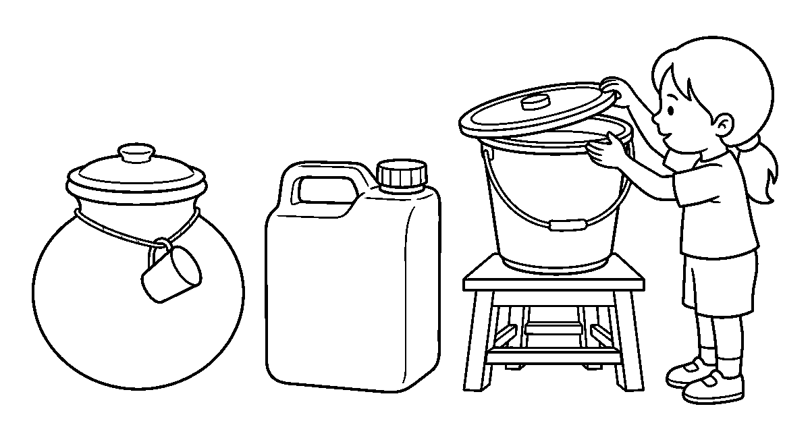

Worksheet
1. A good water container must always be A) painted B) clean and covered C) sweet D) left on the floor
2. Which of these is used to store water? A) insecticide drum B) open plate C) covered bucket D) sieve
3. Before we put water in a container we should A) wash it out B) burn it C) fill it with sand D) leave it open
4. Water stored in an open bucket becomes dirty because A) it is cold B) it is heavy C) dust and insects fall in D) the bucket is blue
5. Fill in: We keep the water container on a ____ or a bench, not on the floor.
6. Mention two containers you have seen used for water at home.
7. Write two sentences on how your family keeps its water clean.
My own work
Draw the water container in your house with its lid on, then colour the lid the colour of the real one.

WEEK 2 — WATER-BORNE DISEASES: SICKNESS THAT COMES WITH DIRTY WATER
Depth: NERDC Nursery 3 · Basic Science and Technology · Third Term W3 (pp 497–502).
You will learn to
• say what a water-borne disease is
• name diseases that come from dirty water
• tell how dirty water makes us sick
• say how to stop these sicknesses
Things to know
• A water-borne disease is a sickness that comes to us from dirty water or from water with
germs in it.
• The ones we must know: diarrhoea, cholera, typhoid fever and dysentery.
• Diarrhoea means passing loose water many times a day; the body loses water and becomes weak.
• In cholera the stomach pains, the child vomits and passes watery stool again and again.
• Dysentery is diarrhoea with blood and pain in the belly.
• Typhoid fever brings long heat (fever), a bad head and a tummy that will not work well.
• Germs enter the body when we drink dirty water, wash food in dirty water, or touch food with
hands that have not been washed after the toilet.
• The signs to watch for: stomach pain, vomiting, loose stool, weakness, fever.
• Prevention is better than cure: boil or treat the water, wash hands with soap, **cover the
water, use the toilet, and wash the food** before it is eaten.
• A child with diarrhoea must drink plenty of clean water and the ORS water the clinic gives,
and must be taken to the clinic the same day if the belly pain or fever does not stop.
Words for my notebook
Water-borne diseases — diarrhoea, cholera, typhoid and dysentery — come from dirty water. Clean water, washed hands and covered containers keep us away from them.
Let us talk
1. What is the danger in drinking water straight from a stream?
2. Name one sign of a child who has diarrhoea.
3. When must we wash our hands with soap?
4. Which water is safer for drinking: boiled water or water from the barrel?

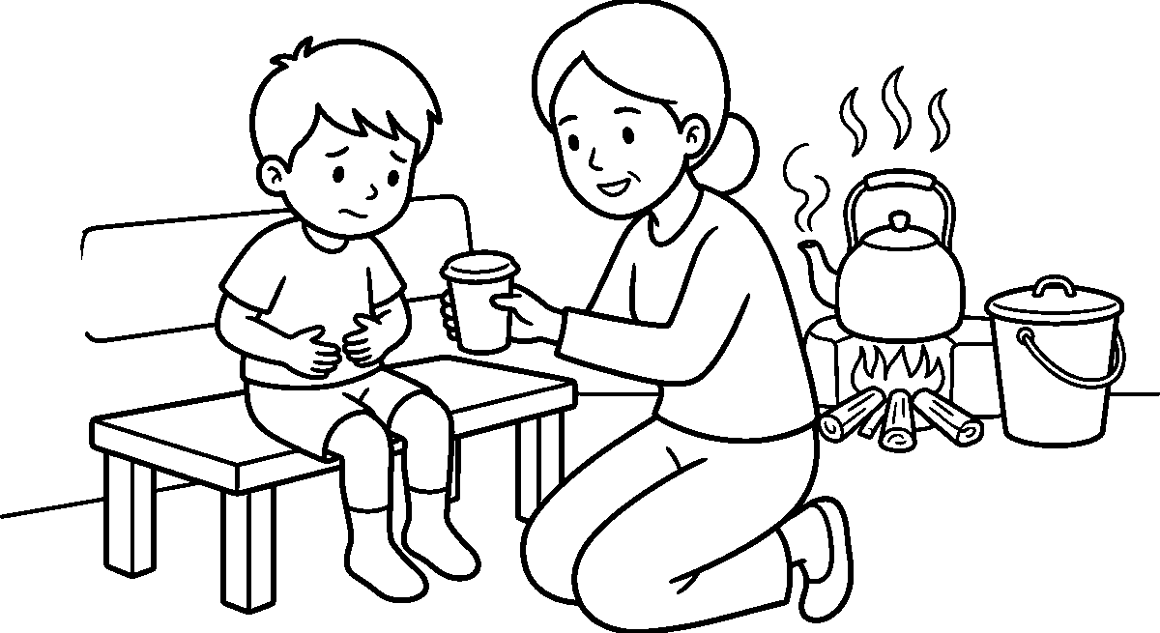
Worksheet
1. A water-borne disease comes from A) new shoes B) a loud noise C) dirty water D) cold air
2. Which of these is a water-borne disease? A) ring worm B) toothache C) diarrhoea D) rash
3. To keep water safe for drinking we may A) keep it open B) boil it C) add sand D) leave it in the sun
4. The loose-water sickness with blood and belly pain is A) cough B) dysentery C) measles D) rash
5. Fill in: A child with diarrhoea must drink plenty of clean ____.
6. Mention three signs of a water-borne disease.
7. Write two sentences on what you do before you eat to keep germs away.
My own work
Draw a glass of clean covered water and a glass with dirt in it, then colour only the safe glass.

WEEK 3 — TECHNOLOGY: SECURITY GADGETS THAT KEEP US SAFE
Depth: NERDC Nursery 3 · Basic Science and Technology · Third Term W4 (pp 497–502).
You will learn to
• say what security means
• name gadgets that keep people and things safe
• tell what each gadget does
• do the right thing when an alarm sounds
Things to know
• Security means keeping people and property safe from thieves, fire and danger.
• A security gadget is a machine or a tool that helps people stay safe.
• Locks and keys keep doors and gates shut so that a stranger cannot walk in.
• A burglar alarm makes a loud sound when somebody forces a door or a window.
• A CCTV camera watches the gate or the shop and records what happens, so the police can see it.
• A security light turns bright at night so that nobody can move in the dark unseen.
• A smoke alarm warns the house when there is fire or smoke, long before the fire is big.
• A security man uses a torch, a whistle, a radio, a uniform and a gate book to
know who is coming and going.
• When an alarm sounds: leave the house at once, go to the place your family has agreed on, and
tell a security person or a grown-up at the gate — never hide under the bed and never go back for a toy.
• Gadgets help, but they do not think: a gate left open and a key under the mat undo a good lock.

Words for my notebook
Security gadgets — locks, alarms, cameras, lights and smoke detectors — help keep people and property safe. When an alarm sounds we leave the house and tell the person at the gate.
Let us talk
1. What keeps a gate shut at night?
2. What does a camera on the wall of a shop do?
3. What sound does a smoke alarm make, and what do we do when we hear it?
4. Name one thing a security man carries.
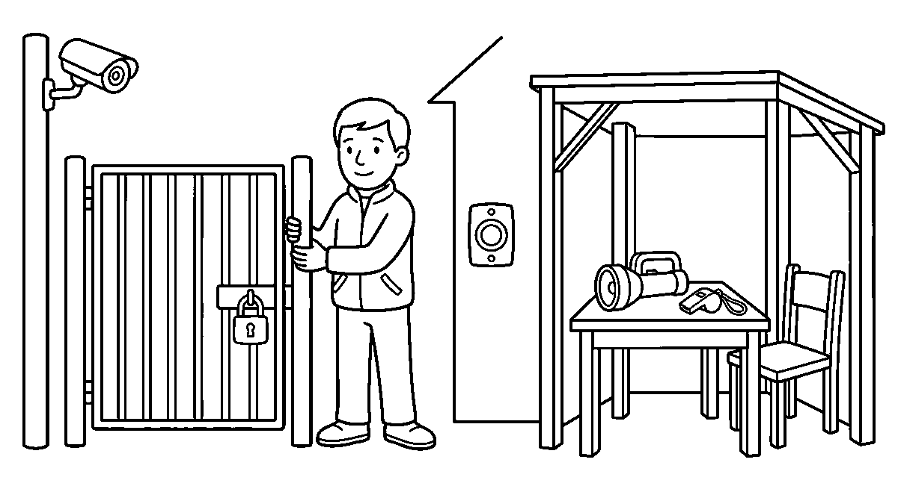
Worksheet
1. Security means keeping people and property A) warm B) busy C) safe D) tall
2. Which gadget makes a loud sound when somebody forces a door? A) broom B) burglar alarm C) kettle D) ruler
3. A CCTV camera is used to A) cool the room B) pound yam C) water the lawn D) record what happens
4. The gadget that warns of fire and smoke is the A) smoke alarm B) doorbell C) scale D) torch
5. Fill in: When the alarm sounds we leave the house and tell the person at the ____.
6. Mention three security gadgets you can see in your street.
7. Write two sentences on what you do when the alarm rings at night.
My own work
Draw the gate of your house with its lock, then colour the gate and draw the key on a nail beside it.

WEEK 4 — ANIMALS AND THE HOMES THEY LIVE IN
Depth: NERDC Nursery 3 · Basic Science and Technology · Third Term W7 (pp 497–502).
You will learn to
• say that animals live in different places
• name the home of an animal
• tell a wild home from a home made by people
• say why an animal needs a home
Things to know
• Every animal has a home where it sleeps, hides its young ones and stays safe.
• Names we must know: dog → kennel, chicken → coop, cow → shed or barn, horse → stable,
bee → hive, bird → nest, lion → den, rabbit → burrow, ant → anthill,
spider → web, fish → water.
• A nest is built by the bird out of twigs, grass, mud and feather.
• A web is spun by the spider out of its own thread to catch small flies.
• An anthill is dug by ants under the ground; the loose soil is what we see heaped up outside.

• A burrow is a hole in the ground; the rabbit and the groundnut live in one.
• Wild homes are not made by people: the forest, the cave, the river, the tree hole,
the rock.
• Homes people make are for the animals we keep: the kennel, the coop, the shed, the
stable, the aquarium.
• An animal chooses or builds its home for shade, safety, rest and young ones.
• If a home is destroyed, the animal must move, find food elsewhere or die — that is why we do not
burn bushes carelessly or cut every tree.
Words for my notebook
Animals live in homes: a dog in a kennel, a bird in a nest, a cow in a shed, a fish in water. Some homes are made by nature; some are made by people who keep the animals.
Let us talk
1. Where does your neighbour's dog sleep at night?
2. What does a bird use to build its nest?
3. Which animal lives in a web?
4. Name an animal whose home is in the ground.
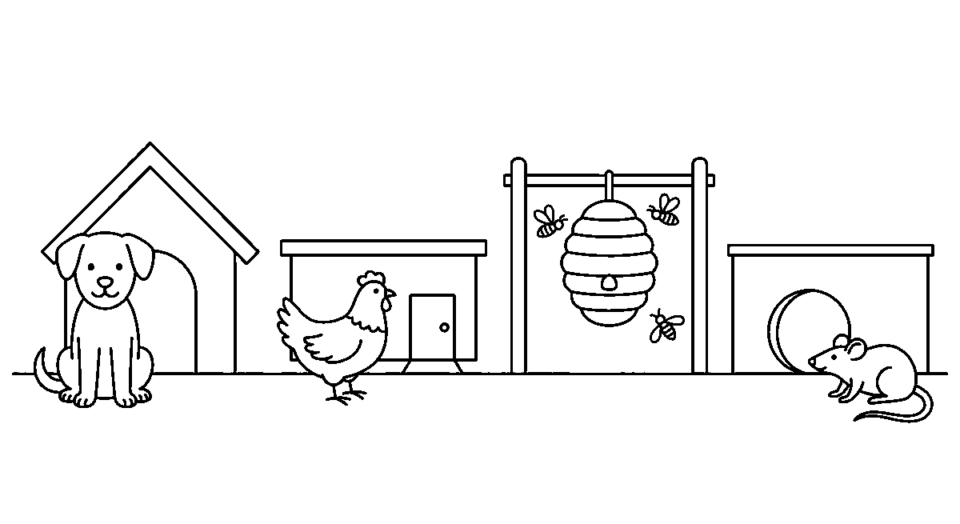
Worksheet
1. The home of a chicken is called a A) den B) hive C) coop D) burrow
2. A spider lives in a A) nest B) web C) stable D) tank
3. The home of a cow is a A) barn or shed B) kennel C) nest D) hive
4. Which animal lives in an anthill? A) fish B) goat C) dog D) ant
5. Fill in: A rabbit lives in a hole in the ground called a ____.
6. Mention three animals whose homes are made by people.
7. Write the name of the home for each of these: bird, lion, fish, bee.
My own work
Draw six animals and their homes on one page, join each animal to its home with a line, then colour.

WEEK 5 — ANIMALS AND THEIR YOUNG ONES
Depth: NERDC Nursery 3 · Basic Science and Technology · Third Term W8 (pp 497–502).
You will learn to
• say that animals have young ones
• name the young one of an animal
• tell how a parent animal cares for its young
• match an animal to its young one
Things to know
• A young one is the baby of an animal; most young ones look like their parents, only smaller.
• The names we must know: dog → puppy, cat → kitten, cow → calf, horse → foal,

sheep → lamb, goat → kid, chicken → chick, duck → duckling, lion → cub,
elephant → calf, bear → cub.
• Some young ones do not look like the parent at first: the frog's young one is a tadpole
that swims with a tail and has no legs; the butterfly's young one is a caterpillar that crawls.
• The growth from tadpole to frog and from caterpillar to butterfly is a change of shape.
• A mother animal gives milk to its young, keeps them warm, cleans them and warns them.
• A father animal may guard the young, as the dog guards the pups in the kennel.
• Birds feed the chick by carrying food in the mouth to the nest.
• The young one of a hen hatches from an egg; the young one of a cat is born alive.
• Animals that lay eggs: hen, duck, tortoise, fish, snake, butterfly. Animals that are born alive:
dog, cat, cow, goat, horse, rabbit.
• We are kind to young animals: we do not chase them, we do not take them from the nest, and we do not
tie a rope round a kid for play.
Words for my notebook
The young of a dog is a puppy, of a cat a kitten, of a hen a chick, of a cow a calf. Some, like the tadpole and the caterpillar, change shape before they grow into the adult.
Let us talk
1. What do we call the baby of a hen?
2. Which animal's young one is called a kid?
3. Show me how a mother cat keeps her kittens warm.
4. What does a cow give its calf to drink?
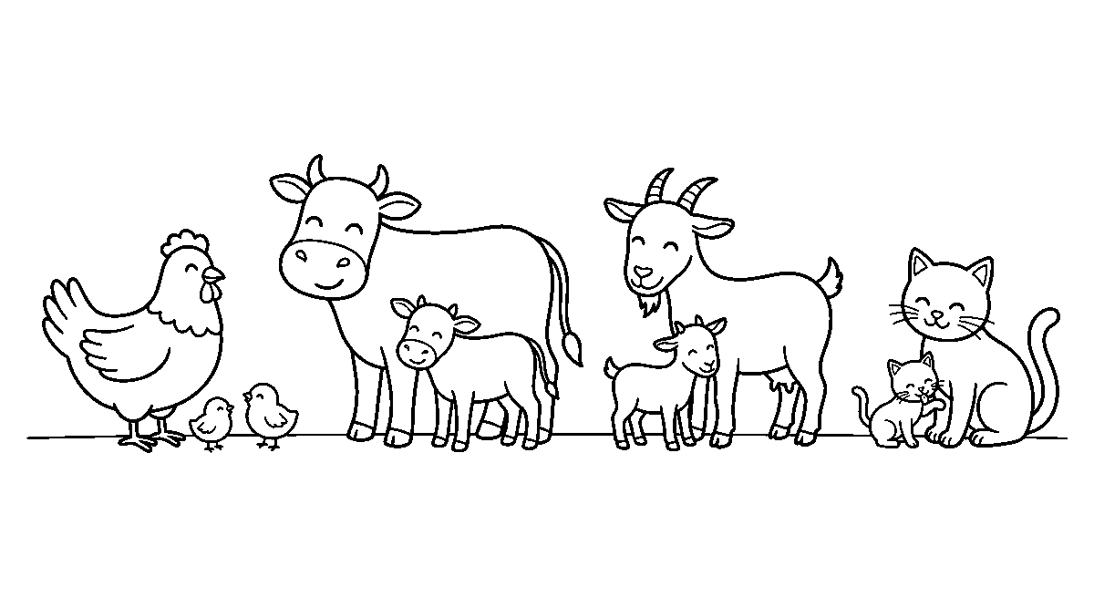
Worksheet
1. The young one of a goat is a A) kid B) lamb C) cub D) foal
2. A puppy is the young one of a A) hen B) dog C) cow D) bee
3. The young one of a butterfly is a A) pupa only B) chick C) caterpillar D) tadpole
4. Which of these animals hatches from an egg? A) horse B) dog C) duck D) goat
5. Fill in: The young one of a frog is called a ____.
6. Match four animals to their young ones by writing the name beside each.
7. Write two sentences on how a mother animal cares for her young ones.
My own work
Cut out pictures of animals and their young ones from an old paper, match them in pairs and paste each pair on one line of your book.

WEEK 6 — TECHNOLOGY: SIMPLE MACHINES USED IN THE HOME
Depth: NERDC Nursery 3 · Basic Science and Technology · Third Term W9 (pp 497–502).
You will learn to
• say what a machine is
• name the simple machines used at home
• tell the work each one does
• handle a sharp tool safely
Things to know
• A machine is anything people make that makes work easier, faster or better.
• A simple machine has few parts and is moved by my own strength.
• In the kitchen: a broom sweeps the floor, a cutlass and a knife cut, a spoon and a
fork carry food to the mouth, a plate holds the food, a pot cooks it.
• For the hands: a bottle opener and a can opener lift lids, a hammer knocks a nail, a
screwdriver turns a screw, a spanner holds a bolt.
• For the body and the house: an iron presses clothes, a fan moves air, a torch gives
light, a bucket carries water, a wheelbarrow carries loads.
• A machine makes work easier but it still needs care: a knife cuts the hand that holds it badly, a
hot iron burns, a fan blade hurts a finger put inside it.
• Some machines are for grown-ups to use, and I only watch: the cutlass, the sharp knife, the hot
iron, the blender that is plugged in.
• After use a tool is cleaned, dried and put back in its place; a knife is never left on the edge of
a table and never carried about by its blade.
• Never touch a plug, socket or wire with wet hands, and never pull a cable to bring a machine down.
• Keeping tools in good order is part of using them: a blunt cutlass is more dangerous than a sharp one,
because the hand slips.
Words for my notebook
A machine makes work easier. At home we use a broom, a knife, a spoon, a can opener, a hammer, an iron and a fan. Every one of them needs care and a safe place.
Let us talk
1. Which machine in your house makes the clothes smooth?
2. What do we use to sweep the compound?
3. Which tools must a child not hold?
4. Where should a knife be kept after use?
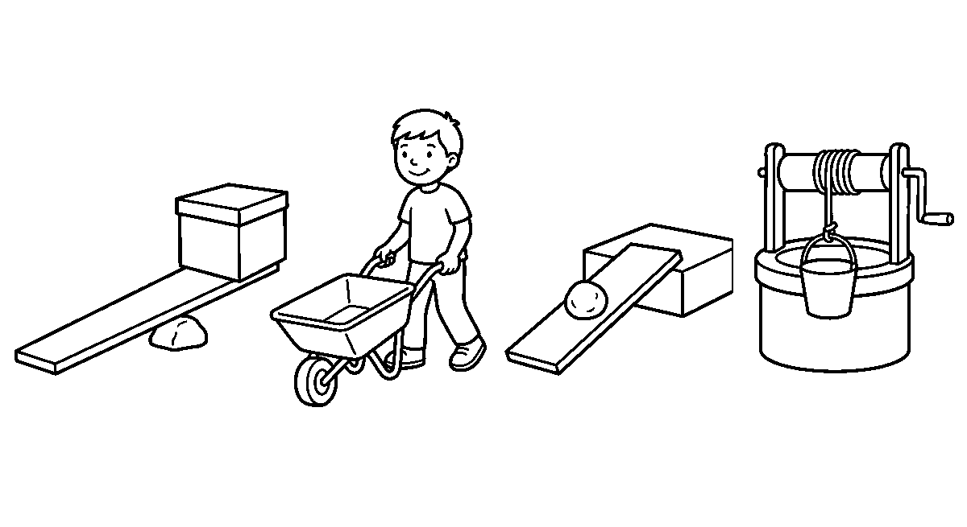
Worksheet
1. A machine is something that makes work A) harder B) easier C) longer D) wetter

2. Which tool is used to sweep the floor? A) spoon B) plate C) broom D) cup
3. A hammer is used to A) cut cloth B) drink water C) iron a shirt D) knock in a nail
4. Which of these is used for opening a tin of food? A) can opener B) broom C) basin D) mat
5. Fill in: We must never touch a plug or a wire with ____ hands.
6. Mention four simple machines you see in your kitchen.
7. Write two sentences on how you keep a sharp tool safe at home.
My own work
Draw four tools from your home in a row and colour the two that a child may hold up.

WEEK 8 — TECHNOLOGY: SIMPLE MACHINES USED IN SCHOOL
Depth: NERDC Nursery 3 · Basic Science and Technology · Third Term W10 (pp 497–502).
You will learn to
• name the simple machines we use in school
• tell what each one does for me
• use a sharp machine safely in class
• keep a school tool in good order
Things to know
• A pencil sharpener cuts the wood away so the lead comes out to a point; turn the pencil, not the
blade.
• Scissors cut paper for art: hold the paper with the fingers away from the line the blade follows.
• A stapler joins two or three sheets with a small pin; press flat, never staple the desk.
• A hole puncher makes a round hole so the page can go into a file.
• A ruler measures in centimetres and draws a straight line; it is not a throwing stick.
• An eraser (a duster for the board) removes pencil marks; chalk and a board duster keep the
board clean for the next writing.
• The bell or the gong calls the class in and out; one person rings it at the agreed time.
• A dustpan and brush carry the sweepings out of the room — the brush sweeps into the pan, never at
another child.
• On the playground the swing and the slide are simple machines too: the swing is a **wheel and
axle with a rope and the slide is an inclined plane** (a slope that saves the lifting).
• Every machine in the class is school property: it is carried with two hands, used for its own
work, counted before it is returned to the cupboard, and reported at once when it is damaged.
Words for my notebook
At school I use a sharpener, scissors, a stapler, a hole puncher, a ruler, an eraser, a duster, a bell and a dustpan. They are school things; I use them for their own work and return them in good order.
Let us talk
1. What do you use to make the pencil sharp again?
2. Which machine joins two sheets of paper?
3. Who rings the bell in our school?
4. What should we do when a scissors is broken?

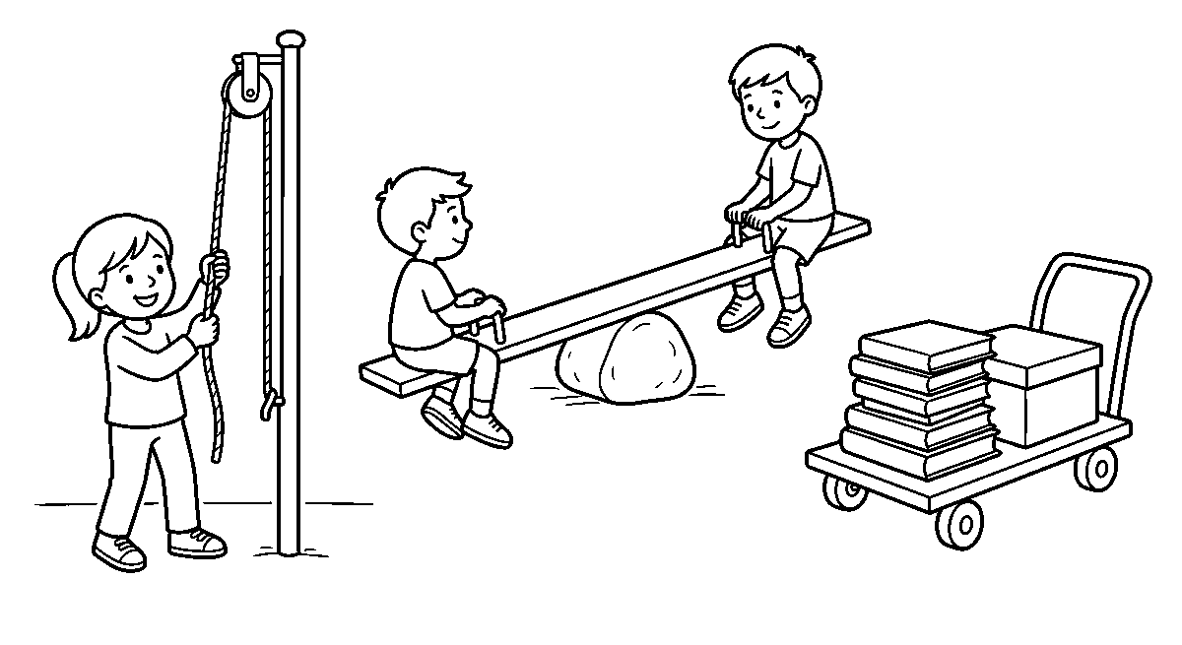
Worksheet
1. A pencil sharpener is used to A) cut paper B) make the pencil point C) clean the board D) carry books
2. Two sheets are joined together with a A) duster B) ruler C) stapler D) bell
3. Which machine makes a round hole in a page? A) hole puncher B) eraser C) brush D) chalk
4. The slide on our playground is a kind of machine called a A) lever B) wheel C) slope D) pulley
5. Fill in: A broken school tool must be ____ at once.
6. Mention four simple machines you use in the classroom.
7. Write two sentences on how you take care of one machine in your class.
My own work
Trace the straight edge of your ruler five times to make five lines, then colour the space between two of them.

WEEK 9 — EXPLORING OUR ENVIRONMENT
Depth: NERDC Primary 1 · Basic Science · First Term W1–2 (pp 624–625), the year's ending look at the child's own surroundings.
You will learn to
• say what my environment means
• name things I see, hear and smell around me
• describe my classroom, my compound and my street
• keep the place where I live clean
Things to know
• My environment is everything around me: the room I sit in, the compound, the street, the
market, the church or mosque, the stream, the trees and the people.
• I learn about my environment with the five senses: I see colours and shapes, hear the
seller's bell and the generator, smell cooking and dirty water, touch rough wall and smooth table, and sometimes taste the salt air or the dust.
• In the classroom: table, bench, board, duster, cupboard, fan, poster, my bag and my book.
• In the school compound: the block, the office, the toilet, the bin, the assembly ground, the
playground, the water tank, the guard's chair.
• At home: the living room, the kitchen, the bedroom, the bathroom, the compound, the gutter, the
bin, the gate.
• People are part of my environment too: my family, my teacher, my friends, my neighbours, the
seller, the driver, the person who sweeps our street.
• Things that make an environment unpleasant: a blocked gutter, refuse in the gutter, a toilet with
no water, a stream of dirty water, broken glass, an open drain.

• Things that make it pleasant: a swept compound, a covered bin, grass cut, trees planted, clean
water, a painted wall, a classroom with light in it.
• On a nature walk I look, I listen, and I say what I found; I do not pick unknown fruit, and I do
not put anything in my mouth.
• I can keep my place clean: refuse goes in the bin, the gutter is cleared, the tap is closed after
use, and I wash my hands after the toilet.
Words for my notebook
My environment is everything around me — the room, the compound, the street, the people. I know it with my five senses, and I help to keep it clean.
Let us talk
1. Name three things you can see from our classroom window.
2. What sound can you hear outside this room right now?
3. Which place in your compound must be kept cleanest, and why?
4. What did you find on our walk round the school?
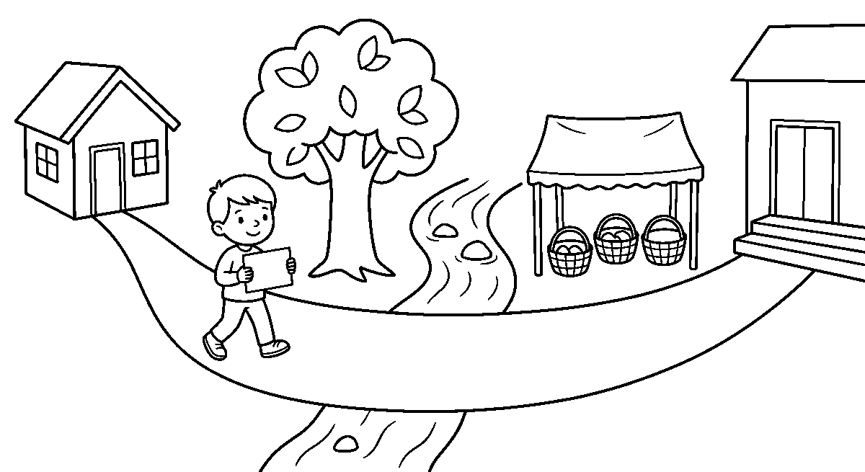
Worksheet
1. My environment means A) my exercise book B) everything around me C) only my family D) my shoes
2. Which sense tells me that water from the tap is cold? A) seeing B) hearing C) touching D) smelling
3. Refuse in the compound should be put A) in the gutter B) on the road C) in a covered bin D) under the bench
4. Which of these is part of my environment? A) the moon only B) my old shoe only C) nothing outside D) the seller in my street
5. Fill in: Everything around me that I can see, hear and smell is my ____.
6. Name four places inside your school compound.
7. Write two sentences on one thing you will do this week to keep your class clean.
My own work
Draw the map of your way from home to school with four things you pass on it, then colour the road.

CULTURAL AND CREATIVE ARTS (CCA)
Weeks 1 to 6, 8 and 9. Week 7 is Mid-Term Break, Week 10 Revision, Week 11 Examination, Week 12 Closing — those weeks carry no note. Depth: NERDC 2025 · Nursery 3 · Creativity · Third Term, pp 572–575, and Primary 1 Cultural and Creative Arts · First Term, pp 662–663 (taken two terms ahead, as the pack directs).

WEEK 1 — MAKING CARDS: PAPER THAT CARRIES A MESSAGE
Depth: NERDC Nursery 3 · Creativity · Third Term W9 (pp 572–575).
You will learn to
• say what a card is used for
• name four kinds of card
• fold a paper into a card
• write or copy a short message inside a card
Things to know
• A card is a small piece of stiff paper we fold and give to somebody to carry a message.
• A card says what the mouth finds hard to say: thank you, I am sorry, well done, **get
well soon**.
• Kinds of card we know: a birthday card, a thank-you card, a get-well card, a
congratulations card, an invitation card and a holiday card.
• We make the card by folding the paper once, in the middle, so it has a front, an inside
and a back.
• The front carries a drawing or a picture; the inside carries the words.
• Words for the inside are kept short: "Happy birthday, Mama." "Thank you for the rice."
• We decorate with crayon, colouring, cut-out paper, stickers, a ribbon or a
little glitter.
• Glitter and paste go on the front, never inside where the words are written.
• A card is given with two hands and is opened by the person it was written for.
• A card is art and speech together: the picture shows the feeling, the words say it.
Words for my notebook
A card is folded stiff paper that carries a short message and a picture. We make a birthday, a thank-you or a get-well card, then write inside and decorate the front.
Let us talk
1. Whose birthday did you recently celebrate?
2. What would you write inside a get-well card?
3. Which part of the card carries the drawing — the front or the inside?
4. Show me how you fold one paper into a card.

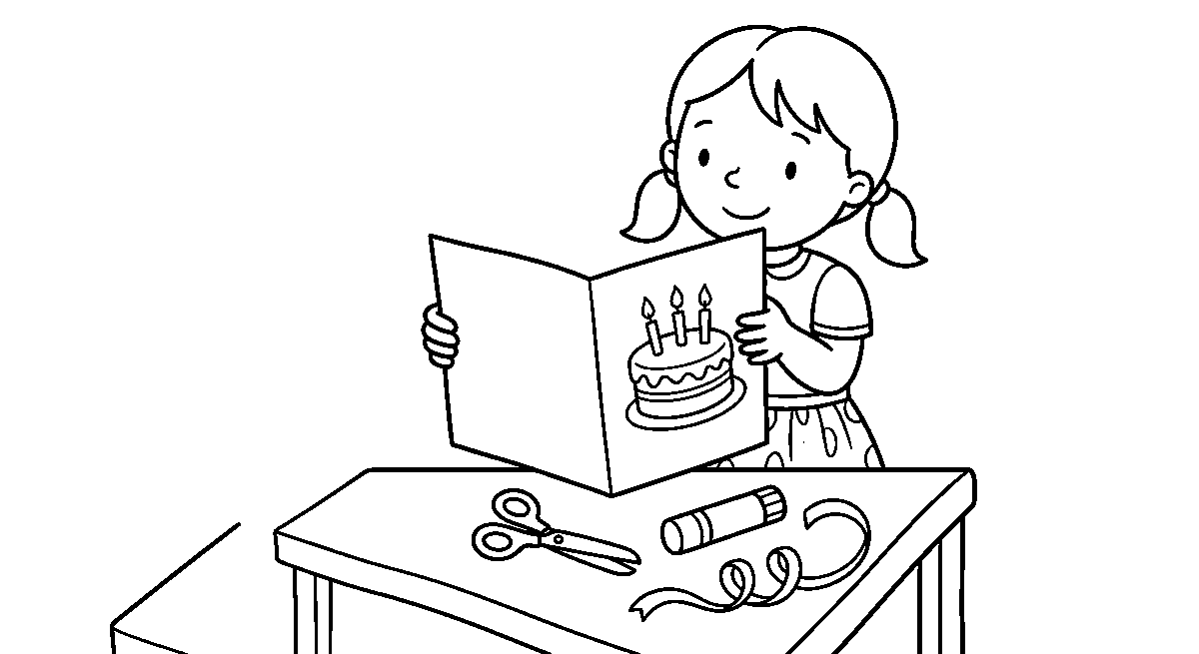
Worksheet
1. A card is made by ____ a stiff paper. A) tearing B) folding C) burning D) wetting
2. Which card do we send to a friend who is sick? A) birthday card B) invitation card C) holiday card D) get-well card
3. The words of a card are written on the ____ of it. A) inside B) back C) edge D) fold
4. A card carries a message and a ____ . A) price B) name of a shop C) picture D) key
5. Fill in: The words of a card are written on the ____ of it.
6. Mention two kinds of card you know.
7. Write two sentences on a card you made and the person you gave it to.
My own work
Fold a paper, draw a cake on the front and copy "Happy birthday" inside it.

WEEK 2 — COLOUR SPLASH AND FEATHER ART
Depth: NERDC Nursery 3 · Creativity · Third Term W10 (pp 572–575).
You will learn to
• splash colour on paper with a brush
• control where the splash falls
• stick feathers flat on paper
• name a picture made with feathers
Things to know
• Splash art is colour thrown from a wet brush onto paper; the drops make marks no hand could draw.
• To splash, hold the brush over the paper and tap it gently with a finger — never at your neighbour.
• A comb or a toothbrush combed through the wet colour makes a fine spray of little dots.
• Cover the table with newspaper first; splash art goes where it is meant to go, not everywhere.
• More colour on the brush makes a heavy splash; a nearly dry brush makes a light, thin one.
• Feather art uses soft feathers stuck on paper with paste to make a picture.
• Feathers give a picture texture — it feels soft and raised, not flat like crayon.
• Pictures we can make from feathers: a bird, a peacock with a long tail, an angel's wing, a
heap of grass in the wind.
• A feather stuck on its edge looks like a line; stuck flat it looks like a wing.
• Feathers are natural things, so we handle them gently and do not pull them from a living bird.
Words for my notebook
Splash art is colour tapped off a wet brush, and feather art is soft feathers pasted flat on paper to give a picture texture and a raised edge.

Let us talk
1. What falls on the paper when you tap a wet brush?
2. How do we keep splash off the table and our clothes?
3. Does a feather feel smooth, rough or soft?
4. Which bird can we make from feathers on paper?
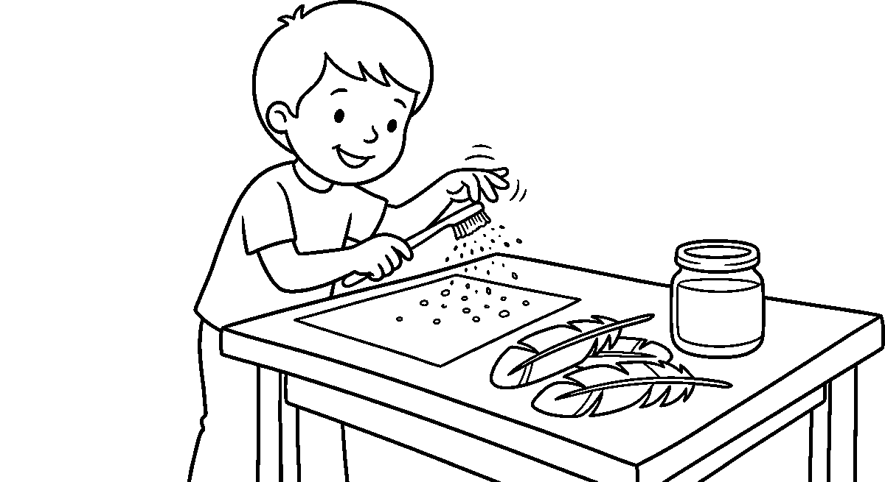
Worksheet
1. We get a fine spray of colour by tapping a wet brush over a ____ . A) cup B) floor C) comb D) shoe
2. A picture with feathers feels ____ to the finger. A) soft and raised B) hot C) wet D) sharp
3. Feathers are best stuck on paper with ____ . A) water B) mud C) a stone D) paste
4. Heavy splash colour comes from a brush that is ____ . A) dry B) very wet with colour C) clean D) small
5. Fill in: Tapping a wet brush over paper makes ____ art.
6. Mention two pictures we can make with feathers on paper.
7. Write two sentences on how you kept the colour off the table.
My own work
Splash colour on one half of a paper, then paste three feathers on the other half to make a bird's tail.

WEEK 3 — WHAT ART IS AND WHAT WE MAKE IT WITH
Depth: NERDC Primary 1 · Cultural and Creative Arts · First Term W1 (pp 662–663).
You will learn to
• say what art is
• name four kinds of art
• name the materials we use for art
• say how a picture can show a feeling
Things to know
• Art is making something beautiful or something that shows what we feel or think.
• Art is all around us: on cloth, on walls, on pots, on doors, on the floor mats.
• Kinds of art we do in class: drawing, painting, colouring and craft (making things by hand).
• Materials: pencils, crayons, chalk, water colours, brushes, paper, cardboard,
glue and scissors.
• A crayon gives a soft thick line; a pencil gives a thin light one; chalk works on the floor.
• A brush is held near the metal ring, not at the end, so the hand can steer it.
• Colours used for a picture: red, blue, yellow, green, brown, black, white.
• A smiling face drawn big and round shows joy; a face with a dropped mouth shows sadness.
• Looking at an artwork means saying what we see, then what it reminds us of.

• Art is not only for the quick child; every finished picture in this class is kept and looked at.
Words for my notebook
Art is making beautiful things with our hands and eyes — drawing, painting, colouring and craft — with pencils, crayons, brushes, colour, paper and scissors.
Let us talk
1. Point to something in this room that was made beautiful on purpose.
2. Which art material makes a soft thick line?
3. Draw a face that looks happy and a face that looks sorry.
4. What do you do with a brush before you dip it in colour?
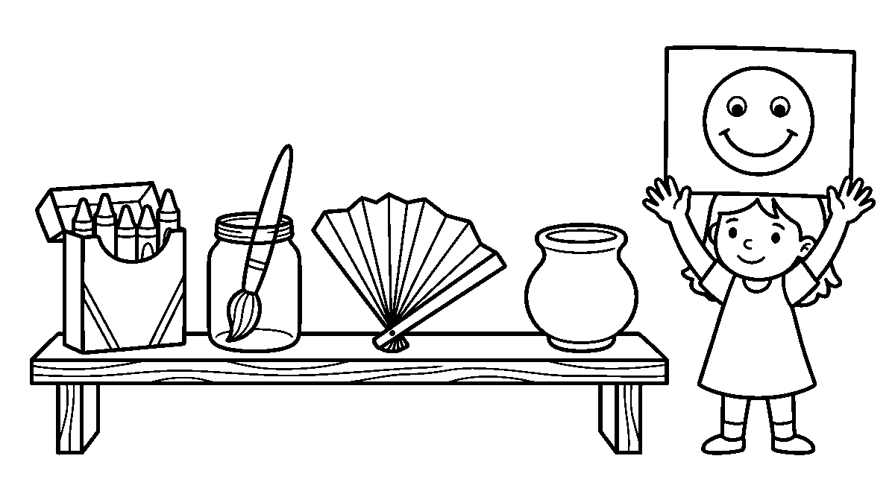
Worksheet
1. A picture drawn with a pencil is made with the hand and the ____ . A) nose B) feet C) ears D) eyes
2. Which of these is a craft? A) singing B) folding paper into a boat C) running D) sleeping
3. The material that gives a soft thick line is a ____ . A) ruler B) needle C) crayon D) spoon
4. To show joy we can draw a face that is ____ . A) sleeping B) crying C) blank D) smiling
5. Fill in: Drawing, painting, colouring and ____ are kinds of art.
6. Mention three materials you use for art.
7. Write two sentences on a picture you saw on cloth or on a wall.
My own work
Draw two faces on one paper — one happy, one sad — and colour the happy one with two bright colours.

WEEK 4 — SCRIBBLING, LINES AND SHAPES
Depth: NERDC Primary 1 · Cultural and Creative Arts · First Term W2 (pp 662–663).
You will learn to
• scribble all over a paper and then inside a boundary
• draw straight, curved and zigzag lines
• draw a circle, a square and a triangle
• join dots to finish a picture
Things to know
• Scribbling is the hand moving the pencil freely; it makes the hand strong for writing.
• First we scribble all over the paper; then we scribble only inside a drawn ring.
• A straight line goes from one place to another without bending — like a piece of stick.
• A curved line bends like a smile, like a road going round a hill, like a banana.
• A zigzag line goes up and down sharply, like teeth, like the mountain in the distance.
• A circle is a round line whose ends meet; we say "one round line, no corner".

• A square has four corners and four like sides; a triangle has three corners and three sides.
• Things with a circle in them: a plate, a ball, the sun, a clock.
• Things with a square or a rectangle in them: a window, a book, a mat, a box.
• To join dots, the pencil starts at one dot and walks to the next without lifting off the paper.
Words for my notebook
We scribble first on the whole paper, then only inside a line. Straight, curved and zigzag lines make circles, squares and triangles, and dots joined with no lift finish the picture.
Let us talk
1. Show me a zigzag line in the air with your finger.
2. How many corners does a triangle have?
3. Name two round things you saw on your way here.
4. Which is easier to draw, a circle or a square?
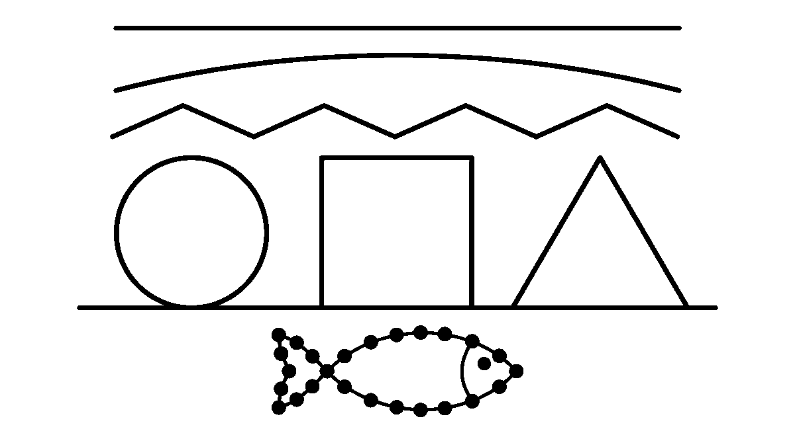
Worksheet
1. A line that goes up and down sharply is a ____ line. A) zigzag B) flat C) quiet D) long
2. A circle is a round line whose ends ____ . A) stay apart B) cross twice C) meet D) point
3. How many corners does a square have? A) one B) four C) two D) three
4. Before joining dots, the pencil must not ____ . A) touch paper B) hold chalk C) be black D) lift off
5. Fill in: A square has ____ corners and four like sides.
6. Mention one round thing and one square thing you saw today.
7. Write two sentences on the lines you drew — straight, curved and zigzag.
My own work
Fill one paper with scribble, then draw a big circle, a square and a triangle inside it and colour only the triangle.

WEEK 5 — MAKING LETTERS AND NUMBERS BEAUTIFUL
Depth: NERDC Primary 1 · Cultural and Creative Arts · First Term W3 (pp 662–663).
You will learn to
• draw a big letter and colour its inside
• decorate a letter with dots and lines
• make a pattern using numbers
• paste paper bits onto a letter
Things to know
• A letter can be art as well as writing: we draw it big and leave it hollow to colour in.
• To make a hollow letter, trace a big letter twice, once beside itself, then join the tops and the feet.
• We decorate the outline with dots, small circles, zigzags or little leaves drawn on it.

• Colour stays inside the letter; the line of the letter is left whole and dark.
• Numbers can be decorated too: 1 with a hat, 2 with a boat's sail, 8 with two round plates.
• A pattern is marks that repeat: dot, line, dot, line — or 1, 2, 1, 2, 1, 2.
• A collage letter is made by pasting small bits of coloured paper, seeds or beads on the letter.
• Paste is spread thin with a finger or a stick, and the paper is pressed flat, not rubbed.
• Our own name is the best letter to decorate, because we can read every one of its letters.
• Artistic writing means the letter is still readable after we have made it beautiful.
Words for my notebook
We draw big hollow letters and numbers, colour inside them, decorate the edge with dots and lines, and paste paper bits to make a pattern that can still be read.
Let us talk
1. Which letter of your name is the roundest?
2. What repeats in the pattern: dot, line, dot, line?
3. Show me how you press a pasted paper bit flat.
4. Which number looks like two plates on top of each other?
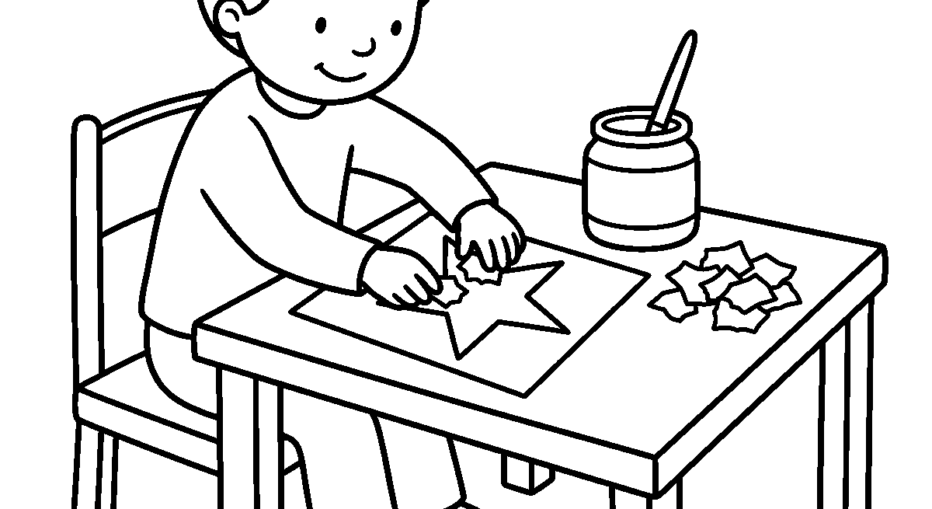
Worksheet
1. A hollow letter is one we can ____ inside. A) tear B) colour C) fold D) erase
2. Dots on a line of a letter are there to make it ____ . A) heavy B) wet C) beautiful D) new
3. A pattern of dot, line, dot, line is made of marks that ____ . A) melt B) disappear C) stand still D) repeat
4. A letter covered with pasted paper bits is called a ____ . A) collage B) song C) plate D) dream
5. Fill in: A pattern is made of marks that ____ .
6. Mention two ways to decorate the line of a letter.
7. Write two sentences on the letter you decorated and the colour you used.
My own work
Draw the first letter of your name big and hollow, colour inside it, then put dots all along its line.

WEEK 6 — COLOURS: THE THREE THAT MAKE THE OTHERS
Depth: NERDC Primary 1 · Cultural and Creative Arts · First Term W4 and W7 (pp 662–663).
You will learn to
• name the three primary colours
• name the three secondary colours
• mix two colours to get a new one
• point to colours in our surroundings

Things to know
• A colour is what makes things look red, blue, yellow or green to the eye.
• The primary colours are red, blue and yellow; no two colours can be mixed to make them.
• Two primary colours mixed give a secondary colour.
• Red + yellow = orange (the colour of a ripe palm fruit and of sunset).
• Yellow + blue = green (the colour of a fresh leaf and of the grass).
• Red + blue = purple (the colour of a ripe plum and of some beans).
• Other colours we use: black, white, brown, pink and grey.
• In our surroundings: the sky is blue, the grass is green, the sun is yellow, a ripe tomato
is red, the soil after rain is brown.
• Much red with a little white makes pink; much black with a little white makes grey.
• Before two colours are mixed on paper, the brush is rinsed in the water cup, or the mix turns muddy.
Words for my notebook
Red, blue and yellow are primary colours. Mixing two of them gives orange, green or purple, and the rest of the colours we see are around us in the sky, the leaves and the soil.
Let us talk
1. What colour is the sky at noon today?
2. Which two colours must I mix to get green?
3. Point to something brown in this room.
4. What colour is a ripe orange — the fruit?
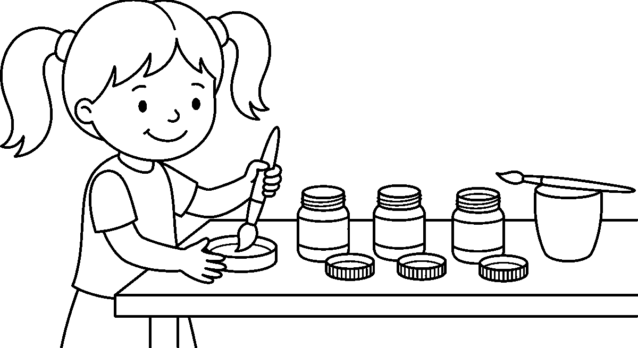
Worksheet
1. Which colour is a primary colour? A) green B) orange C) purple D) yellow
2. Red and yellow mixed together give ____ . A) green B) orange C) black D) blue
3. The colour of a fresh leaf is ____ . A) green B) white C) red D) grey
4. How many primary colours are there? A) one B) eight C) three D) two
5. Fill in: Red and blue mixed together give ____ .
6. Mention the three primary colours.
7. Write two sentences on colours you saw outside on your way to school.
My own work
Colour one leaf green, one orange and one purple, then draw a ring round each colour you mixed yourself.

WEEK 8 — CRAFTS: MAKING THINGS WITH OUR HANDS
Depth: NERDC Primary 1 · Cultural and Creative Arts · First Term W8 (pp 662–663).

You will learn to
• say what a craft is
• name three kinds of craft
• fold paper into halves and quarters
• carry and use scissors safely
Things to know
• A craft is a thing we make with our hands, usually something we can use or wear.
• Crafts we know in class: paper craft, clay modelling and bead work.
• Materials for craft: paper, cardboard, glue, scissors, clay, thread, beads,
old bottle caps.
• Folding a paper once, corner to corner or edge to edge, gives two halves; folding again gives
four quarters.
• A crease is made by running a fingernail along the fold, so the paper keeps the shape.
• A paper boat, a hat and an aeroplane are all made from one folded paper.
• Clay modelling: roll clay on the table into a snake, then coil it into a pot; keep the clay
cool and covered with a damp cloth.
• Bead work: beads are threaded on a strong thread, one after another, to make a necklace or a
bracelet.
• Scissors are carried with the blades closed and the handles forward to the person you hand them to.
• Scissors cut paper and cloth; they do not cut hair, thread on a garment, or a neighbour's work.
Words for my notebook
A craft is a thing made with our hands: paper folding, clay modelling and bead work. We fold halves and quarters, press every crease, and carry scissors closed with the handles forward.
Let us talk
1. What did you make with clay last time?
2. How many quarters do you get when a paper is folded twice?
3. Which part of the scissors do you hold when you pass them to a friend?
4. Name one thing that scissors must never cut.
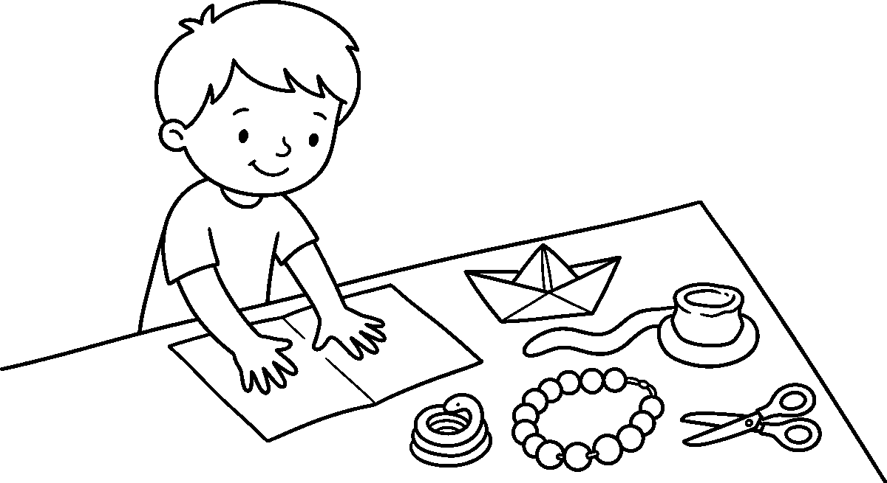
Worksheet
1. A craft is a thing made with our ____ . A) ears B) hands C) toes D) teeth
2. Folding a paper once, edge to edge, gives two ____ . A) cups B) birds C) halves D) rings
3. A coiled snake of clay can become a ____ . A) pot B) song C) shadow D) colour
4. We carry scissors to a friend with the ____ forward. A) blades B) points C) paper D) fingers

5. Fill in: Folding a paper once, edge to edge, gives two ____ .
6. Mention three things we use for craft work.
7. Write two sentences on how scissors are carried and used safely.
My own work
Fold a paper into four quarters, cut one edge into fringes, then open it to see a paper fan.

WEEK 9 — DECORATION: MAKING PLAIN THINGS BEAUTIFUL
Depth: NERDC Primary 1 · Cultural and Creative Arts · First Term W10 (pp 662–663).
You will learn to
• say what decoration means
• make a paper flower and a garland
• draw a border pattern round a picture
• make a decorated name tag
Things to know
• Decoration means making a plain thing beautiful by adding colours, patterns or shapes to it.
• We decorate the classroom walls, our notice board, our books, our name tags and the corners of a drawing.
• A pattern repeats: dots, then lines, then small circles; a border is a pattern that runs round the edge.
• A paper flower is made by cutting petals round a circle, folding it, and pressing a button centre in it.
• A garland is made by stringing paper cups, leaves or beads one after another on a thread.
• For a garland, two shapes are placed back to back and the thread runs between them.
• Our country's colours, green and white, can be used in a garland for a school day.
• A name tag carries the name written big and clear, with a pattern round the edge.
• Decoration must not cover what we need to see: the name stays readable, the border stays outside it.
• Everything used for decoration is what we find: paper, leaves, seeds, old cloth, caps, string.
Words for my notebook
Decoration makes plain things beautiful. We repeat a pattern to draw a border, cut paper flowers, string a garland of paper cups, and write our name big on a tag with a pattern round the edge.
Let us talk
1. Which wall in this room could use a decoration?
2. What shape do we cut for a paper flower's petals?
3. What repeats in the border you drew today?
4. Why must a name tag still be easy to read?
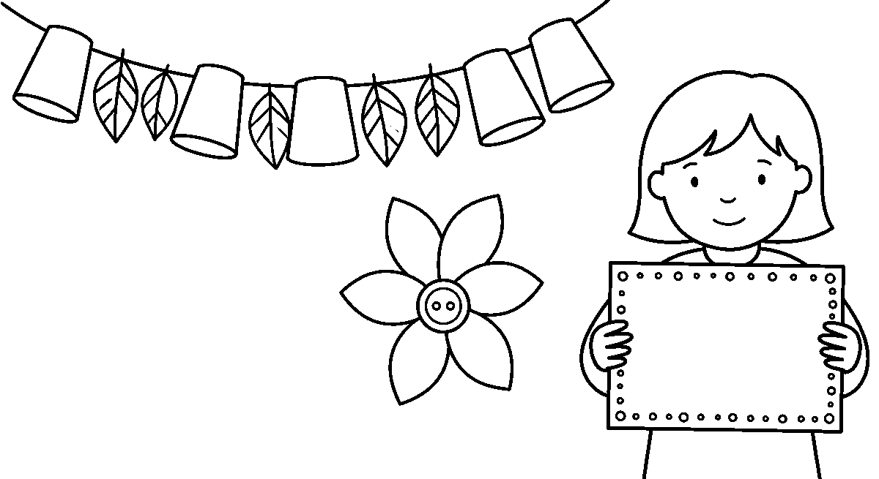
Worksheet
1. Decoration makes a plain thing ____ . A) beautiful B) heavier C) wetter D) quieter

2. A pattern that runs round the edge of a drawing is a ____ . A) song B) border C) floor D) shadow
3. A garland is made by stringing cups or beads on a ____ . A) stone B) needle C) thread D) plate
4. On a name tag, the name must still be ____ . A) hidden B) folded C) erased D) readable
5. Fill in: A pattern that runs round the edge of a drawing is a ____ .
6. Mention two things we decorate in this class.
7. Write two sentences on the name tag you made and the pattern on its edge.
My own work
Draw your name big, then put a border of dots and lines all round it and colour two corners green.

CHRISTIAN RELIGIOUS STUDIES (CRS)
Weeks 1 to 6, 8 and 9. Week 7 is Mid-Term Break, Week 10 Revision, Week 11 Examination, Week 12 Closing — those weeks carry no note. *Depth: NERDC 2025 · Primary 2 · Christian Religious Studies · First Term, pp 699–701, and Nursery 3
• CRS · Third Term (Jesus our Saviour, pp 576–578), taken from the pack's off-by-three mapping.*

WEEK 1 — JESUS CHRIST OUR SAVIOUR
Depth: NERDC Nursery 3 · CRS · Third Term (pp 576–578).
You will learn to
• say what a saviour is
• tell why Jesus came into the world
• say what Jesus did for me on the cross
• tell the Easter story in my own words
Things to know
• A saviour is somebody who saves us or rescues us out of danger.
• A sin is the wrong thing we do — fighting, lying, stealing, refusing to obey.
• Everybody does wrong things sometimes; the Bible says all have sinned (Romans 3:23).
• Sin puts a wall between us and God, because God is holy and cannot be pleased with wrong.
• We cannot pull the wall down ourselves; Jesus came to take it down for us.
• Jesus died on the cross for us. He did no sin, yet He took the punishment that was ours.
• His death shows how much God loves us: God so loved the world that He gave His only Son (John 3:16).
• On the third day Jesus rose from the dead — the women came and the stone was rolled away.
• Jesus is alive in heaven today, near God the Father, and He still hears us when we speak.
• Because Jesus died and rose again, we can be called God's children and live with God for ever.
• To accept Jesus is to say: You are my Saviour; I will follow You.
Words for my notebook
A saviour is one who saves. We all do wrong, and sin puts a wall between us and God, so Jesus died on the cross for us and rose again on the third day that we may be God's children.
Let us talk
1. What does the word saviour mean?
2. Name one wrong thing the Bible calls sin.
3. On which day did Jesus rise from the dead?
4. What do you say when you accept Jesus as your Saviour?
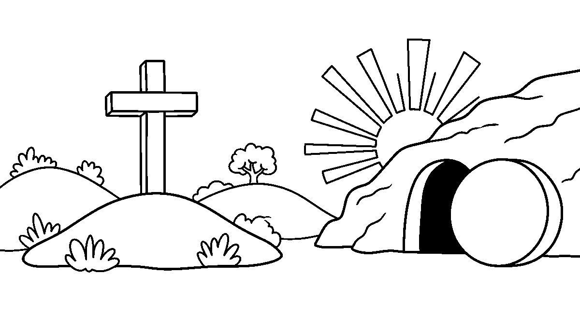

Worksheet
1. A saviour is somebody who ____ us. A) frightens B) saves C) forgets D) paints
2. Jesus died on the ____ for us. A) hill B) road C) river bank D) cross
3. Jesus rose from the dead on the ____ day. A) third B) seventh C) tenth D) second
4. Because Jesus died and rose again, we can be ____ . A) kings of the earth B) rich men C) owners of land D) children of God
5. Fill in: A sin is the ____ thing we do.
6. Mention two wrong things the Bible calls sin.
7. Write two sentences on why Jesus came into the world.
My own work
Draw three hills with a cross on the middle hill, then draw the sun rising behind it.

WEEK 2 — JESUS CALLS US FRIENDS, BROTHERS AND SISTERS
Depth: NERDC Nursery 3 · CRS · Third Term (pp 576–578).
You will learn to
• say what Jesus calls us
• tell who my brothers and sisters in God's family are
• show a friend what love looks like
• say how we prove that we are Jesus' friends
Things to know
• Jesus said, "You are My friends" (John 15:15) — He did not call those who follow Him strangers.
• A friend is one who stays near, tells the truth, shares and does not hurt you.
• Jesus is a friend who never leaves, even when other children go home.
• In God's family, everybody in the class is my brother or my sister.
• That is why we do not say "that child is not my relation, I will not help him".
• Jesus wants us to love one another; this is the sign by which people will know us.
• We show that we are Jesus' friends by obeying what He taught, not only by singing.
• A friend is known in what he does: sharing a bench, giving a drink, carrying a heavy book.
• Little children can be Jesus' friends too — He did not wait for us to grow tall.
• When I hurt my friend, I go back and say "I am sorry", because friends do not keep anger.
Words for my notebook
Jesus calls us friends and brothers and sisters in God's family. We prove we are His friends by loving and obeying one another, and by saying sorry when we hurt a friend.
Let us talk
1. What does Jesus call the ones who follow Him?
2. Who is your brother or sister in God's family?
3. What did you do for a friend today?
4. How do we show that we are Jesus' friends?

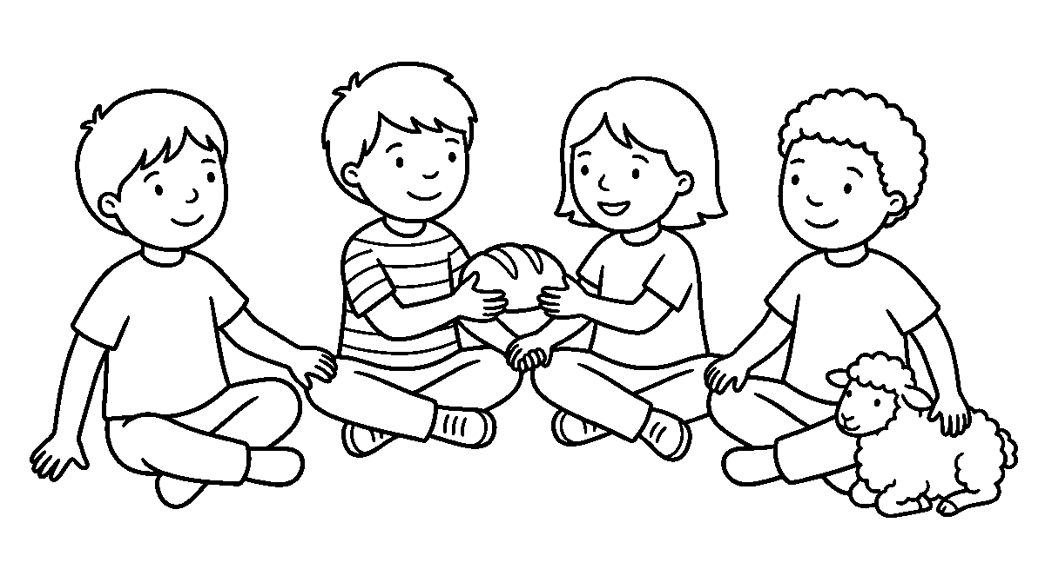
Worksheet
1. Jesus said, "I call you ____ " (John 15:15). A) servants only B) strangers C) friends D) visitors
2. In God's family, everybody in the class is my ____ . A) brother or sister B) paying guest C) neighbour far away D) class enemy
3. A friend is one who ____ . A) hides my exercise book B) hurts me C) laughs at me D) stays near and tells the truth
4. We show that we are Jesus' friends by ____ . A) forgetting Him B) obeying what He taught C) teasing the small ones D) sleeping in church
5. Fill in: When I hurt my friend, I go and say "____" .
6. Mention three things a friend does for you.
7. Write two sentences on the friend you thank God for.
My own work
Draw four children holding hands in a ring, then draw a small lamb sitting inside the ring.

WEEK 3 — JESUS COMMANDS US TO LOVE
Depth: NERDC Nursery 3 · CRS · Third Term (pp 576–578).
You will learn to
• say the greatest commandment of the law
• tell who my neighbour is
• show love to God in three ways
• show love to people by what I do
Things to know
• The greatest commandment: love the Lord your God with all your heart (Matthew 22:37).
• The second is like it: love your neighbour as yourself (Matthew 22:39).
• Jesus said, "Love one another as I have loved you" (John 13:34).
• Love is the most important thing Jesus taught; all other teaching hangs on these two.
• We show love to God by praying, by thanking Him, by worshipping and by obeying.
• Who is my neighbour? Everybody around me — my family, my class, my teacher, the baby at home.
• My neighbour is also the stranger at the gate and the child who is different from me.
• Love is a verb: helping a friend up, sharing an orange, giving water to the old woman.
• Love does not push, does not scold, does not take what is not mine.
• A kind word is love; a kept promise is love; a divided biscuit is love.
• It is easy to love those who love me; Jesus asks me to love even the child who annoys me.
Words for my notebook
Jesus gave two great commands: love God with all my heart and love my neighbour as myself. My neighbour is everybody around me, and love is known by what I do — helping, sharing and being kind.

Let us talk
1. Which is the greatest commandment of the law?
2. Who counts as your neighbour?
3. Name one way you showed love at home this week.
4. How do we show love to God without leaving this class?
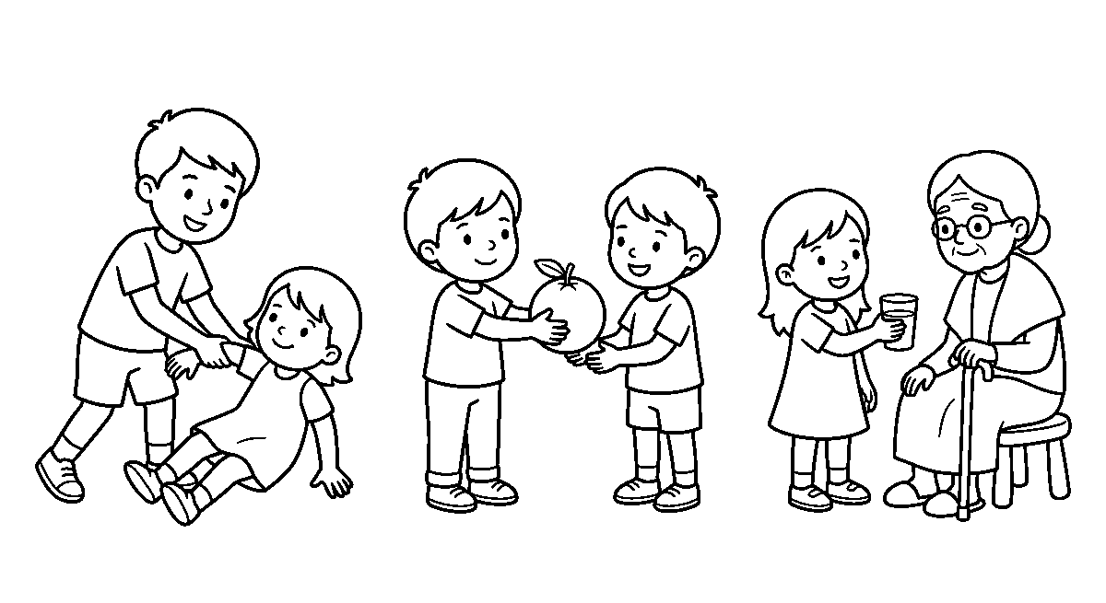
Worksheet
1. The greatest commandment is to love ____ . A) my ball B) my teacher only C) the market D) God with all my heart
2. The second commandment is to love ____ . A) my neighbour as myself B) only my brothers C) nobody D) only those who give me things
3. Love is mostly known by what we ____ . A) dream B) hide C) do D) own
4. "Love one another as I have loved you" were words of ____ . A) Jesus B) Pharaoh C) my classmate D) the soldier
5. Fill in: My neighbour is everybody ____ me.
6. Mention four people you must show love to.
7. Write two sentences on a kind thing you did for somebody different from you.
My own work
Draw a boy helping a small girl to stand up, then draw two children sharing one orange between them.

WEEK 4 — JESUS WANTS US TO OBEY GOD'S COMMANDMENTS
Depth: NERDC Primary 2 · CRS · First Term (pp 699–701), and Exodus 20 in child's words.
You will learn to
• say what a commandment is
• name five of God's rules for living
• tell why we obey God
• say who brought God's rules to the people
Things to know
• God's rules for living are called commandments — they are not punishments, they are guidance.
• God gave His rules through Moses on the mountain; they were written on two tables of stone.
• We keep them in our hearts: love God only, do not make an image to worship, do not steal, do not lie, do not be jealous of what others have, and give honour to father and mother.
• We obey God because He loves us and knows what is best for us.
• A child who obeys keeps himself out of a great deal of sorrow.
• Jesus obeyed God perfectly all His life, even when obeying was painful.
• Jesus did not obey only when He felt like it; that is what "perfectly" means.
• Obeying God makes us happy and pleases Him, like a good song pleases the one who hears it.
• We cannot obey in our own power: we ask Jesus to help us obey every morning.

• To lie, to take what is not mine, to hit a smaller child — each one breaks a rule we know.
Words for my notebook
Commandments are God's rules for living, given through Moses on two tables of stone. We obey because God loves us and knows what is best, and Jesus obeyed God perfectly so that we may learn from Him.
Let us talk
1. What do we call God's rules for living?
2. Who brought the commandments to the people?
3. Which rule keeps my mouth true?
4. Why is it good to obey God?
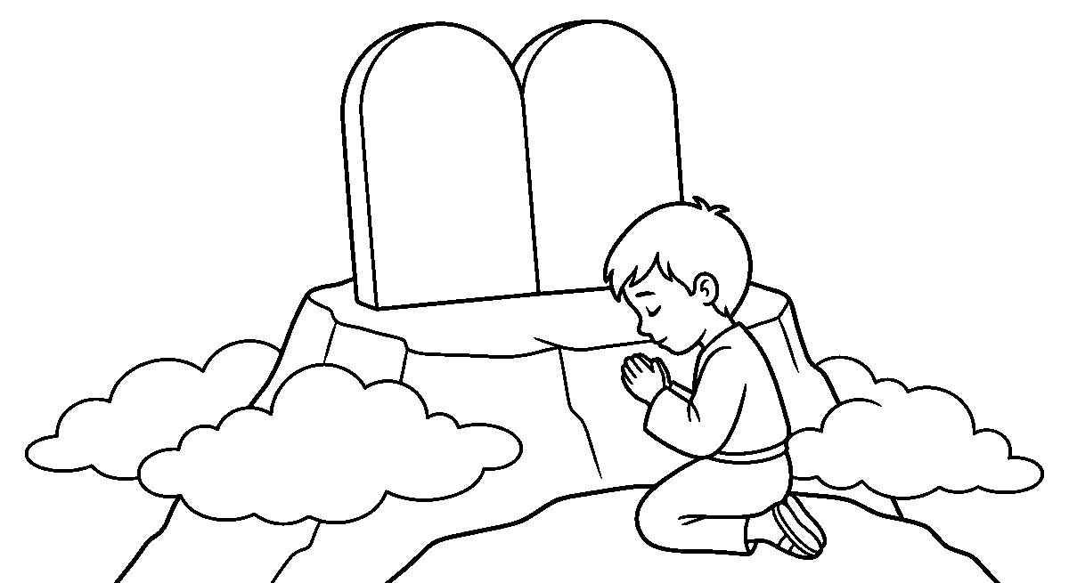
Worksheet
1. God's rules for living are called ____ . A) commandments B) birthday gifts C) market prices D) class songs
2. The commandments were given through ____ on the mountain. A) Pharaoh B) Moses C) the soldier D) my neighbour
3. Which of these is one of God's rules? A) take what you like B) always sleep late C) do not lie D) hide your book
4. We obey God because He ____ . A) is far away B) cannot see us C) lives in the sky only D) loves us and knows what is best
5. Fill in: Jesus obeyed God ____ , even when it was painful.
6. Mention three of God's rules you learnt this week.
7. Write two sentences on a time you chose to obey instead of doing wrong.
My own work
Draw two plain stone tables standing side by side on a mountain, and a small boy kneeling in front of them.

WEEK 5 — THE MEANING OF PRAYER
Depth: NERDC Primary 2 · CRS · First Term W1–2, prayer (pp 699–701).
You will learn to
• say what prayer is
• name four places I can pray
• tell who listens when I pray
• pray in two different ways
Things to know
• Prayer is talking to God — with my mouth, or only in my heart where nobody can hear.
• Prayer is like talking to a father or a friend: I say what I did, what I need and what I thank for.
• God listens when I pray; He is not far and He is not busy.
• God loves it when His little children speak to Him, and He does not mind small words.
• I can pray anywhere: at home, in class, in the church, on the playground, in the bus.
• I can pray any time: in the morning, in the afternoon, at night, and between two lessons.
• We pray out loud when we are together, and silently in our hearts when we are many.

• We also pray by singing to God, and by reading the prayers He gave us in the Bible.
• Folding the hands and closing the eyes are not what makes God hear; they help me to think on Him.
• Nobody has to be tall to pray: a child's short prayer is heard the same as the pastor's long one.
• Prayer is our conversation with God — He speaks to me in His word, I speak to Him in prayer.
Words for my notebook
Prayer is talking to God like talking to a father or a friend. I can pray anywhere and any time, out loud or in my heart, and God listens to me.
Let us talk
1. What is prayer?
2. Where did you pray yesterday?
3. Who listens when you pray?
4. What is the difference between praying out loud and praying in your heart?
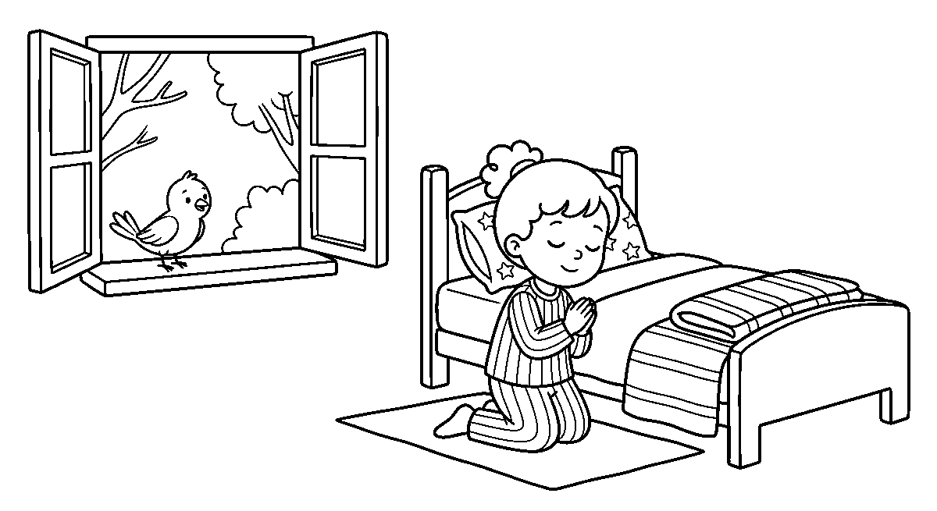
Worksheet
1. Prayer is talking to ____ . A) my friend B) God C) the door D) my toy
2. God hears my prayer because He ____ . A) is far away B) cannot hear small ones C) is busy with angels D) listens to me
3. Which of these is a way to pray? A) singing to God B) hiding under a bed C) counting my beads D) shouting at friends
4. Folding my hands and closing my eyes help me to ____ . A) find my shoes B) sleep well C) think on God D) warm my hands
5. Fill in: We can pray at home, in class, in the church and on the ____ .
6. Mention four times of the day I am allowed to pray.
7. Write two sentences on what you thanked God for this morning.
My own work
Draw a girl kneeling beside her bed with her hands folded, and a bird sitting on the window sill.

WEEK 6 — WHEN TO PRAY
Depth: NERDC Primary 2 · CRS · First Term W3–4, when to pray (pp 699–701).
You will learn to
• name the special times we pray every day
• say what we ask God in the morning and at night
• thank God before a meal
• tell when else it is good to pray
Things to know
• There is no wrong time to pray; we can pray any time we want.
• In the morning we thank God for the night that kept us safe, and we ask for protection for the day.
• Before a meal we thank God for the food; that short prayer is called saying grace.

• At night we thank God for the day and ask for peaceful sleep.
• Before school we ask God for wisdom to understand and safety on the road.
• When we are happy, we pray and thank God; when we are sad or afraid, we ask for help and comfort.
• When somebody is sick, we pray for their healing; when a friend is hurting, we pray with them.
• Before a class test we ask God to open our minds, not to give us another child's work.
• The Bible says, "Pray without ceasing" (1 Thessalonians 5:17) — that means keep talking to God all day.
• A child who prays at these four times — morning, food, school, bed — is learning to keep God near.
• Praying with the family at home is good, and praying alone is good too.
Words for my notebook
We pray in the morning, before a meal, before school and at night. We also pray when we are happy, sad, afraid, or when somebody is sick, for the Bible says we should pray without ceasing.
Let us talk
1. What do you thank God for in the morning?
2. What do we say before we eat?
3. Name one other time it is good to pray.
4. What does "pray without ceasing" mean for a child?
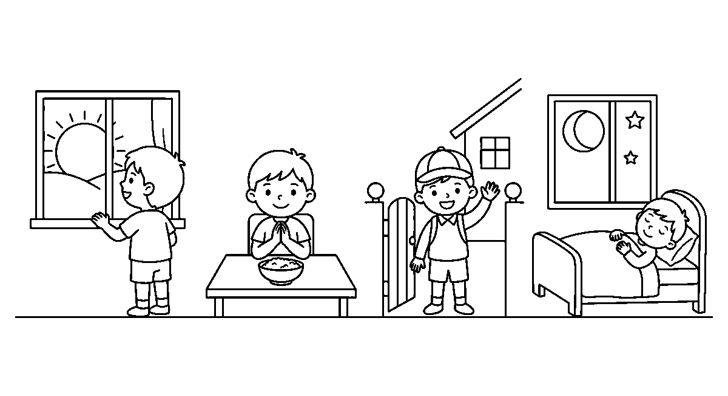
Worksheet
1. In the morning we thank God for the ____ . A) night that kept us B) rain in the farm C) market on Sunday D) lost shoe
2. The short prayer we say before a meal is called ____ . A) church bell B) roll call C) saying grace D) day break
3. At night we ask God for ____ . A) another plate of food B) a long class C) a new cap D) peaceful sleep
4. When somebody is sick we ____ . A) laugh at them B) play louder C) leave the house D) pray for their healing
5. Fill in: The Bible says, "Pray without ____ ."
6. Mention four times we should pray in a single day.
7. Write two sentences on the last time you prayed before you ate.
My own work
Draw four small pictures in a row: the rising sun, a bowl of food, a school cap at a gate, and the moon in a window.

WEEK 8 — HOW TO PRAY
Depth: NERDC Primary 2 · CRS · First Term W1–2, how to pray (pp 699–701).
You will learn to
• show three positions we can pray in
• tell why we fold the hands
• pray a short prayer with the class
• say what Jesus did when He prayed

Things to know
• We may pray standing, sitting, kneeling or simply with the head bowed.
• Kneeling and bowing the head are ways of showing God honour, not rules that make the prayer work.
• Jesus Himself knelt when He prayed in the garden (Luke 22:41).
• Folded hands keep the fingers from fidgeting; closed eyes keep the mind from wandering.
• When we pray together, one voice speaks and the rest say "Amen" at the end, meaning so be it.
• A prayer can be as short as "Thank You, God, for my mother", and as long as a whole song.
• We thank first, then we ask for what we need, then we ask God to wash away the wrong we did.
• It is right to pray for somebody else: my friend who is sick, my teacher, my father and mother.
• Prayer is not only words from the mouth; the heart must go with the mouth.
• After praying, I listen quietly for a moment, because God also speaks to me through His word.
• Do not copy another child's prayer in a loud voice; God is not hearing the class, He is hearing you.
Words for my notebook
We can pray standing, sitting or kneeling, with folded hands and bowed head. We thank God first, then ask, then own our wrong, and we may pray for other people as well as for ourselves.
Let us talk
1. Show me a position you like to pray in.
2. Why do we fold our hands when we pray?
3. What do we say at the end of a prayer together?
4. Put your own short prayer in this order: thank, ask, own what you did wrong.
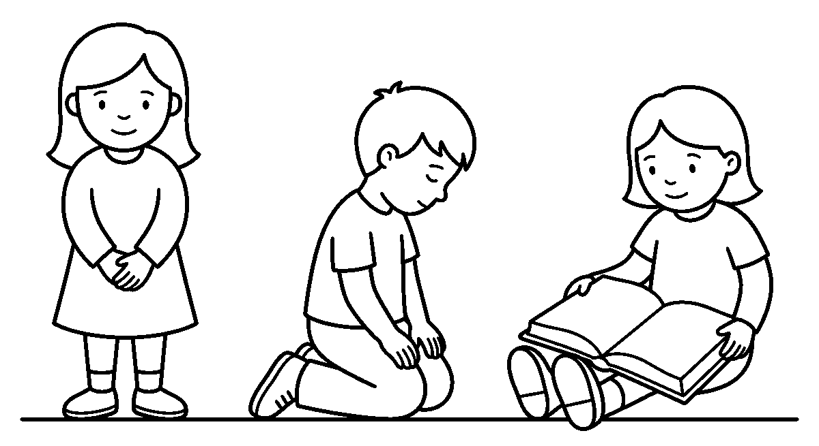
Worksheet
1. Which of these is a position we may pray in? A) kneeling B) swimming C) running D) dancing
2. We fold our hands and close our eyes to help us to ____ . A) find a seat B) hide from friends C) fix our minds on God D) keep warm
3. When the class finishes praying we say ____ . A) good night B) sleep well C) the class is through D) Amen
4. In this class we pray first to ____ God. A) thank B) fool C) frighten D) pay
5. Fill in: Jesus ____ when He prayed in the garden.
6. Mention three positions of the body used in prayer.
7. Say and write your own two-sentence prayer for a friend who is sick.
My own work
Draw three children praying: one standing, one kneeling with the head bowed, one sitting with an open book.

WEEK 9 — PRAYING EVERY DAY
Depth: NERDC Primary 2 · CRS · First Term W3–4, keeping on in prayer (pp 699–701).
You will learn to
• keep a daily order of prayer
• use the pattern Jesus taught
• pray for four kinds of people
• tell how God speaks back to my prayer
Things to know
• A daily order keeps prayer from being forgotten: morning, before food, before school, bed.
• Jesus taught His friends a pattern: "Our Father in heaven, may Your name be honoured; give us our
food today; forgive us as we forgive others; keep us from evil" (Matthew 6:9–13).
• That pattern has four parts: praise God, ask for daily needs, own wrong and forgive, ask for keeping.
• We pray for the sick, for our parents and guardians, for our teachers and the class, and for our
country and its leaders.
• We also pray for the person who annoys us; that is the hardest and the best prayer a child can say.
• God speaks to us through the Bible, through a good thought, and through what a grown-up tells us.
• God replies in three kinds of way: "yes", "wait", and "I have something better".
• A prayer is not better because it is long; the widow's two coins were smaller than the rich man's
basket, yet they were noticed.
• Keeping a small mark on a paper chart each morning is a way to see the order grow — one tick a day.
• If I forget a time, I do not start all over in shame; I simply begin again at the next time.
Words for my notebook
I keep a daily order of prayer — morning, before food, before school and at bed — using the pattern Jesus taught: praise God, ask for needs, own my wrong and forgive, and ask to be kept. God replies yes, wait, or something better.
Let us talk
1. Which part of your day will you never leave without a prayer?
2. What are the four parts of the pattern Jesus taught?
3. Name somebody outside this class you will pray for tonight.
4. What do you do when God's reply to your prayer is "wait"?
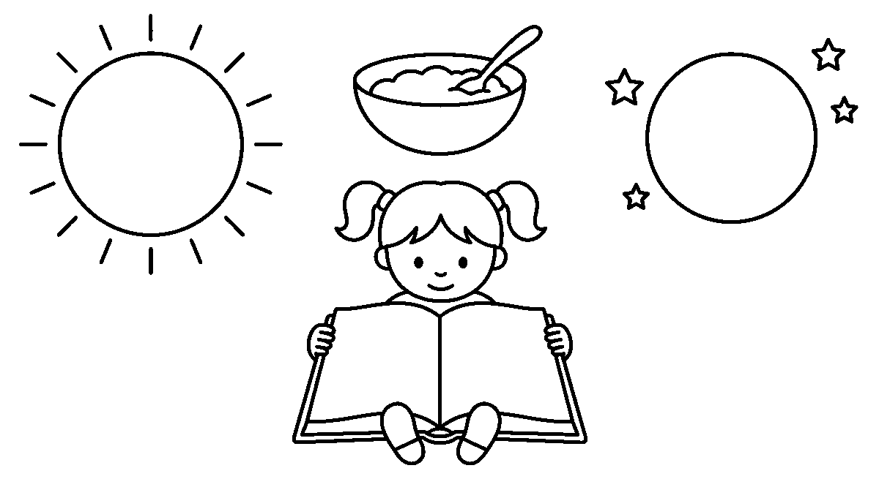
Worksheet
1. The pattern of prayer Jesus taught begins with "Our ____ in heaven." A) Father B) teacher C) king D) neighbour

2. Which of these is not one of the four parts of that pattern? A) praising God B) asking for my daily bread C) counting my toys D) asking to be kept from evil
3. We should also pray for the person who ____ us. A) annoys B) loves C) calls D) sees
4. God's reply to a prayer may be yes, wait, or ____ . A) never B) something better C) go away D) sleep on it
5. Fill in: A prayer is not better because it is ____ .
6. Mention four kinds of people we should pray for.
7. Write the four times you will mark on your own prayer chart for tomorrow.
My own work
Draw a sun at one end of a line, a bowl of food in the middle and a moon with two stars at the other end, then put a tick under each.

BASIC DIGITAL LITERACY
Weeks 1 to 6, 8 and 9. Week 7 is Mid-Term Break, Week 10 Revision, Week 11 Examination, Week 12 Closing — those weeks carry no note. Depth: NERDC 2025 · Nursery 3 · Basic Digital Literacy · Third Term — the pack puts one internal part of the computer on each week (headphones and care, CPU, RAM, hard drive, motherboard, power supply, cooling, how the parts work together), with the same pool of input and output devices across all of them.

WEEK 1 — HEADPHONES, AND HOW WE CARE FOR A MACHINE
Depth: NERDC Nursery 3 · Basic Digital Literacy · Third Term W1.
You will learn to
• say what headphones are for
• wear headphones the right way
• name two machines that use headphones
• say three rules for caring for a computer
Things to know
• Headphones are two small sound cups on a band; they put sound into the ears and nowhere else.
• We use headphones to hear a story, a song or a lesson without disturbing the rest of the class.
• Put the band over the top of the head, then let the cups sit on the ears; never push them inside.
• Sound kept low is how a child hears a long time; loud sound makes the ear tired and can hurt it.
• One headphone for one child — we do not share the cup that sat on another child's ear.
• Headphones are used with a computer, a phone, a radio and a tablet.
• The wire is kept free from pulling, from the wheel of a chair and from being stepped on.
• We care for a machine by keeping food and water away from it and by washing the hands before use.
• A screen is wiped with a soft dry cloth, never with a wet one and never with a pencil tip.
• We hold a keyboard with two hands when we carry it, and we put the chair back under the table.
Words for my notebook
Headphones put sound into our ears and keep it out of the class. We wear them low and clean, we keep food and water from the machine, and we wipe a screen only with a soft dry cloth.
Let us talk
1. What do we hear with on a computer?
2. Why is a low sound better than a loud one?
3. What must stay away from a keyboard and a screen?
4. Show me how you put the band of a headphone over your head.
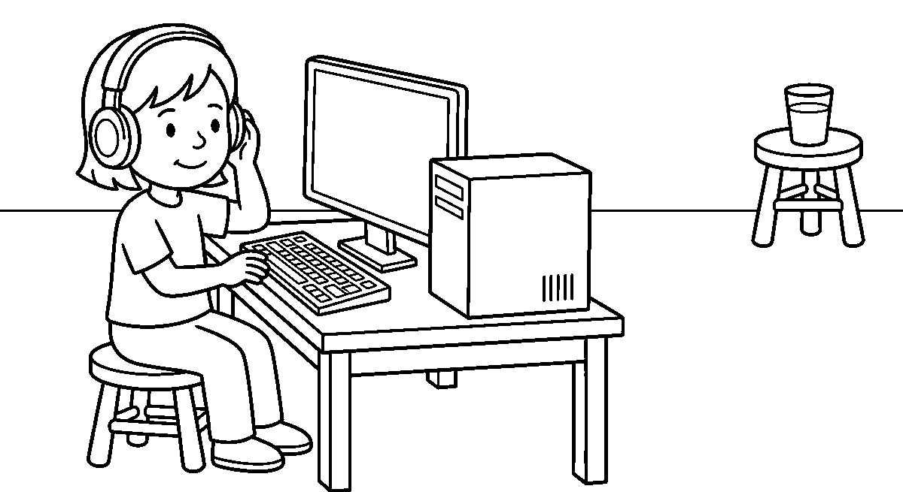
Worksheet
1. Headphones put sound into our ____ . A) nose B) hair C) ears D) shoes

2. Which of these is used with headphones? A) a computer B) a broom C) a cutlass D) a pot
3. A screen is wiped with a ____ . A) wet rag B) rough sand C) pencil tip D) soft dry cloth
4. Before we touch a keyboard we wash our ____ . A) feet B) hands C) ears D) knees
5. Fill in: Loud sound makes the ear ____ and can hurt it.
6. Mention three things we keep away from a computer.
7. Write two sentences on how you wear a headphone the right way.
My own work
Draw a pair of headphones with a band and two round cups, then draw a child wearing them with one hand up to an ear.

WEEK 2 — THE CPU: THE PART THAT THINKS
Depth: NERDC Nursery 3 · Basic Digital Literacy · Third Term W2.
You will learn to
• say what the CPU is
• tell what the CPU does for the whole machine
• name the box where the CPU lives
• say why we do not open the box
Things to know
• The CPU is the part of the computer that does the thinking; it is like the head of a person.
• When you press a key, the news runs to the CPU, and the CPU decides what the screen will show.
• CPU means Central Processing Unit — the words a big man uses; we call it the thinking part.
• The CPU lives inside the big box under the screen, called the system unit or the computer's body.
• The box has small holes for air; the CPU gets warm when it works hard, like a leg gets warm when it runs.
• We do not open the box and we do not put a finger or a pencil inside it; there is power in there.
• Inside the box the CPU sits on a flat board with its little brothers: RAM and the hard drive.
• Other machines think too: a phone, a television, a radio and a pump all have a small CPU.
• A computer with a tired CPU is like a child with no sleep — it works slowly.
• We keep the box on a table, not on the floor, so that dust and water stay away from it.
Words for my notebook
The CPU is the thinking part of a computer, like the head of a person. It lives in the big box under the screen, it gets warm when it works, and we never open the box or push anything inside it.
Let us talk
1. Which part of you does your thinking?
2. What happens when you press a key on the keyboard?
3. Why must we keep our fingers out of the big box?
4. Name two other machines that have a thinking part.

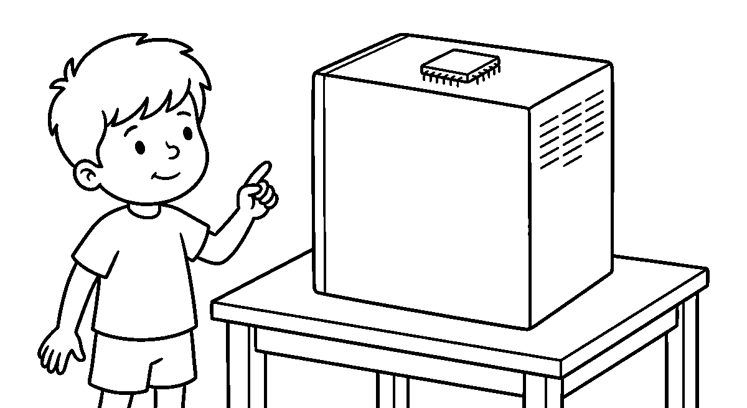
Worksheet
1. The part of the computer that does the thinking is the ____ . A) shoe B) CPU C) bag D) chair
2. The CPU is like the ____ of a person. A) elbow B) toe C) finger D) head
3. The CPU lives inside the ____ . A) lunch box B) school bag C) big box under the screen D) shoe rack
4. The box has small holes so that the CPU can get ____ . A) air B) water C) sunlight D) sleep
5. Fill in: We must not ____ the big box of the computer.
6. Mention three machines that have a thinking part.
7. Write two sentences on why the CPU gets warm.
My own work
Draw a big box with a small square inside it and dots for the air holes, then draw a line from the box to a screen.

WEEK 3 — RAM: THE MEMORY THAT HOLDS THINGS A LITTLE WHILE
Depth: NERDC Nursery 3 · Basic Digital Literacy · Third Term W3.
You will learn to
• say what RAM is for
• tell how RAM is different from the hard drive
• say what happens to RAM when power goes off
• name one thing we do before we lose our work
Things to know
• RAM is the computer's short memory; it holds what we are working on just now.
• RAM is like carrying things in both hands: it is fast, but the hands can hold only so much.
• When the machine is switched off, what was in RAM is gone — the hands become empty.
• The hard drive is different: it keeps things until tomorrow, like a box in the cupboard.
• If we write a name on the computer and never save it, the power failure will take it away.
• More RAM means the computer can hold more work at the same time, like two hands and not one.
• RAM lives inside the big box, flat on the same board as the CPU, in a long thin strip.
• A power failure is a common way to lose work, so we save as we go, not only at the end.
• Little things in RAM are fast; big things kept in the hard drive are slower to bring out.
• A machine with too little RAM pauses; a patient child waits and does not hit the keyboard.
Words for my notebook
RAM is the computer's short memory, like work held in two hands; it is emptied when power goes off. The hard drive keeps things until tomorrow, so we save as we go and do not wait for the end.

Let us talk
1. What holds your work when the machine is still on?
2. What happens to that work when power goes off?
3. Where does the machine keep a thing until tomorrow?
4. Why do we save before we finish?
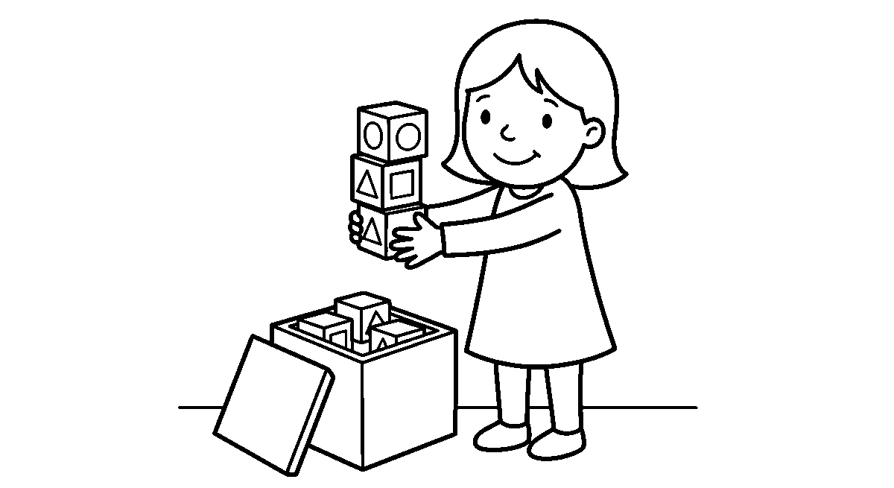
Worksheet
1. The computer's short memory is called ____ . A) the bag B) the box C) the screen D) RAM
2. RAM holds the work we are doing ____ . A) just now B) last year C) next week D) yesterday
3. When the machine is switched off, RAM becomes ____ . A) heavier B) bigger C) empty D) warm
4. The part that keeps our work until tomorrow is the ____ . A) cup B) pencil C) keyboard D) hard drive
5. Fill in: We save our work because a ____ may take it away.
6. Mention two things that make a computer pause or work slowly.
7. Write two sentences on what you do so that your work is not lost.
My own work
Draw two hands carrying three blocks each, then draw an empty box beside them with the blocks inside it.

WEEK 4 — THE HARD DRIVE: THE BOX THAT KEEPS OUR WORK
Depth: NERDC Nursery 3 · Basic Digital Literacy · Third Term W4.
You will learn to
• say what the hard drive keeps
• tell where our picture and our song are kept
• name one thing that hurts a hard drive
• say the word for putting work back into the machine
Things to know
• The hard drive is the computer's keeping box; what goes in there stays until we take it out.
• Our drawing, our song and the story we wrote live in the hard drive.
• Save means to put work into the keeping box; open means to bring it out again.
• A hard drive can hold very many things — a thousand pictures and more — yet it is small.
• Some keeping boxes live outside the machine on a small stick called a flash drive.
• A flash drive is small enough for a pocket and can be carried to another machine.
• A hard drive does not like a knock or a shake while it is working, so a running machine stays still.
• If the keeping box is full, we throw away old songs and pictures the way we clear a shelf.
• The hard drive sits inside the big box on the same board as the CPU and RAM.
• We do not pull the plug out of a machine that is still saving, or the work may be lost.

Words for my notebook
The hard drive is the keeping box of the computer: our picture, our song and our story live there until we open them again. A flash drive is a small keeping box that can go into a pocket and to another machine.
Let us talk
1. Where does the computer keep your drawing until tomorrow?
2. What do we call putting your work into the keeping box?
3. What is a flash drive like in your house?
4. Why must a machine that is working stay still?
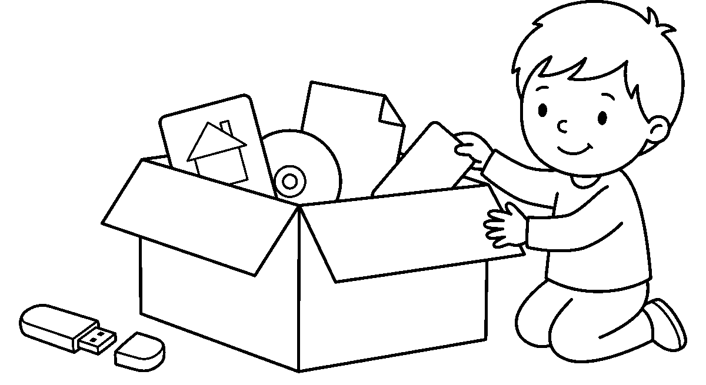
Worksheet
1. The keeping box of the computer is the ____ . A) hard drive B) school cap C) door D) spoon
2. To put work into the keeping box we say ____ . A) open B) break C) save D) sing
3. A small keeping box we can carry in a pocket is a ____ . A) plate B) cup C) pillow D) flash drive
4. A hard drive does not like ____ while it is working. A) sleep B) a knock or a shake C) a fan D) a cover
5. Fill in: If the keeping box is full, we ____ away old pictures.
6. Mention three things we may keep in a hard drive.
7. Write two sentences on the last thing you saved on a machine.
My own work
Draw a box with a picture, a note and a song card inside it, then draw a small stick with its own lid beside it.

WEEK 5 — THE MOTHERBOARD: THE FLOOR EVERY PART SITS ON
Depth: NERDC Nursery 3 · Basic Digital Literacy · Third Term W5.
You will learn to
• say what a motherboard is
• name three parts that sit on it
• tell how parts pass news to one another
• say why water is the enemy of a board
Things to know
• The motherboard is the big flat board inside the box that joins all the parts together.
• It is like the floor of a house: the CPU, the RAM and the hard drive all sit on it and are connected.
• Thin lines run over the board like roads, and news travels along them from one part to another.
• A port is a little door on the board where a wire from the keyboard or the mouse is put in.
• The cable is the wire that carries news and power from one thing to another.
• If one part is loose, the news cannot pass, and the machine refuses to work — like a road with a hole.
• Water is the enemy of a board: it leaves spots that break the little roads.
• A spilled cup on a laptop can finish the whole machine, so drink sits on the other table.

• We never touch the board of an opened machine; the power inside can give a child a shock.
• Small metal pins hold parts to the board; they are for a grown-up's tool, not for a finger.
Words for my notebook
The motherboard is the big flat board inside the computer's box. The CPU, the RAM and the hard drive sit on it, and news passes between them along thin lines like roads, which is why water must never touch a board.
Let us talk
1. What is the board inside the box called?
2. Which three parts sit on that board?
3. What do we call the little door where a wire goes in?
4. Why must a cup of water stay away from a machine?
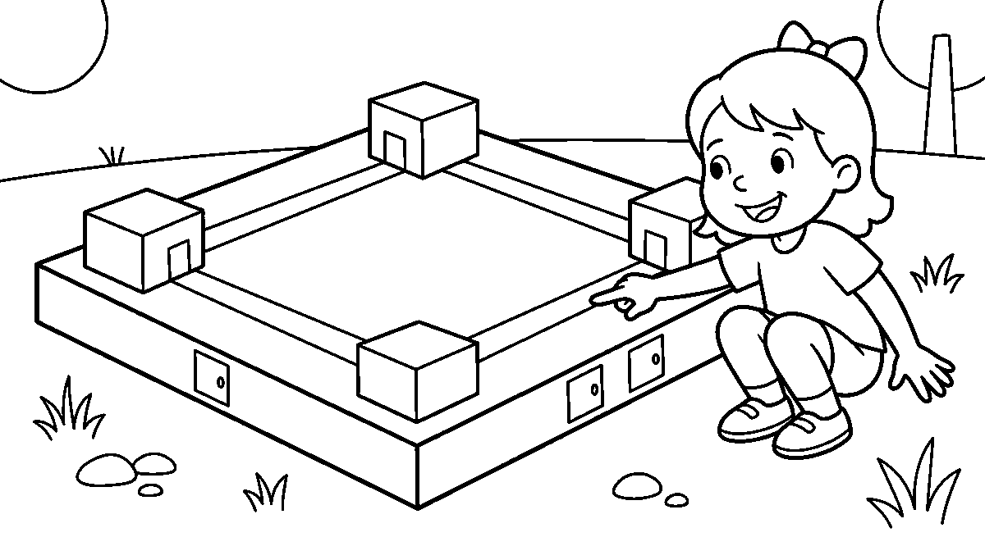
Worksheet
1. The big flat board that joins the parts is the ____ . A) table cloth B) wall C) motherboard D) curtain
2. Which of these sits on the motherboard? A) the CPU B) a shoe C) a plate D) a ball
3. The little door on the board where a wire is put in is a ____ . A) port B) gate C) pocket D) lid
4. News travels between parts along thin lines called ____ . A) rivers B) roads like lines C) ropes D) belts
5. Fill in: The enemy of a board is ____ .
6. Mention three parts that sit on the motherboard.
7. Write two sentences on what a spilled cup can do to a machine.
My own work
Draw a big flat square board, put three small boxes on it and join them with straight lines, then draw a circle for a port.

WEEK 6 — POWER SUPPLY: THE PART THAT BRINGS THE MACHINE TO LIFE
Depth: NERDC Nursery 3 · Basic Digital Literacy · Third Term W6.
You will learn to
• say what a power supply does
• name where the power for a machine comes from
• tell how a machine keeps working when light goes off
• say two safety rules about electricity
Things to know
• The power supply is the part inside the box that takes electricity in and gives it to the other parts.
• Without power the CPU cannot think, the screen cannot shine and the fan cannot turn.
• Power for a machine comes from the socket in the wall, from an inverter, a generator or a battery.
• A plug goes into the socket; the cable carries the power along to the machine.
• A power bank or battery keeps a phone or a small lamp working when NEPA takes the light off.
• A machine uses a button to be switched on and off — we press it once, gently, with a finger.

• We do not pull the cable to switch a machine off; we press the button and then remove the plug.
• Electricity can kill: never put a finger, a pin or water into a socket, and never touch a cut cable.
• A surge from lightning can spoil a machine, so during a storm we take the plug out of the wall.
• The power supply has a fan too, because the work of carrying power makes it warm.
Words for my notebook
The power supply takes electricity from the wall and gives it to the parts of the machine. We press the button to switch on and off, never pull the cable, and keep fingers, pins and water far from a socket.
Let us talk
1. Where does a computer get its power from?
2. What part gives power to the other parts?
3. What do we do with the plug during a storm?
4. Name one thing that must never go into a socket.
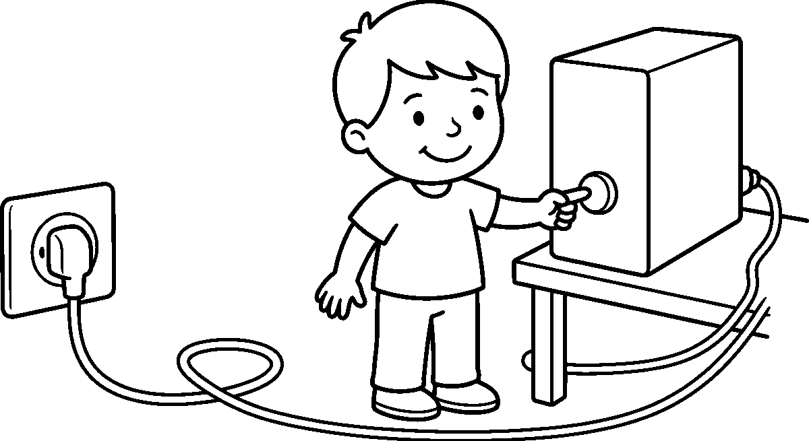
Worksheet
1. The part that brings power into the machine is the ____ . A) shoe box B) power supply C) lunch cup D) broom
2. A plug goes into the ____ in the wall. A) socket B) window C) shelf D) curtain
3. Which of these can keep a small lamp working when light goes off? A) a stone B) a leaf C) a battery D) a cup
4. To switch a machine off we ____ . A) pull the cable hard B) press the button C) pour water on it D) hit the screen
5. Fill in: During a storm we take the ____ out of the wall.
6. Mention three places power for a machine can come from.
7. Write two sentences on the safety rules for a socket.
My own work
Draw a wall socket with a plug in it, a cable running to a box, and a small switch with a finger pressing it.

WEEK 8 — COOLING: HOW A MACHINE KEEPS FROM SWEATING
Depth: NERDC Nursery 3 · Basic Digital Literacy · Third Term W8.
You will learn to
• say why a machine needs cooling
• point to the places air goes in and out
• tell where a machine must stand to stay cool
• name one thing that stops a fan from turning
Things to know
• A machine works hard, and hard work makes heat — the same way running makes your legs warm.
• Too much heat will spoil the CPU, so the machine has a cooling fan inside it.
• A fan is a small spinning blade, the same idea as the electric fan in your class.
• Air goes in at one side of the box, passes over the hot parts and goes out at the other side.

• The holes you see on the box are the machine's nose; if we cover them, the machine gets too hot.
• A machine must stand on a hard flat table, not on a soft mattress or a cloth that shuts the holes.
• Dust and hair can choke a fan; a clean machine is a cool machine.
• A laptop on a bed can become hot because the bed closes the air way underneath it.
• Some big machines have air like a room cooler; a phone just rests and cools itself.
• If a machine becomes too hot, it switches itself off to rest — let it cool before you press again.
Words for my notebook
Hard work makes a machine hot, so it keeps a small fan and holes at the sides for air. We set the machine on a hard flat table, leave the holes free, and let a hot machine rest before we switch it on again.
Let us talk
1. What makes your legs warm at playtime?
2. What part inside the box blows the heat away?
3. Why must we not cover the holes on the box?
4. Where is a bad place to keep a laptop, and why?
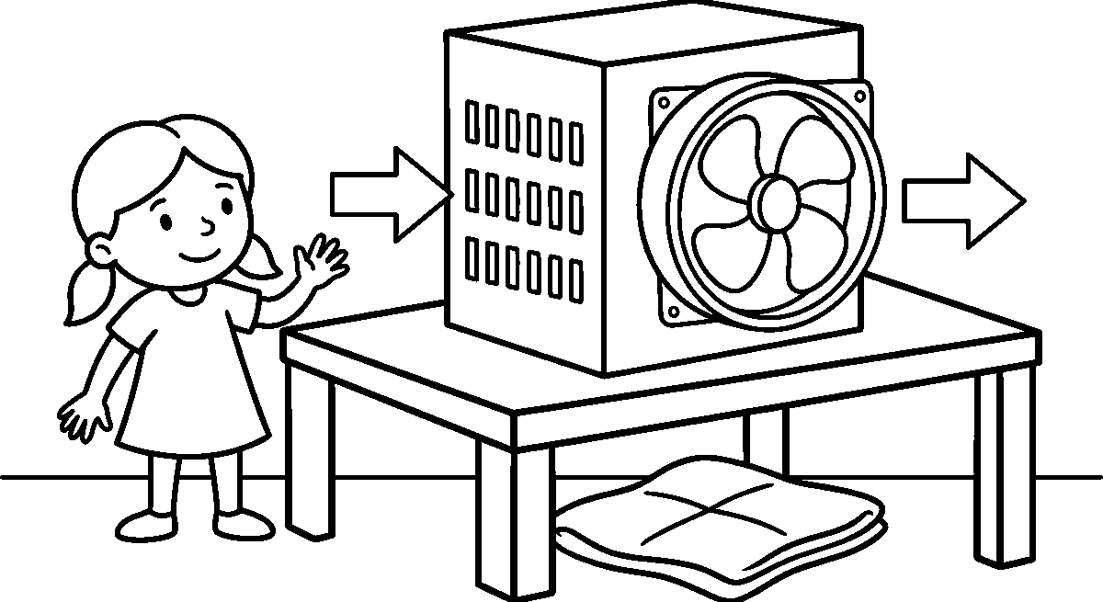
Worksheet
1. A machine gets hot because it ____ . A) works hard B) sleeps long C) sings D) waits
2. The part that blows heat away is a ____ . A) spoon B) fork C) cooling fan D) plate
3. Air goes in and out of the box through the ____ . A) holes at the side B) screen C) keyboard D) mouse
4. A bad place to put a machine is on a ____ . A) wooden table B) hard shelf C) stone slab D) soft bed
5. Fill in: If a machine becomes too hot, it ____ itself off.
6. Mention two things that can choke a fan.
7. Write two sentences on where you would keep a machine so it stays cool.
My own work
Draw a box with three lines of holes on one side and a round fan with four blades on the other, then draw arrows for the air.

WEEK 9 — HOW THE PARTS WORK TOGETHER
Depth: NERDC Nursery 3 · Basic Digital Literacy · Third Term W9.
You will learn to
• tell the story of a letter from the keyboard to the paper
• name an input device and an output device
• say what hardware and software mean
• put three steps of computer work in order
Things to know
• Input means things that send news into the machine: a keyboard, a mouse, a
microphone, a scanner and a webcam.

• Output means things that bring news out: a screen, a printer, a speaker and headphones.
• The story of one letter: you press a key, the news runs to the CPU, the CPU shows it on the
screen, and it is kept in the hard drive.
• To get the letter on paper, the machine sends it out at the printer.
• Hardware is every part we can see and touch — the box, the board, the keyboard, the mouse.
• Software is the work inside we cannot touch — the writing program, the picture program, the game.
• A machine with hardware but no software is like a mouth with nothing to say.
• Order of work: put the news in, let the machine think, bring the news out, keep it.
• All the parts need the motherboard to sit on and the power supply to feed them.
• The parts are not one big boss; they are like a class at work — one writes, one reads out, one keeps the book.
Words for my notebook
Input things send news into the machine, output things bring news out, and the CPU thinks between the two. Hardware is what we touch, software is what we cannot touch, and every part sits on the motherboard and eats from the power supply.
Let us talk
1. Which part sends news into the machine when you want to write a name?
2. Which part brings the name out on paper?
3. Say two things that are hardware and two that are software.
4. Put this in order: think, print, type, keep.
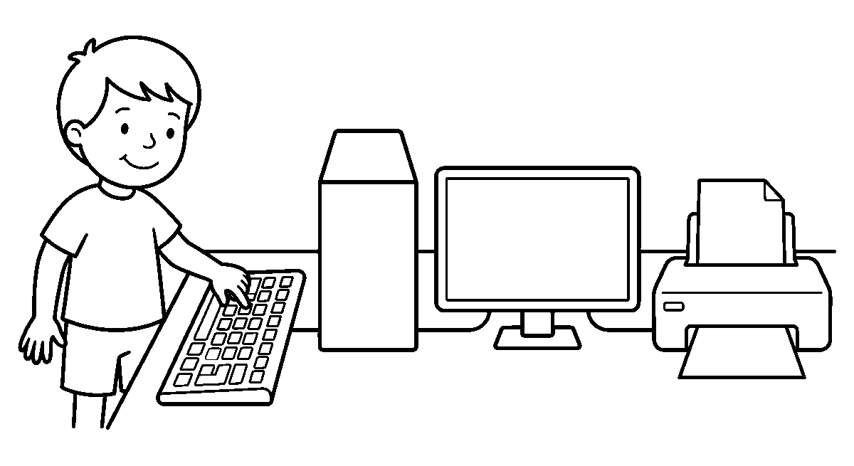
Worksheet
1. A keyboard and a mouse send news ____ the machine. A) into B) under C) behind D) above
2. Which of these brings news out of the machine? A) the CPU B) the keyboard C) the screen D) the mouse
3. The parts we can see and touch are the ____ . A) soft words B) power C) air D) hardware
4. The work inside the machine we cannot touch is ____ . A) software B) the box C) the cable D) the stand
5. Fill in: First we type, then the ____ thinks, then the screen shows.
6. Mention two input devices and two output devices.
7. Write two sentences on what happens to a letter you press on the keyboard.
My own work
Draw a keyboard, a box, a screen and a printer in a row, then join them with three straight lines.

NIGERIAN HISTORY
Weeks 1 to 6, 8 and 9. Week 7 is Mid-Term Break, Week 10 Revision, Week 11 Examination, Week 12 Closing — those weeks carry no note. Depth: NERDC 2025 · Nursery 3 · Nigerian History · Third Term — traditional rulers and title holders, the Local Government Chairperson, and leadership qualities, from the pack's off-by-one mapping.

WEEK 1 — TRADITIONAL RULERS IN OUR COMMUNITY
Depth: NERDC Nursery 3 · Nigerian History · Third Term W1.
You will learn to
• say who a traditional ruler is
• tell what a ruler does for the community
• say why we respect the throne
• name two things a ruler keeps safe for the people
Things to know
• A traditional ruler is the head of the people in his area, chosen from the ruling house by the elders.
• He is not a man who was voted for like the chairperson; his family has held the throne for a long time.
• A ruler keeps the peace: when two families are fighting, they are taken to him to be settled.
• He is the custodian of our culture — the festivals, the land, the names and the customs belong to his keeping.
• People show respect to the throne: they stand, they greet well, they do not shout in his presence.
• A ruler gives titles to good men and women who have helped the community.
• He speaks for the people to the government and brings news of the village to the town.
• The ruler's staff, stool or horse are the things that show the throne is there.
• Where there is no ruler in sight, the family father and the compounds' elders keep the same work of peace.
• We obey the ruler's good rules the way we obey our father and mother — because they keep us safe.
Words for my notebook
A traditional ruler is the head of the people in his area, kept from the ruling house by the elders. He settles quarrels, keeps our festivals and customs safe, and gives titles to those who help the community.
Let us talk
1. Who is the head of the family at home?
2. What does a ruler do when two families are fighting?
3. How do people show respect to their ruler?
4. Name one thing the ruler keeps safe for the people.
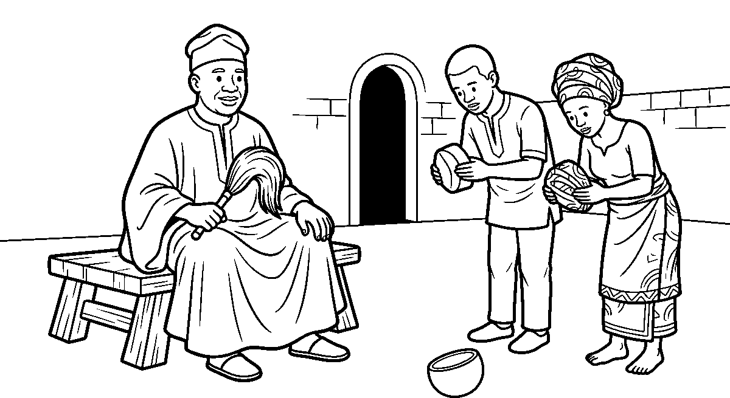
Worksheet
1. A traditional ruler is the ____ of the people in his area. A) head B) visitor C) trader D) child

2. A ruler is chosen into the throne by ____ . A) the children B) the elders of the ruling house C) the market D) the class monitor
3. When two families are fighting, they are taken to the ruler to be ____ . A) forgotten B) punished loudly C) settled D) divided
4. The ruler keeps our ____ safe for the people. A) customs and festivals B) old shoes C) broken cups D) school fees
5. Fill in: We ____ when the ruler is in front of us.
6. Mention two things that show a throne is present.
7. Write two sentences on a ruler you have seen and what he was wearing.
My own work
Draw a ruler on a stool holding a fly whisk, with two people standing on the other side with their caps in their hands.

WEEK 2 — EMIR, OBA, IGWE: DIFFERENT RULERS IN NIGERIA
Depth: NERDC Nursery 3 · Nigerian History · Third Term W2.
You will learn to
• name the ruler of the North, the West and the East
• tell one thing each ruler is known by
• say that Nigeria has many thrones, not one
• point to where each ruler's people live
Things to know
• In the North, the traditional ruler is called an Emir; he is known by his turban and his horse.
• In the Southwest, the ruler is called an Oba; he is known by his long coral beads and his crown.
• In the Southeast, the ruler is called an Igwe or an Eze; he is known by his red cap and his staff.
• Other people have rulers with other names: the Obi, the Olu, the Amanyanabo, the Shehu, the Sultan.
• Different names do not mean different value — every throne is as important as the other.
• A child can say at once which ruler is which, because of the cap, the beads, the turban and the staff.
• The ruler of a town may sit in a palace with a big yard in front, where people gather on festival days.
• Nigeria has many kingdoms and many thrones, and that is one of the things that make the country wide.
• We do not say "my ruler is better than yours"; we say my ruler is the one my people keep.
• When two rulers meet, they greet each other with honour, and their people learn peace from that day.
Words for my notebook
The Emir rules in the North with his turban and horse, the Oba in the Southwest with coral beads and a crown, and the Igwe or Eze in the Southeast with a red cap and a staff. Nigeria has many thrones, and each one is honoured by its own people.
Let us talk
1. What do we call the ruler in the North?
2. Which ruler is known by long coral beads?
3. Name one thing you can tell a ruler by, without hearing his name.
4. Why is it wrong to say "my ruler is better than yours"?

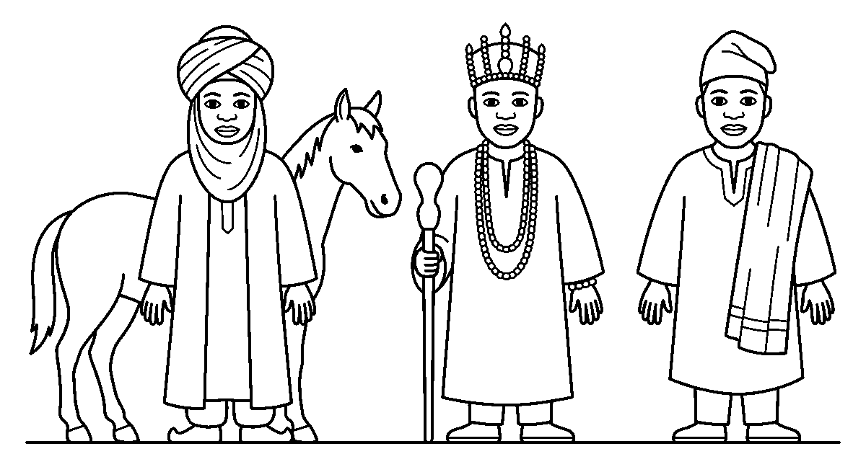
Worksheet
1. An Emir is the traditional ruler of the ____ . A) rivers B) coast C) bush D) North
2. The Oba is known by his long ____ . A) beads of coral B) school bag C) fishing net D) broom
3. In the Southeast the ruler is called an Igwe or an ____ . A) Emir B) Eze C) pilot D) Oba
4. Many thrones in one country teach the people to ____ . A) forget one another B) fight C) honour one another D) sell the land
5. Fill in: When two rulers meet they greet each other with ____ .
6. Mention three rulers and the place each one rules.
7. Write two sentences on what you would see in a palace yard on a festival day.
My own work
Draw three rulers standing side by side: one with a turban, one with a crown and long beads, one with a red cap and a staff.

WEEK 3 — TRADITIONAL TITLE HOLDERS
Depth: NERDC Nursery 3 · Nigerian History · Third Term W3.
You will learn to
• say what a chief is
• tell how a person is given a title
• name two ways a title holder helps
• say why a title is not a thing we buy
Things to know
• A title holder is a man or a woman given an honourary name by the ruler, to help govern the people.
• A chief is a title holder who speaks for a group of families and answers for them at the palace.
• Titles are given for good work: helping the community, telling the truth, giving time, keeping peace.
• A person may be chosen by the people of his area and then confirmed by the ruler with drum and blessing.
• A title is not sold and not bought; money cannot buy the honour of a good name.
• Some titles are very old and have been carried by the same family for many years.
• A title holder wears what shows his title: a cap, a bead, a staff, a horse or a special broom.
• He helps by explaining the ruler's words to the people and carrying the people's words to the ruler.
• A title holder who behaves badly loses the respect of the people, even when he keeps the name.
• We greet a titled person well, the way we greet an elder: with the right hands, not with a shout.
Words for my notebook
A title holder is a man or woman honoured by the ruler to help govern the people. Titles are given for good work and cannot be bought, and a chief carries the words of the families to the palace and back.

Let us talk
1. What do we call a person given an honourary name by the ruler?
2. For what kind of work are titles given?
3. Name two things a title holder may wear.
4. Can a child buy a title for his father with money? Why not?
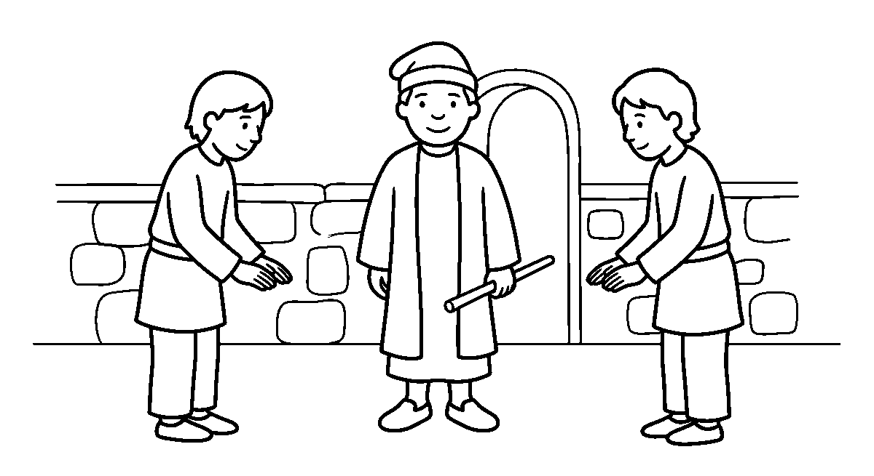
Worksheet
1. A chief is a ____ who speaks for a group of families. A) trader B) stranger C) child D) title holder
2. Titles are mostly given to people who ____ . A) tell the truth and help the community B) shout loudest C) own many goats D) come from far away
3. A title is given first by the people and then ____ by the ruler. A) forgotten B) denied C) confirmed D) sold
4. Which of these is true about a title? A) it can be bought B) it cannot be bought C) it is a toy D) it is a market day
5. Fill in: A title holder carries the words of the families to the ____ .
6. Mention three things a chief may wear to show his title.
7. Write two sentences on how you greet an elder with your hands.
My own work
Draw a chief with a cap and a short staff standing in front of a palace door, and two people greeting him with both hands.

WEEK 4 — BAALE, IYALOJA, OTUNBA: THE WORK OF TITLES
Depth: NERDC Nursery 3 · Nigerian History · Third Term W4.
You will learn to
• say what a Baale, an Iyaloja and an Otunba do
• tell how each one helps the community
• say why the ruler needs helpers
• name one way each title keeps the town working
Things to know
• The Baale is the father of the compound or the village street; he is the oldest and settles small quarrels.
• The Iyaloja is the mother of the market; she keeps the stalls in order and settles traders' disputes.
• The Otunba is a chief who stands next in line to help the ruler, and carries messages to the quarters.
• Titles work like the parts of a house: the roof, the pillars and the floor each hold something up.
• The ruler cannot be everywhere at once, so the title holders see to the streets, the market and the families.
• A title holder calls meetings, tells the people news, and leads them in clean-up and safety work.
• The Iyaloja knows the price of yam and rice and can tell when a seller is cheating a buyer.
• The Baale knows where every family lives and who is sick, who is new and who needs help.
• Title holders are to be respected as institutions, not as rich persons: the honour belongs to the chair they sit on.

• When the ruler and his chiefs work together, roads are watched, markets are open and festivals go well.
Words for my notebook
The Baale is the father of the street, the Iyaloja is the mother of the market, and the Otunba helps the ruler with messages and the quarters. The ruler cannot be everywhere, so titles hold the town up together.
Let us talk
1. Who settles small quarrels in the village street?
2. Who keeps order in the market?
3. Why does a ruler need title holders to help him?
4. What does the Iyaloja know about the price of food?
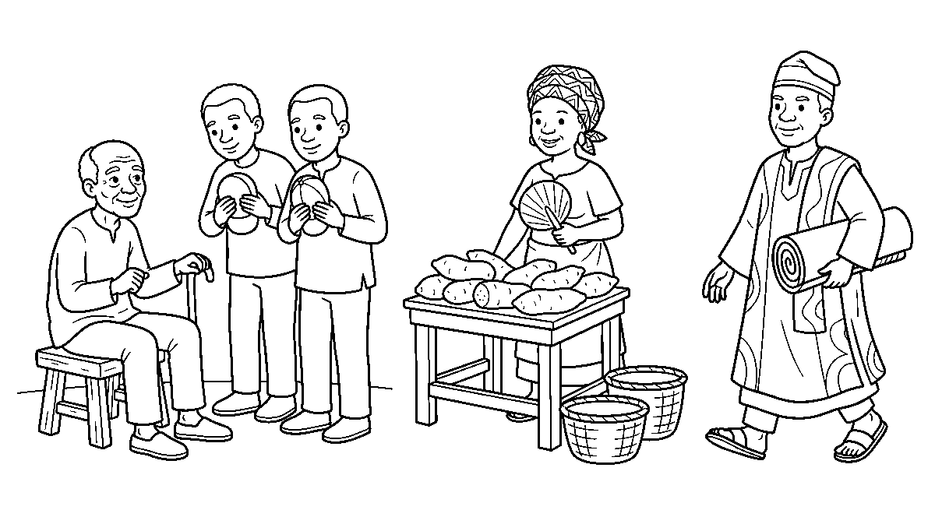
Worksheet
1. The father of the village street, who settles small quarrels, is the ____ . A) Baale B) Iyaloja C) Otunba D) stranger
2. The mother of the market is called the ____ . A) Otunba B) Iyaloja C) Baale D) Baby
3. The chief who carries messages to the quarters for the ruler is the ____ . A) visitor B) child C) Otunba D) farmer
4. Title holders are respected as ____ , not as rich persons. A) institutions B) traders C) friends D) singers
5. Fill in: The ruler cannot be ____ at once, so titles help him.
6. Mention two things an Iyaloja does in the market.
7. Write two sentences on work the Baale does for your street.
My own work
Draw a market scene with a woman standing by a stall holding a fan, two children carrying small baskets, and a mat on the ground.

WEEK 5 — THE LOCAL GOVERNMENT AND ITS CHAIRPERSON
Depth: NERDC Nursery 3 · Nigerian History · Third Term W5.
You will learn to
• say what a Local Government is
• name the head of a Local Government
• tell how a chairperson comes to office
• say why we count votes
Things to know
• Nigeria is divided big: the country, then 36 states and the FCT, then 774 Local Governments.
• A Local Government is the nearest government to the people — it is the one that touches your street.
• The head of a Local Government is called the Executive Chairman.
• A chairman is chosen by voting: the people mark the man or woman they want, and the most votes wins.
• Voting is how we settle who leads without fighting — the box of votes takes the place of the machete.
• To vote, one must be eighteen years or more; a child's work is to behave well at the election, not to queue.
• The chairman works with councillors, each one sent by a ward to speak for that ward.

• The palace and the council are different: the ruler sits on the throne, the chairman sits on an elected chair.
• A chairman's time is limited — four years, then the people choose again; a throne is for life.
• Our own things come from the Local Government: the primary school, the health centre, the street drains, the market stalls.
Words for my notebook
A Local Government is the nearest government to the people, and its head is the Executive Chairman, chosen by voting. The most votes wins, so we settle who leads without fighting, and a chairman's time is limited to a few years.
Let us talk
1. Which government is nearest to your street?
2. What do we call the head of a Local Government?
3. How do the people choose a chairman?
4. Name two things a Local Government brings to a community.
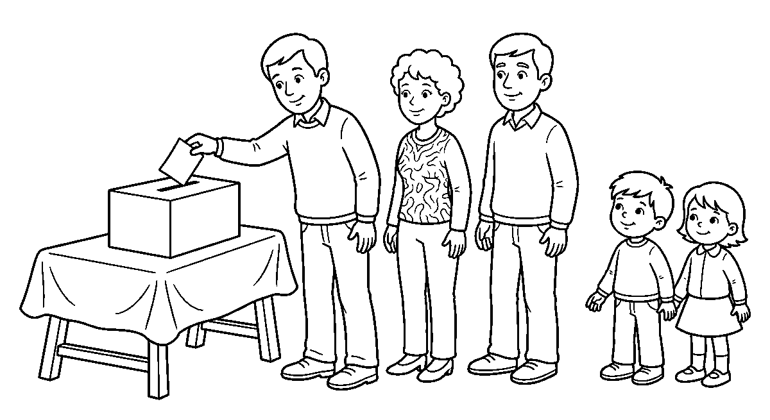
Worksheet
1. The nearest government to the people is the ____ . A) palace B) church C) Local Government D) market
2. The head of a Local Government is called the ____ . A) king B) class teacher C) Babalawo D) Executive Chairman
3. A chairman comes to office by ____ . A) voting B) a coin toss C) a race D) buying the chair
4. A ruler sits on the throne while a chairman sits on ____ . A) a mat B) a stool C) a bed D) an elected chair
5. Fill in: To vote for a chairman, one must be ____ years or more.
6. Mention three things a Local Government gives a community.
7. Write two sentences on how the people choose a class monitor and how the people choose a chairman.
My own work
Draw two lines of children in front of a school gate, then draw a table with a box on it and a man putting a paper in the box.

WEEK 6 — WHAT A GOOD CHAIRMAN DOES
Depth: NERDC Nursery 3 · Nigerian History · Third Term W6.
You will learn to
• name four services a chairman provides
• tell the difference between a ruler and a chairman
• say what makes a leader good
• tell how a ruler and a chairman work together
Things to know
• A chairman builds and mends the roads, so that our yam and palm oil can reach the town.
• He sees to the primary schools — rooms, benches, books and the teacher's pay.
• He keeps the health centre working, with a nurse, drugs and a place for a mother to rest.
• He clears drains and gutters before the rains, so that water will not enter our rooms.

• He opens the market, the borehole and the street lamps, and lights them at night.
• A ruler keeps the customs and settles the people at the palace; a chairman keeps the services and signs the papers.
• A ruler is on the throne for life; a chairman is in his office for a fixed time.
• A good leader is honest, listens before he decides, shares work fairly and does not take what is not his.
• When the ruler and the chairman sit together, the town gets both wisdom and money.
• If a chairman does not do the work, the people do not vote for him again at the end of his time.
Words for my notebook
A chairman mends roads, keeps the school and the health centre working, clears drains before the rain and opens the market. A ruler keeps our customs and sits for life; a chairman keeps the services and stays a fixed time, and both work together for the town.
Let us talk
1. What does a chairman do for the road before the market day?
2. Which of the two, a ruler or a chairman, sits for a fixed time only?
3. Name three services you can see in your community.
4. What happens to a chairman who does not work?
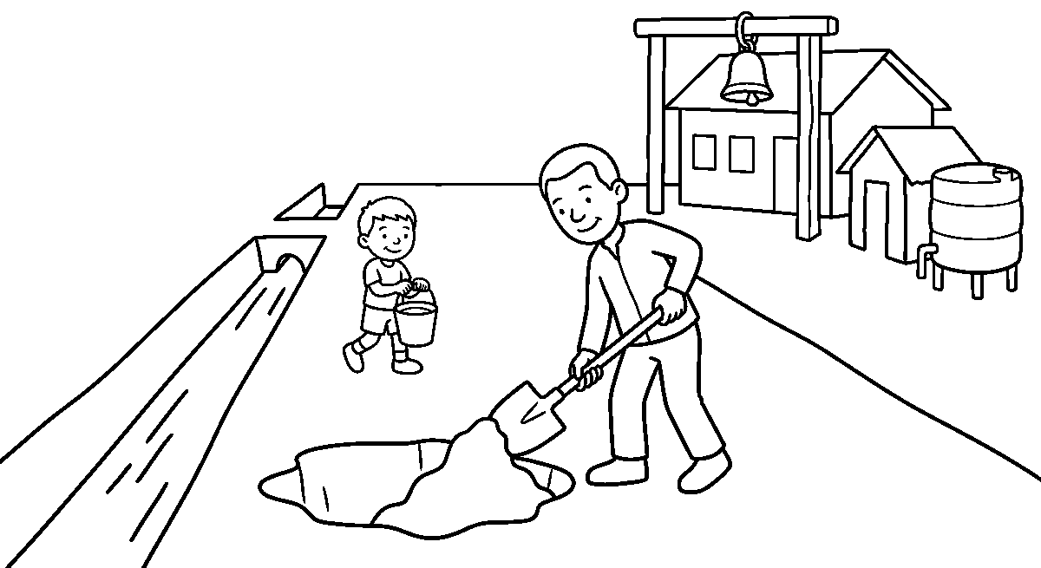
Worksheet
1. Who mends the road and clears the drains in a Local Government? A) the class monitor B) the trader C) the chairman D) the driver
2. Which of these is a service a chairman provides? A) rain B) sleep C) sunlight D) a working health centre
3. A ruler sits on the throne ____ , while a chairman stays a fixed time. A) for life B) for one week C) for one day D) for an hour
4. A leader who is ____ does not take what is not his. A) sleepy B) rich C) honest D) tall
5. Fill in: When the ruler and the chairman sit ____ , the town gains wisdom and money.
6. Mention four services a good chairman provides.
7. Write two sentences on the state of the road to your school and what should be done to it.
My own work
Draw a road with two holes in it, a man with a shovel mending it, and a boy carrying a bucket of tar behind him.

WEEK 8 — WHAT MAKES A GOOD LEADER
Depth: NERDC Nursery 3 · Nigerian History · Third Term W8.
You will learn to
• name five qualities of a good leader
• tell why a leader must listen
• say what fairness looks like in my class
• show responsibility with one small job

Things to know
• A leader is anybody who goes in front — a ruler, a chairman, a monitor, a mother, the one holding the rope.
• The first quality is honesty: a leader tells the truth even when the truth will bring him trouble.
• Truthfulness means he does not say one thing to the ruler and another thing to the people.
• Kindness is a leader's second hand: he corrects without insulting, and helps before he shouts.
• Fairness means the same rule for every child, not a sweet for the one he likes best.
• A good leader listens to both sides before he decides; a leader who only talks will decide wrongly.
• Responsibility: if he is given the key, the key is not lost; if he is given the chalk, the chalk is finished well.
• Hard work: a leader is the first to arrive and the last to drop the broom.
• A leader admits his own mistake; only a small man hides behind "it was not me".
• A leader does not use his position to take the class biscuits for his own brothers.
Words for my notebook
A good leader is honest and truthful, kind and fair, listens before he decides, keeps what he is given and works hard. He owns his own mistake and never uses his position to take what belongs to all.
Let us talk
1. Who are the leaders you know besides the ruler and the chairman?
2. What does a fair teacher do with two children who quarrelled?
3. Show me how a leader listens before he decides.
4. What do we call a leader who takes the class things for his brothers?
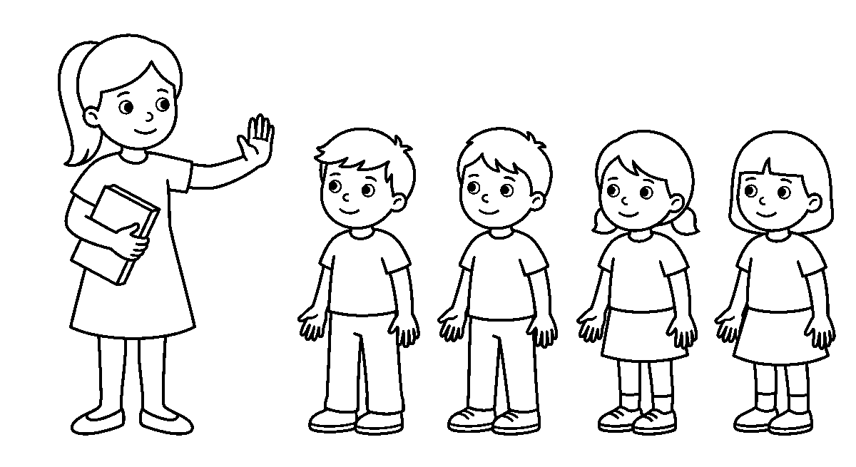
Worksheet
1. A leader is anybody who ____ . A) sleeps late B) goes in front C) eats first D) stands behind
2. Telling the truth even when it brings trouble is called ____ . A) honesty B) sleeping C) running D) hiding
3. Fairness means the rule is ____ . A) only for small children B) only for boys C) the same for every child D) changed every day
4. Before he decides, a good leader ____ . A) listens to both sides B) runs away C) closes his ears D) hits the table
5. Fill in: A leader who is given the key must not ____ it.
6. Mention five qualities of a good leader.
7. Write two sentences on a time you were given a small job and finished it well.
My own work
Draw a monitor standing at the head of a line of four children, one hand up to keep them in order, carrying the class book.

WEEK 9 — LEADERSHIP IN MY OWN DAY
Depth: NERDC Nursery 3 · Nigerian History · Third Term W9.
You will learn to
• say what a class monitor does
• tell how a leader leads by example
• name three ways I can lead today
• say how a leader shows respect to others
Things to know
• A class monitor is a child chosen to keep order, to carry a note to the office and to stand at the head of the line.
• A prefect does the same for the whole school; he is a leader before he is a boss.
• Leading by example: if I want the class to be quiet, my own mouth must be quiet first.
• If I want others to keep the room clean, I pick my own paper up without waiting to be called.
• A child can lead in small ways: share a chalk, help a friend to read, line the class up, hold the gate.
• A leader says please and thank you, because his position does not make him bigger than anybody.
• A leader respects those who lead before him — he greets the monitor, the teacher and the ruler's chief.
• Leadership skills are learnt young: the child who keeps one promise becomes the man who keeps many.
• In role play, one child sits on the stool as the Baale and another brings him the quarrel of two dolls; the class watches how the case is settled.
• A leader is known by what he does when nobody is watching, not by the cap on his head.
Words for my notebook
A class monitor keeps order and stands at the head of the line; a prefect does it for the whole school. A leader leads by example — my own mouth quiet before I ask for quiet, my own paper picked up before I call to others — and leadership is learnt young.
Let us talk
1. Who is the monitor of this class?
2. What must I do first before I ask the class to be quiet?
3. Name two ways you can lead your small brother or sister today.
4. What does a leader say when he wants somebody to pass him a book?
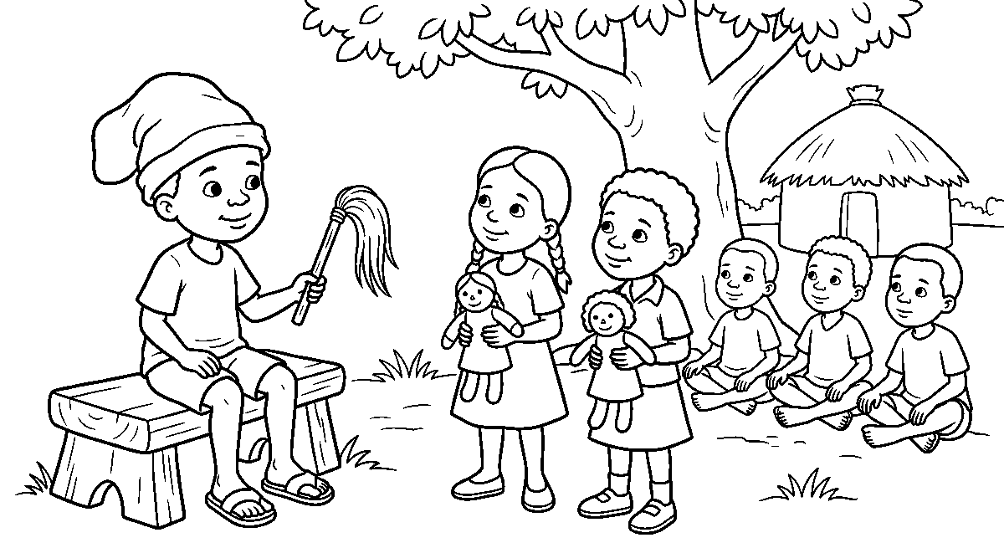
Worksheet
1. A child chosen to keep order in the class is the ____ . A) visitor B) class monitor C) trader D) baby
2. A prefect is a leader for ____ . A) the whole school B) one house C) his own friends only D) the market
3. To lead by example, before I ask for quiet I must be ____ myself. A) loud B) singing C) quiet D) running
4. A leader shows respect by saying ____ . A) nothing at all B) please and thank you C) go away D) I am the king

5. Fill in: A leader is known by what he does when ____ is watching.
6. Mention three ways a child can lead in this class today.
7. Write two sentences on the part you took in the role play of the Baale settling a quarrel.
My own work
Draw a small court with a child sitting on a stool as the ruler and two other children standing before him, each holding one doll.

PHYSICAL AND HEALTH EDUCATION (PHE)
Weeks 1 to 6, 8 and 9. Week 7 is Mid-Term Break, Week 10 Revision, Week 11 Examination, Week 12 Closing — those weeks carry no note. Depth: NERDC 2025 · Nursery 3 · Physical and Health Education · Third Term, pp 558–563 (sports facilities and equipment, the ball games, table tennis, chess, video games), and Primary 1 PHE motor-skills weeks for W8–W9.

WEEK 1 — PLACES WE PLAY AND THINGS WE PLAY WITH
Depth: NERDC Nursery 3 · PHE · Third Term W1 (pp 558–563).
You will learn to
• say what a sport place is
• name four places where sport is played
• tell the difference between a facility and an equipment
• say three things we do to care for the class equipment
Things to know
• A sport facility is the place or the building where a game is played.
• A sport equipment is the thing you hold or wear to play the game.
• Places we know: the playground for running and football, the court for basketball and tennis, the
field for the big matches, and the pool for swimming.
• Equipment we know: a ball, a whistle, a stopwatch, bibs to mark the two teams,
boots, shin guards, nets, goal posts, cones to mark a line and mats to fall on.
• Facilities make the game possible and keep us from being hurt by a hole or a stone.
• Equipment must be used well: we do not kick a football at a window, and we do not sit on the mat stack.
• After play, things go back to their box or their store, and the monitor counts them.
• A thing that is torn or broken is reported, not hidden under the bench.
• Not every school has a pool or a gym; a good class plays well with what it has — a rope, four stones
for a goal, and a flat ground.
Words for my notebook
A facility is the place we play in and an equipment is the thing we play with. We use both well, put every thing back in the store after play, and report the one that is torn or broken.
Let us talk
1. Where does this school play football?
2. Name two things you hold when you play.
3. Why do we put the ball back in the box?
4. What do we do if a net is torn?
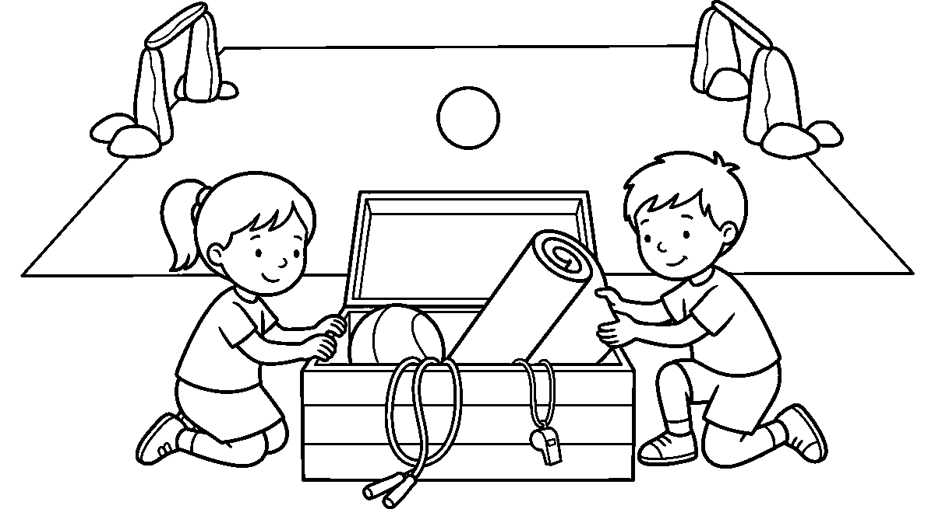

Worksheet
1. The place where a game is played is a sport ____ . A) facility B) trouble C) dream D) song
2. Which of these is an equipment? A) the field B) the court C) a ball D) the pool
3. We keep the class things safe by putting them back in the ____ . A) fire B) store C) bag of a stranger D) water
4. When the school has no court, the class ____ . A) does not move again B) sells the rope C) sleeps D) plays on the flat ground it has
5. Fill in: A torn net must be ____ , not hidden.
6. Mention four places sport can be played.
7. Write two sentences on how you cared for the class ball today.
My own work
Draw a football field with two goals made of stones, and beside it a box holding a ball, a whistle and a rope.

WEEK 2 — FOOTBALL: KICK IT, KEEP IT, SCORE IT
Depth: NERDC Nursery 3 · PHE · Third Term W2 (pp 558–563).
You will learn to
• pass a ball with the inside of the foot
• dribble the ball close to your feet
• shoot at a goal
• name four things a football team wears
Things to know
• Football is played with a round ball and two teams; the team that puts the ball in the goal wins.
• Passing is kicking the ball to a mate; the inside of the foot is the truest pass a child can make.
• Dribbling is running the ball along while you keep it close to your feet and look up to see your mates.
• Shooting is kicking at the goal — not the loudest kick, but the steady one.
• No hand for a player in the field; only the goalkeeper may use his hands, and only inside his own box.
• A goal is made of two posts and a bar, with a net behind to catch the ball.
• What a player wears: a jersey, shorts, socks, boots and shin guards inside the socks.
• The referee carries the whistle; one short blast means play, a long one means a foul was done.
• When we lose, we shake hands; when we win, we do not mock the other side — that is sportsmanship.
• A small field, a size-3 ball and two piles of stones for posts make a real match for our class.
Words for my notebook
In football we pass with the inside of the foot, dribble with the ball kept close, and shoot steadily at the goal. Only the goalkeeper may touch the ball with his hands, and a good team shakes hands after the game.
Let us talk
1. Which part of the foot makes the truest pass?
2. Who alone may use his hands in the game?
3. What does the referee blow?
4. What do we do to the other team when we have beaten them?

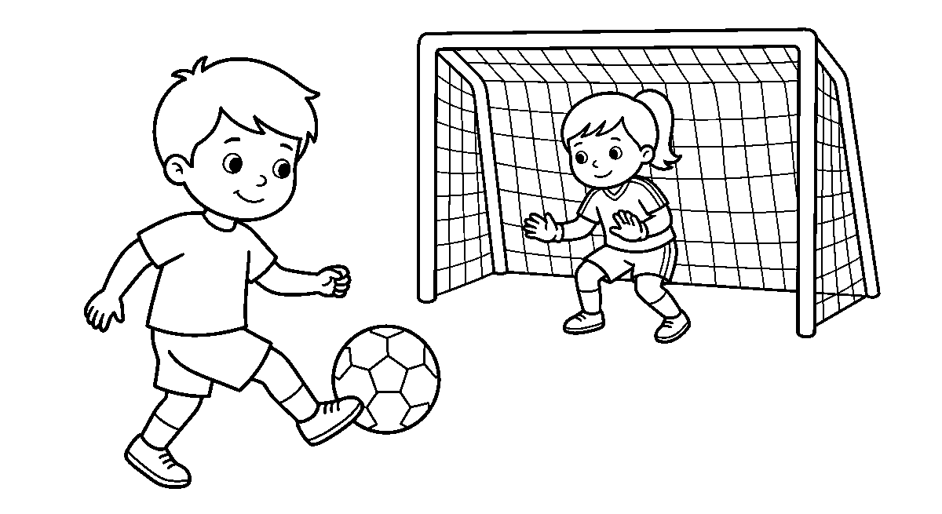
Worksheet
1. In football, only the ____ may touch the ball with his hands. A) referee B) striker C) goalkeeper D) runner
2. A truest pass is kicked with the ____ of the foot. A) inside B) top C) heel D) toe nail
3. While dribbling, the ball is kept ____ . A) far ahead B) close to the feet C) in the hands D) under a chair
4. The referee starts and stops play with a ____ . A) drum B) bell C) book D) whistle
5. Fill in: A goal is made of two posts and a ____ .
6. Mention four things a football player wears.
7. Write two sentences on the last match you played and how it ended.
My own work
Draw a boy kicking a ball with the inside of his foot towards two stones laid on the ground for a goal.

WEEK 3 — BASKETBALL: BOUNCE IT AND THROW IT IN
Depth: NERDC Nursery 3 · PHE · Third Term W3 (pp 558–563).
You will learn to
• bounce a ball on the spot with one hand
• pass a ball from the chest with two hands
• throw a ball towards a hoop
• say one rule of basketball
Things to know
• Basketball is played with a big bouncy ball and two teams; the ball is thrown, not kicked.
• The hoop is raised on a board, and into it the ball must go to give a point to the team.
• Dribbling is bouncing the ball with the finger tips of one hand, keeping it low, and looking up.
• The ball is not carried while the feet run: bounce it or pass it — that is the first rule a child learns.
• A chest pass is pushed from the chest with both hands, thumbs ending down.
• A bounce pass is thrown to the floor so the ball jumps up into your mate's hands.
• To shoot, we balance, keep our eyes on the hoop, bring the elbow under the ball and follow through with
the wrist.
• A foul is pushing, holding or hitting the other child's arm; two free throws are given for it.
• In our class the hoop is put low, and a ring painted on the wall will do just as well.
• Basketball makes the legs springy, the hands quick and the eyes steady.
Words for my notebook
In basketball the ball is bounced with the finger tips, passed from the chest with two hands and thrown at a raised hoop. We do not run while we hold the ball — we bounce it or we pass it.

Let us talk
1. Which part of the hand pushes the ball down when we dribble?
2. What do we do instead of running with the ball in our hands?
3. Where must the ball go to give our team a point?
4. What is a foul in this game?
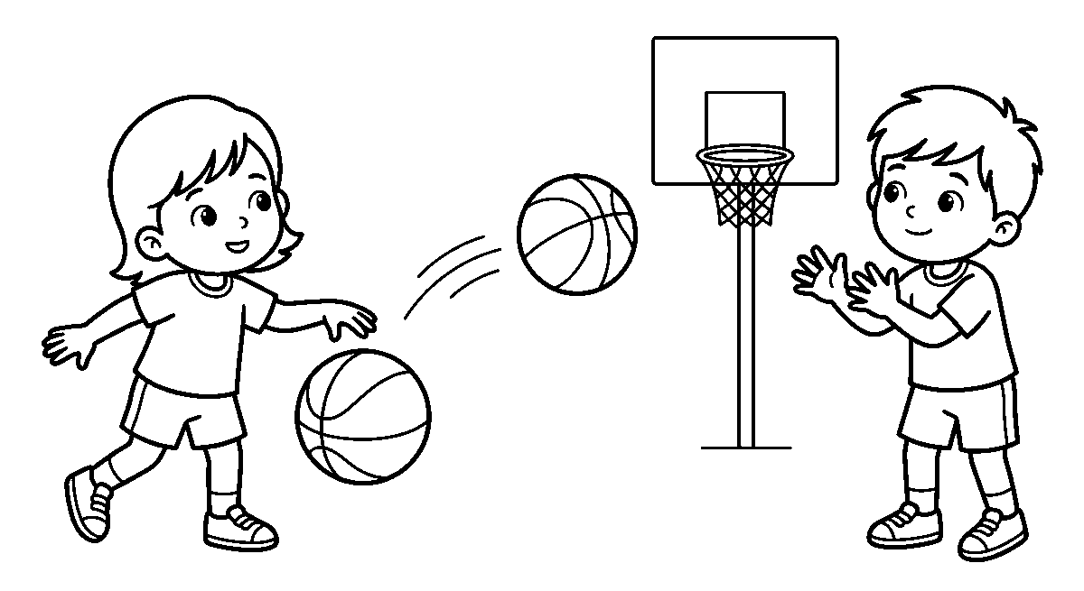
Worksheet
1. In basketball the ball is thrown at a raised ____ . A) net on the ground B) hoop C) wall D) ladder
2. To move with the ball you must ____ it on the floor. A) roll B) hide C) bounce D) kick
3. A chest pass is pushed out with ____ hands. A) one B) two C) three D) no
4. While dribbling, the head stays ____ . A) down on the shoe B) under the ball C) turned away D) up to see the mates
5. Fill in: In our class the hoop is put ____ so that children can reach it.
6. Mention two kinds of pass in basketball.
7. Write two sentences on the game where you bounced the ball best.
My own work
Draw a girl bouncing a big ball with one hand, and a hoop on a board above a low stand at the other side of the page.

WEEK 4 — TABLE TENNIS: THE BALL THAT MUST NOT DROP
Depth: NERDC Nursery 3 · PHE · Third Term W4 (pp 558–563).
You will learn to
• hold a bat the right way
• serve so the ball bounces twice
• hit the ball back over the net
• name three things needed for the game
Things to know
• Table tennis is like tennis on a table, and that is how it got its name.
• It is played by two children or by four, two on each side of the net.
• The bat is held like a handshake — the flat part in the palm, the handle between the fingers.
• To serve, the ball is thrown up lightly and hit underhand, so that it bounces on **your own side
first** and then on the other.
• During play the ball may bounce only once on a side; the second bounce is a point for the other pair.
• We hit forehand on the side the hand holds out, and backhand across the body.
• What the game needs: a table with a net across it, two bats and a small light ball.
• A table needs no big ground, so it can be played in the rain or in the shade — one of its kindnesses.
• The eye must stay on the ball the whole time; a child who watches the ball cannot miss it for long.

• The ball is not blown at to make it move, and the bat is not raised above the table edge to hit down
at the other child's face.
Words for my notebook
Table tennis is tennis on a table. We hold the bat like a handshake, serve so the ball bounces once on our side and once on theirs, and hit it back before it bounces twice.
Let us talk
1. What is the small net on the table for?
2. Show me how you hold a bat like a handshake.
3. How many times may the ball bounce on one side during play?
4. Why can this game be played when it is raining?
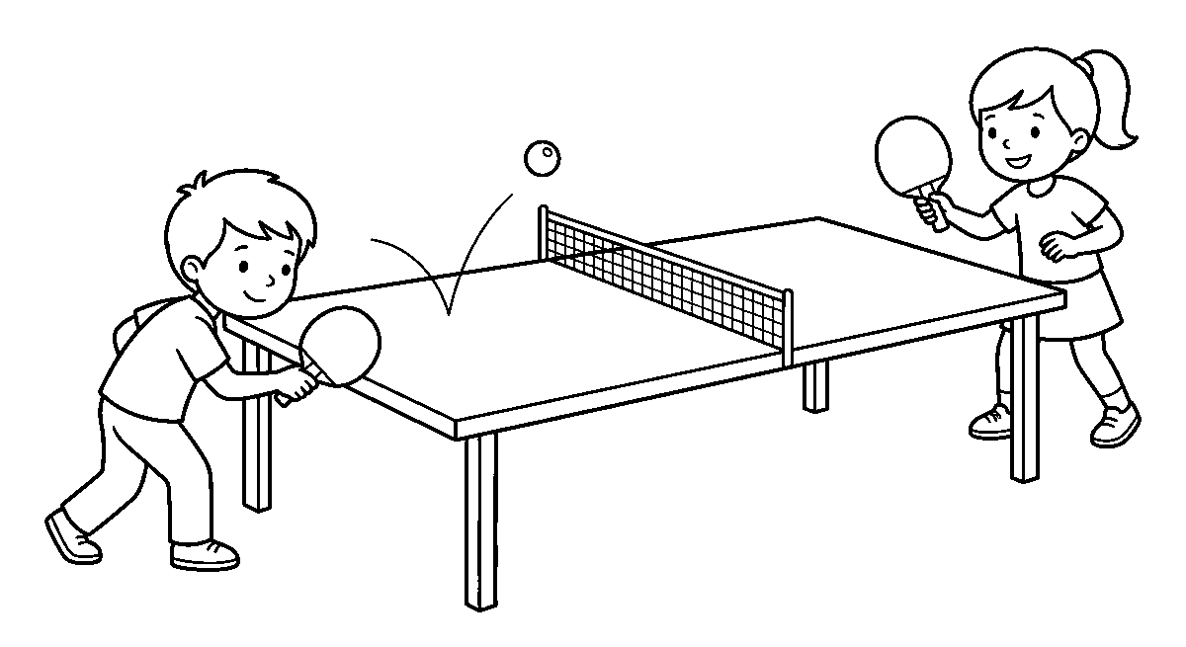
Worksheet
1. Table tennis is played on a ____ . A) big field B) table C) road D) roof
2. At serve, the ball bounces first on ____ . A) your own side B) the floor C) the roof D) the bag
3. The eyes of a good player stay on the ____ . A) shoe B) window C) ball D) net post
4. How many children may play one game of table tennis? A) four only B) one C) ten D) two or four
5. Fill in: The ball may bounce only ____ on a side during play.
6. Mention three things needed to play table tennis.
7. Write two sentences on how you held the bat when you played.
My own work
Draw a table with a low net across it, a ball above one half, and two children at the ends holding bats.

WEEK 5 — CHESS: THE GAME PLAYED WITH THE HEAD
Depth: NERDC Nursery 3 · PHE · Third Term W5 (pp 558–563).
You will learn to
• say what chess is
• point to the two colours on a board
• name four chess men
• say one thing chess teaches a child
Things to know
• Chess is a thinking game for two players; nobody runs and nobody shouts.
• It is played on a checkered board of light and dark squares, and each player takes the **light
corner on his right hand**.
• Each side begins with the same family of men: **a king, a queen, two castles, two jumpers and eight small
men in front**.
• The king is the most important man on the board; the game is ended when he cannot escape.
• The queen is the mightiest: she goes as far as the board is long, straight or crooked.

• The castle goes straight, the jumper leaps over a man in an L shape, and the small man goes
one square at a time.
• We learn chess for thinking ahead, for patience and for sitting still to look well.
• Touching a man means playing it — a child who has touched must move, so look before the hand goes out.
• If a man is moved by mistake, we say nothing and play it; the game is also a school for truth.
• Chess is played all over the world, in houses, in clubs and in big halls where grown-ups sit very quiet.
Words for my notebook
Chess is a thinking game for two on a board of light and dark squares. Each side keeps a king, a queen, two castles, two jumpers and eight small men, and the game ends when the king cannot get away.
Let us talk
1. Does chess need running or thinking?
2. Which man on the board must be kept safe above all others?
3. What do the two colours of squares look like?
4. What must you do before your hand goes out to a man?
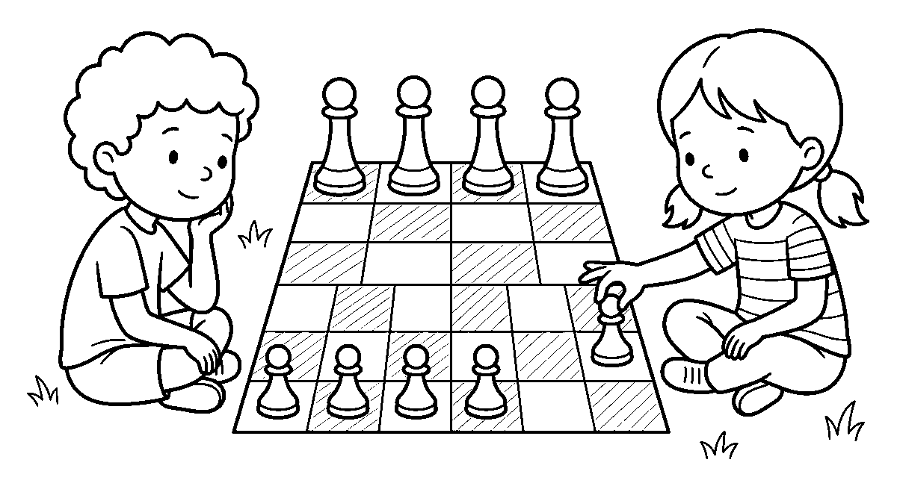
Worksheet
1. Chess is a game of ____ . A) running B) sleeping C) thinking D) singing
2. A chess board is made of squares that are ____ . A) light and dark B) all black C) all white D) red and green
3. Which man may go straight forward or sideways as far as the board is long? A) the small man B) the queen C) the jumper D) the baby
4. The game ends when one king can no longer ____ . A) sing B) sleep C) escape D) count
5. Fill in: When you touch a man you must ____ it.
6. Mention four men found on a chess board.
7. Write two sentences on what chess teaches a child to do.
My own work
Draw a board of sixteen squares, light and dark, with four big men standing on the top row and four small ones below.

WEEK 6 — VIDEO GAMES: FUN IN LIMITS
Depth: NERDC Nursery 3 · PHE · Third Term W6 (pp 558–563).
You will learn to
• say what a video game is
• name two games a small child may play
• say why play on a screen is limited
• tell what must come before the screen
Things to know
• A video game is a game played on an electronic thing: a computer, a tablet, a phone or a box joined
to the television.

• Video games are indoor play — the child sits, and the fingers work.
• Games a small child may play: a card game where the cards are matched, a running game where the
figure jumps the holes, a puzzle of pictures, a counting or word game, and a football game on the screen.
• Some games are made for big young men, with fighting and bad language; **a child of five does not play
those**, and if he sees them on a screen he says to a grown-up at home.
• A screen is fun in a little amount; it is not the first thing for the day.
• Outside play comes first: running, jumping, throwing, and helping at home — then a short time on the
screen, if it is allowed.
• Eyes get tired and the head becomes stiff when we sit long; that is why the time is limited.
• We do not take a screen to bed, and we do not play while food is on the table.
• If our school or house has no machine, we are not less: a rope, a ball and two lines on the ground carry the
same joy.
Words for my notebook
A video game is played on a computer, a tablet or a phone, and it is indoor fun kept in a small amount. Outside play, lessons and sleep come first, and games made for big people are not for a child of five.
Let us talk
1. What do we call a game played on a tablet?
2. Which comes first, the screen or play outside?
3. Why is our time on a screen kept short?
4. What do you say when a big brother shows you a fighting game?
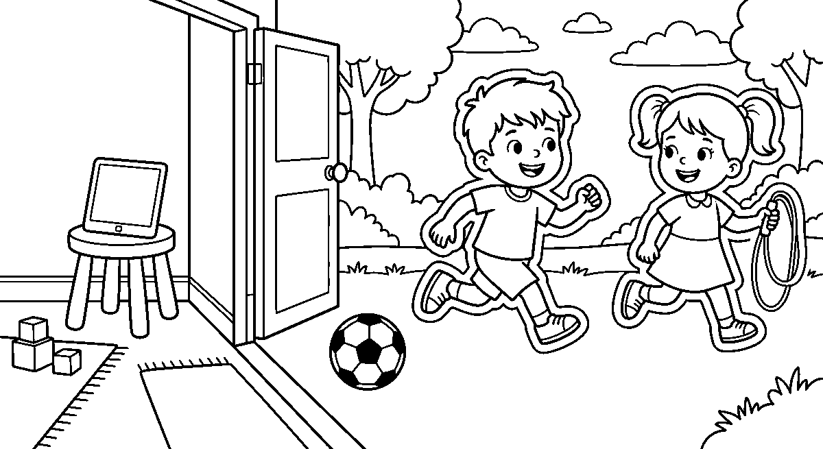
Worksheet
1. A video game is played on a(n) ____ . A) wooden stool B) cooking pot C) tablet or phone D) bucket
2. Time on a screen should be kept ____ . A) for the whole day B) short C) till morning D) during class
3. Games with fighting and bad words are made for ____ . A) big people B) babies C) our class D) the dog
4. Before the screen, a child first ____ . A) plays outside and does his lesson B) sleeps C) eats sweets D) hides
5. Fill in: We do not take a screen to ____ .
6. Mention two games a small child may play on a screen.
7. Write two sentences on the outdoor game you like better than a screen game.
My own work
Draw a tablet lying on a table with two children running past it towards a football on the ground outside.

WEEK 8 — MOVING OUR BODY PARTS
Depth: NERDC Primary 1 · PHE · motor skills, moving our body parts (part 1).
You will learn to
• name ten parts of the body
• move each part by itself
• stretch the arms, the legs and the back
• do the actions of a body song
Things to know
• The parts we name: head, neck, shoulders, chest, back, waist, arms, hands, fingers, legs, feet and toes.
• Nodding the head means yes; shaking it means no; both move the neck.
• Shrugging lifts the shoulders up to the ears and drops them — the way a man carries a heavy load.
• Waving moves the whole arm from the shoulder, with the open hand going left and right.
• Stretching the arms above the head makes the body long, like a plant reaching for the sun.
• Bending to touch the toes stretches the back and the legs; the knees stay straight, and we do not jerk.
• Turning the waist from side to side with the hands on the hips wakes up the middle of the body.
• Shaking out the hands after writing makes the fingers ready again.
• In a body song we do what the song says — head, shoulders, knees and toes — and we get faster each time.
• Every movement is done slowly at first, on a clear space, with no child within reach of your legs.
Words for my notebook
We name the parts of the body and move them one at a time: nodding the head, shrugging the shoulders, waving the arms, stretching up and bending to the toes, all done slowly in a clear space.
Let us talk
1. Point to your waist and then to your neck.
2. What movement do we do when we want to say yes?
3. Why must nobody stand near you when you stretch your legs?
4. Sing the body song once with the actions.
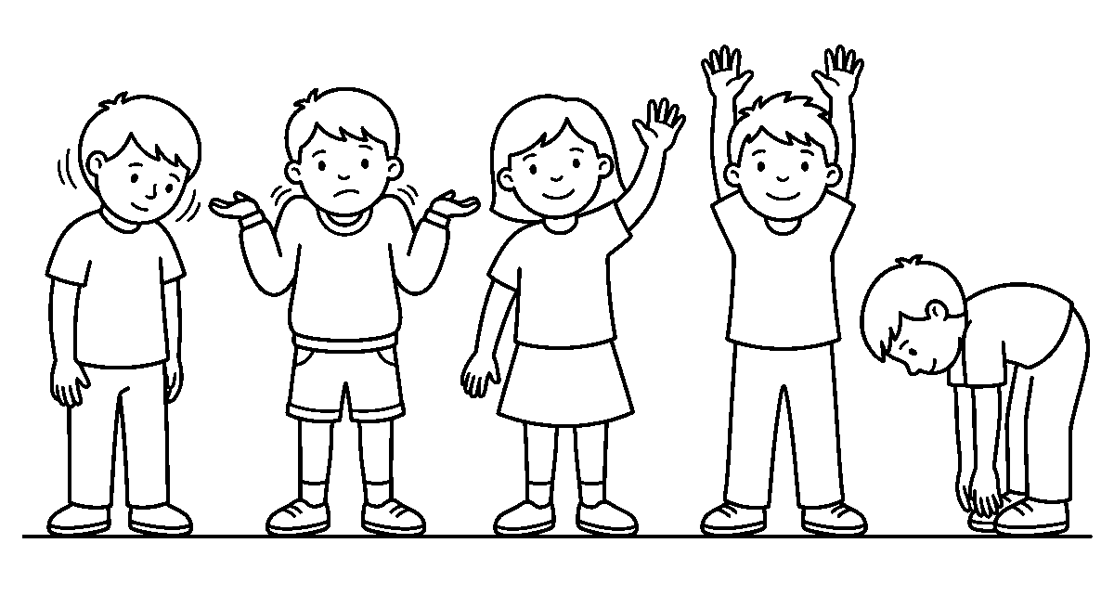
Worksheet
1. When we want to say yes we ____ the head. A) nod B) hide C) wash D) paint
2. Lifting the shoulders to the ears and dropping them is called ____ . A) waving B) shrinking C) shrugging D) singing
3. Waving moves the whole ____ . A) toe B) ear C) tooth D) arm
4. To stretch the back we bend down and touch our ____ . A) toes B) cap C) bag D) book
5. Fill in: Before we stretch, we look for a clear ____ .
6. Mention six parts of the body you can name.

7. Write two sentences on the body song you did today and what you touched.
My own work
Draw a child with both arms stretched high above the head, feet flat on the ground, and a small friend beside her waving one hand.

WEEK 9 — MOVING WELL IN EVERYDAY WORK
Depth: NERDC Primary 1 · PHE · motor skills, daily activity movements.
You will learn to
• pick a thing up from the floor the right way
• carry a light thing safely
• push and pull without hurting the back
• go up and down stairs well
Things to know
• To pick up a thing from the floor, bend the knees and keep the back near straight — do not fold the back.
• A thing is held close to the body when carrying; the further it is from you, the heavier it feels.
• Two small loads are easier than one big one: carry in two trips rather than fall with one.
• Pushing is better than pulling for a heavy box: push with the legs and the shoulder, not the back.
• When we pull, the hands come in low and the body leans forward, so we will not be dragged down.
• On the stair we go one after another, hold the rail, and do not look at the child below.
• Nothing is thrown down the stair and no child slides the rail.
• An obstacle course trains the body: walk the line, step over the low bar, crawl under the rope, jump the
two marks, and run back to touch the last child's hand.
• In a relay, the stick or the bean bag is passed in the zone, not thrown from far.
• These same moves keep us safe at home — for a child who lifts well spills less, drops less and aches less.
Words for my notebook
We pick things up by bending the knees, hold the load close, push with the legs and lean forward when we pull. On the stair we go one after another and hold the rail, and in a race we pass the bag in the zone.
Let us talk
1. Which part of you should do the work when you lift a bucket — the back or the legs?
2. Why is two small loads better than one big one?
3. Show me how you hold the rail on the stair.
4. Where do we pass the stick in a relay?
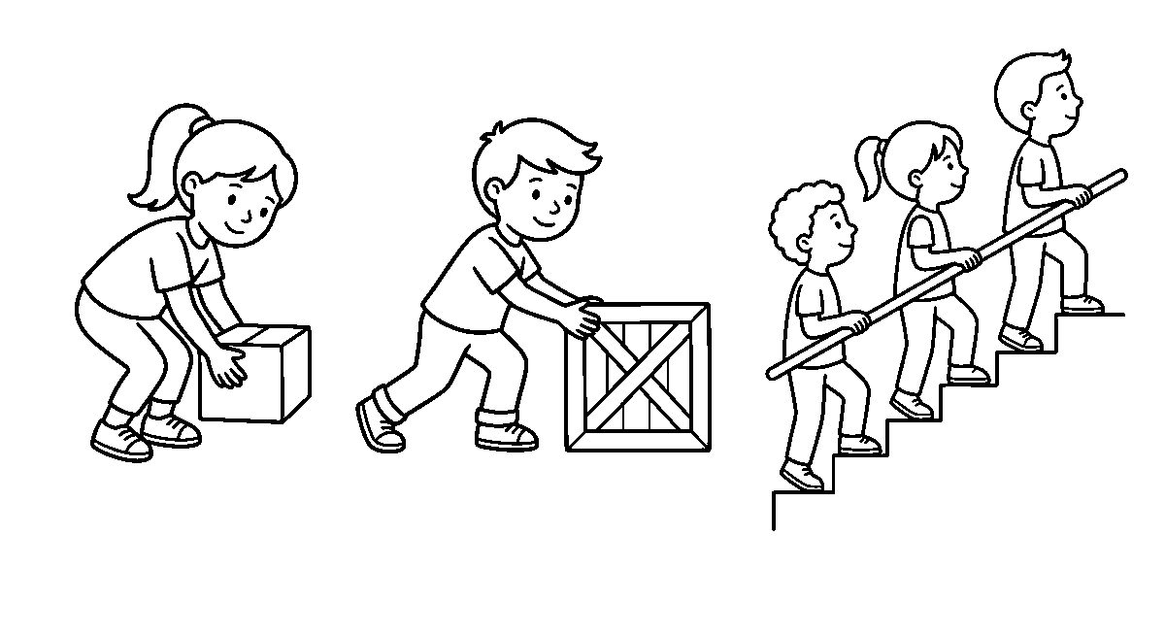
Worksheet
1. To lift a thing from the floor we bend the ____ . A) neck B) ears C) knees D) fingers

2. A heavy box is best moved by ____ it with the legs. A) pushing B) kicking C) smelling D) hiding
3. When we pull a rope we lean the body ____ . A) up B) sideways C) off D) forward
4. On the stair a child goes ____ . A) one after another B) three at a time C) with his eyes closed D) running fast
5. Fill in: A load is carried ____ to the body, not far from it.
6. Mention four things an obstacle course makes you do.
7. Write two sentences on how you carried water or firewood at home without dropping it.
My own work
Draw a boy bending his knees to lift a box, then a line of children going up a stair one after another with hands on the rail.

PREVOCATIONAL STUDIES (PVS)
Weeks 1 to 6, 8 and 9. Week 7 is Mid-Term Break, Week 10 Revision, Week 11 Examination, Week 12 Closing — those weeks carry no note. Depth: NERDC 2025 · Nursery 3 · Prevocational Studies · Third Term — farm tools, their care and storage, and safety on the farm and in the kitchen, from the pack's off-by-one mapping.

WEEK 1 — THE TOOLS WE WORK WITH, AND WHERE THEY REST
Depth: NERDC Nursery 3 · Prevocational Studies · Third Term W1.
You will learn to
• name six common farm tools
• say what each tool is used for
• tell the difference between a spade and a hoe
• say where tools rest when work is over
Things to know
• A spade digs and lifts soil; a hoe opens the ground and clears small weeds; a cutlass cuts
grass and stick.
• A rake pulls soil smooth and gathers dry leaves; a watering can carries water to the young plant;
a basket and a wheelbarrow carry what we have cut or dug.
• A spade has a flat wide blade and a long handle; a hoe has a short flat blade set at an angle.
• A rake has teeth; a spade has none — that is how you know them at a glance.
• Tools are for work, not for play: a cutlass and a hoe are for a grown-up's hand, and a child carries
the small watering can or the light basket.
• After work, a tool is cleaned of mud, dried, and hung on the rack or laid on a shelf with the
blade down.
• A tool left on the ground in the path is a trap for the next foot; a tool on the rack is a tool kept.
• Rust spoons an edge, so tools are kept dry and under a roof, not on the wet soil overnight.
• A damaged handle is not carried back to the rack; it is shown to a grown-up and mended first.
Words for my notebook
A spade digs, a hoe clears weeds, a cutlass cuts, a rake smooths, a watering can brings water, and a basket or a wheelbarrow carries. After work every tool is cleaned, dried and hung on the rack with its blade down.
Let us talk
1. Which tool do we use to pull dry leaves together?
2. Show me how a hoe's blade is different from a spade's.
3. Where does a tool rest when the work is over?
4. Which two things may a child carry on the farm?
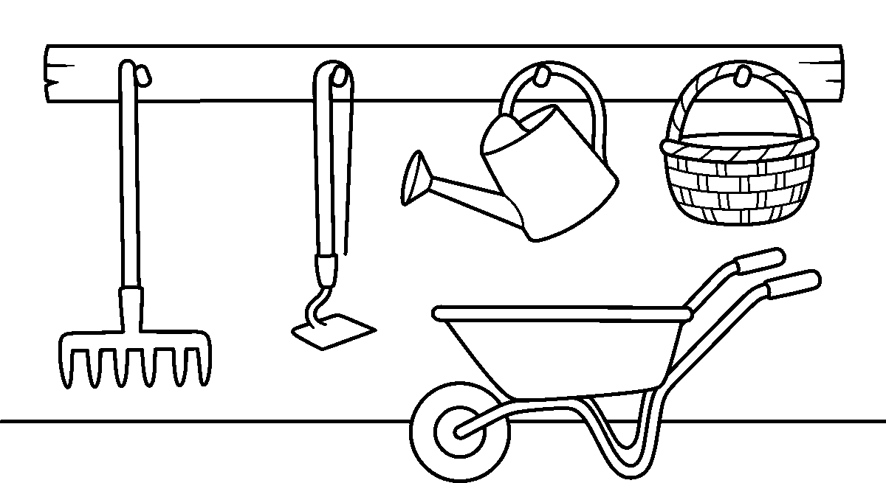

Worksheet
1. A rake is used to ____ . A) cut grass B) pull leaves and smooth soil C) carry water D) dig a hole
2. The tool with a flat wide blade for lifting soil is a ____ . A) basket B) can C) spade D) rake
3. A cutlass and a hoe are carried by ____ . A) anybody who wants B) the smallest child C) the class monitor D) a grown-up at work
4. Where should a tool rest after work? ____ . A) in the path B) on the wet ground C) under the tree D) dry, on the rack
5. Fill in: A tool with a cracked handle is shown to a ____ before it is used.
6. Mention three tools that carry or hold things instead of cutting.
7. Write two sentences on a tool you have held and what you did with it.
My own work
Draw a wall with a rack on it, then draw a rake, a hoe, a watering can and a basket hanging neatly in a row.

WEEK 2 — WHAT WE MEAN BY SAFETY
Depth: NERDC Nursery 3 · Prevocational Studies · Third Term W2.
You will learn to
• say what safety means
• name three rules we keep on the farm
• tell why the ground is cleared before work
• say what we do with a thing that can hurt
Things to know
• Safety means keeping ourselves and other people from being hurt while we work or play.
• Safety is not a thing we wear once; it is the way we do everything — walking, carrying, putting down.
• Before work begins we look at the ground: a stone, a stick, a hole or a peel can send a person down.
• A tool is pointed away from people and never swung over a head; the space behind is looked at first.
• Nothing that can cut is thrown, pushed into the soil, or left in the grass where a foot will find it.
• When we carry something sharp, a grown-up carries it; the child's hands hold the **watering can, the cup,
the basket**.
• Reporting is part of safety: a broken thing, a spill, or a wasps' nest by the fence is told, not hidden.
• The store and the fire have rules too: the insect medicine stays shut and high, and never in a bottle
that once held water to drink.
• A safe farm is a working farm: a cut hand keeps a family from the market for a week.
Words for my notebook
Safety means keeping ourselves and others from being hurt. We clear the ground before we work, we point a tool away from people, we carry sharp things with a grown-up, and we report what is broken or dangerous.
Let us talk
1. What does the word safety tell you?
2. What do we look at before we start work on the ground?
3. Who carries a cutlass, and who carries the watering can?
4. Name one thing you would report to a grown-up at once.

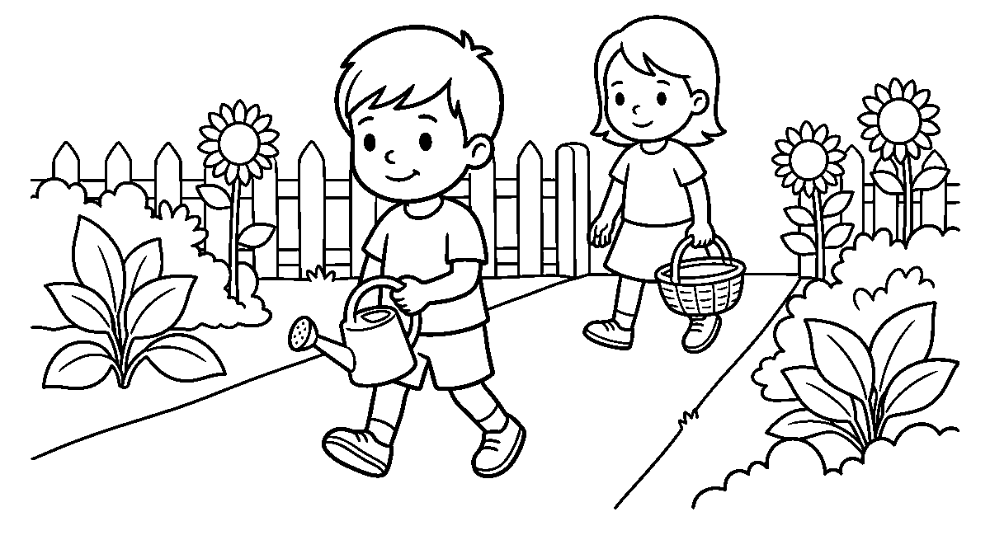
Worksheet
1. Safety means keeping people from being ____ . A) hurt B) paid C) called D) counted
2. Before work starts on the ground we ____ . A) run across it B) look for stones and holes C) water it D) sing on it
3. A tool is carried with its sharp end ____ . A) up over a head B) towards a friend C) away from people D) in the grass
4. A wasps' nest near the fence is ____ . A) kicked B) hidden C) waited for till next year D) reported to a grown-up
5. Fill in: A safe farm is a ____ farm.
6. Mention three rules we keep when tools are about.
7. Write two sentences on how you cleared a place before you played or worked.
My own work
Draw two children in a garden, one carrying a small watering can with both hands, with no tool or stone lying on the path between them.

WEEK 3 — WHY SAFETY MATTERS SO MUCH
Depth: NERDC Nursery 3 · Prevocational Studies · Third Term W3.
You will learn to
• say three good things that come from safe work
• tell what one carelessness can cost
• name the people who are hurt by our carelessness
• say why a careful child is trusted with more
Things to know
• Safe work keeps the body whole — eyes for reading, hands for holding, legs for running.
• It keeps the work going: a farm with a hurt worker loses days, and a kitchen with a burnt pot loses a meal.
• It saves money: a cloth for a cut and medicine for a fever are dearer than the care that prevented them.
• It keeps the family glad: a child who comes home unhurt is the reason the day was good.
• Carelessness does not hurt only the careless one: a swung hoe can reach a smaller child standing behind.
• A careful child is trusted with more — first the basket, then the small rake, then bigger work.
• Being quick is good; being quick and careless is the slowest way to do a thing.
• Safe work is also neat work: things in their place, the ground cleared, the tool cleaned after use.
• We do not brag about a danger we have passed; we tell the class the rule that kept us whole.
Words for my notebook
Safety keeps the body whole, keeps the work going, saves money and keeps the family glad. Carelessness can hurt the one standing behind, so a careful child is the one who is trusted with more work.
Let us talk
1. Name two good things that come from working safely.

2. Who else can be hurt by your carelessness?
3. What does a family lose when a worker hurts a hand?
4. Which comes first, being quick or being careful?
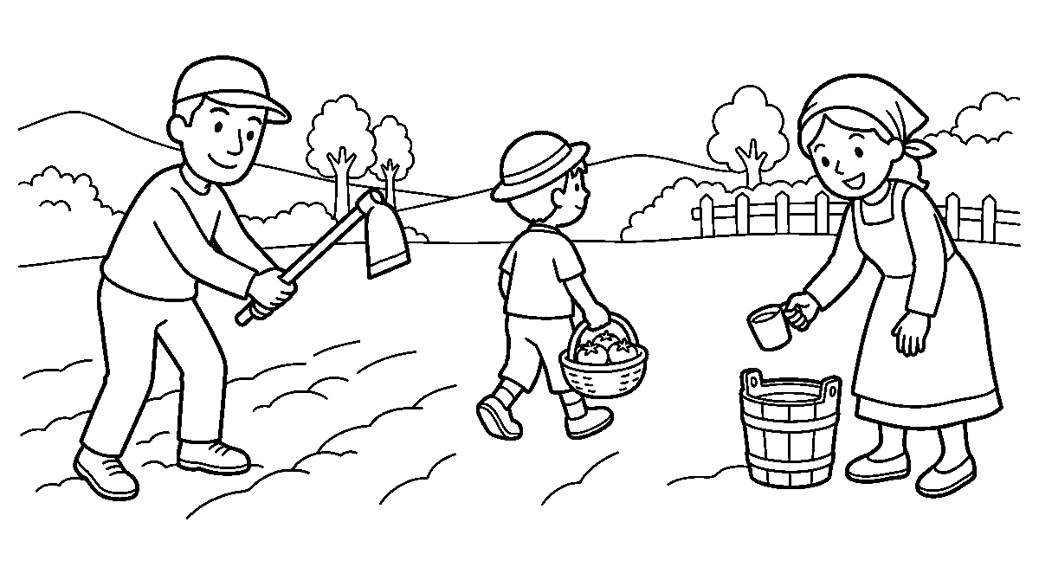
Worksheet
1. Safe work first of all keeps the ____ . A) body whole B) house painted C) fire bright D) dog fed
2. A farm that loses a worker to a hurt hand will ____ . A) earn more B) lose days of work C) rest and prosper D) plant twice
3. Who can be hurt by the person swinging a tool? A) nobody B) only the worker C) a child standing behind D) the birds only
4. A child who works carefully is ____ . A) sent away B) forgotten C) given the biggest hoe D) trusted with more work
5. Fill in: Being quick and careless is the ____ way to do a thing.
6. Mention four good results of safe work.
7. Write two sentences on a time you were careful and it kept you unhurt.
My own work
Draw a family working on a small farm plot: a grown-up with a hoe, a boy carrying a basket of tomatoes and a girl drawing water, all standing clear of one another.

WEEK 4 — WHAT HAPPENS WHEN A TOOL IS MISUSED
Depth: NERDC Nursery 3 · Prevocational Studies · Third Term W4.
You will learn to
• name four dangers on a farm or in a home
• tell what a cracked handle can do
• say why a hole in the ground is marked
• tell what we do with a tool that is broken
Things to know
• A cracked or loose handle can slip off while the tool is swinging, and the blade goes where nobody
meant it.
• A tool left in the grass is seen by nobody until a foot steps on it; a blade turned down in the soil is
the same trap.
• An open hole — a post hole, a burrow, a washed gully — turns an ankle; the rule is to fill it or
mark it with stones or a stick until it is filled.
• A wet floor, a peel, or a stone in the path is a fall waiting; the quick child picks it up, not jumps it.
• A blade used for the wrong work — a cutlass to split wood, a knife to open a tin — chips, and a chipped
blade cuts worse and slips more.
• Fire and hot ash are not moved by a child; a pot handle is turned in on the stove, not out into the path.
• A broken tool is taken up and told about, not hidden under the rack; the mending is small, the hiding is
not.

• First aid for a small cut: clean water on it, a clean cloth over it, and a grown-up told — no dust and no
leaf pressed into the wound.
Words for my notebook
A cracked handle flies off, a tool in the grass waits for a foot, and a hole in the ground turns an ankle. We mark the hole, pick up the stone, take the broken tool to be mended, and wash and cover a small cut.
Let us talk
1. What can a loose handle do while a man is swinging?
2. What do we do with a hole we cannot fill today?
3. Why is a chipped blade more dangerous than a good one?
4. What are the three steps for a small cut?
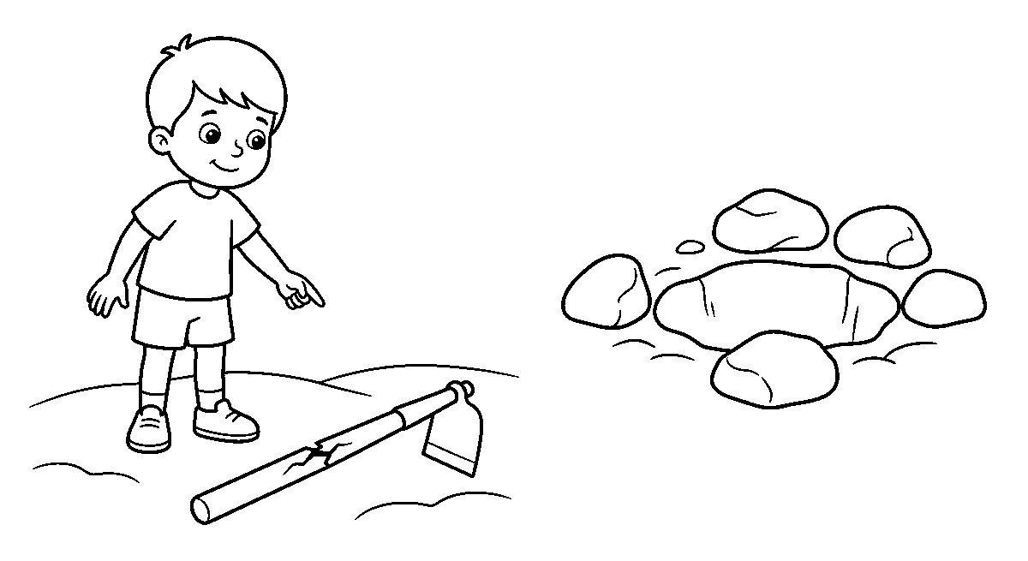
Worksheet
1. A tool with a cracked handle may ____ . A) lose its handle while it swings B) work faster C) keep better D) stay clean longer
2. A hole in the ground that cannot be filled today is ____ . A) left for the goats B) marked with stones C) hidden with grass D) jumped by everyone
3. A chipped blade is dangerous because it ____ . A) shines less B) is heavier C) slips and cuts worse D) costs more
4. The three steps for a small cut are clean water, a clean cloth and ____ . A) a leaf pressed in B) dust from the floor C) the finger hidden D) a grown-up told
5. Fill in: A broken tool is taken up and ____ , not hidden.
6. Mention four dangers you can find on a farm or in a kitchen.
7. Write two sentences on a danger you saw and what was done about it.
My own work
Draw a boy pointing at a hoe with a cracked handle lying on the ground, and beside them a small hole ringed with stones to warn the feet.

WEEK 5 — THE KITCHEN, AND WHY A GROWN-UP IS NEEDED
Depth: NERDC Nursery 3 · Prevocational Studies · Third Term W5.
You will learn to
• say what a kitchen is for
• name four dangers found in a kitchen
• tell which jobs need a grown-up
• say how a child can still help in the kitchen
Things to know
• The kitchen is the room where food is kept, washed and cooked; it feeds the whole house.
• Its dangers are quick: **fire, hot water, a hot pot, a sharp knife, a wet floor, and a covered pot that
spits when the lid is lifted**.
• A hot surface does not wait for a small hand; the pot's handle is turned in, so a sleeve will not
catch it.
• Knives are laid on a shelf or in a rack, blade away from the edge, never in a basin of water you cannot

see through.
• The jobs of fire, boiling, cutting and lifting a hot pot belong to a grown-up; a child stands back and
carries what is cool.
• A child helps well by **washing vegetables, carrying a cool cup, setting things on the table, sweeping, and
fetching** what is asked for.
• A grown-up is needed not because a child is slow but because a spill, a burn or a cut is bigger than a
child's hand can put right.
• If a fire starts in a pot, the lid is put on and the air taken away; nobody carries a burning pot
across the room.
• The floor is wiped at once; a wet floor sends a person to the wall — and the wall sends the pot down.
Words for my notebook
The kitchen cooks the food and keeps it, and it holds fire, hot water and sharp knives. Those jobs belong to a grown-up; a child washes, carries what is cool, sweeps, and keeps the floor dry.
Let us talk
1. What do we do in a kitchen?
2. Name two things in a kitchen that can hurt quickly.
3. Which kitchen jobs must a child wait for a grown-up to do?
4. Name two ways you help in the kitchen today.
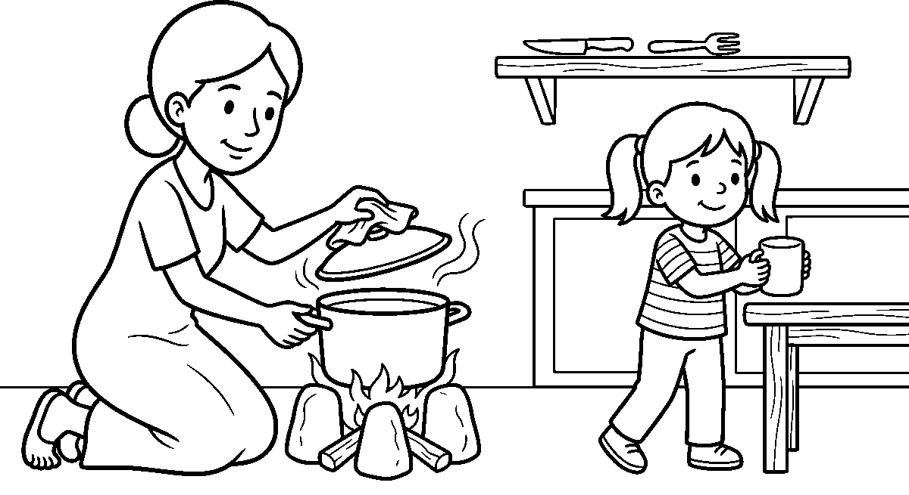
Worksheet
1. A kitchen is the room where food is kept, washed and ____ . A) sewn B) cooked C) sold only D) buried
2. The handle of a pot on the fire is turned ____ . A) out into the path B) up in the air C) on the floor D) in, away from the path
3. Boiling, cutting and lifting a hot pot are jobs for ____ . A) a grown-up B) the smallest child C) the visitor D) a class friend
4. A child helps in the kitchen by ____ . A) carrying the burning pot B) washing vegetables and sweeping C) playing with the lid D) running with a knife
5. Fill in: A wet floor is wiped ____ , so nobody falls.
6. Mention four dangers found in a kitchen.
7. Write two sentences on one kitchen job you do at home and why it is safe for you.
My own work
Draw a woman lifting the lid of a pot on a fire with a cloth in her hand, a girl bringing a cool cup to the table, and a knife lying high on a shelf.

WEEK 6 — THE RULES WE KEEP WHEN TOOLS ARE ABOUT
Depth: NERDC Nursery 3 · Prevocational Studies · Third Term W6.
You will learn to
• state five rules we keep with tools
• show how a sharp tool is carried
• say why we watch the space behind us

• tell how tools are shared in a class
Things to know
• Never run with a tool; walk, and keep the blade or the teeth pointing down.
• Never throw a tool — even to a friend who is near; it is put into the hand and the hand is waited for.
• Never swing a tool over anybody. Before you swing, look behind you — the handle comes round too,
and it can hit a person standing there.
• One tool, one work: a hoe for the soil, a cutlass for grass, a knife for food.
• A tool is passed by the handle, so the receiver's hand is where the grip goes.
• Space is kept: at least the length of two arms between anybody working and anybody watching.
• A tool is not stood in the soil where it can fall on a foot; it is laid down or hung up.
• In a class we take turns with the watering can and never grab it mid-pour.
• Medicine for insects, kerosene and soap are kept shut, kept high and kept apart from drink and food.
• A rule is only good when it is said out loud to the one who forgot it, kindly and before the accident.
Words for my notebook
We walk with a tool and point it down, we pass it by the handle, we put it into a hand instead of throwing it, and we look behind before we swing. One tool does one work, and two arms' space is kept from anybody watching.
Let us talk
1. Which way should a tool point when it is carried?
2. Why must we look behind before we swing a hoe?
3. How do we give a tool to another person?
4. What do we say when a friend forgets a rule?
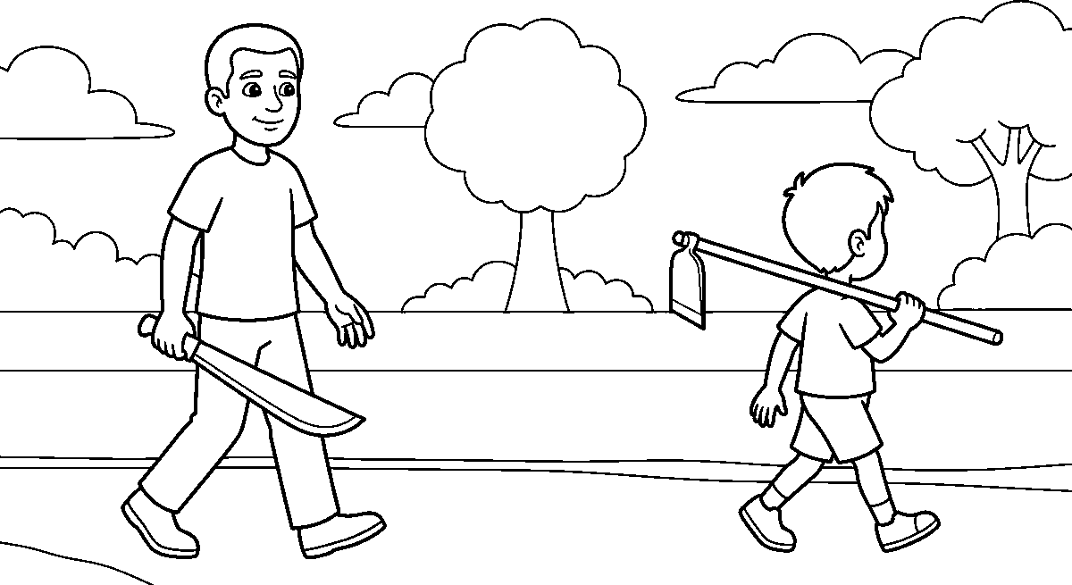
Worksheet
1. A sharp tool is carried with its blade ____ . A) pointing down B) up over a head C) on the shoulder D) in a pocket
2. To give a friend a tool, you ____ . A) throw it B) leave it in the grass C) put it into his hand D) stand it in the soil
3. The space kept between a worker and a watcher is about ____ . A) one finger B) the width of a mat C) two arms' length D) a whole field
4. A hoe is for the soil and a knife is for ____ . A) the roof B) the fence C) the drum D) food
5. Fill in: Medicine for insects is kept shut, kept ____ , and kept apart from drink.
6. Mention five rules we keep when tools are about.
7. Write two sentences on how your class shares one watering can.
My own work
Draw a man carrying a cutlass with its point down and a boy walking behind him with a hoe on his shoulder, blade down and well apart.

WEEK 8 — CLOTHES AND THINGS THAT PROTECT THE BODY
Depth: NERDC Nursery 3 · Prevocational Studies · Third Term W8.
You will learn to
• name four things worn to keep us safe at work
• say what each one protects
• tell when they must be worn
• say how a child dresses for the farm
Things to know
• The things we wear to keep the body safe are called protective gear: **gloves, boots, a hat and an
overall** (the big loose cloth that covers the clothes).
• Gloves keep the hands from thorns, blisters from a rough handle, and wet medicine off the skin.
• Boots keep the feet from a nail, a stone, water in the gutter, and a tool that slips.
• A hat keeps the sun off the head and neck, so the head does not become hot and painful.
• An overall keeps the school clothes free of mud and oil, and loose cloth keeps branches from a hand.
• Gear is worn before the work begins, not after the first scratch.
• It is clean and whole: a glove with a hole lets in what the glove was for.
• A child on the farm wears a cap, sandals or shoes, and clothes that are not too long, so the feet will
not trip on the hem.
• Gear is not a toy to play with; the gloves and the hat are for work and are put back on the peg.
• Eyes are kept safe too: nobody looks at the sun, and nobody points a stick where a face is.
Words for my notebook
Gloves for the hands, boots for the feet, a hat for the head, and an overall for the clothes are the gear we put on before work. The gear is clean and whole, and it goes back on its peg when the work is over.
Let us talk
1. Which thing keeps a nail or a stone from the foot?
2. Why must a glove have no hole in it?
3. What does a hat keep off the head?
4. What do we do with the gear when work is finished?
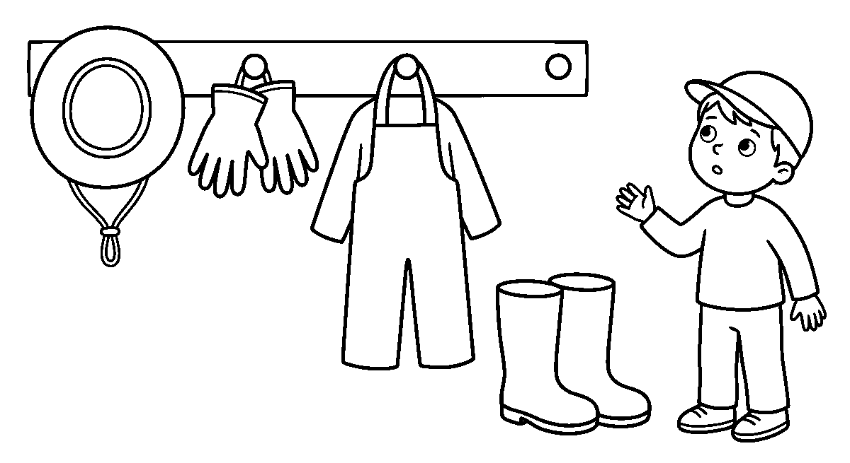
Worksheet
1. Boots are worn to keep the ____ safe. A) eyes B) head C) feet D) hands
2. Gloves are worn to keep the hands from ____ . A) thorns and blisters B) water only C) the sun D) the basket
3. The loose cloth we wear over our clothes on the farm is the ____ . A) apron B) overall C) umbrella D) school cap
4. Protective gear is put on ____ the work begins. A) long after B) when it is over C) if it rains D) before

5. Fill in: A glove with a ____ lets in what the glove was for.
6. Mention four things worn to keep us safe at work.
7. Write two sentences on what you wear on your head and feet when you go to the farm.
My own work
Draw a peg on a wall with a hat, a pair of gloves, an overall and a pair of boots hanging on it, and a boy standing beside them in his cap.

WEEK 9 — PUTTING THINGS AWAY, TELLING WHAT IS BROKEN, AND FIRST AID
Depth: NERDC Nursery 3 · Prevocational Studies · Third Term W9.
You will learn to
• say how tools and chemicals are stored
• tell who is told about a broken thing
• give first aid for a small cut and for a burn
• say what a store place must keep out
Things to know
• A store is a dry place, off the ground, where tools, cans and baskets are kept with the blade down
and the sharp edges in.
• Tools are cleaned of mud and dried before they go in, or the mud will keep the rust alive.
• Insect medicine, kerosene and acid are kept shut, high, and marked; they never go into a bottle that a
child drinks from.
• A broken thing is reported at once to the grown-up in charge, and it is not used again until it is
mended.
• A small cut: wash with clean water, press a clean cloth on it, keep the hand up; a grown-up puts a
cover on it. Dust, leaf and ash are never rubbed into a wound.
• A small burn: hold the place under cool clean water for a while, cover loosely with a clean cloth,
and tell a grown-up. No oil, no paste and no leaf is put on a burn.
• A nosebleed: sit up, lean a little forward, and pinch the soft part of the nose; the head is not
thrown back.
• First aid is what we do before the clinic or the hospital; a deep cut, a bad burn or a fall where the leg
will not bear weight is taken to a grown-up and to the clinic at once.
• The store and the first-aid box are kept clean, closed and known — everybody in the house can point to
both of them.
Words for my notebook
Tools are cleaned, dried and stored with the blade down; medicine is kept shut and high; a broken thing is reported and not used. A cut is washed and covered, a burn is cooled with clean water, and a grown-up is told at once.
Let us talk
1. What is done to a tool before it is put on the rack?
2. Who is told about a broken rake?
3. What is put on a small burn first?
4. Why is a nosebleed child made to lean forward?

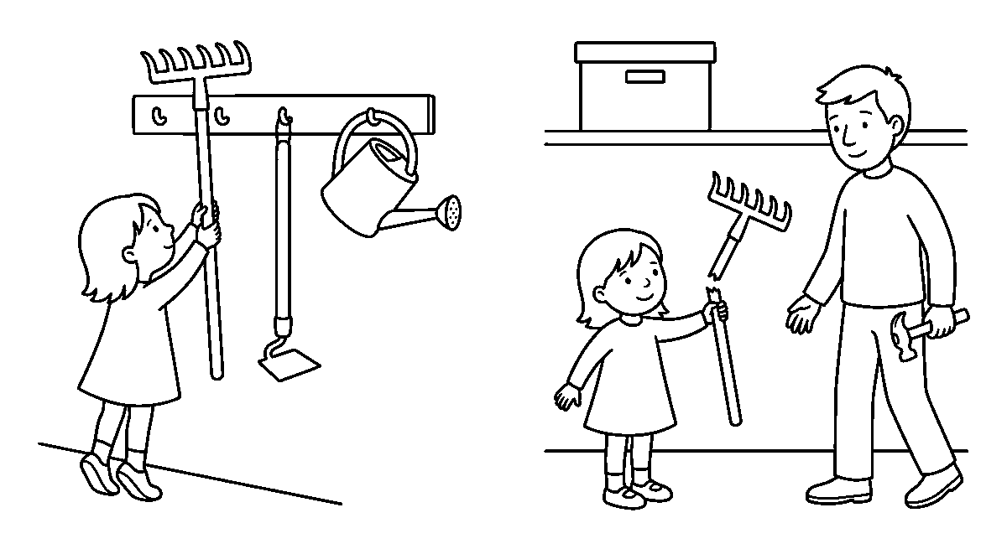
Worksheet
1. Tools are stored in a place that is ____ . A) wet and open B) under the tree C) in the path D) dry and off the ground
2. Insect medicine is kept shut, high, and ____ . A) beside the drinking cups B) marked C) left on the floor D) poured in a drink bottle
3. A broken tool must be ____ . A) used carefully B) hidden C) reported and not used D) thrown in the bush
4. For a small cut we first use ____ . A) ash from the fire B) a leaf C) dust from the floor D) clean water and a clean cloth
5. Fill in: A small burn is held under ____ clean water.
6. Mention three things a store place must keep out or keep away.
7. Write two sentences on where the first-aid box is kept in your house and who knows it.
My own work
Draw a rack with three tools hanging on it and a box on a high shelf below a notice that is left blank; then draw a girl showing a broken rake handle to a man with a hammer.

SOCIAL AND CITIZENSHIP STUDIES (SCS)
Weeks 1 to 6, 8 and 9. Week 7 is Mid-Term Break, Week 10 Revision, Week 11 Examination, Week 12 Closing — those weeks carry no note. Depth: NERDC 2025 · Nursery 3 · Social and Citizenship Studies · Third Term — our place and its weather, the animals about us, the naira and saving, being a citizen, our community, its leaders and the wide world, from the pack's off-by-one mapping.

WEEK 1 — THE PLACE WE LIVE, AND THE WEATHER THAT CHANGES
Depth: NERDC Nursery 3 · Social and Citizenship Studies · Third Term W1.
You will learn to
• keep the place where we live clean
• put waste where it belongs and never throw it about
• name the kinds of weather we know
• say what we can do when the weather changes too much
Things to know
• A bin with a cover is where paper, peels and wrappers go; the ground is not a bin.
• A wrapper or a tin left on the ground is called litter; it makes the place ugly and it can cut a foot.
• When the gutter is choked with litter, rain water has no way out and the water comes into the compound.
• A broken fence, a deep hole or a pool of dirty water is told to a grown-up so that it is mended.
• Weather is what the sky does today: sun, rain, wind, hot and cold.
• Climate is the weather a place has over many years — we know rain will come in its season.
• When rain, heat and wind change from what they used to be, we call it climate change.
• Too much heat dries the soil and the young plants die; too much rain brings a flood; a long time
without rain is a drought.
• Our own part is small but real: plant a tree, shut the tap when water is not wanted, keep our place clean.
Words for my notebook
We keep our place clean by putting waste in a covered bin and never on the ground, and a broken or dangerous thing is told to a grown-up. Weather is what the sky does today — sun, rain, wind, hot or cold — and when it changes for many years we call it climate change; a tree planted and water saved both help.
Let us talk
1. Where do paper, peels and wrappers go?
2. What happens when a gutter is choked with litter?
3. Name three kinds of weather you know.
4. What are two things you can do when the heat grows too much?
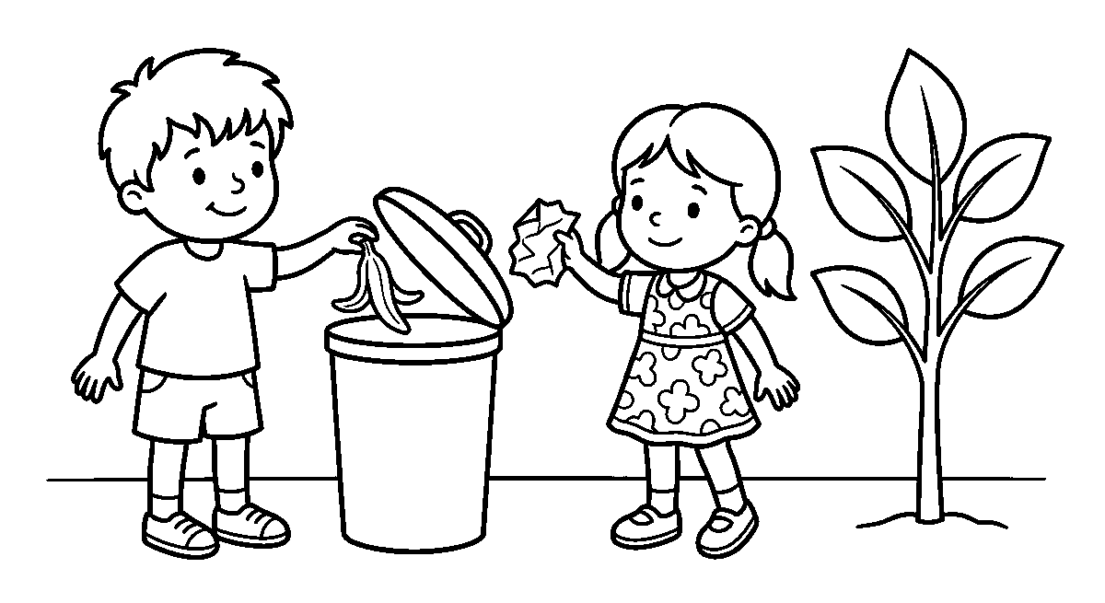
Worksheet
1. Waste like paper and peels should be put ____ . A) into a covered bin B) on the ground C) in the gutter D) under a leaf

2. A wrapper left on the ground is called ____ . A) a gift B) litter C) soil D) water
3. When the gutter is choked with litter, rain water ____ . A) goes away faster B) dries at once C) has no way out D) becomes clean
4. A broken fence at the edge of the road is best ____ . A) kicked B) hidden C) painted by a child D) told to a grown-up
5. Fill in: The weather a place has over many years is its ____ .
6. Mention three kinds of weather you know.
7. Write two sentences on two things you can do to help the place where you live.
My own work
Draw a boy and a girl putting banana peel and paper into a bin with a cover on it, and a young tree beside them; colour the leaves of the tree green.

WEEK 2 — THE ANIMALS THAT LIVE BY THEMSELVES
Depth: NERDC Nursery 3 · Social and Citizenship Studies · Third Term W2.
You will learn to
• say what wildlife means
• name animals that live in our forests and grasslands
• tell where each of them lives
• say why we do not harm them
Things to know
• Wildlife are the animals and birds that live in nature by themselves, in the bush, by the river and on
the grassland.
• Animals we find in Nigeria are the monkey, antelope, bushbird, lizard, snake and butterfly.
• A monkey lives in the trees of the forest; an antelope feeds on the grassland; a snake keeps to the
long grass and the holes in the ground.
• Fish and frogs live in or beside the river, and a butterfly goes from flower to flower for the drink in
the flower.
• Animals are part of nature: the bird eats the insect that would spoil our farm, and the bee helps a
flower become a fruit.
• Some animals are nearly gone — that is called endangered — because their homes are cut down or they are
killed for food.
• Conservation means keeping nature and its animals safe, so that a child yet to come will still see a
monkey in a tree.
• We do not hurt them or pull down their homes: no burning the bush, no cutting every tree, no stone
thrown at a bird.
• A zoo is a place where animals are kept and fed so that people may learn about them; there we look
quietly and we do not throw anything in.
Words for my notebook
Wildlife are animals that live in nature by themselves — a monkey in the tree, an antelope on the grassland, a fish in the river. Conservation means keeping them and their homes safe: we do not burn the bush, cut every tree or stone a bird.
Let us talk
1. What does wildlife mean?
2. Where does a monkey live, and where does an antelope feed?
3. Name two animals you have seen with your own eyes.
4. Why should we not burn the bush?

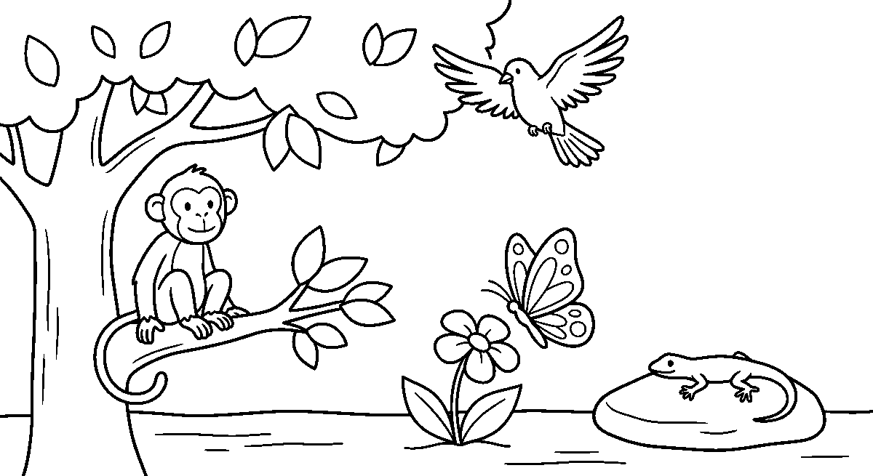
Worksheet
1. Animals that live in nature by themselves are called ____ . A) pets B) wildlife C) crops D) tools
2. An antelope feeds on the ____ . A) grassland B) sea C) roof D) market
3. A monkey lives in ____ . A) a hole in the path B) the long grass C) the trees of the forest D) the river
4. Keeping nature and its animals safe is called ____ . A) littering B) digging C) burning D) conservation
5. Fill in: Some animals are nearly gone because their ____ are cut down.
6. Mention three animals we find in Nigeria.
7. Write two sentences on one animal you like and the place it lives in.
My own work
Draw one forest home: a monkey on a branch, a bird in the air, a lizard on a stone and a butterfly by a flower; colour the leaves and do not hurt anything in the picture.

WEEK 3 — THE MONEY WE USE IN NIGERIA
Depth: NERDC Nursery 3 · Social and Citizenship Studies · Third Term W3.
You will learn to
• say what money is used for
• name the money of Nigeria
• tell a coin from a note
• say why money has value
Things to know
• Money is the thing we use to buy what we need: food, cloth, a pencil and a bus ride.
• The money of Nigeria is the naira, and its mark is the letter N with two strokes through it.
• Round money made of metal is a coin; the ₦1 and the ₦2 coins are still carried in a pocket.
• Money made of paper is a note: ₦5, ₦10, ₦20, ₦50, ₦100, ₦200, ₦500 and ₦1000.
• A note carries a number, a face and a shining strip, and one note is not the same colour as another.
• Money has value: a ₦100 note will buy more than a ₦5 note buys.
• Money is got by work — the grown-up who works is paid money for the work done.
• A note is not folded into a plane and not torn: it is kept clean, flat and shut in a purse or a box.
Words for my notebook
The money of Nigeria is the naira. Round metal money is a coin and paper money is a note; money is got by work, it has value, and it is kept clean, flat and shut.
Let us talk
1. What do we use money for?
2. What is the name of the money of Nigeria?

3. Show me with your hands how a coin is different from a note.
4. Why is a note not for folding into a plane?
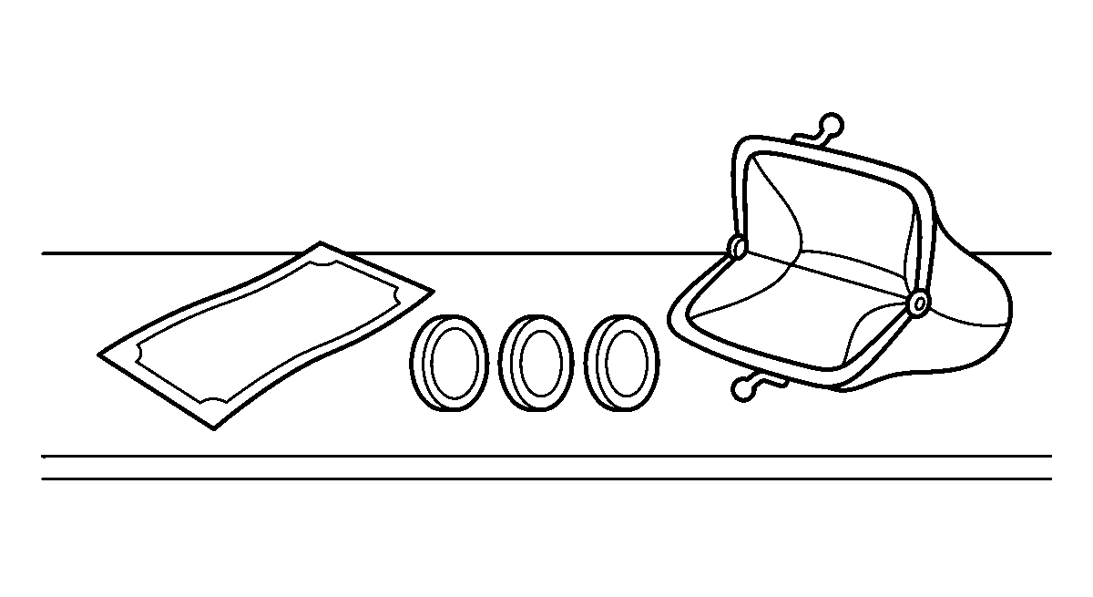
Worksheet
1. The money of Nigeria is called the ____ . A) pesewa B) cedi C) naira D) kobo
2. Round money made of metal is a ____ . A) note B) coin C) card D) cup
3. Money made of paper is called a ____ . A) coin B) cup C) plate D) note
4. People are paid money because they ____ . A) sleep B) work C) play D) wait
5. Fill in: A ₦100 note will buy ____ than a ₦5 note buys.
6. Mention four things money is used to buy.
7. Write two sentences on the way a note should be kept.
My own work
Draw one folded note and three round coins lying on a table beside an empty purse, then colour the note green and the coins gold.

WEEK 4 — SPENDING WISELY AND SAVING A PART
Depth: NERDC Nursery 3 · Social and Citizenship Studies · Third Term W4.
You will learn to
• name what money buys for a family
• tell a need from a want
• say where money for later is kept
• say how we behave with money that is not ours
Things to know
• Money buys food, cloth and shoes; it pays for school, for the bus, and now and then for a toy.
• A need is a thing we must have — garri, oil, a uniform. A want is a thing that would be nice — a
second toy.
• Buying what we need first is spending wisely; when the money is finished there is nothing left for food.
• Saving is keeping part of the money for later use — a piggy bank, a box with a slit, or the bank.
• Money saved little by little grows: two coins today and two coins tomorrow make a heavier box.
• Money that is not ours is never taken — not from a bag, a drawer, a table or a friend's pocket.
• If we find money on the floor we give it to the person who lost it, or take it to the class teacher.
• Being honest with money is worth more than any toy bought with money that is not ours.
• We thank the grown-up who buys for us and we do not cry for everything we see in the shop.
• In the market we count what we are given and say thank you; a buyer and a seller are both doing a work.

Words for my notebook
Money buys what we need first — food, cloth, school and the bus — and a part of what is left is saved in a box or a bank. Money that is not ours is never taken, and we thank the grown-up who buys for us.
Let us talk
1. Name three things money buys for a family.
2. What is the difference between a need and a want?
3. Where can money kept for later be put?
4. What do you do if you find money on the floor?
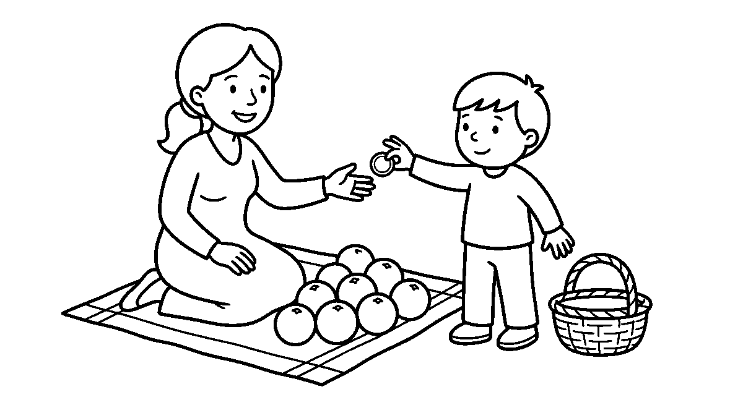
Worksheet
1. A thing we must have, like garri or a uniform, is a ____ . A) want B) need C) toy D) gift
2. Keeping part of the money for later use is ____ . A) saving B) losing C) hiding D) spending
3. Money that is not ours is ____ . A) put in a pocket B) spent at once C) never taken D) shared with friends
4. In the market, money given to us is ____ . A) thrown B) counted C) buried D) torn
5. Fill in: A box used for keeping money for later is a ____ bank.
6. Mention four things money is used for in a family.
7. Write two sentences on what you do when something is bought for you.
My own work
Draw a market scene: a woman sitting behind a heap of oranges, a boy handing her one coin, and an empty basket on the ground beside them.

WEEK 5 — BEING A GOOD CITIZEN
Depth: NERDC Nursery 3 · Social and Citizenship Studies · Third Term W5.
You will learn to
• say what a citizen is
• name the rights of a child
• name the things we must do for others
• say how a good citizen behaves every day
Things to know
• A citizen is a person who belongs to a country; every child born in Nigeria is a citizen of Nigeria.
• A good citizen is a good person in the place where they live: they greet, they keep the rules, they help.
• Our rights are these: to learn, to play, to be safe, to be treated fairly, and to be fed and cared for.
• Our responsibilities are the other half: to be kind, to help others, to keep the rules and to respect
everybody.
• A right is mine and it is my friend's too, so I do not push to the front of the line.
• Fairness means a girl and a boy, a small child and a big one, a Yoruba child and a Hausa child all get
the same turn.

• When a thing is wrong — a child being bullied, a tap left running — we speak up and tell a grown-up.
• We take care of the community: the bin is used, the bench is kept clean and the classroom is swept.
• Being proud to be Nigerian means knowing the colours of the flag, greeting in the tongue of our people
and singing our song well.
• A good choice is a small thing done many times: sharing a pencil, saying sorry, holding a door.
Words for my notebook
A citizen is a person who belongs to a country, and we are all citizens of Nigeria. A good child has rights — to learn, to play, to be safe, to be treated fairly — and duties too: to be kind, to help, to keep the rules and to respect everybody.
Let us talk
1. What is a citizen?
2. Name three rights of a child.
3. What is the other half that comes with a right?
4. When is the right time to speak up?
Worksheet
1. A person who belongs to a country is a ____ . A) visitor B) citizen C) baby D) leader
2. One right of a child is the right to ____ . A) stay home alone B) take a friend's pen C) shout in class D) learn and play
3. Treating a girl and a boy the same is being ____ . A) fair B) slow C) quiet D) afraid
4. When a small child is being bullied we ____ . A) look away B) laugh C) speak up and tell a grown-up D) join in
5. Fill in: Every child born in Nigeria is a ____ of Nigeria.
6. Mention four things a good citizen does in the place where they live.
7. Write two sentences on one good choice you made today.
My own work
Draw two children sitting on one bench with one book between them, and a flag on a pole behind them; the flag has three tall strips of colour and nothing is written on it.

WEEK 6 — OUR COMMUNITY: THE TOWN AND THE VILLAGE
Depth: NERDC Nursery 3 · Social and Citizenship Studies · Third Term W6.
You will learn to
• say what a community is
• tell a town from a village
• name things a village sends to a town
• say what a community values
Things to know
• A community is people living and working together in one place: the houses, the shops, the school, the
market and the stream.
• Our community is part of who we are — where we are from is known by our tongue and by our food.
• A town is a busy place: many buildings, many cars, big markets and street lights.
• A village is a quiet place: farms around the houses, animals going about, and nature close by.
• The two are different but connected — the village sends food to the town, and the town has the big
hospital, the good road and the larger school.
• When a flood comes, the town sends cloth and food to the village and the village sends baskets of yam
back; communities help one another.
• The values of a good community are sharing, helping and working together — a meeting, a road swept by

all, a neighbour taken to the clinic.
• Our own part: greet an elder, keep the path clear, help with a heavy load, and do not fight over a piece of
land.
• No community is better than another; one is busy and one is quiet, and both are needed.
Words for my notebook
A community is people living and working together in one place. A town is busy with many buildings and a village is quiet with farms near the houses, and both need each other: food comes from the village and the big school and hospital are in the town.
Let us talk
1. What is a community?
2. Name two things a town has that a village has few of.
3. What does a village send to the town?
4. Mention two ways people in a community help one another.
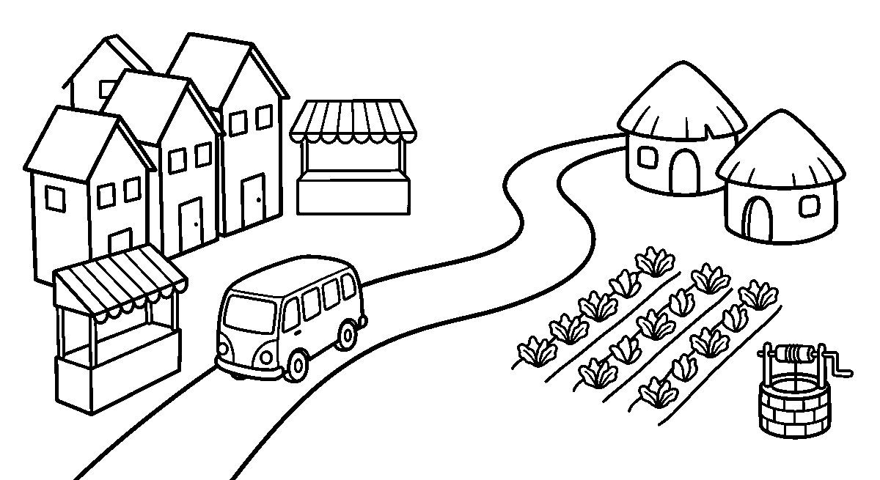
Worksheet
1. People living and working together in one place are a ____ . A) class B) market C) community D) family
2. A busy place with many buildings and markets is a ____ . A) village B) town C) farm D) bush
3. A place with farms around the houses and quiet roads is a ____ . A) town B) city C) village D) port
4. A village sends ____ to the town. A) food B) street lights C) tall buildings D) buses
5. Fill in: A good community shares, helps and works ____ .
6. Mention three values of a good community.
7. Write two sentences on one special thing about the place where you live.
My own work
Draw one page with a town on the left — three houses close together, a market stall and a bus — and a village on the right with two houses and a farm, then draw the road that joins the two.

WEEK 8 — THE LEADERS IN OUR COMMUNITY
Depth: NERDC Nursery 3 · Social and Citizenship Studies · Third Term W8.
You will learn to
• say what a leader does
• name four kinds of leader we know
• say the things a good leader is
• name the ways a child may lead
Things to know
• A leader is a person who guides people and serves them, not one who only shouts orders.
• The qualities of a good leader are these: honest, kind, fair, brave, helpful and a good listener.
• Traditional leaders in our land are the Oba, the Emir, a chief and a village head.

• Religious leaders teach people the way of their faith: a pastor or an imam.
• Community leaders keep order in a place: a Baale, a ward head or the chairman of the local
government.
• School leaders are the head teacher, the class captain and the prefects, and **family
leaders** are a father, a mother and a grandparent.
• We respect and support our leaders by listening to them, keeping their rules and greeting them well.
• Leaders serve the community by settling quarrels, calling the people to work on the road and looking after
the school.
• A child can lead in small ways: a line leader, giving out the books, saying the prayer, or helping two
friends make peace.
• A child's leadership skills are speaking clearly, listening to others, being fair and helping to settle
a quarrel.
Words for my notebook
A leader guides people and serves them. We have traditional leaders like an Oba or an Emir, religious leaders like a pastor or an imam, community leaders like a Baale or a chairman, school leaders like a head teacher and a class captain, and family leaders at home.
Let us talk
1. What does a leader do besides give orders?
2. Name two traditional leaders in our land.
3. Who are the leaders of your school?
4. What are two ways a child can lead in the class?
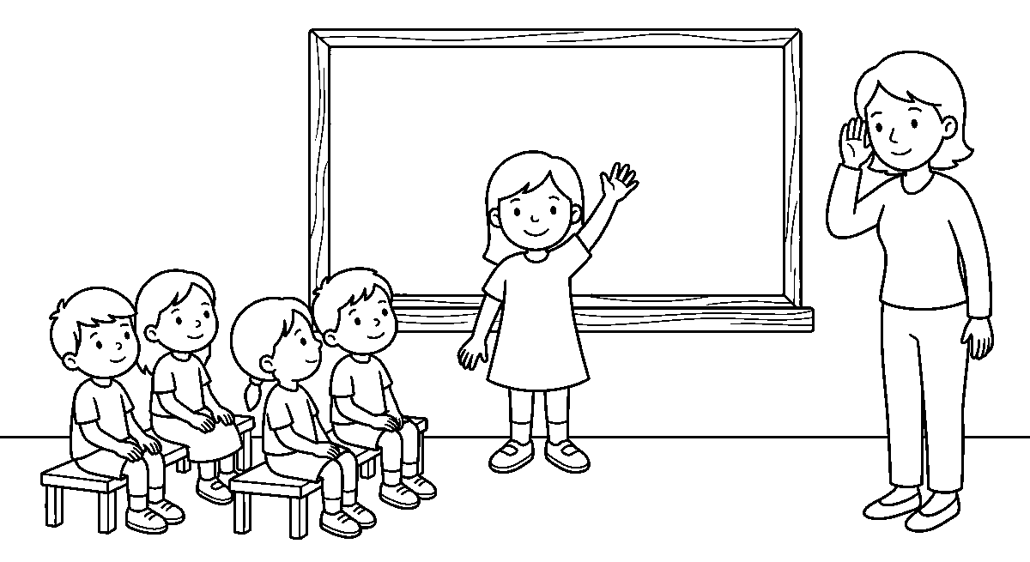
Worksheet
1. A leader is a person who ____ people. A) guides and serves B) frightens C) counts D) follows
2. A traditional leader in our land is a ____ . A) driver B) chief C) seller D) pupil
3. The head of a school is the ____ teacher. A) sports B) junior C) head D) music
4. Which of these is a quality of a good leader? ____ . A) Cheating B) Laziness C) Anger D) Being a good listener
5. Fill in: A good leader is ____ — he never takes what is not his.
6. Mention four kinds of leader in a community.
7. Write two sentences on one thing you lead in your class.
My own work
Draw a class captain standing in front of the class with one hand raised, four children seated on benches in front of her, and a teacher standing at the side, listening.

WEEK 9 — THE BIG WORLD WE ARE ALL IN
Depth: NERDC Nursery 3 · Social and Citizenship Studies · Third Term W9.

You will learn to
• say what we learn about in this subject
• name the tongues and foods of our own land
• say why we learn about other countries
• name two ways we show that we are part of the world
Things to know
• We learn about people, places and how they live — our family, our community, our country and the world.
• Learning about others helps us know ourselves better and stops us laughing at what is different.
• Nigeria has many cultures and many tongues: Yoruba, Igbo, Hausa, Tiv, Kanuri, Efik and about four
hundred more.
• Our foods are many too: amala and efo, garri, tuwo, pounded yam and pepper soup, and each people has
their own.
• A greeting is different as well — "ẹ káàárọ̀", "good morning", "sannu" and "eto" all say respect; say your
own one well.
• Nigeria is one country in a world of many countries, and other children go to school, work at home and
play, just as we do.
• We are all part of the world: the rain that falls here, the air we breathe and the sea are shared with
people far away.
• We value what is like ours and what is not: a friend from another place may eat a different food and
still be a friend.
• Asking a question and then looking for the answer — in a book, from an elder, by watching — is how we learn
the world.
Words for my notebook
We learn about people and places so that we can live well with them. Nigeria has many cultures and many tongues, and it is one country in a world of many countries where children go to school and play as we do.
Let us talk
1. What do we learn about in this subject?
2. Name three tongues spoken in Nigeria.
3. How do you greet an elder in your own tongue?
4. What do children in other countries do, just as you do?
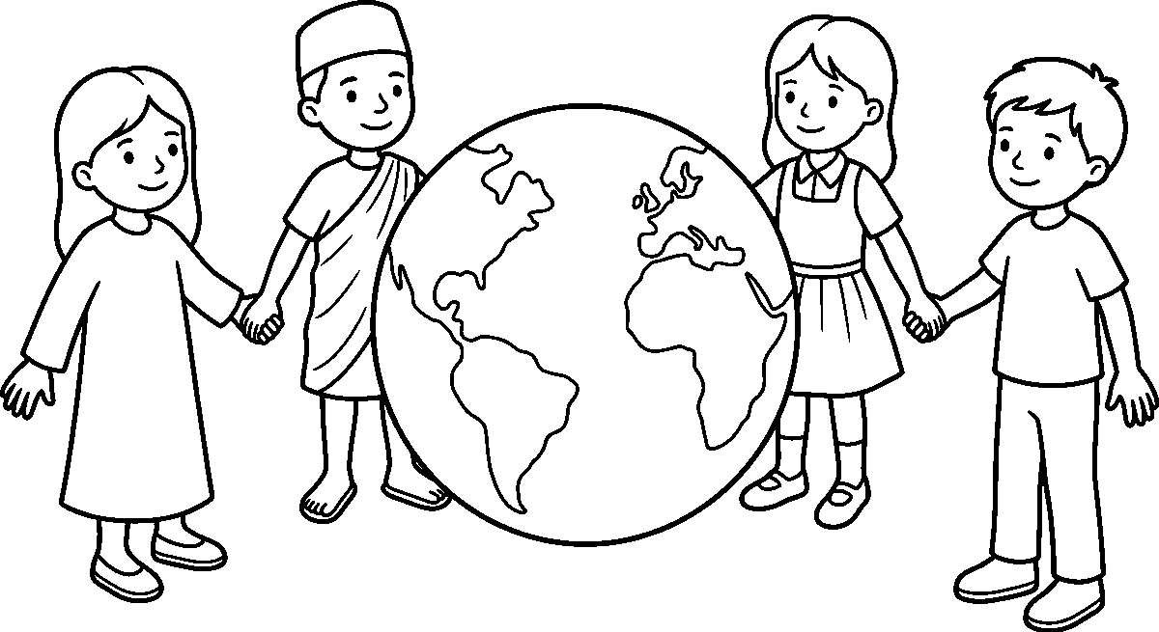
Worksheet
1. In this subject we learn about people, places and ____ . A) how they live B) the price of yam C) the way to count D) birds only
2. Our country has ____ tongues and cultures. A) two B) one C) many D) no
3. Amala and efo, garri and pounded yam are ____ of our people. A) tools B) games C) songs D) foods
4. A child in another country ____ . A) never plays B) goes to school and plays as we do C) has no tongue D) does not eat

5. Fill in: A child from another place may eat a different food and still be my ____ .
6. Mention three things that are different between people of various places.
7. Write two sentences on one thing you want to learn about the world.
My own work
Draw a big round ball of the world with three shapes of land on it and no writing anywhere, then draw four children holding hands around it, each in different clothes; colour the land green and the sea blue.

YORUBA
Weeks 1 to 6, 8, 9 and 11. No note for Week 7 (Mid-Term Break) or Week 10 (Revision);
Week 11 carries a note because the school's own table prints it as a teaching row
("Exam Preparation"), not as an examination week. Week 12 is Closing. Depth: this subject is school-generated — there is no NERDC Yoruba scheme to floor it against. The extent of each week is the three strands the school itself prints (Ẹ̀dẹ̀ · Àṣà · Lítíréṣọ̀). The master corpus prints Yoruba without tone marks; tone marks are added in the body of the note so that the child reads the word correctly, and the topic line is left exactly as the school prints it. Where the school names a song or a poem by its first words only, the note keeps that one line and teaches the form, the answer and the meaning — it does not invent the rest.

WEEK 1 — Ede: Sise nnkan (ase oluko) / Asa: Itesiwaju ikini ni orisirisi akoko / Litireso: Orin ere idaraya
Depth: school-generated — three strands as printed in the master corpus for N2 T3 W1.
You will learn to
• do what you hear in Yoruba and say the action back
• greet at the right time of the day and answer a greeting
• sing a play song, move with it and stop when it stops
Things to know — Ẹ̀dẹ̀ (ṣíe nǹkan — the actions the teacher names)
• A word that tells us to do a thing is a command: ẹ dú! (stand), ẹ jó! (sit down), ẹ rìn! (walk).
• More commands we use in class every day: ẹ ka (read), ẹ kọ́ (write), ẹ wo (look), ẹ gbọ́ (listen), ẹ dáhùn (reply).
• To be polite we put jọ̀wọ́ in the middle: "Ẹ jọ̀wọ́, ẹ dú." — stand, please.
• Saying ẹ before the word is how we speak to a teacher or to many people; má ṣe stops a thing: "Ẹ má ṣe sọ̀rọ̀."
• Each action has its own body: fọ́ — wash, ṣí — open, tì — shut, fi sí — put on, yọ — take off.
• Ẹ wò ó, ẹ sì tún un ka — look at the line on the board and then read it again.
• Game: an action is called out and we do it; when "Dúró!" (stop!) is called, nobody moves.
• We answer in a whole line, not one word: "Mo ń kà á." (I am reading it), "Mo ń kọ́ ọ́." (I am writing it).
• New words go in the notebook with the action drawn small beside each — a hand, a book, a foot.
Things to know — Àṣà (ìtẹ̀síwájú ìkíni — greetings at their times)
• Morning: "Ẹ káàárọ̀." — the answer is "Ẹ ṣe àárọ̀ rere."
• Afternoon: "Ẹ ká ọ̀sán." — the answer is "Ẹ ṣe ọ̀sán rere."
• Evening: "Ẹ káàlẹ́." — the elder answers "Ọ́ àáṣẹ̀."
• To ask how people are: "Báwo ni?" — the answer is "Àà báwo ni." (it is well).
• For a thing done for us we say "Ẹ ṣé."; the answer is "À ń ṣé."
• A boy greets an elder by lying full length (ìdòlẹ̀kọ̀); a girl kneels (ìkúnbálẹ̀); both rise when they are told.
• We greet the first person we meet in the morning, and we greet all of them in turn — nobody is skipped.
• Time changes, the greeting changes; the respect stays the same.
Things to know — Lítíréṣọ̀ (orin eré ìdárayá — the play song)
• A play song is not sung sitting down: it carries the step, the clap and the turn.
• The leader sings a line; the class answers the same line back — that is how a play song is built.
• Our rule this week: while the song goes on we move; when the song stops, we stand still.
• We sing in a ring, and the child in the middle picks the next line.

• The song teaches the ears: a child who can answer the line can answer the teacher too.
Words for my notebook
Ẹ dú · ẹ jó · ẹ ka · ẹ kọ́ · ẹ wo · ẹ gbọ́. Ẹ káàárọ̀ · ẹ ká ọ̀sán · ẹ káàlẹ́ · ọ́ àáṣẹ̀ · báwo ni — àà báwo ni · ẹ ṣé.
Let us talk
1. What do I say when I want the whole class to sit down?
2. Add the polite word to "ẹ dú".
3. Which greeting belongs to the evening, and what does the elder answer?
4. How does a girl greet an elder, and how does a boy greet?
Worksheet
1. "Ẹ jó!" tells the class to ____ . A) stand B) sit down C) read D) wash
2. The polite word we put inside a command is ____ . A) ṣé B) jọ̀wọ́ C) àáṣẹ̀ D) báwo
3. "Ẹ ká ọ̀sán" is the greeting for ____ . A) afternoon B) morning C) night D) Monday
4. When the elder is greeted in the evening, he answers ____ . A) ẹ ṣé B) báwo ni C) ọ́ àáṣẹ̀ D) àà báwo ni
5. Fill in: The answer to "Báwo ni?" is "Àà ____ ni."
6. Say four actions the teacher names in Yoruba, and do them.
7. Sing one line of the play song and answer it back as the class does.
My own work
Write the six actions in your notebook and draw a small hand, book or foot beside each; then colour the one you like best.

WEEK 2 — Ede: Siso oro onileta po (F+K+F) / Asa: Orisirisi eso ile wa / Litireso: Alo apamo ati alo apagbe
Depth: school-generated — three strands as printed in the master corpus for N2 T3 W2.
You will learn to
• say a Yoruba word sound by sound and then say it at once
• name the fruits our land carries and where they come from
• tell an àlọ́ àpamọ́ from an àlọ́ àpàgbé
Things to know — Ẹ̀dẹ̀ (sọ̀rọ̀ onílétà pọ̀ — joining the letters)
• A Yoruba syllable is short and clean: à, kà, rà — one vowel with one consonant, and the tone rides on it.
• The school writes the drill fawẹ̀lì + kọ́nsonantì + fawẹ̀lì: a vowel, a consonant, a vowel — ọ + kọ́ = ọkọ́.
• Say it slowly first, then at once: à (pause) kà (pause) rà (pause) — àkàrà, bread.
• More words we join: bà + tà = bàtà (shoes) · ò + gò + gò = ògò́gò (a pot) · ẹ̀ + kẹ́ = ẹ̀kẹ́ (beads).
• The dots change the word: ọ is not o, ẹ is not e; àkàrà without its dots is not the word.
• Tone is part of the letter: ọkọ́ (husband) and òkọ̀ (hoe) are written with the same shapes and say two things.
• We count the sounds on our fingers: à-kà-rá is three sounds, three fingers up.
• Every day this week, one new word is joined on the board before we read it.
Things to know — Àṣà (oríṣiríṣi ẹsọ́ ilé wa — the fruits of our land)
• ọ̀gẹ̀dẹ̀ — banana · áńbà — mango · ọ̀pẹ̀ — palm fruit · bílíbilí — watermelon · àmùtì — pineapple.
• Ọ̀gẹ̀dẹ̀ and áńbà come from a tree in the compound; ọ̀pẹ̀ comes from the palm and bílíbilí from the ground.
• A fruit is ripe when it gives us its own sign: the banana turns yellow, the mango softens, the watermelon knocks hollow.
• The palm fruit is boiled and pressed and it becomes the red oil our soup is made with.

• When a child picks a fruit from a neighbour's tree, he asks first; a Yoruba home shares what it has and gives the first of the season to an elder.
• Fruits wash before they are eaten, and the peel goes into the bin, not on the path.
Things to know — Lítíréṣọ̀ (àlọ́ àpamọ́ àti àlọ́ àpàgbé)
• An àlọ́ begins with a call and an answer: "Àlọ́ o!" — "Àpamọ́!"
• Àlọ́ àpamọ́ hides a lesson inside it; when it ends, the hearer can say what he learnt.
• Àlọ́ àpàgbé is the light one: it is told to make us laugh and to carry the evening away (gbàgbé is to forget).
• At an àlọ́ we sit, we listen, and we do not finish another person's story with a lie.
• The teller may stop in the middle and ask the children a question; the one who answers goes on with the story.
Words for my notebook
à-kà-rá = àkàrà · bà-tà = bàtà · ò-gò-gò = ògò́gò · ọ-kọ́ = ọkọ́. Ọ̀gẹ̀dẹ̀, áńbà, ọ̀pẹ̀, bílíbilí, àmùtì. Àlọ́ o — Àpamọ́!
Let us talk
1. Join the three sounds of à-kà-rá and say the word.
2. Which two fruits in our list come from a tree?
3. What do we say to answer "Àlọ́ o!"?
4. Tell me one thing an àlọ́ àpamọ́ does that àlọ́ àpàgbé does not.
Worksheet
1. "à-kà-rá" joined together says ____ . A) kàrà B) àkàrà C) ráà D) àrákà
2. The word "bàtà" is made of ____ sounds. A) one B) three C) four D) two
3. "ọ̀pẹ̀" is the ____ fruit. A) mango B) banana C) palm D) watermelon
4. When somebody says "Àlọ́ o!", we answer ____ . A) Àpamọ́! B) Ẹ ṣé! C) Báwo ni! D) Àà ṣé!
5. Fill in: The dots under ẹ and ọ change the ____ of the word.
6. Name five fruits of our land and say where one of them comes from.
7. Say two lines about an àlọ́ you have heard and what it taught.
My own work
Write five joined words, and under each one draw the thing it names; colour the fruit you would like to eat.

WEEK 3 — Ede: Isorongbesi laarin oluko ati akekoo / Asa: Imototo: ara fifo, enu fifo / Litireso: Orin kiko
Depth: school-generated — three strands as printed in the master corpus for N2 T3 W3.
You will learn to
• ask the teacher a question and answer one in a full line
• keep the body and the mouth clean at the two set times
• sing a working song with the leader and the answer
Things to know — Ẹ̀dẹ̀ (íṣọ̀rọ̀ńbẹ̀sí — teacher and pupil talking)
• The pupil opens with respect: "Báwo ni, olùkọ́?" — the teacher: "Ó dára, ọmọ mi."
• To ask for a thing: "Ẹ jọ̀wọ́, fi ìwé sí mi." — to be given: "Ẹ ṣé, olùkọ́."
• When a question is asked and you know, say "Mi ò, mi ò" (me, me) with the hand up, not a shout.
• Answer in a line, not one word: "Kí ni ẹ̀ ní?" — "Mo ní àkọ̀wé àti pencil."
• When you did not hear, say "Ẹ jọ̀wọ́, tún un sọ" (say it again) — that is not rudeness.
• Asking about a thing: "Ṣé èyí jẹ́ ti mi?" (is this mine?) · Answer: "Bẹ́ẹ̀ni" (yes) or "Rárá" (no).
• At the end of the talk both say "À ń ṣé."

• When "Ẹ sí i" (go on) is said, the next child speaks and the class listens to the end.
Things to know — Àṣà (ìmọ́tótó: ara fọ́, ẹnu fọ́)
• The body is washed twice a day — òwúrọ̀ before school and ìṣẹ́ (evening) before rest.
• Hands wash with soap before food and after the toilet; the nails are cut short, not bitten.
• The mouth is washed in the morning and at night; that is when ẹnu fọ́ is done, with the brush or the twig.
• Cloth for school is clean and pressed; a cloth worn yesterday for play is not today's cloth.
• Feet wash and dry before the sandals go on; a wet shoe spoils and the foot itches.
• Food is covered, the compound is swept, and the water in the bucket is for washing, not for drinking.
Things to know — Lítíréṣọ̀ (orin kíkó — the carrying song)
• A carrying song is sung when hands are busy: it keeps the step of the load and the step of the feet together.
• One person leads the line, everybody else carries the answer: "ọ̀wọ́ ọ̀wọ́ — ẹẹ!"
• The song does not hurry the back; it gives the back a rhythm to rest on.
• When the load comes down, the song ends with the last line — it does not just stop.
Words for my notebook
Báwo ni, olùkọ́? — Ó dára, ọmọ mi. Ẹ jọ̀wọ́, tún un sọ. Bẹ́ẹ̀ni · rárá · À ń ṣé. Ara ń fọ́ òwúrọ̀ àti ìṣẹ́; ẹnu ń fọ́ ní méjèèjì.
Let us talk
1. How do you greet your teacher in the morning?
2. What do you say when a word was too fast for you?
3. At what two times is the body washed?
4. Who leads a carrying song, and who answers?
Worksheet
1. "Báwo ni, olùkọ́?" is said by ____ . A) the pupil B) the guard C) a baby D) the cook
2. When we did not hear a word, we say ____ . A) ẹ ṣé B) rárá C) tún un sọ D) mi ò
3. "Bẹ́ẹ̀ni" means ____ . A) maybe B) no C) please D) yes
4. The mouth is washed ____ a day. A) twice B) never C) once in a month D) only on Friday
5. Fill in: Before food and after the toilet, the ____ wash with soap.
6. Say four things a clean child does every day.
7. Sing one line of a carrying song and let the class answer it.
My own work
Draw a cup, a brush and a bar of soap in three boxes on one page, and write one Yoruba word under each box.

WEEK 4 — Ede: Onka 21-40 (aropo ati ayokuro) / Asa: Ojo inu ose (itan ojo kookan) / Litireso: Ewi kika
Depth: school-generated — three strands as printed in the master corpus for N2 T3 W4.
You will learn to
• count from twenty-one to forty in Yoruba
• name the seven days and say the meaning one day carries
• read a poem aloud with the voice up and the pause in
Things to know — Ẹ̀dẹ̀ (oníka 21–40 — àròpọ̀ àti àyọkúrò)
• Twenty is ogún; from there we keep adding with àti: ogún àti ọ̀kan (21), ogún àti èjì (22), ogún àti ẹ̀ta (23).
• Thirty has its own name: ọ̀rúnmọ́lẹ́dógún — and it is ogún àti ẹ́wàá (20 + 10).
• Forty is ogótà; fifty is ọ̀ọ́dúnrún — the two big steps we say without counting up.

• Àròpọ̀ (adding): ogún àti ọ̀kan plus ọ̀kan = ogún àti èjì (21 + 1 = 22).
• Àyọkúrò (taking away): ogún àti ẹ̀ta less ọ̀kan = ogún àti èjì (23 − 1 = 22).
• We count with the fingers and with the pebbles: ten pebbles make one line on the board.
• Say the ladder out loud: 21, 22, 23 … 40; then come back down from 40 to 21 without falling.
• The marks of the number are written small in the notebook: ogún àti ẹ̀rin = 24.
Things to know — Àṣà (ọjọ́ inú ọ̀ṣẹ́ — the story of each day)
• Ọjọ́ Àìkú — Sunday: the day of thanks and rest; "àìkú" is not-dying, so we sing and we visit.
• Ọjọ́ Ayé — Monday: the day the world opens; market, farm and school all begin again.
• Ọjọ́ Ìṣẹ́gun — Tuesday: the day of victory; the work that began on Monday is pushed through.
• Ọjọ́rú — Wednesday: the day in the middle; the week is half gone and we do not drop.
• Ọjọ́bọ̀ — Thursday: the day of the cow and the big market; things are bought for the weekend.
• Ọjọ́ Ẹtì — Friday: the last edge of the working week; Muslims worship on this day.
• Ọjọ́ Àbámẹ́ta — Saturday: the day we meet again — compound swept, hair combed, play allowed.
• Seven days make one ọ̀ṣẹ́; the week has no day we sleep through.
Things to know — Lítíréṣọ̀ (èwì kíkà — reading a poem out)
• A poem is not read like a tale: it has room inside it for the breath.
• One line, one breath; a comma is a stop, a full stop is a rest.
• The voice goes up at a question and down at the end of a line.
• We read the line once slowly, once at the right speed, and once from memory.
• A hard word is not skipped: the class says it alone, then puts it back in the line.
Words for my notebook
Ogún àti ọ̀kan (21) · ogún àti èjì (22) · ogún àti ẹ̀ta (23) · ọ̀rúnmọ́lẹ́dógún (30) · ogótà (40). Ọjọ́ Àìkú, Ayé, Ìṣẹ́gun, Ọjọ́rú, Ọjọ́bọ̀, Ẹtì, Àbámẹ́ta.
Let us talk
1. Say 21, 22 and 23 in Yoruba.
2. Which day is ọ̀rúnmọ́lẹ́dógún built from two numbers?
3. Name the day the market is big and the day of thanks.
4. What do we do with a hard word in a poem?
Worksheet
1. "Ogún àti ẹ̀ta" is the number ____ . A) 23 B) 30 C) 13 D) 32
2. Forty in Yoruba is ____ . A) ọ̀ọ́dúnrún B) ogótà C) ogún D) ẹ́wàá
3. The first day of the week, the day of thanks, is ____ . A) Ọjọ́bọ̀ B) Ọjọ́ Ayé C) Ọjọ́ Àìkú D) Ọjọ́rú
4. Ọjọ́ Àbámẹ́ta is ____ . A) Wednesday B) Friday C) Sunday D) Saturday
5. Fill in: Ogún àti ọ̀kan plus ọ̀kan is ogún àti ____ .
6. Write the seven days of the week in order.
7. Read one line of this week's poem twice: once slowly, once at the right speed.
My own work
Write 21 to 30 in figures and in Yoruba on one folded sheet, then cut the sheet into ten cards and shuffle them for the class to read.

WEEK 5 — Ede: Awon awo olorisirisi / Asa: Iwa rere ati iwa ti ko to / Litireso: Ewi: Ise ni oogun ise
Depth: school-generated — three strands as printed in the master corpus for N2 T3 W5.

You will learn to
• name the colours of things around us in Yoruba
• tell an ìwà rere from an ìwà tí kò dára
• say the poem of work with its meaning
Things to know — Ẹ̀dẹ̀ (àwọ̀ olóríṣiríṣi — the many colours)
• funfun — white · dúdú — black · púpà — red · àwọ̀ ọ̀sàn — orange · àwọ̀ ewé — green · àwọ̀ òfurufú — blue.
• The colour of the leaf is àwọ̀ ewé because it is the colour of ẹwẹ̀; the colour of the sky is àwọ̀ òfurufú.
• àwọ̀ ilẹ̀ is brown, the colour of the road after rain, and àwọ̀ omi is the pale colour of water in a calabash.
• Ask and answer: "Kí ni àwọ̀ bọ́ọ̀lù yìí?" — "Púpà ni." (it is red).
• A uniform has its colour, a cap has its own; we say both words: "àwọ̀ ọ̀sàn àti funfun."
• Things may share a colour and not a name: the milk and the paper are both funfun.
• àwọ̀ wúnì is purple, and fàdákà is the pale shine of a new coin.
• The colour comes after the thing: bọ́ọ̀lù púpà (a red ball), ìwé funfun (a white book).
Things to know — Àṣà (ìwà rere àti ìwà tí kò dára)
• Ìwà rere is good character: ọ̀wọ̀ (respect), ìrẹ̀lẹ̀ (humility), òtítọ́ (truth), ìpín (sharing), kíkó nǹkan ṣe ní títò (doing a thing well).
• Ìwà tí kò dára is the bad kind: èké (a lie), ìjìgbe (taking what is not ours), ìpaniyaníyàn (making a child afraid), àìmọ́tótó (dirtiness) and sísọ̀rọ̀ àyò (tale-bearing).
• An ọmọlúàbí is the child the whole street trusts: he greets, he tells the truth, he leaves a place better than he found it.
• A good act done once is a start; done every day, it becomes ìwà — the character the elders name.
• When we do wrong, we say "Ì jẹ́ mi, ẹ̀ṣẹ́ mi ni" (it is my fault) and put the thing right.
Things to know — Lítíréṣọ̀ (èwì: ìṣẹ́ ni òògùn ìṣẹ́)
• The line the school prints is: "Iṣẹ́ ni òògùn ìẹ́, tí kò bá ṣiṣẹ́, òògùn wo ló ń lò ó?"
• It says: work is the medicine for shame; a child who will not work has no medicine left.
• The first half answers the question, and the second half asks it back — that is how èwì moves.
• We say it with the hand on the chest, once slowly and twice at speed, and then we say what it means.
Words for my notebook
Funfun · dúdú · púpà · àwọ̀ ọ̀sàn · àwọ̀ ewé · àwọ̀ òfurufú · àwọ̀ ilẹ̀. Ìwà rere: ọ̀wọ̀, òtítọ́, ìrẹ̀lẹ̀, ìpín. Iṣẹ́ ni òògùn ìẹ́.
Let us talk
1. What colour is the sky in Yoruba?
2. Name three things of the colour funfun.
3. Which word is the opposite of òtítọ́?
4. What does the poem say is the medicine for shame?
Worksheet
1. The Yoruba for red is ____ . A) funfun B) dúdú C) púpà D) àwọ̀ ewé
2. "àwọ̀ ewé" is the colour of ____ . A) a leaf B) the sky C) milk D) a stone
3. Which of these is ìwà rere? A) èké B) òtítọ́ C) ìjìgbe D) ìpaniyaníyàn
4. "Iṣẹ́ ni òògùn ìẹ́" teaches the value of ____ . A) sleeping B) play C) work D) wealth
5. Fill in: A child the whole street trusts is called ọmọ____ .
6. Name six colours in Yoruba and say the colour of your school bag.
7. Say the poem line and write what it means in one English sentence.

My own work
Colour one leaf green, one ball red, one cup white and one sky blue, and write the Yoruba colour word on each.

WEEK 6 — Ede: Apeko (gbo, ko sile) / Asa: Ojuse ebi: egbon ati aburo / Litireso: Orin iwa (Kini n o fi ole se)
Depth: school-generated — three strands as printed in the master corpus for N2 T3 W6.
You will learn to
• listen once, hear the word, and write it down with its marks
• do the duty of an ẹ̀gbọ́n and the duty of an àbúrò
• answer the character song's question in a full line
Things to know — Ẹ̀dẹ̀ (Apeko: gbọ́, kọ́ sílẹ̀ — hear it, write it)
• Sit straight, hold the pencil, and keep both hands on the book — that is how the ear opens.
• The word is said twice: the first time we hear it, the second time we catch its marks.
• We write the dots and the tones as we hear them: ẹ̀kẹ́, not "eke".
• Nobody looks at a friend's book; a wrong word written is a word we will fix together after.
• When all have written, the class reads the line back and the board is checked.
• Words this week: àkàrà · bàtà · ìwé · ọkọ́ · ògò́gò · ẹ̀kẹ́ — six words, six sounds.
• A wrong word is not rubbed hard: cross it with one clean line and write it again.
• The last thing is reading our own line back; a missing mark is added before the book goes up.
Things to know — Àṣà (ojúṣe ẹbí: ẹ̀gbọ́n àti àbúrò)
• Ẹ̀gbọ́n is the elder sibling; his duty is to lead by the hand, to share what he has, and to be the example.
• An ẹ̀gbọ́n does not raise his hand on a smaller child; he carries the load and calls the younger one to wash.
• Àbúrò is the younger; her duty is to listen, to follow, and to ask before she takes.
• A younger child does not hide an elder's book, and an elder does not eat the younger's share.
• When the parents are away, the ẹ̀gbọ́n keeps the house quiet and the àbúrò keeps the compound clean.
• The two are one hand: one cannot comb the other's hair alone, and both greet the same elder at the same time.
Things to know — Lítíréṣọ̀ (orin ìwà: "Kí ni n ń fi ọ̀lẹ̀ ṣe?")
• The song the school prints is called by its question: "Kí ni n ń fi ọ̀lẹ̀ ṣe?" — what do we do with a thief?
• A character song asks the class something and waits: the answer is the song's other half.
• Our answers this week: we do not beat him, we ask him why, we take the thing back, and we tell a grown-up.
• Sing the question; answer it in a line; the class that answers loudest sings the next question.
Words for my notebook
Ẹ̀gbọ́n ń dá àpẹẹrẹ, ó sì ń pín; àbúrò ń gbọ́, ó sì ń béèrè. Orin ìwà ń béèrè pé: Kí ni n ń fi ọ̀lẹ̀ ṣe?
Let us talk
1. How many times is a dictation word said, and for what?
2. What are two duties of an ẹ̀gbọ́n?
3. What does an àbúrò do before she takes a thing?
4. What does our class answer to the song's question?
Worksheet
1. In a dictation, the word is said ____ . A) twice B) never C) five times D) only once for the whole year

2. The elder sibling is called ____ . A) àbúrò B) ẹ̀gbọ́n C) ọmọ ìyá D) àgbàlagbà
3. Before a younger child takes a thing, she ____ . A) runs B) hides it C) asks D) sells it
4. "Kí ni n ń fi ọ̀lẹ̀ ṣe?" is a question from ____ . A) a market song B) a counting card C) a number line D) a character song
5. Fill in: We write the dots and the ____ as we hear them.
6. Name four duties shared by ẹ̀gbọ́n and àbúrò in one house.
7. Sing the song's question and write the class's answer in one line.
My own work
Write the six dictation words with their marks, then draw two hands holding one basket between them.

WEEK 8 — Ede: Akosoro (ka, pe iro, fa koko yo) / Asa: Oge sise ni ile Yoruba / Litireso: Orin kiko (Ori ewe ma paya)
Depth: school-generated — three strands as printed in the master corpus for N2 T3 W8.
You will learn to
• read a hard line slowly, then say it fast without breaking
• tell the steps of cassava work in a Yoruba home
• sing the carrying song and answer its line
Things to know — Ẹ̀dẹ̀ (akọ̀sọ̀rọ̀: kà, sọ ọ́ yarayara, fa kọ́kọ́ yọ)
• An akọ̀sọ̀rọ̀ is a line that is hard on the mouth; we practise it until the mouth is free.
• Step one: kà á pẹ́lẹ́ — read it slowly, one word at a time, with the eyes on the board.
• Step two: sọ ọ́ yarayara — say it fast three times, and do not bend the tones.
• Fa kọ́kọ́ yọ is to pull out the knot: find the one word that trips you and say only that word ten times.
• Our lines this week: "Ẹyin ẹyẹ kan, ẹyin ẹyẹ méjì." · "Ọ̀wọ́ọ̀n mẹ́ta, ẹran mẹ́ta." · "Àkàrà mẹ́fà, ọ̀gẹ̀dẹ̀ mẹ́rin."
• Nobody laughs at a mouth that is learning; we clap the one who tries again.
• In ẹyin ẹyẹ the first two sounds are alike, and the mouth must not slide them into one.
• A hard name is said by the whole class slowly once before anybody says it fast.
Things to know — Àṣà (ọ̀gẹ̀ ṣíṣe ní ilé Yorùbá — cassava work at home)
• Ọ̀gẹ̀ is cassava, and the work of it is the work of the whole house.
• A ń wa ọ̀gẹ̀ — we dig it out of the ground, and the long root is cut from the stem.
• A bo ọ̀gẹ̀, a fọ́ ọ — it is peeled and washed until the white inside shows.
• A ge é gege — it is grated, put into a bag, and a fún un — pressed, so that the water goes out.
• The wet flour is ṣíṣẹ́ (sieved) and then ìfọ̀ (fried) in a dry pot; that is gari.
• From the same ọ̀gẹ̀ we get ẹ̀kọ́, àmàlà from the dried chips, and ẹ̀bà from gari — nothing of it is thrown away.
• The work needs the big hands of a grown-up at the fire and at the press; a child carries the basin and counts the cups.
Things to know — Lítíréṣọ̀ (orin kíkó: "Ori ewe ma paya")
• The school prints this carrying song by its first line only — Orí ẹwẹ̀, má ṣe payà — so we learn that line and its answer.
• The leader carries the line; the class carries the answer after him, the way a load is shared by two.
• The song keeps the feet: one step to one word, and the load does not shake.
• When we do not know the rest of a song, we do not stop — we sing the line we know twice.

Words for my notebook
Ẹyin ẹyẹ kan, ẹyin ẹyẹ méjì. Ọ̀gẹ̀: a wa á, a bo ó, a fọ́ ọ, a ge é gege, a fún un, a ṣe gari. Orí ẹwẹ̀, má ṣe payà.
Let us talk
1. What are the two speeds of an akọ̀sọ̀rọ̀?
2. Say the cassava work in order, from the ground to the pot.
3. Who leads a carrying song and who answers?
4. What do we do when we do not know the rest of a song?
Worksheet
1. "Fa kọ́kọ́ yọ" means ____ . A) eat the food B) sweep the yard C) pull out the knot D) fetch the water
2. The first thing done to ọ̀gẹ̀ in the house is ____ . A) frying B) peeling and washing C) selling D) drying in rain
3. Gari is made by frying the ____ flour. A) sieved B) burnt C) frozen D) sweetened
4. A carrying song is answered by ____ . A) the dog B) one child alone C) the class after the leader D) the drum only
5. Fill in: Before the pot goes on the fire, the wet flour is pressed so that the ____ goes out.
6. Say five steps of cassava work in order.
7. Say one akọ̀sọ̀rọ̀ line slowly, then fast, and write what was hard for your mouth.
My own work
Draw five small boxes and put one cassava step in each box — dug, peeled, washed, grated, fried — then number the boxes 1 to 5.

WEEK 9 — Ede: Didaruko eya ara / Asa: Oba alade ni ile Yoruba / Litireso: Aroso lori eye
Depth: school-generated — three strands as printed in the master corpus for N2 T3 W9.
You will learn to
• name the parts of the body in Yoruba and point to them
• say who the Oba is and how people greet him
• make a short àròsọ line about a bird
Things to know — Ẹ̀dẹ̀ (dídárúkọ̀ ẹ̀yà ara — the parts of the body)
• orí — head · ojú — eye · etí — ear · imú — nose · ẹnu — mouth · ahọ́n — tongue.
• ọwọ́ — hand · ìka — finger · ẹsẹ̀ — leg · àṣọ̀ ẹsẹ̀ — the shoe · ọ̀rùn — neck · ẹ̀yìn — back · ikùn — stomach.
• The teeth are ehín, the hair is ìrìn, and the ear's inside keeps the sound — eti hears.
• Game: "Ẹ fi ọwọ́ kan ..." (put the hand on ...) — orí, ọ̀rùn, ikùn, ẹsẹ̀ — fast, and nobody looks at a friend.
• Two eyes see, two ears hear, two hands work; one mouth, so we speak less than we hear.
• A body part that hurts is told the same day: "Orí mi ń ṣà àìlẹ̀" (my head pains me).
• ejín is the knee and ìkún ọwọ́ is the elbow; the two of them bend so that we can sit and reach.
• Most of them come in pairs — ojú méjì, etí méjì, ọwọ́ méjì — and one orí, ẹnu kan.
Things to know — Àṣà (Òba aláde ní ilẹ̀ Yorùbá — the crowned king)
• The Òba is the ruler of a Yoruba town, and àdé is the beaded crown he wears.
• The crown's beads hang before his face, so that the king is seen by all and looks on all with patience.
• Under the Òba are his chiefs, and over a village is the Baale.
• Great titles among the Yoruba: Ọọni (Ìlé-Ifẹ̀), Aláàfin (Ọ̀yọ́), Àwújàlẹ̀ (Ìjẹ̀bú), Olúbadan (Ìbàdàn).
• A man greets the Òba by lying down (ìdòlẹ̀kọ̀), a woman by kneeling (ìkúnbálẹ̀); the words are "Kábíyèsí o."
• The Òba does not run a market or settle a small quarrel; he keeps the town together and is the father of it.

• A child's part is small: when the procession passes, we stand, we do not shout, and we follow with the eyes.
Things to know — Lítíréṣọ̀ (àròsọ lórí ẹyẹ — a riddle line on a bird)
• An àròsọ is a short line said fast, with a thing hidden in it; the class guesses.
• It begins with a call — "Àròsọ o!" — and the answer is "Jẹ́ kó o!" (let it come).
• Our line about a bird goes by what the bird does, not by its name: "Ẹyẹ tí ń fò, tí kò ṣẹ̀ṣẹ̀ wọ ilẹ̀ — ẹnu ńlá, ẹsẹ̀ kékeré."
• Then we say what the riddle means, and the class makes up a line of its own about a bird they know.
Words for my notebook
Orí · ojú · etí · imú · ẹnu · ahọ́n · ọwọ́ · ìka · ẹsẹ̀ · ọ̀rùn · ẹ̀yìn · ikùn. Òba ń ṣàdé; a ń kí i: Kábíyèsí o.
Let us talk
1. Point to three parts of the body and say them in Yoruba.
2. What is the crown of the Òba called, and what hangs before his face?
3. How does a woman greet the Òba?
4. What do we say to answer "Àròsọ o!"?
Worksheet
1. "Ahọ́n" is the ____ . A) ear B) nose C) tongue D) neck
2. The beaded crown of the Òba is the ____ . A) àdé B) ìka C) ẹ̀kẹ́ D) asọ̀
3. The head of a village, under the Òba, is the ____ . A) Ọọni B) Olówọ́ C) Aláàfin D) Baale
4. "Ẹ fi ọwọ́ kan ẹsẹ̀" tells you to touch the ____ . A) foot B) back C) head D) hand
5. Fill in: The riddle call "Àròsọ o!" is answered "Jẹ́ kó o!" — a short line with a thing ____ in it.
6. Name eight parts of the body in Yoruba.
7. Make one àròsọ line about a bird and write what it means.
My own work
Draw a boy from the top of the head to the feet, and write the Yoruba name beside the head, the hand, the foot and the mouth.

WEEK 11 — Exam Preparation
Depth: school-generated revision row; it revises Weeks 1–9 of this term. Week 12 is Closing.
You will learn to
• say everything of this term out loud without looking at the book
• write the Yoruba words with their dots and their tones
• answer in a full Yoruba line, not one word
What to revise — Ẹ̀dẹ̀
• the actions: dú, jó, rìn, ka, kọ́, wo, gbọ́, dáhùn, fọ́, ṣí, tì — and the polite jọ̀wọ́
• joining the letters: à-kà-rá = àkàrà, ọ-kọ́ = ọkọ́, and why the dots and tones matter
• the teacher-and-pupil lines: Báwo ni? · Àà báwo ni · Tún un sọ · Bẹ́ẹ̀ni · Rárá · À ń ṣé
• counting ogún àti ọ̀kan (21) to ogótà (40), àròpọ̀ and àyọkúrò in the same ladder
• àwọ̀: funfun, dúdú, púpà, àwọ̀ ọ̀sàn, àwọ̀ ewé, àwọ̀ òfurufú, àwọ̀ ilẹ̀
• dictation: sit, hear it twice, write the marks, read it back
• ẹ̀yà ara: orí, ojú, etí, imú, ẹnu, ahọ́n, ọwọ́, ìka, ẹsẹ̀, ọ̀rùn, ẹ̀yìn, ikùn
• the six dictation words — àkàrà · bàtà · ìwé · ọkọ́ · ògò́gò · ẹ̀kẹ́ — written with their marks
What to revise — Àṣà
• the greetings and their times: káàárọ̀ · ká ọ̀sán · káàlẹ́ · ọ́ àáṣẹ̀, and ìdòlẹ̀kọ̀ / ìkúnbálẹ̀

• the fruits of the land and where each one comes from
• ìmọ́tótó at the two times of day, and the hands before food
• the seven days of the week and the meaning of four of them
• ìwà rere and ìwà tí kò dára, and the word ọmọlúàbí
• the duties of ẹ̀gbọ́n and àbúrò; the steps of ọ̀gẹ̀ ṣíe; who the Òba aláde is
What to revise — Lítíréṣọ̀
• the play song's rule: we move while it goes, we stand when it stops
• àlọ́ àpamọ́ and àlọ́ àpàgbé, and the call "Àlọ́ o! — Àpamọ́!"
• the carrying song, the leader and the answer; Orí ẹwẹ̀, má ṣe payà
• the poem Iṣẹ́ ni òògùn ìẹ́ — its two halves and what it says about work
• orin ìwà and its question: Kí ni n ń fi ọ̀lẹ̀ ṣe?
• akọ̀sọ̀rọ̀ at two speeds, and how to begin an àròsọ line
Words for my notebook
Mo mọ àwọn ìṣe, ìkíni, oníka 21–40, àwọ̀, ẹ̀yà ara, ìwà rere àti àlọ́. Mo lè kọ ọ́, mo sì lè sọ ọ́ ní ọ̀rọ̀ tí ó kún.
Let us talk
1. Say the eleven actions of the term and do three of them.
2. Count from 21 to 40, then back to 21.
3. Greet me at the three times of the day and answer yourself.
4. Say the poem line, then say what it means in one sentence.
Worksheet
1. "Ẹ tì ìlèkùn" tells you to ____ the door. A) shut B) open C) wash D) knock
2. The number 30 in Yoruba is ____ . A) ogótà B) ogún C) ọ̀rúnmọ́lẹ́dógún D) ọ̀ọ́dúnrún
3. The colour of the sky is ____ . A) àwọ̀ ewé B) púpà C) funfun D) àwọ̀ òfurufú
4. A king of Ọ̀yọ́ is called ____ . A) Olúbadan B) Aláàfin C) Baale D) Àwújàlẹ̀
5. Fill in: The answer to "Àlọ́ o!" is "____!"
6. Write five fruits, six colours and four parts of the body in Yoruba.
7. Say two lines you will not forget in the examination and write what each one teaches.
My own work
Fold a sheet into six boxes. Write one thing of this term in each box — the actions, the numbers 21–40, the colours, the days, the body parts and one song line. Read the box you know best to the class.

MATHEMATICS & ENGLISH
Weeks 1 to 6, 8 and 9. Week 7 is Mid-Term Break, Week 10 Revision, Week 11 Examination, Week 12 Closing — those weeks carry no note.
Stream: LITERACY — LANGUAGE DOMAIN.
Depth: NERDC 2025 · Nursery 3 · Literacy (Language Domain) · Third Term — the sound patterns reviewed, naming words, doing words, the two put together, longer sentences, reading on our own, writing a story of ours and then the whole of it in one page, from the pack's off-by-one mapping.
Weeks 1 to 6, 8 and 9. Week 7 is Mid-Term Break, Week 10 Revision, Week 11 Examination, Week 12 Closing — those weeks carry no note.
Stream: LITERACY — LETTER WORK.
Depth: NERDC 2025 · Nursery 3 · Literacy (Letter Work) · Third Term — sight words and sentences, five- letter words, compound words, story reading, describing words, action words, writing our own story and the marks that end a sentence, from the pack's off-by-one mapping.
Weeks 1 to 6, 8 and 9. Week 7 is Mid-Term Break, Week 10 Revision, Week 11 Examination, Week 12 Closing — those weeks carry no note.
Stream: NUMERACY.
Depth: NERDC 2025 · Nursery 3 · Numeracy · Third Term — halves and quarters, length, weight, time, three-dimensional shapes, two-dimensional shapes and patterns, and the first look at collecting things we count, from the pack's off-by-one and off-by-two mapping.
LITERACY — LANGUAGE DOMAIN

WEEK 1 — THE PATTERNS WE ALREADY KNOW: BLENDS, DIGRAPHS, THREE-LETTER SOUNDS
Depth: NERDC Nursery 3 · Literacy (Language Domain) · Third Term W1.
You will learn to
• say a word that begins with two consonants run together
• read words where two letters make one sound
• read words with three letters held to one sound
• use the three new sight words in a line of our own
Things to know
• A blend is two consonants that keep their own sounds and still run together: blue, flag,
clap, green, plant, trip, skip, stamp, snail, swim.
• A digraph is two letters that make one sound between them: shop, chair, three,
when, phone, and the ck at the end of clock and duck.
• A trigraph is three letters held to one sound: the tch in catch and match, the air in hair and
chair, the are in share and square, the ure in pure.
• Say them slowly and then at once: sh… irt — shirt; c… l… o… c… k — clock;
h… air — hair.
• Our three sight words for this week are shirt, clock and hair; each one hides a pattern we
know — the sh in shirt, the cl and ck in clock, the air in hair.
• Read the lines with your finger on them: "The child in the red shirt looks at the clock." —
"She has long hair and a new brush."
• Fluency is the same words read again, only smoother: once with the finger, once with the eyes.
• Word hunt in the class: a thing with sh, a thing with ck, a thing with air — say it and put it in
the box on the board.
• Do not guess a word from its first letter; sound the whole of it and then say it.

Words for my notebook
A blend keeps both sounds: fl, gr, st, sn. A digraph is two letters, one sound: sh, ch, th, wh, ph, ck. A trigraph is three letters, one sound: tch, air, are, ure. Our words this week: shirt, clock, hair.
Let us talk
1. Which sound do the two letters at the end of "clock" make?
2. Name a thing in this room that begins with a blend.
3. Say the three-letter sound in "hair" and find it in one more word.
4. Read the line about the red shirt, once slow and once smooth.
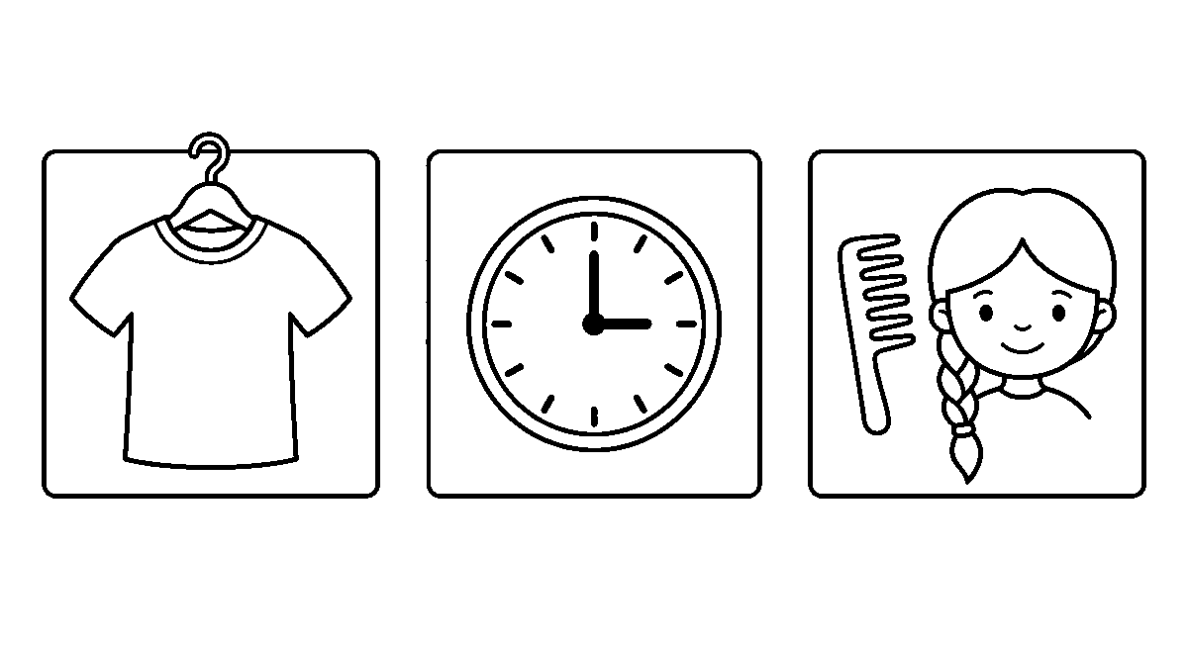
Worksheet
1. Two consonants that keep their own sounds and run together are called a ____ . A) digraph B) sight word C) blend D) full stop
2. The letters sh in "shirt" make ____ . A) one sound B) two sounds apart C) no sound D) a long line
3. The three-letter sound in "catch" is ____ . A) cat B) tch C) atc D) ach
4. Which word has the air sound in it? ____ . A) clock B) shirt C) dress D) chair
5. Fill in: In "clock" the two letters at the end are the digraph ____.
6. Say six words that begin with a blend of two consonants.
7. Read the two lines about the shirt and the clock out loud, then write one line of your own with either word.
My own work
Draw a shirt on a hanger, a clock with twelve marks and no numbers, and a comb beside a girl's long hair — one thing in each of three boxes.

WEEK 2 — NAMING WORDS: THE WORDS THAT CALL THINGS BY NAME
Depth: NERDC Nursery 3 · Literacy (Language Domain) · Third Term W2.
You will learn to
• tell a naming word (a noun) from a word that is not one
• name people, places, things and animals as nouns
• put a big letter on a proper name
• say one thing for many, and more than one thing
Things to know
• A noun is a naming word — it is the word we call a person, a place, a thing or an animal by.
• People: boy, girl, teacher, man, woman. Places: school, home, park, shop. Things: **book, pen,
car, chair. Animals: dog, cat, bird, fish**.
• A proper noun is the name of one single person or place — Ada, Tunde, Lagos,
Friday — and it always begins with a big letter.
• Test a word by putting "the" before it: the book, the dog, the school work; "the run" does
not, because run is not a naming word.
• One singular noun is one thing; more than one is plural, and we usually add s: cat / cats,

book / books, pen / pens.
• Some plurals change a little and we do not add s to them: one child, two children; one foot, two
feet; one tooth, three teeth.
• Our three sight words are old, young and should; old and young are each other's opposite, and we
put them before a naming word: an old man, a young boy.
• Should tells us a thing is right to do: "You should greet your teacher."
• Sort a page of words into two hoops: naming words in one, all the others in the other.
Words for my notebook
A noun names a person, a place, a thing or an animal. A name like Ada or Lagos is a proper noun and begins with a big letter. One cat, two cats; one child, two children. Old and young are opposites, and should tells us what is right.
Let us talk
1. Name four things in this room and say what kind of noun each one is.
2. Which words in this list are proper nouns: friday, Lagos, book, Ada?
3. Say the plural of child, and of foot.
4. Make a line with "old" and one with "young" before a naming word.
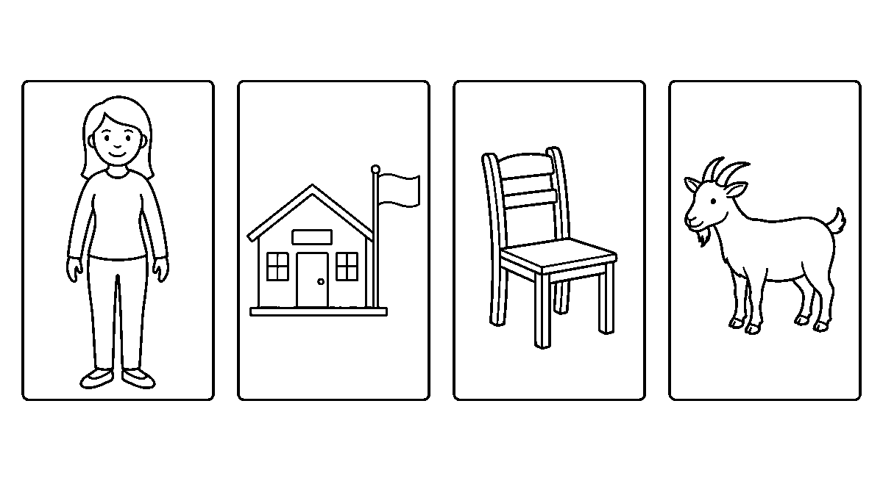
Worksheet
1. A noun is a word that ____ . A) names a thing B) tells a size C) ends a line D) shows time
2. Which of these is a proper noun? A) school B) river C) Bola D) chair
3. "One child, two ____" . A) childs B) children C) childes D) childrens
4. The opposite of "an old man" is ____ . A) a young boy B) a tall tree C) a big house D) a new book
5. Fill in: A naming word that begins with a big letter is called a ____ noun.
6. Sort these into people, places, things and animals: teacher, park, pen, goat, woman, shop.
7. Write two lines, one with the word "should" and one with the word "young".
My own work
Draw four boxes and put in them one person, one place, one thing and one animal, then write the naming word under each box.

WEEK 3 — DOING WORDS: THE WORDS THAT MOVE THE LINE
Depth: NERDC Nursery 3 · Literacy (Language Domain) · Third Term W3.
You will learn to
• find the doing word (the verb) in a line
• show a doing word with the body
• say the doing word again when one person is spoken of
• ask with "What" and answer in a whole line

Things to know
• A verb is a doing word: it tells what somebody or something does — **run, jump, walk, sit, eat,
drink, sleep, play, read, write, sing, dance**.
• More we add today: swim, fly, hop, skip, catch, throw, kick, clap.
• Find it by asking what is happening: in "The baby sleeps", the doing word is sleeps.
• Say the word and do it: the class becomes the picture of the word, and the body remembers what the ear
heard.
• When we speak of one person — he, she, Ada, the dog — the doing word usually takes an s: I run, but
she runs; they play, but he plays.
• What is our asking word: "What do you do at play?" — and we answer in a line, not one word:
"I jump and I clap."
• Upon is the old-time word for on: "the book is upon the table" says the same thing.
• Little tells a size before the naming word: a little cat, a little bird.
• Write three lines about your own day, each carrying one doing word.
Words for my notebook
A verb is a doing word: run, jump, eat, sing, read, write, hop, skip, catch, clap. We say "I run" but "she runs". What is the asking word, little tells a small size, and upon means on.
Let us talk
1. What is the doing word in "The dog barks"?
2. Show us "hop" and "skip" with your body — are they the same?
3. Why does "run" become "runs" when we say "she"?
4. Ask the class a line that begins with "What" and let one child answer fully.
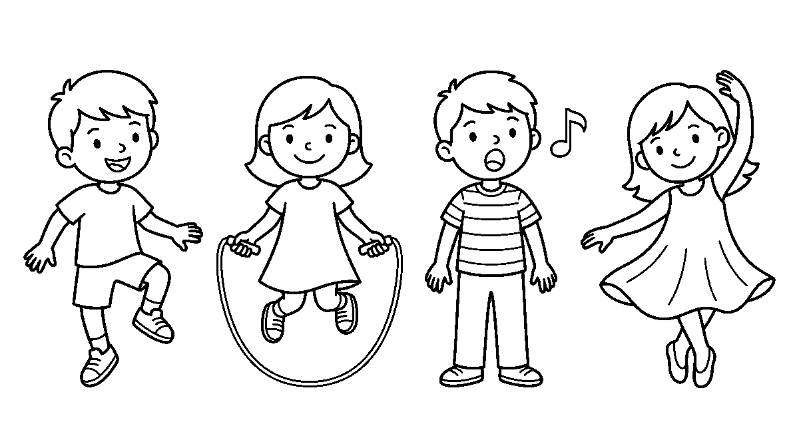
Worksheet
1. A verb tells us what somebody ____ . A) does B) owns C) looks like D) is called
2. Which of these is a doing word? A) green B) table C) clap D) small
3. We say "I sing" but "she ____" . A) sings B) sing C) singing D) singed
4. "Upon" means much the same as ____ . A) under B) upon the old C) on D) off
5. Fill in: The asking word that begins "____ do you do?" is What.
6. Name eight doing words you can show with your body.
7. Write three lines about today, each with one doing word in it.
My own work
Draw four children in four boxes doing four different things, then write the doing word for each under its box.

WEEK 4 — A NAMING WORD AND A DOING WORD MAKE A SENTENCE
Depth: NERDC Nursery 3 · Literacy (Language Domain) · Third Term W4.

You will learn to
• say the two parts every sentence must have
• put the right doing word with the right naming word
• tell who the line is about and what it does
• build a line that carries three kinds of word at once
Things to know
• A sentence needs two things: who or what it is about (the naming word) and what happens
(the doing word).
• The dog runs. — the dog is who, runs is what. The girl jumps. — same shape.
• A line with only one of the two is not finished: "The happy child" is not a sentence, but "The happy child
laughs" is.
• Pairing matters: a bird flies, a fish swims, a teacher teaches, a farmer farms, a
driver drives.
• Find the two parts in any line: ask who? then ask what did they do?
• Our three sight words are yellow, there and your: yellow is a colour word, there shows a place,
your tells that a thing belongs to somebody.
• Put all the kinds together: "Your yellow bird flies." — that line has your, yellow, bird and flies.
• Do not mix there with their: there shows a place, their says a thing belongs to somebody.
• Read your built sentence aloud and count the words on your fingers; a sentence may be two words:
"Dogs run."
Words for my notebook
Every sentence has a naming word and a doing word: the dog runs, the girl jumps. A bird flies, a fish swims, a teacher teaches. Our words: yellow is a colour, there is a place, your means it belongs to you.
Let us talk
1. What two parts must a line have before it is a sentence?
2. Say the doing word that belongs to a bird, and the one that belongs to a teacher.
3. Read "Your yellow bird flies" and point out the colour word and the naming word.
4. Make a two-word sentence and then make it longer.
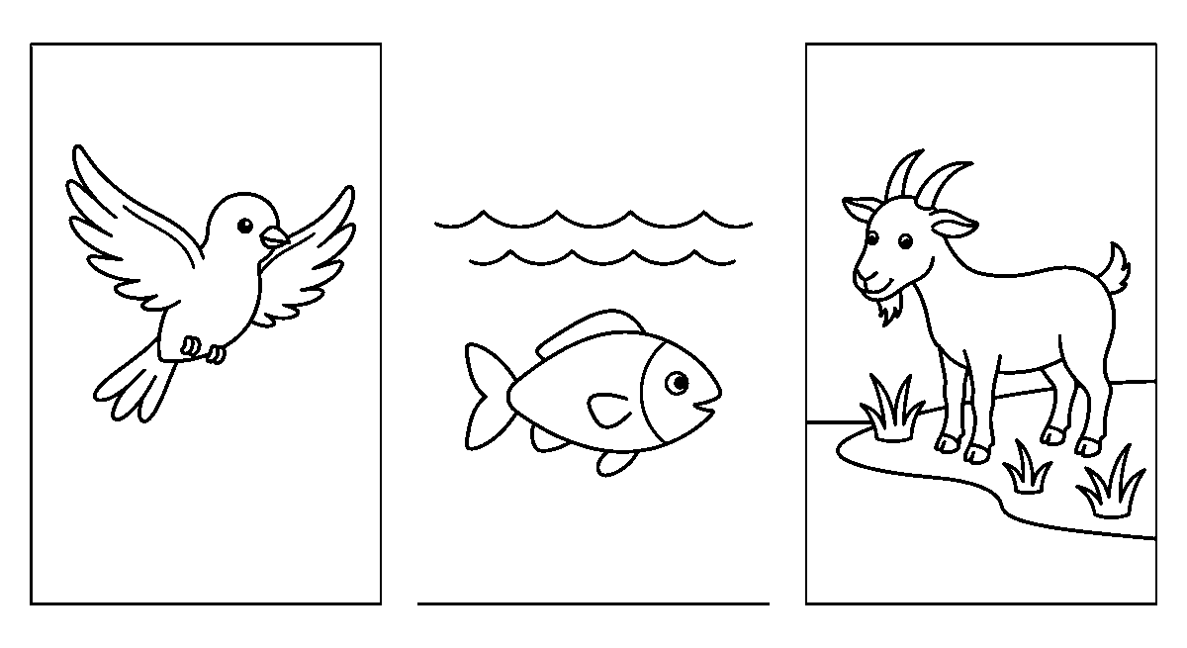
Worksheet
1. A sentence must have a naming word and a ____ word. A) doing B) colour C) long D) plural
2. Which doing word goes with "bird"? A) swims B) flies C) teaches D) drives
3. "____ yellow sun hat" — the word that shows it belongs to you is ____ . A) There B) Your C) They D) Then
4. Which of these is NOT yet a sentence? A) Dogs run. B) The happy child. C) The girl jumps. D) Fish swim.

5. Fill in: "There" is a word about a ____, not about who owns a thing.
6. Match five naming words to the doing word that suits them.
7. Write one line that carries a colour word, a naming word and a doing word.
My own work
Draw a bird in the air, a fish in water and a goat on the bank, and let one line of words go under each picture.

WEEK 5 — LONGER LINES: WHO DOES WHAT, AND WHY
Depth: NERDC Nursery 3 · Literacy (Language Domain) · Third Term W7.
You will learn to
• build the line who-does-what-to-whom
• add a describing word and a second thing to a line
• join two small lines with "and" and give a reason with "because"
• let a small word stand in for people already named
Things to know
• Grow the sentence to naming + doing + naming: The boy kicks the ball — who, does what, to what.
• Add one describing word and the line gets a picture in it: The big boy kicks the red ball.
• Two lines can be joined with and: I run and I jump. — each half could stand alone.
• Because carries the reason: I sleep because I am tired; She smiles because she won.
• Ask and answer about the line: "What does the cat do?" — "The cat sleeps."
• Them is the small word we use instead of the people we already named: "I see the boys" becomes
"I see them."
• Our three sight words are because, them and put; put is a doing word: **"Put the book on the
shelf."**
• Word order is not free in English: The dog bites the man and The man bites the dog are both correct
lines with different meanings, and only one of them is true.
• Check your line with the marks we learnt: big letter first, room between the words, full stop at the end, a
question mark if it asks.
• A long line is only two short lines that learned to hold hands; say the short one first, then add to it.
Words for my notebook
A line can grow: the boy kicks the ball; the big boy kicks the red ball. And joins two lines, because gives the reason, and them stands in for people we already named. Put is a doing word.
Let us talk
1. Make the line "The girl eats" into one with three parts.
2. Which word carries a reason — and or because?
3. Change "I see the goats" so that one small word stands for the goats.
4. Say one line about yourself with "because" in it.

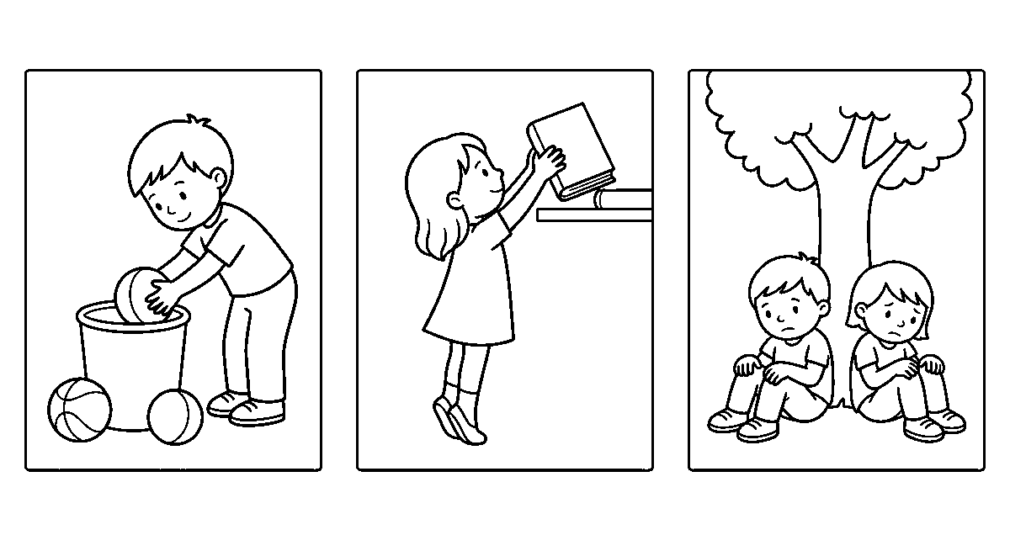
Worksheet
1. "The boy kicks the ball" has a naming word, a doing word and ____ . A) another naming word B) no other word C) only a colour D) a plural mark
2. The word that brings a reason is ____ . A) and B) because C) there D) them
3. "I see the boys" can be said as "I see ____" . A) there B) put C) them D) they're
4. Which line is joined with "and"? A) I run and I jump. B) I run fast. C) Why do I run? D) I run now.
5. Fill in: "____ the cup on the table" — the doing word we need is Put.
6. Grow this line twice: "The dog barks." — add a describing word, then add a second thing.
7. Write two lines about your evening, one with "because" in it.
My own work
Draw three small scenes — a boy putting balls in a basket, a girl putting a book on a shelf, two children sitting because they are tired — and write one line under each.

WEEK 6 — READING ON OUR OWN, AND SAYING WHAT WE HEARD
Depth: NERDC Nursery 2 · Literacy (Language Domain) · Third Term W8.
You will learn to
• read a page that carries the patterns we learnt
• answer the five questions a reader is asked
• find the naming words and the doing words inside a story
• say what will happen next before the page is turned
Things to know
• Our page for this week: **"Sam has a small boat. He puts the boat in the water. The wind blows and the boat
goes fast. Ada claps her hands and runs to the shore."**
• Five questions open a story: Who? (Sam and Ada) What? (a boat on the water) Where?
(at the shore) When? (a windy day) Why? (the wind blew).
• Read with the eyes, not the finger, and stop at the full stop so the listener can breathe.
• The main character is the person the page is mostly about; the events are the things that happen in
order.
• Pick out the naming words in the first line, then the doing words; a page is built from nothing else.
• The sight words we learnt sit in every page: has, in, and, to, he, she, there, what, should — find
them before you sound them.
• Guess ahead: cover the last line and say what you think Ada will do; a reader who predicts is a reader who
is thinking.
• Tie it to yourself: "When the wind blew my boat away, I ran after it."

• Retell the page in your own words afterwards — your line may be shorter than the book's, and that is right.
• Long pages get easier the way a long walk does: a little further each day, read a page more than yesterday.
Words for my notebook
We ask who, what, where, when and why about any page. The main character is who the page is mostly about, and the events are what happens in order. I can guess the next line before I read it.
Let us talk
1. Who is our page mostly about, and what does he have?
2. Where does the story happen, and when?
3. Find two doing words in the second line.
4. What do you think happens after the last line?
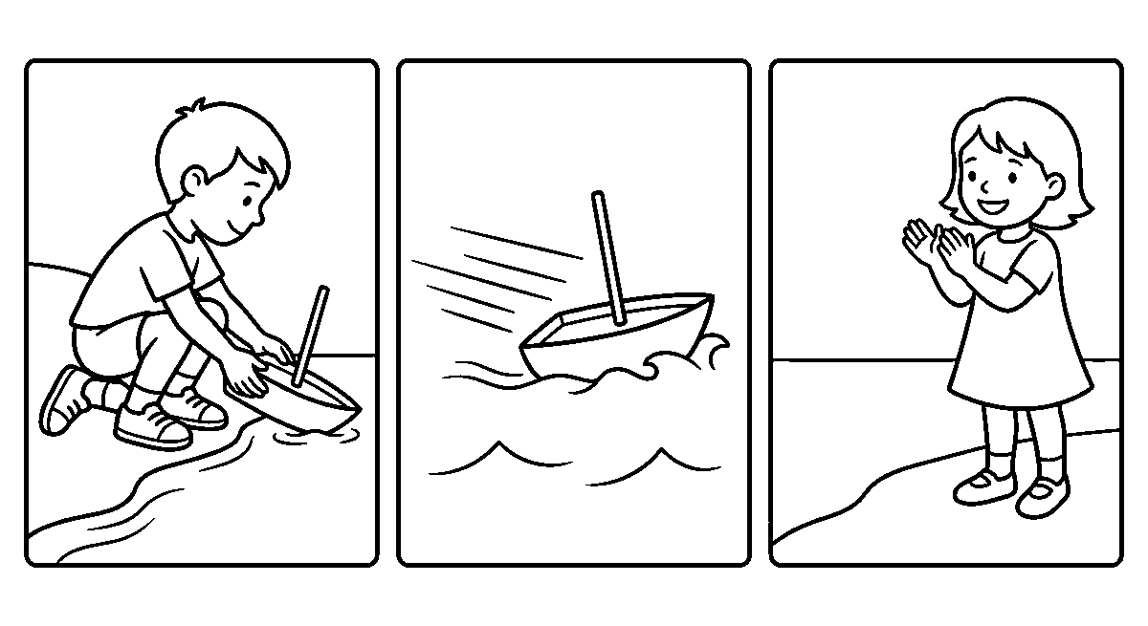
Worksheet
1. The person a story is mostly about is its ____ character. A) main B) small C) last D) quiet
2. Which question asks for the reason? A) Who? B) When? C) Why? D) Where?
3. In "The wind blows", the doing word is ____ . A) wind B) blows C) the D) air
4. Before we turn the page we can ____ what will happen. A) guess B) forget C) erase D) count
5. Fill in: The things that happen in a story, in order, are its ____.
6. Read the page about the boat twice — once slowly, once smooth — and say which time was better.
7. Write two lines about a time the wind took something from you.
My own work
Draw our boat page in three boxes — the boat in the water, the wind blowing it fast, Ada clapping at the shore — and write one line under each box.

WEEK 8 — WRITING A STORY OF OUR OWN, AND THE WORDS THAT START ONE
Depth: NERDC Nursery 3 · Literacy (Language Domain) · Third Term W9.
You will learn to
• begin a story with the words that open a tale
• write a beginning, a middle and an end of our own
• keep "there" and "their" apart
• read what we wrote to the class
Things to know
• Stories often open with the old door-word: "Once upon a time…" and once is our sight word for that.
• Three lines make a story: what was the start, what happened, how it ended.
• Want is a doing word for a wish in the heart: "They want their toys." — that line has both want and
their in it.
• Their tells that things belong to people: their toys, their books; it is the family of "they".
• There shows a place: the ball is there. The two sound the same and are not the same word.

• Put a describing word in the middle line and the listener sees the picture: the small dog,
the long road.
• Write about your own life too, and it is already a story: "What I did", "My family",
"My favourite toy".
• Do not stop at the first line: a story may be wrong in its letters and still be yours; we fix marks after,
not while.
• If a word will not come, draw it in the box above and ask for its letters when you finish.
• Read your story out with your finger under each word; the class may ask you one question about it.
Words for my notebook
Once begins a tale. Want is a wish word, and their means things belong to people — there is about a place and sounds the same. My story has a beginning, a middle and an end.
Let us talk
1. What word often opens a story?
2. Say a line with "want" and "their" in it.
3. Which one is about a place — there or their?
4. What will you write about: your day, your family, or your favourite toy?
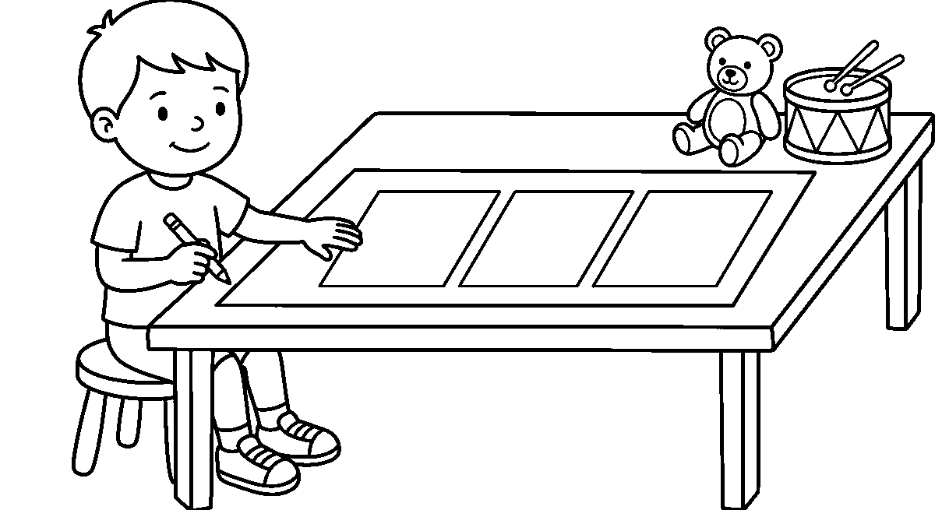
Worksheet
1. "____ upon a time" begins a story with which word? A) Once B) One C) Only D) Over
2. "They ____ their shoes" — the wish word is ____ . A) there B) want C) their D) when
3. The words that mean things belong to the people spoken of are ____ . A) there B) they C) their D) then
4. "The ball is there" — there tells us ____ . A) a place B) a colour C) a number D) a reason
5. Fill in: "there" and "their" sound the same but do not mean the same ____ .
6. Write the three lines of your story, each with one naming word and one doing word.
7. Add one describing word to your middle line and read it to the class.
My own work
Draw three empty boxes for the beginning, the middle and the end of your own story, then write one line under each box.

WEEK 9 — THE WHOLE OF IT ON ONE PAGE
Depth: NERDC Nursery 3 · Literacy (Language Domain) · Third Term W10.
You will learn to
• read a page that mixes every pattern we learnt
• say what kind of word each word in a line is
• write a clean page with the marks in their places
• look back over your own work and mend what is wrong

Things to know
• Our last page carries all of it at once: **"Kemi finds a little black cat under a bench. She takes it home
and gives it milk. The cat drinks, jumps up and sleeps upon her bed."**
• Sounds hidden in it: the bl and ck of black, the nd of and, the sh in she, the tch in
bench, the air we met in hair.
• Name the kinds of word: Kemi, cat, bench, home, milk, bed are naming words; **finds, takes, gives,
drinks, jumps, sleeps are doing words; little, black** describe.
• Marks to check on every line of yours: big letter first and on every name, room between words, full stop at
the end, question mark if it asks.
• Proofreading is reading your own work slowly with your finger, looking for the four things above and
nothing else.
• The sight words we took all term are here too: **upon, little, what, there, their, should, old, young,
because, them, put, once, want, your, yellow, shirt, clock, hair**.
• Reading on and on without stopping is a muscle, not a trick: a page more each day, and the arm does not tire.
• When a word will not come, say its sounds, count them on your fingers, and write one letter for each.
• Read your page to a friend and let them ask you who, what, where, when and why about it.
• What you can do on the last day of this term — read a page, name the kinds of word, write three clean lines —
is what the next class will build on.
Words for my notebook
On one page I can find the naming words, the doing words and the describing words, and the sounds we learnt. I check my own lines for a big letter, room between words and the right mark at the end. That is what I take to Primary 1.
Let us talk
1. Read Kemi's page once with your finger and once with your eyes.
2. Name three doing words and two describing words in it.
3. Which four things do you look for when you proofread your own line?
4. What will you still want to be better at when you are in Primary 1?
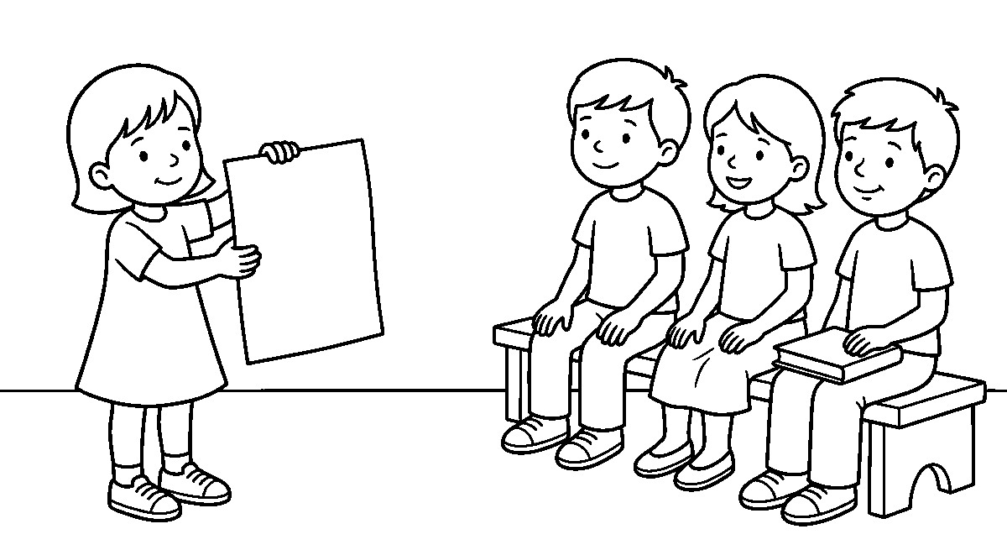
Worksheet
1. In "the small black cat", the describing words are ____ . A) small and black B) the and cat C) cat only D) the only
2. Which word in Kemi's page is a doing word? A) bench B) drinks C) milk D) bed
3. The tch in "bench" is a sound made of ____ letters. A) two B) four C) three D) one
4. Proofreading your own line means reading it ____ . A) slowly with your finger B) aloud to nobody C) very fast D) with your eyes shut
5. Fill in: Every name of a person or a place begins with a ____ letter.

6. Write three clean lines about Kemi and the cat, with the marks we learnt.
7. Say two things you can do now that you could not do in the first term.
My own work
Write three lines about the little cat on your own page, then draw one thing from your story beside it and read both to the class.
LITERACY — LETTER WORK

WEEK 1 — THE WORDS WE KNOW AND THE SENTENCES WE BUILD
Depth: NERDC Nursery 3 · Literacy · Third Term W1.
You will learn to
• read the sight words we learnt, without stopping
• put words in a line and read the whole sentence out
• begin a sentence big, leave room between words, and end with a full stop
• match a sentence to the picture it tells about
Things to know
• A sight word is a word we know at once, the way we know a face: **I, a, the, is, am, and, it, in, at,
on, he, she, we, me, my, to, go, no, up, can**.
• More we add this term: see, look, here, there, come, have, like, play, run, jump.
• A sentence gives a whole talk: "I can see the dog." — five words, one full stop.
• Three things make a sentence neat: a big letter first, a space between every word, a full stop
at the end.
• The word the is the one we meet most; say it without spelling it out.
• Read with your finger along the line, and do not jump to the next line before this one is finished.
• A picture and a sentence are friends: for a boy with a ball, we may write "He can play."
• The same words can make different sentences: "She is here." and "Here is she." — the first one is the
way we say it.
• When we write, we sit well, hold the pencil lightly, and keep the line under the words.
Words for my notebook
The sight words of this term: I, a, the, is, am, and, it, in, at, on, he, she, we, me, my, to, go, no, up, can, see, look, here, there, come, have, like, play, run, jump. A sentence begins big, has room between its words, and ends with a full stop.
Let us talk
1. Which word do we meet most in a sentence?
2. Read the line "I can see the red ball." with your finger on it.
3. Name the three things that make a sentence neat.
4. What could we write under a picture of a girl with a book?

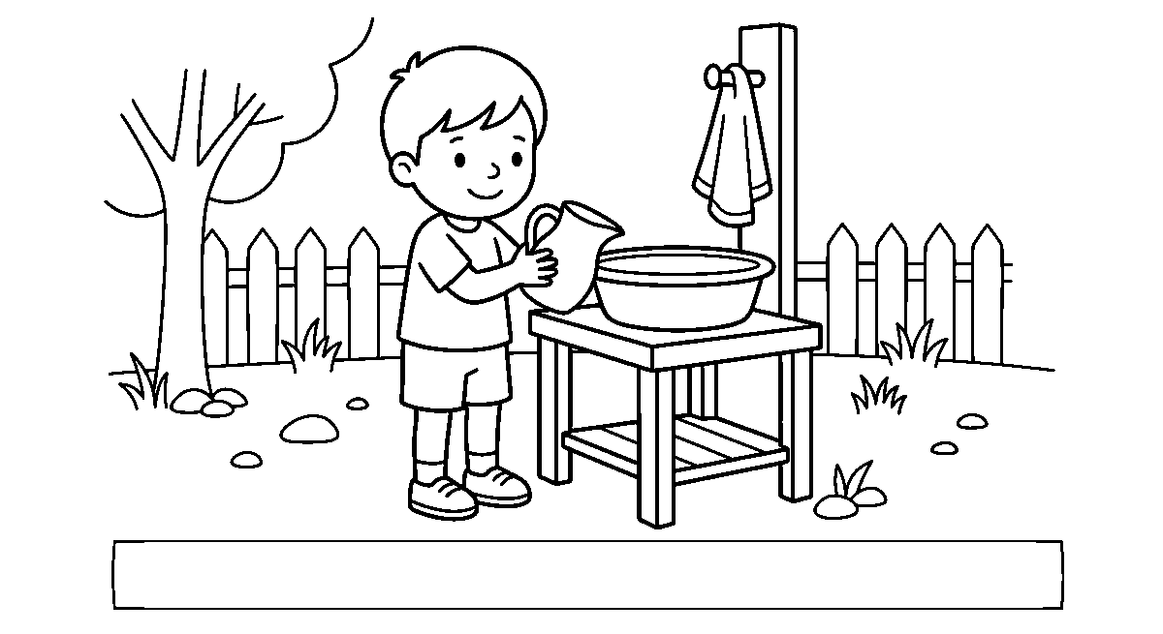
Worksheet
1. A word we know at once, without spelling it, is a ____ word. A) sight B) long C) new D) hard
2. Every sentence ends with a ____ . A) comma B) space C) full stop D) big letter
3. In "the boy can run", which word do we meet most in English? A) run B) the C) can D) boy
4. A space is left ____ . A) before the full stop only B) at the start of the line C) inside a word D) between every two words
5. Fill in: The first letter of a sentence is a ____ letter.
6. Read these words out: come, play, here, see, jump.
7. Write one sentence about what you did this morning.
My own work
Draw one picture of what you do in the morning, then write one sentence about it under the picture.

WEEK 2 — FIVE-LETTER WORDS AND WORDS LONGER STILL
Depth: NERDC Nursery 3 · Literacy · Third Term W2.
You will learn to
• count the letters in a word on your fingers
• put five sounds together and say the word
• read words where two consonants or two letters go together
• use a long word in a sentence of your own
Things to know
• plant has five letters: p-l-a-n-t; we say the five sounds and join them at once.
• Words can begin with two consonants joined: plant, brush, stamp, stand, drink,
frost — the two run together, they are not pulled apart.
• Two letters can also make one sound between them: sh in sheep, th in three and think, ch in
chain, wh in while, qu in queen.
• Say them slowly, then fast: p… l… a… n… t — plant; sh… ee… p — sheep.
• Five-letter words we read this term: **plant, brush, stamp, stand, drink, frost, sheep, three, chain,
queen, while, think, trend**.
• A longer word is only a short word with more sounds; nothing in it is frightening.
• Put the new word in a line you know: "I put the plant in the sun."
• Word hunt: when we see one of our words in a page, we touch it and say it out.
• Writing a long word: say it, count the sounds on your fingers, then write one letter for each sound.
Words for my notebook
Five-letter words: plant, brush, stamp, stand, drink, frost, sheep, three, chain, queen, while, think. Two consonants at the start run together, and sh, th, ch, wh and qu are two letters that make one sound.

Let us talk
1. How many letters has "brush"? Count them on your fingers.
2. Which two letters make one sound in "sheep"?
3. Say the sounds of "plant" slowly, then say the word fast.
4. Make a sentence with the word "drink".
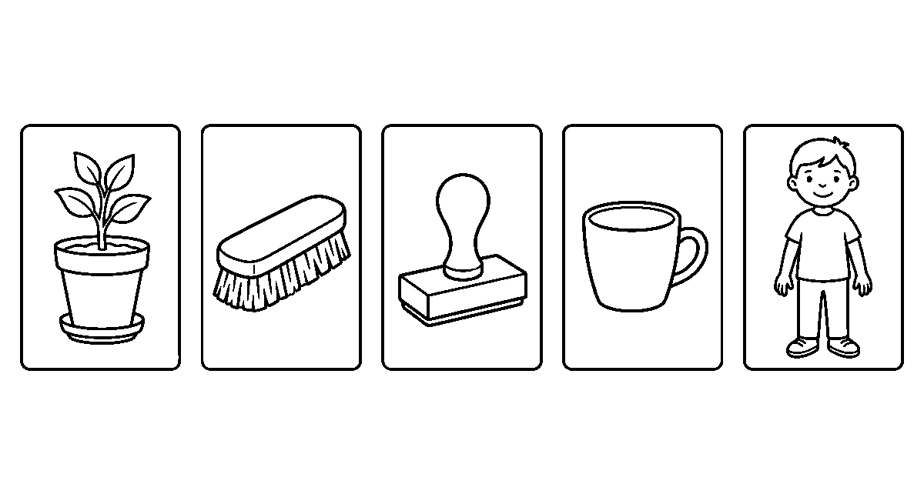
Worksheet
1. The word "stamp" has ____ letters. A) four B) five C) six D) three
2. In "three", the two letters that make one sound at the start are ____ . A) th B) re C) ee D) hr
3. The two letters at the start of "brush" say ____ . A) two long sounds apart B) no sound C) one joined sound D) a full stop
4. "Sheep" is spelled s-h-e-e-p: how many sounds joined make it? A) two B) three C) five D) six
5. Fill in: In "rain + bow = rainbow" the two parts join to make one ____.
6. Read five of our long words out loud and put one in a sentence.
7. Write three five-letter words and underline the two letters that start them.
My own work
Draw the five things — a plant, a brush, a stamp, a cup to drink from and a boy standing — one in each box.

WEEK 3 — TWO WORDS JOINED: COMPOUND WORDS
Depth: NERDC Nursery 3 · Literacy · Third Term W3.
You will learn to
• say the two small words inside a big word
• join two words to make a new one
• part a joined word and say what each part meant
• read a line that carries a joined word
Things to know
• Two words can hold hands and become one word: this is a compound word.
• sun + set = sunset — the time the sun goes down; rain + bow = rainbow — the colour band after rain.
• foot + ball = football — the game the foot plays; cup + cake = cupcake — a small cake baked in a
cup shape.
• Places are named this way: bed + room = bedroom, class + room = classroom,
play + ground = playground, note + book = notebook.
• Position words too: out + side = outside, in + side = inside.
• The morning plate has a name made the same way: break + fast = breakfast — the meal that breaks the fast
of the night.
• Say the parts first and the whole after: sun — set — sunset.
• The whole word often means more than its parts: a playground is not only a ground that plays.

• Some joined words keep two beats of the voice; clap the word: bed-room is two claps, plant is one.
• Make your own and test it on the class: pan + cake = pancake, snail + shell = snailshell — the
class says whether the word is used or only made.
Words for my notebook
A compound word is two words joined into one: sun + set = sunset, rain + bow = rainbow, foot + ball = football, bed + room = bedroom, note + book = notebook, break + fast = breakfast.
Let us talk
1. Which two words make "rainbow"?
2. What is a bedroom?
3. Clap "classroom" — how many claps?
4. Say a joined word you made yourself and what it would mean.
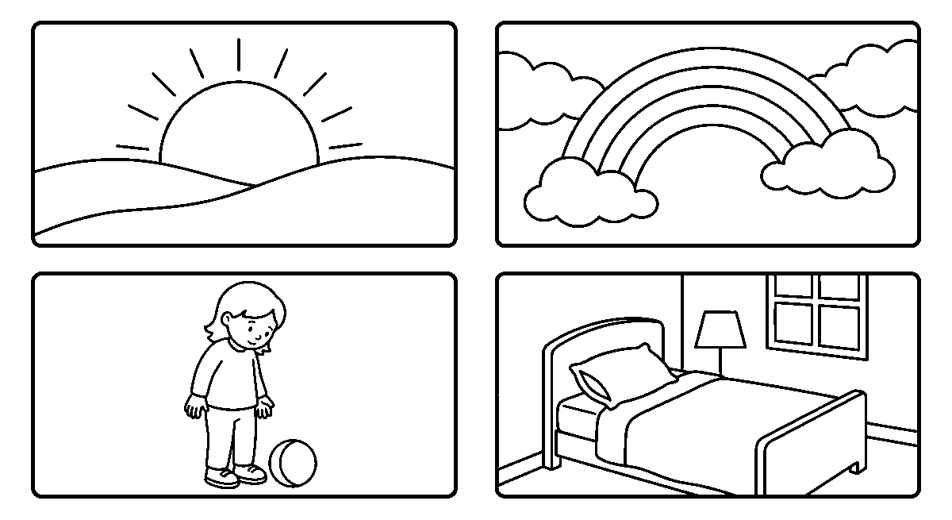
Worksheet
1. "Sun + set" joined makes ____ . A) sunset B) set C) sun D) Sunday
2. Which two words make "notebook"? A) note + bake B) node + book C) note + book D) note + bookcase
3. A playground is a place we ____ . A) sleep in B) play in C) cook in D) wash in
4. "Breakfast" is the meal that ____ the fast of the night. A) doubles B) keeps C) breaks D) buys
5. Fill in: rain + bow makes one word called a ____ word.
6. Part these words into two: bedroom, cupcake, outside.
7. Write two sentences, each with one joined word in it.
My own work
Draw a sunset with a rainbow over it, a ball at the foot of a child, and a bed inside a room.

WEEK 4 — READING A STORY AND SAYING WHAT YOU HEARD
Depth: NERDC Nursery 3 · Literacy · Third Term W4.
You will learn to
• read a short story of words we already know
• say who is in the story and where it happens
• tell what happened first, next and last
• answer with a whole line, not one word
Things to know
• A story has three parts: the beginning, the middle and the end.
• The characters are the people or animals the story is about; the setting is where and when it
happens.
• Our story for this week, read line by line: **"The hen goes out. She sees a corn. She eats the corn. The
rain comes. The hen runs home."**
• Three questions will open nearly any story: Who? (the hen) What? (she found corn) Where? (by the
fence, then home).

• Beginning — the hen goes out; middle — she sees and eats the corn; end — the rain comes and she runs home.
• Retell it in your own words: it is not the same as reading it; your line may be shorter or longer.
• Say what you liked and why: "I like the part with the corn because the hen is happy."
• Tie it to your own day: "When the rain came, I ran home too."
• Look for the words we learnt inside the story — the, she, goes, sees, comes, runs, home, out.
• A story you have read is a story you can draw: three boxes, three parts, in order.
Words for my notebook
A story has a beginning, a middle and an end. The characters are who it is about and the setting is where it happens. Who? What? Where? are the three questions we ask.
Let us talk
1. Who is in our story, and what did she find?
2. Where was the hen when the rain came?
3. Which part of the story happened first?
4. What part did you like, and why?
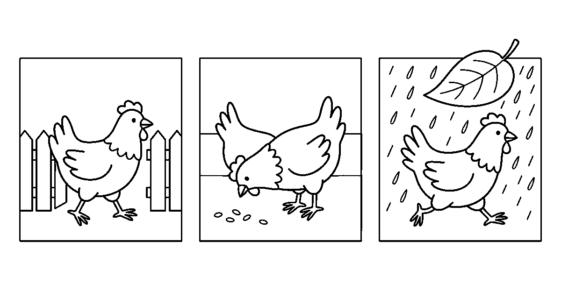
Worksheet
1. The people or animals a story is about are its ____ . A) setting B) characters C) letters D) pages
2. "Where and when a story happens" is its ____ . A) middle B) end C) setting D) title
3. In our hen story, what happened last? A) The hen runs home. B) She sees a corn. C) The hen goes out. D) She eats the corn.
4. The part of the story that comes first is the ____ . A) end B) middle C) beginning D) last line
5. Fill in: When we tell a story in our own words, we say it is a ____.
6. Answer in a whole line: what did the hen do when the rain came?
7. Write one sentence about a time the rain came while you were outside.
My own work
Draw our hen story in three boxes — beginning, middle and end — and put a number in the corner of each box.

WEEK 5 — WORDS THAT TELL US WHAT A THING IS LIKE
Depth: NERDC Nursery 3 · Literacy · Third Term W7 (Nursery floor).
You will learn to
• use a colour word before a thing
• say how big, how tall or how long a thing is
• use words for how a thing feels or is
• put one describing word in each of two sentences
Things to know
• A word that tells us what a thing is like is a describing word.

• Colour words: red, blue, green, yellow, black, white, brown, pink, orange, purple.
• Size words: big, small, tall, short, long, fat, thin.
• How a thing is: good, bad, hot, cold, happy, sad, fast, slow.
• The describing word usually comes before the thing: "The big dog." — "A red ball."
• Two things can share one word: a tall man and a tall tree; a hot pot and a hot day.
• Say the pair out loud and hear the difference: "a big stone" and "a small stone".
• A line with one describing word is worth a line without: "The dog runs." and "The fast dog runs."
• Match the word to the picture: for a snail, slow; for a running child, fast.
• Do not pile them up: one good describing word is enough in a small sentence.
Words for my notebook
A describing word tells what a thing is like — its colour, its size, or how it is. It usually comes before the thing: the big dog, a red ball, a cold drink.
Let us talk
1. What colour is your bag today?
2. Say one big thing and one small thing in this room.
3. Which word goes with a snail — fast or slow?
4. Make the line "The pot is hot" into a line with the word before the thing.
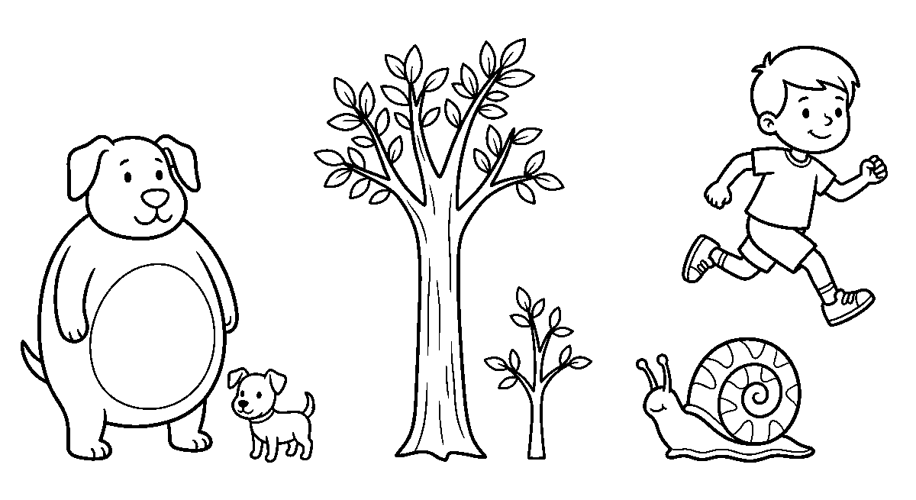
Worksheet
1. A describing word tells us what a thing is ____ . A) like B) worth C) made of D) called
2. In "the tall tree", the describing word is ____ . A) the B) tree C) tall D) one
3. Which word is the opposite of "big"? A) tall B) long C) small D) thin
4. For a snail we say ____ . A) fast B) slow C) hot D) happy
5. Fill in: "A ____ ball" can be filled with a colour word such as red.
6. Name three colour words and three size words.
7. Write two sentences, each with one describing word in it.
My own work
Draw a big dog and a small dog, a tall tree and a short tree, and a snail with a running child near it.

WEEK 6 — ACTION WORDS: THE WORDS THAT MOVE
Depth: NERDC Nursery 3 · Literacy · Third Term W8 (Nursery floor).
You will learn to
• name the words that tell what somebody does
• show an action word with the body
• put an action word in a sentence about yourself
• match the action in a picture to its word

Things to know
• A word that tells what somebody or something does is an action word.
• Our first list: run, jump, walk, sit, stand, eat, drink, sleep, play, read, write, draw.
• More to add to it: sing, dance, swim, fly, hop, skip, clap, throw, catch, kick.
• "I can run" — run is the action; "Birds fly" — fly is the action.
• Say an action word and do it: the class is the picture of the word.
• One picture, one word: children with hands up clapping — clap; a boy and a ball in the air —
throw and catch.
• Action words change a little with who does them: I run, but she runs.
• Write a line about your own day: "I jump at play. I read in class. I sleep at night."
• Guessing game: one child acts, the class names the action word.
• A story without action words would not move at all; that is why we keep them in mind when we write.
Words for my notebook
An action word tells what somebody does: run, jump, walk, sit, stand, eat, drink, sleep, play, read, write, draw, sing, dance, swim, fly, hop, skip, clap, throw, catch, kick.
Let us talk
1. What action word is this picture of two hands together?
2. Say a line that begins "I can" and ends with an action word.
3. Which word changes when we say "she" instead of "I"?
4. Act an action word and let the class guess it.
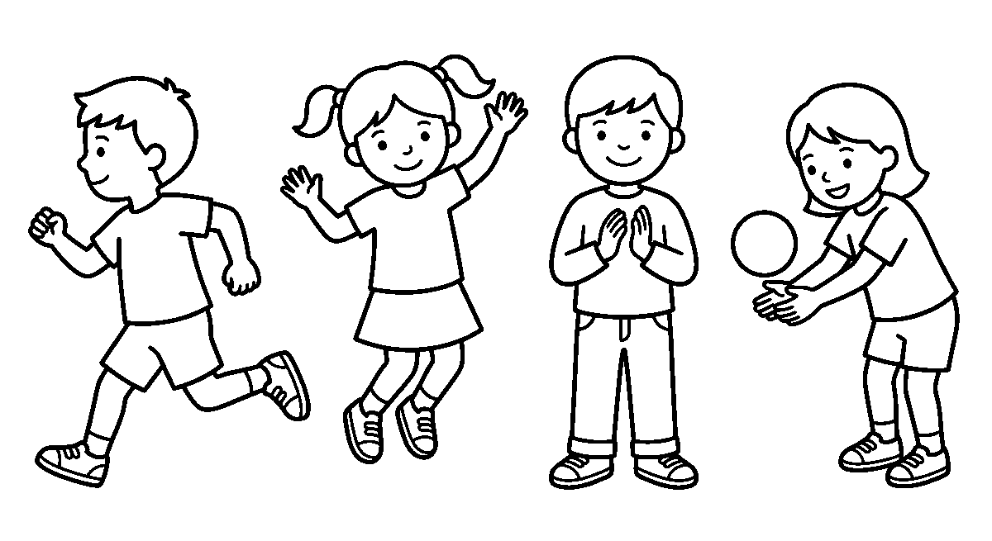
Worksheet
1. An action word tells us what somebody ____ . A) looks like B) does C) owns D) is named
2. In "The girl can swim", the action word is ____ . A) can B) girl C) swim D) the
3. Which pair are both action words? A) red and big B) kick and catch C) hot and cold D) table and chair
4. We say "I run" but "she ____" . A) runs B) run C) running D) ran
5. Fill in: Two hands together, making a sound, shows the word ____.
6. Name eight action words and do three of them.
7. Write three lines about your day, each with one action word.
My own work
Draw four children doing four different things — running, jumping, clapping and catching a ball — and write the action word for each.

WEEK 8 — WRITING A STORY OF OUR OWN
Depth: NERDC Nursery 3 · Literacy · Third Term W9.
You will learn to
• look at three pictures and say the story they hold

• write a beginning, a middle and an end
• use the sight words we know inside our lines
• read our story to the class
Things to know
• A story we write ourselves can be three lines long — that is already a story.
• First line: who and where. Second line: what happened. Third line: how it ended.
• Use what you can write: the sight words, the action words, and the describing words.
• Our three pictures this week: a boy finds a ball; the boy kicks the ball over a fence; a girl
gives the ball back to him.
• A story from those boxes: **"I have a ball. I kick the ball. It goes over the fence. Ada sees the ball. She
gives it to me. We play."**
• Say the line in your head first, then write it; do not leave the space out between the words.
• Begin every new sentence with a big letter and end it with a full stop.
• If a word will not come, draw it in the box above the line and ask for its letters after.
• Give your story a name: "The Ball", "Over the Fence", "My Friend Ada".
• When you read it out, point at each word and let the class look at your picture boxes.
Words for my notebook
My story has a beginning, a middle and an end. I use the words I know, I begin big, I leave room between words, and I end each line with a full stop.
Let us talk
1. What is happening in the first box of our three pictures?
2. Which line of your story tells how it ended?
3. What do you do with a word you cannot write yet?
4. What name will you give your story?
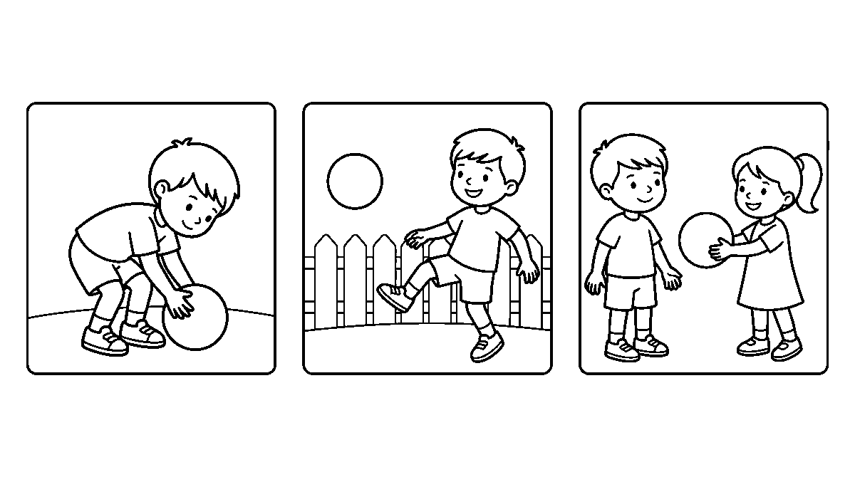
Worksheet
1. The first line of a small story tells us who and ____ . A) where B) why only C) how much D) when last
2. Three boxes for a story hold a beginning, a middle and an ____ . A) colour B) end C) name D) age
3. Each new sentence must begin with a ____ letter. A) small B) tall C) big D) round
4. If a word will not come to you, the note says to ____ . A) stop writing B) ask nobody C) draw it in the box D) leave the page empty
5. Fill in: We end every sentence with a ____ ____.
6. Write your three-line story about the ball, then give it a name.
7. Read your story to the class and say which line you like best.

My own work
Draw three boxes and tell your own story in them, then write one line of words under each box.

WEEK 9 — THE MARKS THAT HELP A READER
Depth: NERDC Nursery 3 · Literacy · Third Term W10.
You will learn to
• begin a sentence and a name with a big letter
• put a full stop where a sentence ends
• use a question mark and an exclamation mark rightly
• leave the right room between words so the page is neat
Things to know
• A big letter (a capital) begins every sentence: "The dog runs."
• A name takes a big letter too: Ada, Tunde, Bola, Musa, and the name of our own town.
• A full stop closes a sentence and tells the reader to breathe: "I can jump."
• A question mark opens a asking line: "What is it?" — it stands where the full stop would.
• An exclamation mark is for a strong call or a surprise: "Look out!", "What a big ball!"
• A sentence never carries two of these marks at once; it is either told, asked or cried.
• Room between words is part of writing: "Ican seeit" is hard, "I can see it" is read at once.
• Neat writing is slow writing done twice: once to say it, once to make the letters sit on the line.
• Read your own page back with your finger; a missing full stop is felt before it is seen.
• The marks are not ornaments — they are the traffic lights of the page: stop, ask, shout.
Words for my notebook
A sentence begins with a big letter and ends with a full stop. A question mark ends an asking line and an exclamation mark ends a strong call. Names take a big letter, and every word keeps its own room.
Let us talk
1. Which mark tells the reader that the sentence is finished?
2. What would you put at the end of "Where is my bag"?
3. Say your own name and tell me which letter in it is big.
4. Read this line the untidy way and then the neat way: "Icanrun."
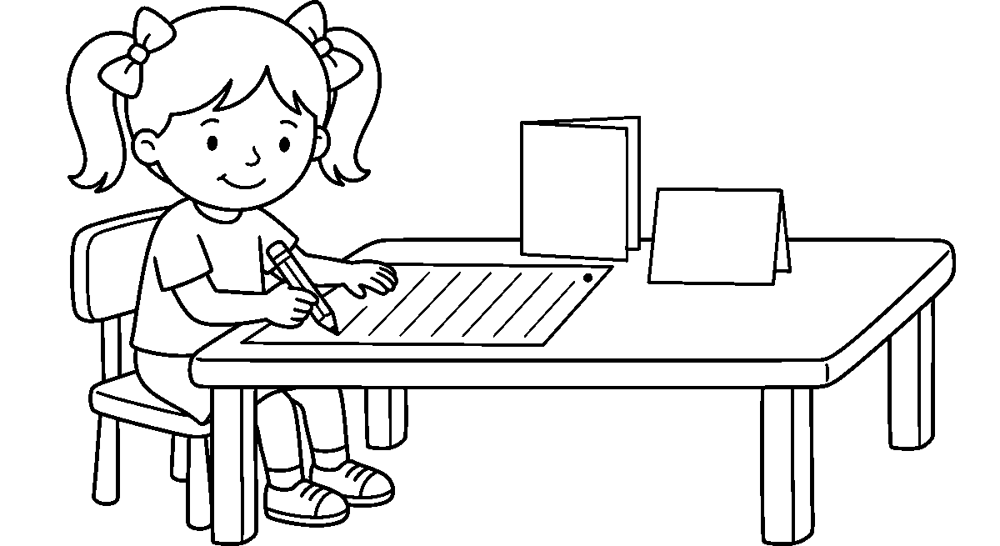
Worksheet
1. A sentence begins with a ____ letter. A) big B) small C) round D) quiet
2. "Where is the boy ____" — the mark it needs is a ____ . A) full stop B) comma C) question mark D) space
3. "Look out ____" is a strong call, so it ends with an ____ mark. A) asking B) exclamation C) equal D) empty

4. The name of a friend takes which kind of letter at its start? A) a big one B) a small one C) none D) a figure
5. Fill in: Room between words makes a page easy to ____ .
6. Rewrite this line well: "ican see it"
7. Write three lines about your family, with the marks we learnt.
My own work
Write three lines about your family, then draw one small mark in each box — a dot, a hook and a straight line with a dot under it.
NUMERACY

WEEK 1 — HALVES AND QUARTERS
Depth: NERDC Primary 1 · Mathematics · Third Term W1, held down to the Nursery floor.
You will learn to
• share two things equally between two friends
• say what half of a thing is
• find half of a shape and shade it
• fold a shape into four equal parts and say the name of one part
Things to know
• Equal means the parts are the same size; two parts of different sizes are not halves.
• When one orange is shared between two children so that both get the same, each one has half — written
½.
• A half is one of two equal parts of a thing; the whole thing is two halves put back together.
• A circle folded once and cut on the fold gives two halves; a square folded corner to corner gives two
halves too — they are triangles.
• To shade half of a shape, divide it into two equal parts and colour one of them — one part only.
• A rectangle can be halved down the middle or across the middle; both are right, because the two parts match.
• Fold a paper circle twice, once and then again, and you have four equal parts: each part is a
quarter, written ¼.
• Four quarters make the whole; two quarters make a half; so a quarter is smaller than a half.
• Sharing game: eight counters between two children is four each — that is half of eight; eight between
four children is two each — that is a quarter of eight.
Words for my notebook
Half is one of two equal parts, and it is written ½. Quarter is one of four equal parts, and it is written ¼. Two halves make the whole, and four quarters make the whole.
Let us talk
1. What must the two parts be like before we can call them halves?
2. Show me how to fold a paper circle into two halves.
3. How many quarters make one whole?
4. If six biscuits are shared among two children, how many does each get?

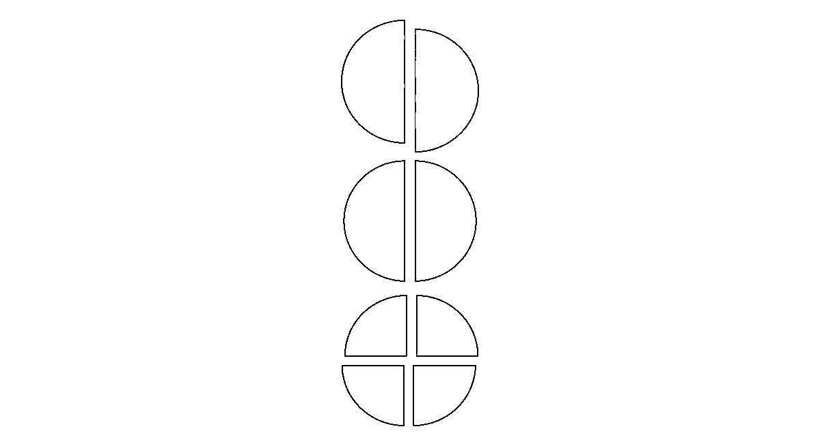
Worksheet
1. When a thing is cut into two equal parts, each part is a ____ . A) quarter B) whole C) half D) side
2. The mark ½ stands for ____ . A) one half B) two halves C) one quarter D) four wholes
3. Which of these is NOT a half? ____ . A) two equal parts B) a fold that matches C) two quarters joined D) the bigger unequal piece
4. A paper circle folded twice and cut gives ____ . A) two halves B) four quarters C) three parts D) one whole
5. Fill in: Four ____ make one whole.
6. Draw a square and shade half of it; then say how you divided it.
7. Write two sentences on sharing ten shells between two friends.
My own work
Fold a paper square into two equal parts and cut along the fold; then draw a circle, a square and a rectangle and shade half of each one.

WEEK 2 — LENGTH: HOW LONG IS IT?
Depth: NERDC Nursery 3 · Numeracy · Third Term W7 and Primary 1 · Mathematics · Third Term W2.
You will learn to
• say which of two things is longer or shorter
• measure with the body: the hand span and the foot
• measure with a pencil, a stick or a piece of thread
• put three things in order from the shortest to the longest
Things to know
• Length is how long a thing is from one end to the other.
• We compare before we measure: this strap is longer, that one is shorter, and two may be **the same
length**.
• A hand span — thumb out to little finger out — is a body measure; so is the foot, the arm from
elbow to fingertip, and one step.
• To measure with a hand span, we put the spans side by side with no gap and no overlap, and count them.
• A pencil, a stick or a piece of thread can carry a measure across, and then we count how many
pencils the desk is.
• The same table measured with a hand and with a foot gives different numbers, because the units are not
the same size — so people agree on one unit.
• The small unit for length is the centimetre (cm) and the big one is the metre (m); one metre is a
long step, and a ruler is marked in centimetres.
• On a ruler the little lines are the centimetres; we lay the thing on the line that begins at zero,
not at the edge of the ruler.
• Order three things by length and say it out: "The stick is the longest, the crayon is the shortest, and the
pencil is between them."

• Estimating is a skill: first say how many spans you think it will be, then measure and see how near you were.
Words for my notebook
Length is how long a thing is from end to end. We can measure with a hand span, a foot, a pencil or a stick, and we can measure with a ruler in centimetres; one metre is 100 centimetres.
Let us talk
1. Which is longer, your exercise book or your pencil purse?
2. How many hand spans is your desk?
3. Why do we count the spans with no gap between them?
4. What do the little lines on a ruler stand for?
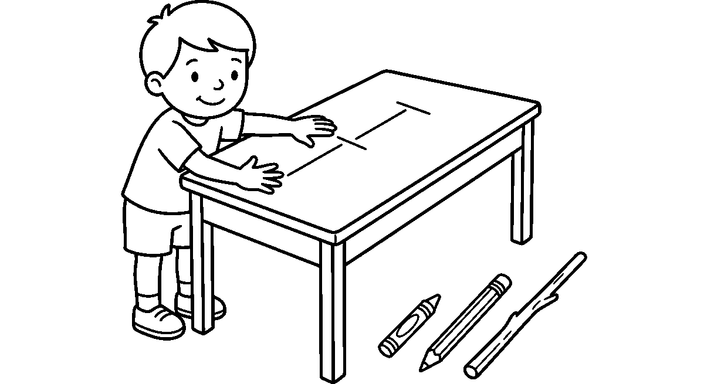
Worksheet
1. Length of a thing is how ____ it is from end to end. A) long B) heavy C) hot D) loud
2. Measuring a desk with your hand span uses a ____ measure. A) paper B) water C) money D) body
3. One metre is the same as ____ centimetres. A) ten B) one hundred C) fifty D) five hundred
4. When two ropes are the same length, ____ . A) one is longer B) both are short C) they match end to end D) one is heavier
5. Fill in: We begin to measure on the line marked ____, not on the edge of the ruler.
6. Put three things in your class in order from shortest to longest and write the order.
7. Write two sentences on what you measured with your foot and how many steps it was.
My own work
Measure three things on your table with your hand span and write the number of spans beside each; then draw a crayon, a pencil and a stick in a row from the shortest to the longest.

WEEK 3 — WEIGHT: HEAVY AND LIGHT
Depth: NERDC Nursery 2 · Numeracy · Third Term W8, with Primary 1 · Mathematics · Third Term W3.
You will learn to
• say which of two things is heavier or lighter
• sort things into heavy, middle and light
• compare weights with a hanger balance
• know that a big thing is not always the heavier thing
Things to know
• Weight is how heavy a thing is — how hard your hand has to work to lift it.
• We say heavier, lighter, the heaviest, the lightest, and the same weight.
• Lifting two things in two hands is the first way to tell: the hand that goes down found the heavier thing.
• A hanger balance — a coat hanger with two cups on string — shows it without lifting: the heavier side
goes down.

• When the two cups stand level, the two things are the same weight.
• We can weigh with blocks: how many blocks does it take to bring the cup level? That number is the
weight in blocks.
• Big is not always heavy: a big balloon is lighter than a small stone; a bunch of cotton wool is bigger
than a chalk and still lighter.
• In the market things are weighed: fruits, yam, rice and oil; the seller puts them on a scale.
• The small unit of weight is the gram (g) and the big one is the kilogram (kg); a small stone is some
grams, and a bag of rice is counted in kilograms.
• Weighing in real life: your school bag on Monday and on Friday may not be the same weight, because the books
inside are different.
• Thinking question: if an orange is heavier than a grape, which one is lighter? — the grape.
Words for my notebook
Weight is how heavy a thing is. The heavier side goes down on a balance, and when the cups are level the two things weigh the same. A big thing is not always heavier: a balloon is bigger than a stone and lighter.
Let us talk
1. Which is heavier, your chair or your bag?
2. What does a level balance tell you about the two cups?
3. Name one big thing that is light and one small thing that is heavy.
4. How many blocks does your pencil purse need to make the cups level?
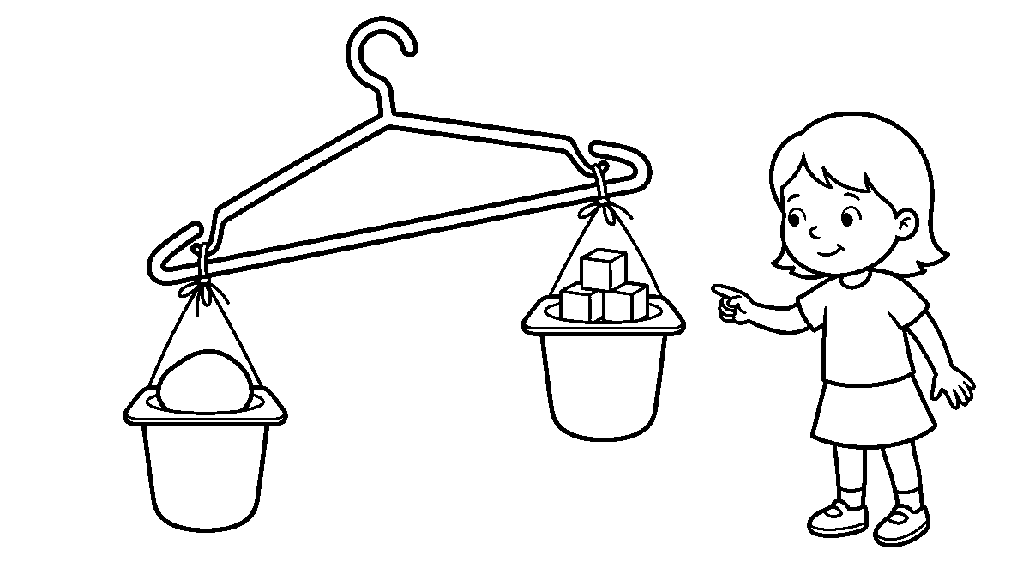
Worksheet
1. Weight tells us how ____ a thing is. A) long B) tall C) wide D) heavy
2. On a balance, the heavier side ____ . A) stays up B) goes down C) swings away D) disappears
3. A big balloon and a small stone: which is lighter? ____ . A) the stone B) neither C) the balloon D) both
4. To weigh with blocks, we count how many blocks make the cups ____ . A) level B) empty C) wet D) higher
5. Fill in: The big unit of weight is the kilo____ .
6. Sort six things in your class into heavy, middle and light and write the three lists.
7. Write two sentences on a thing you lifted that surprised you.
My own work
Draw a hanger balance with a stone in one cup and three blocks in the other, and let the stone side hang lower; then colour the blocks.

WEEK 4 — TIME: THE DAY, THE WEEK AND THE CLOCK
Depth: NERDC Primary 1 · Mathematics · Third Term W4, with Primary 2 · Mathematics · Second Term W9–W10.
You will learn to
• say the parts of the day and the days of the week in order

• use yesterday, today and tomorrow rightly
• name the parts of a clock and read the hour on it
• say what o'clock and half past look like on the clock face
Things to know
• The day has parts: morning, midday, afternoon, evening and night.
• The week has seven days: Monday, Tuesday, Wednesday, Thursday, Friday, Saturday, Sunday.
• Yesterday is the day that is gone, today is the day we are in, tomorrow is the day that is coming.
• A clock is drawn as a face with the numbers 1 to 12 round it and two hands in the middle.
• The short hand counts the hours and the long hand counts the minutes; the short hand moves slowly,
the long hand moves fast.
• It is o'clock when the long hand stands straight up at 12; where the short hand points is the hour — so
long hand at 12 and short hand at 9 is 9 o'clock.
• It is half past when the long hand points down at 6 and the short hand stands past a number: long hand
at 6, short hand past 3, is half past 3.
• A quarter of the way round is quarter past; three quarters is quarter to the hour that is coming.
• a.m. is the morning side of noon and p.m. is from noon to night; school hours are a.m. and supper
time is p.m.
• Things take time: sweeping the yard is short, a farm day is long; we say "it took the morning", "it took two
hours".
• Our day has an order — wake, wash, eat, school, learn, play, bathe, eat, sleep — and the clock tells us
when each part comes.
Words for my notebook
The week has seven days and the day has its parts. The short hand counts the hours and the long hand counts the minutes; when the long hand is at 12 it is o'clock, and when it is at 6 it is half past.
Let us talk
1. Say the seven days, beginning from Monday.
2. What do we call the day that comes after today?
3. Where is the long hand when it is o'clock?
4. Point to the morning part of the day on the clock and say what we do then.
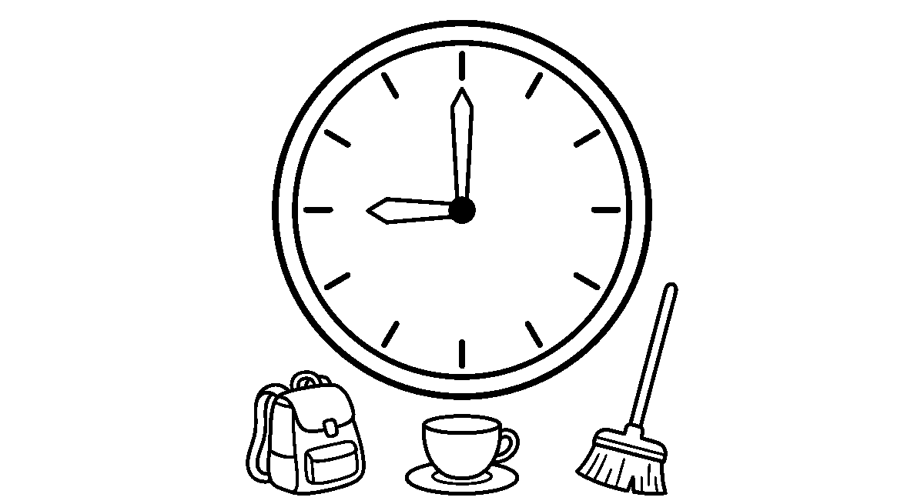
Worksheet
1. The day that has already gone is ____ . A) today B) yesterday C) tomorrow D) midday
2. How many days make a week? ____ . A) five B) ten C) seven D) twelve
3. At o'clock, the long hand stands at ____ . A) 12 B) 6 C) 3 D) 9
4. The short hand on a clock tells the ____ . A) minutes only B) days C) months D) hours

5. Fill in: When the long hand points down at 6, it is half ____.
6. Write the parts of the day in order, from the time you wake to the time you sleep.
7. Write two sentences on how long it takes you to come to school and what you pass on the way.
My own work
Draw a big clock face with twelve short marks round the edge — or the numbers 1 to 12 — and put the short hand on 9 with the long hand straight up. Then draw three things you do at that hour in the morning.

WEEK 5 — SHAPES YOU CAN HOLD: THREE-DIMENSIONAL SHAPES
Depth: NERDC Primary 1 · Mathematics · Third Term W7.
You will learn to
• name five shapes that take up room
• count the flat faces, the edges and the corners of a box
• sort shapes into the ones that roll and the ones that stack
• find these shapes in the house and the class
Things to know
• A shape you can hold takes up room; we call it a three-dimensional shape.
• A cube has six flat faces and every face is a square; a die and a small carton of sugar are cubes.
• A cuboid also has six flat faces, but its faces are rectangles; a exercise book, a matchbox and a
carton of milk are cuboids.
• A sphere is round all over, has no flat face and no corner, and it rolls any way you put it; a ball is a
sphere.
• A cylinder has two round flat faces — one at the top and one at the bottom — and a curved side; a tin of
milk, a cup and a bucket are cylinders.
• A cone has one round flat face at the bottom, a curved side and one corner at the top; a party cap
and a heap-sieve are cones.
• A face is a flat surface, an edge is where two faces meet, and a corner is where edges meet.
• A cube has 12 edges and 8 corners; a cuboid has the same, because it is a stretched cube.
• Rolling test: the sphere and the cylinder roll; the cube and the cuboid do not roll, they slide — and those
two can stack without falling.
• Building: cubes make a wall that stands; balls make a heap that runs away; a cylinder laid on its side
becomes a roller.
• Look round the class: the clock on the wall is a cylinder seen from the front, the ball in the store is a
sphere, the chalk box is a cuboid.
Words for my notebook
A cube has six square faces; a cuboid has six rectangular faces; a sphere rolls and has no flat face; a cylinder has two round faces; a cone has one round face and one corner. Faces, edges and corners are what we count.
Let us talk
1. Bring one thing in the class that is a cuboid and one that is a sphere.
2. How many flat faces has a cube?
3. Which two of our five shapes will roll?
4. Where is the one corner of a cone?

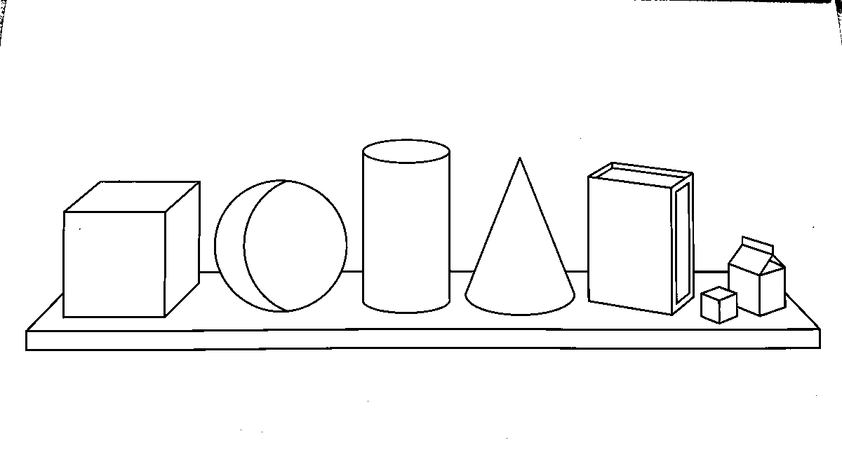
Worksheet
1. A ball is shaped like a ____ . A) sphere B) cube C) cone D) cuboid
2. How many flat faces has a cube? ____ . A) four B) eight C) ten D) six
3. Which shape has one round face and one corner? ____ . A) cylinder B) cone C) cube D) sphere
4. A matchbox and an exercise book are both ____ . A) spheres B) cones C) cuboids D) cylinders
5. Fill in: The place where two faces meet is called an ____.
6. Sort ten things at home into the five shapes and write two of each.
7. Write two sentences on the shape you can stack and the shape you cannot.
My own work
Set a cube, a ball, a tin and a cap on the desk, look at them, then draw all four in a row and colour the tin.

WEEK 6 — FLAT SHAPES: TWO-DIMENSIONAL SHAPES
Depth: NERDC Primary 1 · Mathematics · Third Term W8.
You will learn to
• name five flat shapes
• count the sides and the corners of each
• draw a square, a rectangle and a triangle with a ruler
• find flat shapes on the things about us
Things to know
• A flat shape lies on a surface; it has length and width but nothing to hold.
• A triangle has three sides and three corners; a square has four equal sides and four corners.
• A rectangle has four sides too, but only the opposite sides are equal — it is a stretched square.
• A circle is one curved line with no corner and no side; everything on it is the same distance from the
middle.
• An oval is like a squashed circle: one curved line, no corner — an egg's outline is an oval.
• A side is the line between two corners; a corner is the point where two sides meet.
• To draw straight, lay the ruler down, draw along it, lift the ruler and turn it at the corner.
• Two triangles put side to side make a rectangle; a square cut from corner to corner makes two triangles.
• Shapes are on everything: the exercise book is a rectangle, the clock's face is a circle, a scarf folded is
a triangle, a slate is a rectangle.
• Sorting: shapes with corners in one hoop, shapes with no corner in another; four-sided shapes in a third.

Words for my notebook
A triangle has three sides and three corners. A square has four equal sides and a rectangle has four sides with the opposite ones equal. A circle and an oval are curved and have no corner.
Let us talk
1. How many corners has a triangle, and how many has a square?
2. Which two flat shapes have no corner at all?
3. Show me how you make a rectangle out of two triangles.
4. Name three things in this room with a rectangular face.
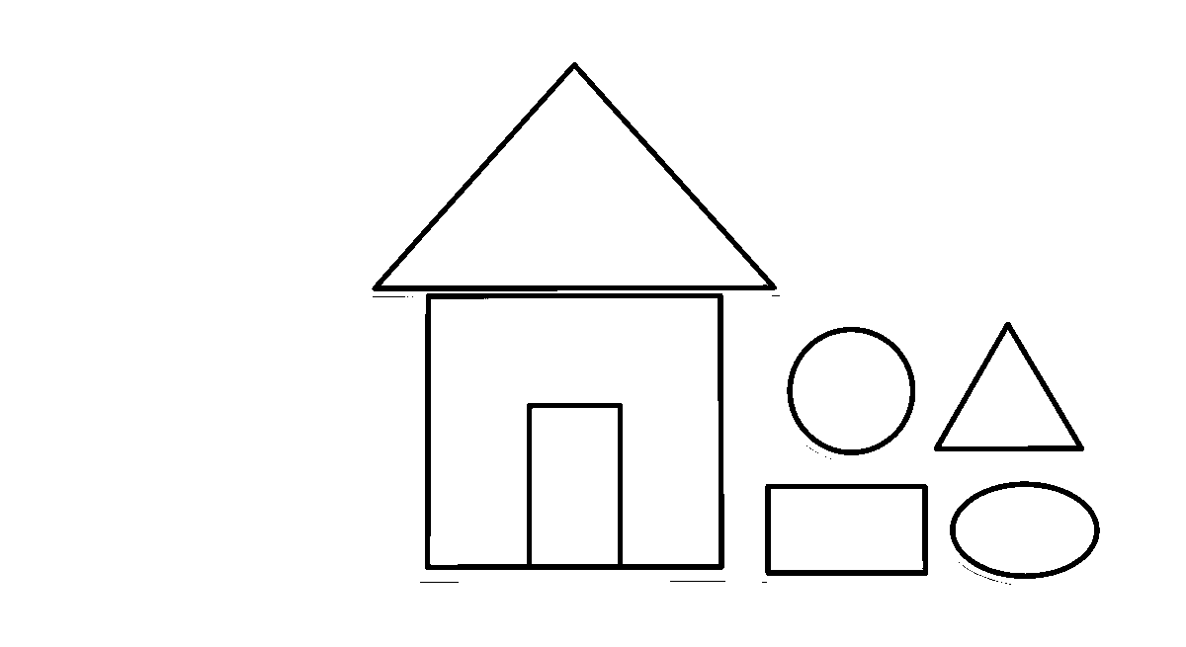
Worksheet
1. A shape with three sides and three corners is a ____ . A) square B) circle C) oval D) triangle
2. How many corners has a rectangle? ____ . A) two B) four C) three D) six
3. Which of these has no corner? ____ . A) a square B) a triangle C) a circle D) a rectangle
4. The sides of a square are ____ . A) equal B) unequal C) curved D) only two
5. Fill in: An oval is like a squashed ____.
6. Draw a triangle, a square and a rectangle with your ruler and count the sides of each.
7. Write two sentences on one thing at home whose face is a circle.
My own work
Draw one row of five flat shapes — circle, triangle, square, rectangle, oval — then cut them out and paste two of them into one new shape.

WEEK 8 — SHAPES THAT GO ON AND ON: PATTERNS AND SYMMETRY
Depth: NERDC Primary 1 · Mathematics · Third Term W9.
You will learn to
• say the next thing in a pattern of shapes
• make a pattern of your own with shapes and colours
• find the flat shape inside a shape you can hold
• tell a line of symmetry on a folded paper
Things to know
• A pattern is things repeated in the same order, so that we can say what comes next.
• In square, circle, square, circle, the part that repeats is two shapes; the next is square.
• In triangle, triangle, circle, triangle, triangle, circle, the part that repeats is three shapes.
• A pattern can grow: one block, then two, then three — the next line has four blocks.
• Colour takes part in a pattern too: red, blue, red, blue is as much a pattern as shape is.
• Take a cube and look at one face: it is a square; a cylinder has a circle at the top; a cone
looks like a triangle from the side.
• A flat shape can be made from other shapes: two triangles make a square; four triangles make a bigger

triangle; a square and two triangles make a house.
• Symmetry means the same on both sides: fold a paper heart and the two halves match all the way round.
• The fold line where the two halves match is the line of symmetry; a square can be folded to match in four
ways, a rectangle in two.
• A circle has no corner to miss: every fold through the middle matches.
• Art with shapes: cut squares, triangles and circles from paper and make a road, a house and a boat on one
page.
Words for my notebook
A pattern repeats the same order, so the next thing can be said. A cube hides a square on each face and a cylinder hides a circle at the top. A fold that makes both halves match shows a line of symmetry.
Let us talk
1. Square, circle, square, circle — what comes next?
2. What shape do you see on the face of a cube?
3. Show me a fold on this paper heart where both halves match.
4. Which two shapes make one square?
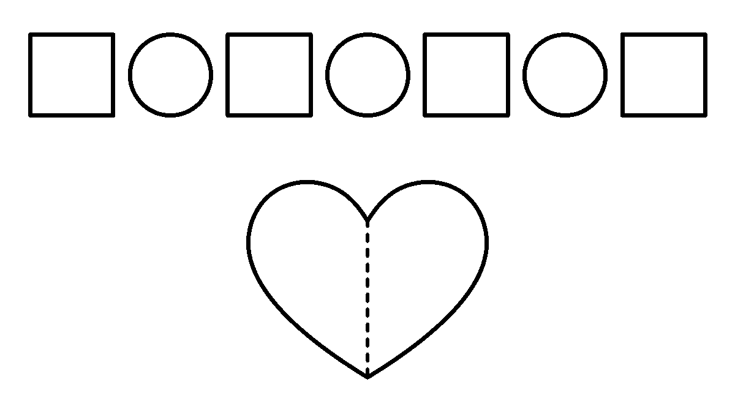
Worksheet
1. Circle, square, circle, square — the shape that comes next is a ____ . A) circle B) square C) triangle D) cone
2. Two triangles placed side by side can make ____ . A) a circle B) an oval C) a square D) a cone
3. When a folded paper matches on both sides, the fold line is a line of ____ . A) symmetry B) length C) weight D) count
4. The top of a cylinder is shaped like a ____ . A) triangle B) square C) rectangle D) circle
5. Fill in: In one, two, three, the next number of blocks is ____.
6. Make a pattern of your own with six shapes and write the part that repeats.
7. Write two sentences on one thing you cut and pasted today.
My own work
Cut two triangles, one square and one circle from paper, paste them into a picture of a house or a boat, and draw the line of symmetry on the square part.

WEEK 9 — COUNTING WHAT THE CLASS SAID: GATHERING INFORMATION
Depth: NERDC Primary 1 · Mathematics · Third Term W10.
You will learn to
• ask a question and write down the answers
• record counts with strokes that are easy to add up
• put the answers into a simple table
• read a picture chart and a block chart of the class
Things to know
• We gather a thing by asking and counting, and then we put the answers in order so that the question is answered.

• First the question, small and clear: "Which fruit do you like best — mango, banana or orange?"
• Then we go round the class and take one answer from each child, and write it as we hear it.
• A stroke stands for one child; four strokes together and a fifth stroke across them means five — that is
why strokes are easier to count than a long line of single marks.
• Answers are put in a table: one column for the fruit, one column for the number of children.
• In a picture chart one picture stands for one thing: three orange pictures mean three children chose
oranges.
• In a block chart the tower of blocks stands for the count; the taller the tower, the more the
children.
• Reading a chart is answering with the eyes: which tower is the tallest, which is the shortest, and by how
many one beats another.
• We can gather the same way about colours, about pets, about the way to school, and about the song the class
likes best.
• The class that counted must check its total: the numbers in the table should come to the number of
children present.
Words for my notebook
We ask one clear question, take an answer from each child, and record it with strokes. A table keeps the answers in order, a picture chart lets one picture stand for one child, and in a block chart the taller tower means more children.
Let us talk
1. What is the first thing we do before we count anything?
2. Why do we put a fifth stroke across four strokes?
3. In a block chart, what does a taller tower tell us?
4. Our table said 8, 7 and 5 for twenty children present — does that add up?
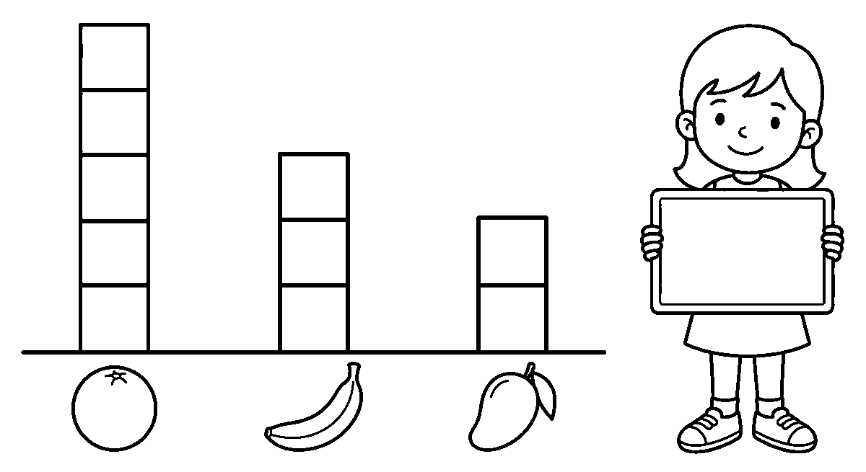
Worksheet
1. Before we count, we first ____ . A) shout in the market B) sleep C) ask one clear question D) draw a clock
2. Four strokes with a fifth stroke across them stand for ____ . A) five B) four C) three D) eight
3. In a picture chart, one picture stands for ____ . A) the class B) a whole week C) ten children D) one child
4. In a block chart, the taller tower means ____ . A) fewer children B) more children C) no child D) a longer day
5. Fill in: The answers are put in a table with one column for the fruit and one for the ____.
6. Ask five friends their favourite colour and record the answers with strokes.
7. Write two sentences on what your class chart showed and what you would ask next.

My own work
Take the answers of ten children on their favourite fruit, record them with strokes, then draw a block chart under the three fruit names and colour the tallest tower.

GENERAL KNOWLEDGE
Weeks 1 to 6, 8 and 9. Week 7 is Mid-Term Break, Week 10 Revision, Week 11 Examination, Week 12 Closing — those weeks carry no note. Depth: NERDC 2025 · Nursery 3 · General Knowledge · Third Term, from the school's own stream line "My Big World & My Country's Story" — our state and town, water and air, the sky, the tools about us, one Nigeria, counting and sorting, the people of great works, and the end-of-year games.

WEEK 1 — MY STATE AND MY TOWN
Depth: NERDC Nursery 3 · General Knowledge · Third Term W1.
You will learn to
• say the name of my state and the town where I live
• put my state on the map of Nigeria, in a big first look
• name the famous things of my state: its food, its festivals and its places
• draw a picture map of my town with the five places we all know
Things to know
• A state is a big piece of the country with its own head; Nigeria has thirty-six states and one
capital territory, and the capital territory is called Abuja.
• Our state is Lagos, and it sits at the south-west of Nigeria, where the land meets the sea.
• The big city of our state is called Ikeja; the town or village where my house stands is my own town.
• On the map we look for three things first: the sea at the bottom, the bridge that goes over the water,
and the lagoon that lies between.
• Famous places in our state: the beach with its soft sand, the harbour where big ships stand, and the
bridge long enough to cross the whole water.
• Famous food of our people: àmàlà with ẹ̀fọ́, and by the sea we also eat fish that came in a boat.
• Festival of our town: Eyo — the day the masked people walk in white through the streets and the whole town
comes out to see.
• Five places every town has: the market, the motor park, the school, a church or a mosque, and
the stream or the water point.
• A town is not only houses: it is the people in them — the seller, the driver, the guard, the teacher and
my own family.
Words for my notebook
My state is Lagos, in the south-west of Nigeria, where the land meets the sea. My town has a market, a motor park, a school, a church and a mosque, and a stream that runs past it.
Let us talk
1. What is the name of your state, and which town is your house in?
2. Point to the sea on the map and then point to our state.
3. Name two foods of our people and one food that comes from the sea.
4. Which four places did we say every town must have?
Worksheet
1. Our state in the south-west of Nigeria is ____ . A) Kano B) Lagos C) Borno D) Enugu
2. The big city of Lagos state is called ____ . A) Ikeja B) Zaria C) Lokoja D) Calabar
3. The festival where masked people walk in white is ____ . A) Durbar B) Ọ̀ṣun C) Eyo D) New Yam
4. On the map of Nigeria, the sea is at the ____ . A) top B) right side C) middle D) bottom
5. Fill in: Nigeria has thirty-six states and one capital territory called ____ .
6. Name the five places that a town has.

7. Write two sentences on the town where your house is.
My own work
Draw a picture map of our town: put the market on one road, the school on another, the motor park by the wide road, and the stream running past behind them; colour the roads.

WEEK 2 — WATER AND AIR: WHY THEY MATTER
Depth: NERDC Nursery 3 · General Knowledge · Third Term W2.
You will learn to
• name where water comes from and what we use it for
• say why air matters even though we cannot see it
• keep water clean and not waste it
• do three small tests with water and air
Things to know
• Water comes to us from the rain, the tap, the well, the stream and the river.
• We use water to drink, to bath, to cook, to wash cloth and plates, and to give the plants.
• Air is everywhere; it is inside the room, inside the bag, and inside the ball we blow up.
• We cannot see air, but we can feel it as wind, and wind can move a leaf, a kite and a small boat.
• Living things breathe: we take air in and let it out; a plant takes in the part we throw out.
• Water stays clean when the vessel is covered, the cup is washed, and the hand does not go inside.
• Water for drinking is boiled by a grown-up and then kept in a clean covered keg.
• We do not waste it: the tap is shut while we rub the teeth, and one cup of water is enough for that.
• Test one — float or sink: a leaf floats, a stone sinks, a bottle top may do either.
• Test two — bubbles: blow water with a straw and the air comes out as round balls.
• Test three — a wind chime: hang shells on a thread by the window and the air plays the tune.
Words for my notebook
Water comes from rain, the tap, the well, the stream and the river; we drink it, bath in it, cook with it and give it to plants. Air is everywhere, we breathe it, and wind is air that is moving.
Let us talk
1. Name four places water comes from.
2. What do we do with water every morning before school?
3. How can we know air is there when we cannot see it?
4. Say two ways we keep water clean and one way we waste it.
Worksheet
1. A stream and a river are places we get ____ from. A) air B) water C) fire D) sand
2. Wind is really ____ that is moving. A) rain B) dust C) air D) smoke
3. Before a child drinks it, water for the house is ____ . A) boiled B) frozen C) buried D) coloured
4. In the float-and-sink test, the thing that goes down is ____ . A) a dry leaf B) a feather C) a small stone D) a bottle top
5. Fill in: We shut the ____ while we rub our teeth, so that water is not wasted.
6. Say five things water is used for at home.
7. Write two sentences on what you saw in the bubble test.
My own work
Draw a tall glass of covered water, and beside it six small things — a leaf, a stone, a feather, a bead, a bottle top and a bit of cloth — then ring the ones you think will float.

WEEK 3 — THE SKY: SUN, MOON, STARS, DAY AND NIGHT
Depth: NERDC Nursery 3 · General Knowledge · Third Term W3.
You will learn to
• say what the sun gives us and when it is up
• name what we see in the sky at night
• tell the parts of the day in order
• sort things into the day and the night
Things to know
• The sun gives us light and warmth; it is the reason the day is bright.
• The daytime is when we work, learn and play; the night is when the world rests and we sleep.
• At night we see the moon and the stars, and sometimes the moon is full and round.
• The parts of the day in order: morning, midday, afternoon, evening, night.
• In the morning the sun rises; at midday it is high and hottest; in the evening it goes down.
• The sky is everything above us; the clouds live in it and the rain comes down out of it.
• A cloud is a big crowd of very small drops of water; when they grow heavy, they fall as rain.
• Day and night are not the same: in the day we see colour, at night we see light from lamps, the moon and fire.
• Sorting game: a kite, a school bag and a market basket go to the day; a torch, a mosquito net and a night
lamp go to the night.
• We do not look straight at the sun; its light is too strong for the eye.
Words for my notebook
The sun gives light and warmth and makes the day. The moon and the stars come with the night, when we rest. The sky is above us, and the clouds and the rain live in it.
Let us talk
1. What two things does the sun give us?
2. Which two things do we see in the sky only at night?
3. Say the parts of the day, from morning to night.
4. Where does rain come from?
Worksheet
1. The thing that gives us light and warmth in the day is ____ . A) the moon B) the lamp C) the sun D) the star
2. At night we see the moon and the ____ . A) rainbow B) stars C) clouds at midday D) shadow at noon
3. The part of the day when the sun is high and hottest is ____ . A) morning B) evening C) night D) midday
4. Rain comes down out of the ____ . A) mountain B) well C) sky D) market
5. Fill in: When the sun goes down in the ____, we light the lamp.
6. Put two things in the day box and two things in the night box.
7. Write two sentences on what you do between evening and sleep.
My own work
Fold a page in two. In one half draw the sun and three things we do in the daylight; in the other half draw the moon, three stars and three things we do at night.

WEEK 4 — SIMPLE MACHINES AND TOOLS AROUND ME
Depth: NERDC Nursery 3 · General Knowledge · Third Term W4.
You will learn to
• name the tools we use at home and at school
• say what each tool is for
• tell which things have wheels and what a wheel does

• say how a simple machine takes work off our hands
Things to know
• Tools at home: spoon for eating, fork for holding food, knife for cutting, broom for the
floor, rake for the yard, bucket for water.
• Tools at school: pencil for writing, crayon for colouring, ruler for drawing a straight line,
scissors for cutting paper.
• A knife and a pair of scissors are sharp, so they are carried with the point down and passed to a
friend by the handle.
• Things with wheels: bicycle, car, wheelbarrow, and the cart at the market; a wheel rolls,
it does not slide.
• A wheel makes a heavy thing easy to move; that is why a load goes in a wheelbarrow and not on the head
alone.
• A ramp is a slope: a plank laid from the ground to a lorry lets a heavy bag slide up instead of being
lifted.
• A lever is a strong stick: put one end under a stone, rest the middle on a small stone, and the big stone
comes up.
• A tool does not do the work for us; it takes part of the work off our hands.
• Touch-and-tell: things go in a bag, a hand goes in, and the class names the tool without looking.
• Every tool has its place: the broom on the wall, the scissors in the box, the pencil in the purse.
Words for my notebook
Spoon, fork, knife, broom, rake and bucket are the tools of the house; pencil, crayon, ruler and scissors are the tools of the class. A wheel rolls, a ramp is a slope, and a lever is a strong stick that lifts a stone.
Let us talk
1. Name four tools of the house and what each one is for.
2. How do you pass a pair of scissors to a friend?
3. What does a wheel do that makes a load easy?
4. Which two tools are kept out of the way of small hands?
Worksheet
1. The tool used for sweeping the floor is the ____ . A) rake B) bucket C) broom D) spoon
2. A wheelbarrow carries a load because it has a ____ . A) rope B) wheel C) lid D) blade
3. When we give a pair of scissors to somebody we hold it by the ____ . A) blades B) point C) spring D) handle
4. A plank laid from the ground up to a lorry is a ____ . A) ramp B) lever C) basket D) keg
5. Fill in: A strong stick used to lift a stone is called a ____ .
6. Match six tools to their work by drawing a line.
7. Write two sentences on the tool you use most in class.
My own work
Draw a box divided into six squares and put one tool in each square. Cut along the outside line with the scissors, then match the tools to their work with a line.

WEEK 5 — WE ARE ONE NIGERIA: BIG FAMILY, MANY PEOPLE
Depth: NERDC Nursery 3 · General Knowledge · Third Term W5.
You will learn to
• say that Nigeria is one country of many peoples
• name foods and tongues that are different among us
• treat every person with the same respect
• take part in the class celebration of one Nigeria

Things to know
• Nigeria is one country made of many peoples; all of us are Nigerians.
• The country took its name from the river Niger that runs through it; the Niger and the Benue are the
two big rivers, and they meet in the middle of the land.
• Among our peoples are the Yoruba, the Igbo, the Hausa, the Tiv, the Edo, the Efik, the
Ijaw, the Kanuri and many more.
• Our foods are different and all of them are good: àmàlà with ẹ̀fọ́ in the west, **pounded yam with
soup in the east, tuwo with soup in the north, and fish** brought in a boat by the coast.
• Our tongues are different, but a smile, the word "hello" and a shared pencil need no translation.
• The flag is our one sign: green, white, green in three tall strips — the green of our land, the white of
peace.
• Respect is for everybody: the old and the young, every tribe, boys and girls, a child who learns fast and
a child who takes time.
• Kindness is a thing we do: sharing a biscuit, carrying a bag for a smaller child, saying "thank you" and
"sorry".
• For the class celebration each child brings one thing of their people — a food, a cloth, a song — and we lay
them on one table and walk round it singing "One Nigeria, one people."
• Different is not wrong; different is more. A pot with only one pepper in it has no taste.
Words for my notebook
Nigeria is one country of many peoples, many foods and many tongues. The flag is green, white and green. I respect everybody the same, because different is not wrong — different is more.
Let us talk
1. What two rivers are the big rivers of Nigeria?
2. Name four peoples of Nigeria.
3. What are the colours of our flag, and how are they arranged?
4. Say three kind things you did this week and to whom.
Worksheet
1. Nigeria takes its name from ____ . A) a city B) a river C) a mountain D) a king
2. The colour in the middle of our flag is ____ . A) red B) green C) white D) gold
3. Our two big rivers, the Niger and the Benue, meet ____ . A) in the middle of the country B) at the sea C) in the north only D) at the market
4. Which of these is a people of Nigeria? ____ . A) the Zulu B) the Yoruba C) the Maya D) the Inuit
5. Fill in: Different is not wrong; different is ____ .
6. Name four foods of the different peoples of Nigeria.
7. Write two sentences on one kind thing you can do for a child who is different from you.
My own work
Draw the flag on a pole — green, white and green in three tall strips — and under it draw four children, each holding one food of their people.

WEEK 6 — COUNTING, SORTING AND EVERYDAY KNOWLEDGE
Depth: NERDC Nursery 3 · General Knowledge · Third Term W6.
You will learn to
• count things about us from one to twenty
• sort things by size, colour, shape and kind
• say the days of the week and the routine of a day

• play the sorting games of the class
Things to know
• Counting is done with the finger on the thing: one bottle top, two bottle tops … twenty bottle tops, and
then we put them in two lines of ten.
• Things in the house we can count: cups, plates, spoons, chairs, the windows, the goats in the yard.
• Sorting by size: big gari basin, small bowl; long cloth, small handkerchief.
• Sorting by colour: everything red in one heap, everything white in another, everything black in the last.
• Sorting by shape: a plate is round, a book is square, a ball is a sphere, a cone hat is a
cone.
• Sorting by kind: fruits on one side — banana, mango, watermelon; vegetables on the other — ugu, spinach,
carrot.
• The seven days come in order: Sunday, Monday, Tuesday, Wednesday, Thursday, Friday, Saturday.
• The routine of my day: wake, wash, dress, eat, school, learn, play, bathe, eat, sleep — and it is the
same order every day, that is why the day feels easy.
• Games of the week: shop play (the seller, the buyer, the coins), counting songs, and a **sorting
race** — who can put ten mixed beads into their colours first.
• A number is not only a word: five is five cups, five fingers, five beats of a drum.
Words for my notebook
I can count from one to twenty and put twenty into two lines of ten. I can sort by size, colour, shape and kind. Sunday, Monday, Tuesday, Wednesday, Thursday, Friday, Saturday are the seven days of the week.
Let us talk
1. Count ten things on your table, out loud.
2. I have a plate, a book and a ball: which one is round?
3. Which day comes after Tuesday, and which comes before Sunday?
4. Say five things you do every day, in order.
Worksheet
1. Twenty bottle tops, put in two equal lines, make lines of ____ . A) five B) eight C) ten D) fifteen
2. A book is like which shape? ____ . A) a circle B) a square C) a cone D) a ball
3. The day that comes after Tuesday is ____ . A) Monday B) Thursday C) Sunday D) Wednesday
4. Which of these is a vegetable, not a fruit? ____ . A) ugu B) mango C) banana D) watermelon
5. Fill in: The day that comes right after Friday is ____ .
6. Sort these into fruits and vegetables: mango, carrot, banana, tomato, ugu, orange.
7. Write the five things you do before you come to school, in order.
My own work
Draw twenty bottle tops in two lines of ten and circle the tens. Under them, draw two baskets: write "fruit" on one and "vegetable" on the other, then draw three things of each kind inside.

WEEK 8 — PEOPLE WHO DID GREAT THINGS
Depth: NERDC Nursery 3 · General Knowledge · Third Term W8.
You will learn to
• name the work-a-day people who keep a town going
• hear two stories of people of the past
• say what a hero does that a child can do too
• tell the class who you want to be when you grow up

Things to know
• The farmer rises before the sun and the whole town eats because of that work.
• The teacher, the nurse, the driver, the cleaner, the seller and the guard are the
people who make a town move; none of them is a small work.
• In the old stories, Ìjà̀pá the tortoise is small and slow but he out-thinks the whole bush; cleverness is
a thing he uses, and the stories also show where it takes him somewhere he did not want to go.
• Queen Amina of Zaria is remembered in the story as a warrior queen: the story says she rode with her
people, made the roads safe for traders, and put up walls round the towns so that nobody could enter unasked.
• Old kings and queens — the Oba, the Emir, the Obi — sat on thrones, but the stories we love are the ones
where they listened to an old woman at the market.
• The people who help many people are the doctor, the nurse, the firefighter, the teacher and
the ones who dig a well in a village that had none.
• Our own parents are in this list too: they work, they cook, they pay school fees, they get up at dawn.
• What a hero does that a child can also do: **tell the truth, help the smaller one, share, stand up when
somebody is being bullied, finish the work begun.**
• Show and tell this week: each child says "When I grow up I want to be ____, because ____."
Words for my notebook
The farmer, the teacher, the nurse, the driver and the seller keep a town going. Ìjà̀pá is the clever one of the stories, and Queen Amina of Zaria is remembered as a warrior queen who made the roads safe. A hero tells the truth and finishes the work begun.
Let us talk
1. Which worker feeds the whole town?
2. What did the story say Queen Amina did for the traders and the towns?
3. Which things does Ìjà̀pá use to get on in the stories?
4. Say who you want to be when you grow up and why.
Worksheet
1. The person whose work makes sure the whole town eats is the ____ . A) farmer B) driver C) guard D) barber
2. In the stories of our people, the small animal that out-thinks the bush is ____ . A) the elephant B) the tortoise C) the lion D) the bird
3. Queen Amina of Zaria is remembered as ____ . A) a warrior queen B) a market seller C) a boat man D) a drum maker
4. Which of these is a thing a child can do and be a hero for it? A) running fast home B) hiding a mistake C) telling the truth D) taking a big share
5. Fill in: The people who put out a fire are the ____ .
6. Name six workers who keep a town going.
7. Write two sentences on the work you want to do when you grow up and why you want it.
My own work
Draw the helper you want to be when you grow big — a nurse, a farmer, a driver, a teacher — and give the figure one thing that person carries; colour the whole drawing.

WEEK 9 — END-OF-YEAR QUIZ GAMES AND SHOW AND TELL
Depth: NERDC Nursery 3 · General Knowledge · Third Term W9.
You will learn to
• answer quiz questions about what we have learnt all year
• play "Who am I?" and "Where does it live?"
• stand and show one thing to the class

• say what we are going to do next year
Things to know
• The quiz cards of this year carry five pictures: the flag, an animal, a colour, a food and a
helper.
• In "Who am I?" the class is told three things and guesses: "I give light and warmth in the day" — the
sun.
• In "Where does it live?" an animal is named and the child says its home: monkey — the forest;
fish — the water; antelope — the grassland; hen — the house yard.
• Show and tell: each child brings one thing — a stone from the road, a fruit of the season, a photo of
the family, a basket from the market — and says three lines about it.
• Three lines are enough: "This is ____. It comes from ____. I like it because ____."
• We sing the year's songs once more in a ring, and we say the rhymes in the order we learnt them.
• In the GK games the class takes two teams; a team that answers quietly gets the point, and a team that
shouts does not.
• At the end we say it together: "I am ready for Primary 1." — new bag, new book, bigger school.
• What we take with us: the greetings, the counting, the names of the tools, the water rule, the flag, and the
way we treat people who are different from us.
Words for my notebook
I answered the quiz about the flag, the animals, the colours, the foods and the helpers. I stood and showed one thing to the class and said three lines about it. I am ready for Primary 1.
Let us talk
1. What do we say when a team wants a point in the quiz game?
2. Name an animal and say where it lives.
3. What are the three lines of a show-and-tell?
4. Say two things you will take with you into Primary 1.
Worksheet
1. In "Where does it live?", a monkey lives ____ . A) in the sea B) in the trees of the forest C) in a house D) at the motor park
2. The first line of a show-and-tell is ____ . A) This is … B) I am sorry C) Good morning D) How are you
3. Which of these is NOT one of our five quiz pictures? ____ . A) the flag B) a colour C) a planet D) a helper
4. A team gets the point in the GK game when it ____ . A) shouts first B) answers quietly C) takes the card D) sings last
5. Fill in: At the end of the day we say, "I am ready for Primary ____ ."
6. Name five things the quiz cards of this year carried.
7. Write your three show-and-tell lines about one thing you brought.
My own work
Make one quiz card: on one side draw an animal of our land, on the other side write its name, where it lives and one thing it eats. Colour the animal and read your card to the class.

EXAMINATION PRACTICE — BASIC SCIENCE (NURSERY 2 · 3RD TERM)
Time: 1 hour · Total: 50 marks
SECTION A — OBJECTIVE (30 MARKS)
Choose the correct option and ring the letter.
1. Water keeps best in a container that is ___
A) clean and covered B) left in the sun C) made of paper D) bright in colour
2. Which of these is used to store water at home?
A) a fishing net B) a writing slate C) a broom D) a jerry can
3. A lid on a water bucket keeps out ___
A) the cold wind B) the light of day C) dirt and insects D) the smell of smoke
4. Before water is put into a container, the container is ___
A) left where it is B) washed out with clean water C) warmed in the sun
D) rubbed with dry sand
5. Water kept in an open bucket becomes dirty because ___
A) the stand is too high B) the water is too cold C) the bucket is too heavy
D) dust and insects fall in
6. A sickness that comes to us from dirty water is called ___
A) a water-borne disease B) an ear disease C) a bone disease D) a skin disease
7. Which of these comes from dirty water?
A) ring worm B) cholera C) measles D) tooth decay
8. Passing loose water many times in one day is ___
A) cough B) sneezing C) rash D) diarrhoea
9. To make doubtful water safe for drinking we can ___
A) boil it B) leave it open C) keep it in the shade D) add palm oil to it
10. After using the toilet, a child must wash the ___
A) ears with sand B) bag in the sun C) hands with soap D) feet with chalk
11. Keeping people and property safe is called ___
A) sleeping B) farming C) cooking D) security
12. Which gadget makes a loud sound when somebody forces a door?
A) a dustbin B) a burglar alarm C) a hand broom D) a water tank
13. A CCTV camera is put up to ___
A) record what happens B) cool the room C) pound the yam D) sweep the gate
14. The gadget that warns a house when there is smoke is a ___
A) door bell B) hand fan C) smoke alarm D) cutlass
15. When an alarm sounds at night, we should ___
A) open the door and look out well B) leave the house at once
C) hide under the bed quietly D) run back inside for our toys
16. The home of a chicken is called a ___
A) coop B) burrow C) den D) hive
17. A spider lives in a ___
A) kennel B) stable C) nest D) web
18. The home of a cow is a ___
A) hive B) web C) shed D) coop
19. Which of these animals lives in an anthill?
A) the hen B) the ant C) the fish D) the goat
20. The young one of a goat is called a ___
A) kid B) cub C) foal D) lamb
21. A puppy is the young one of a ___
A) bee B) cow C) dog D) hen
22. The young one of a butterfly is called a ___
A) chick B) tadpole C) duckling D) caterpillar
23. Which of these animals hatches from an egg?
A) the horse B) the duck C) the dog D) the goat
24. A machine is something that makes work ___

A) darker B) longer C) easier D) wetter
25. Which of these is used for sweeping the floor?
A) a broom B) a cup C) a plate D) a spoon
26. A hammer is used to ___
A) cut the cloth B) drink the water C) iron the shirt D) knock in a nail
27. In the class, two sheets of paper are joined with a ___
A) bell B) duster C) stapler D) ruler
28. Which machine makes a round hole in a page?
A) a hole puncher B) a brush C) an eraser D) a stick of chalk
29. Everything around me that I can see, hear and smell is my ___
A) lunch box B) environment C) exercise book D) school bell
30. Which sense tells me that the water from the tap is cold?
A) seeing B) hearing C) smelling D) touching
SECTION B — SUB-OBJECTIVE (10 MARKS)
Answer briefly.
31. Name the four water-borne diseases you know.
32. Mention four containers that can be used for storing water.
33. Give the home of each of these animals: the dog, the bird, the lion and the rabbit.
34. Write the young one of the dog, the cat, the cow and the sheep.
35. Mention four security gadgets that keep a house safe.
36. Name four simple machines used in the home.
37. Mention four simple machines we use in the classroom.
38. Name the five senses I use to explore my environment.
39. Say three things that make an environment unpleasant.
40. Mention three places you can find inside your school compound.
SECTION C — THEORY (10 MARKS)
Answer in full sentences.
41. What is a water-borne disease? Name four of them and state two ways of keeping it away. (2 marks)
42. Describe how water is kept clean at home. Name the containers that may be used for it. (2 marks)
43. What is security? Name four security gadgets and say the work each one does. (2 marks)
44. Write the home and the young one of each of these animals: the dog, the hen, the cow, the goat and the lion. (2 marks)
45. What is a machine? Name five simple machines used in the home and say what each one is used for. (2 marks)

EXAMINATION PRACTICE — CULTURAL AND CREATIVE ARTS (NURSERY 2 · 3RD TERM)
Time: 1 hour · Total: 54 marks
SECTION A — OBJECTIVE (30 MARKS)
Choose the correct option and ring the letter.
1. A card is made by folding a piece of ___
A) stone B) water C) leaf D) paper
2. We send a get-well card to somebody who is ___
A) asleep B) tall C) sick D) rich
3. The words of a card are written on its ___
A) inside B) outer back C) folded edge D) bottom corner
4. A birthday card carries a short message and a ___
A) price B) picture C) key D) spoon
5. Colour tapped off a wet brush onto paper makes ___
A) clay work B) fold work C) bead work D) splash art
6. A fine spray of colour is got by tapping the brush over a ___
A) cup B) shoe C) comb D) mat
7. A picture with feathers stuck on it feels ___ to the finger
A) soft and raised B) hard and rough C) cold and smooth D) wet and flat
8. Feathers are fastened on paper with ___
A) chalk B) dry soil C) sand D) paste
9. A thing we make with our own hands is called a ___
A) song B) shadow C) craft D) dream
10. A plain wall made beautiful with colour and pattern is ___
A) watered B) decorated C) broken D) darkened
11. A material that gives a soft thick line is a ___
A) crayon B) needle C) fork D) spoon
12. A picture made by pushing colour over paper with a brush is ___
A) writing B) cooking C) painting D) running
13. A line that goes up and down sharply is a ___ line
A) quiet B) flat C) straight D) zigzag
14. A round line whose two ends meet is a ___
A) comb B) circle C) brick D) ladder
15. A triangle has ___ corners
A) two B) ten C) three D) four
16. A square has four corners and four ___ sides
A) soft B) wet C) dark D) like
17. When we join dots, the pencil must not ___ off the paper
A) lift B) look C) tap D) rest
18. A big hollow letter is a letter we can ___ inside
A) burn B) colour C) fold D) tear
19. Marks that repeat again and again in a row make a ___
A) puddle B) window C) pillow D) pattern
20. A letter covered with pasted bits of paper is a ___
A) collage B) bucket C) basket D) castle
21. Red, blue and yellow are called ___ colours
A) running B) primary C) sleepy D) table
22. Red and yellow mixed together give ___
A) purple B) green C) orange D) black
23. Yellow and blue mixed together give ___
A) green B) white C) red D) orange
24. Red and blue mixed together give ___
A) green B) brown C) yellow D) purple
25. The colour of a fresh leaf and of the grass is ___
A) grey B) white C) green D) black
26. Folding a paper once, edge to edge, gives two ___
A) birds B) halves C) spoons D) beads
27. Folding the same paper again gives four ___
A) halves B) circles C) colours D) quarters

28. A rolled snake of clay coiled up can become a ___
A) pot B) song C) shadow D) cloud
29. Scissors are handed to a friend with the ___ forward
A) legs B) points C) handles D) blades
30. Paper cups strung on a thread to hang across a room make a ___
A) garden B) garland C) giraffe D) garment
SECTION B — SUB-OBJECTIVE (10 MARKS)
Answer briefly.
31. Name three kinds of card
32. Name the three primary colours
33. Name two pictures we can make with feathers
34. Name three art materials we use in class
35. Name three shapes we have learnt to draw
36. Say two parts of a card we made
37. Name the three colours we get by mixing
38. Name two things we make in paper craft
39. Name three things we decorate in this class
40. Say two things we need to string a garland
SECTION C — THEORY (10 MARKS)
Answer in full sentences.
41. Write two sentences on a card you made and the person you gave it to. (2 marks)
42. Mention three ways we make the front of a card beautiful. (3 marks)
43. Name the two colours you mix to get green, and the two you mix to get purple. (4 marks)
44. Explain how scissors are carried and used safely in class. (3 marks)
45. Write two sentences on the name tag you made and the pattern on its edge. (2 marks)

EXAMINATION PRACTICE — CHRISTIAN RELIGIOUS STUDIES (NURSERY 2 · 3RD TERM)
Time: 1 hour · Total: 54 marks
SECTION A — OBJECTIVE (30 MARKS)
Choose the correct option and ring the letter.
1. A saviour is somebody who ___ us
A) forgets B) paints C) saves D) frightens
2. Jesus came into the world to save us from our ___
A) sins B) sleep C) school D) soup
3. Jesus died on the ___ for us
A) rock B) cross C) horse D) table
4. Jesus rose from the dead on the ___ day
A) second B) fifth C) third D) tenth
5. Today Jesus is alive in ___
A) heaven B) my school C) the river D) the market
6. God so loved the world that He gave His only ___
A) brother B) donkey C) servant D) Son
7. When we accept Jesus we become children of ___
A) the king B) God C) my teacher D) the priest
8. Jesus said, "I call you ___"
A) friends B) visitors C) neighbours far off D) strangers
9. We show that we are Jesus' friends by ___ Him
A) frightening B) tricking C) obeying D) cheating
10. In God's family everybody in the class is my ___
A) paying guest B) stranger only C) class enemy D) brother or sister
11. The greatest commandment is to love ___
A) the market on Sunday B) God with all my heart C) sleeping in the morning
D) my own new ball
12. The second commandment is to love ___
A) the compound gate B) my morning C) my neighbour as myself D) my teacher's stick
13. Who is my neighbour?
A) everybody around me B) only rich people C) only grown-ups D) only old people
14. We show love to God by praying, thanking Him and ___ Him
A) losing B) hiding from C) teasing D) obeying
15. Jesus said, "Love ___ as I have loved you."
A) strangers only B) one another C) the sun only D) nobody at all
16. God's rules for living are called ___
A) commandments B) birthdays C) market days D) playgrounds
17. The commandments were brought to the people by ___ on a mountain
A) Pharaoh B) Noah C) Goliath D) Moses
18. Which of these is one of God's rules?
A) do not sing B) do not pray C) do not steal D) do not share
19. We obey God because He ___
A) loves us and knows what is best B) is too far away to hear me
C) lives next door and is busy D) does not know what I need
20. Jesus obeyed God ___ all His life
A) by mistake B) perfectly C) never at all D) once a year
21. Prayer is talking to ___
A) the farm B) the moon C) the door D) God
22. We can pray ___
A) only at night B) only in the church C) in any place D) only on Sunday
23. Before a meal we ___
A) thank God for the food B) sleep on the mat C) count the plates D) wash the cup
24. When we are sad or afraid we should ___
A) run and shout B) tell a long lie C) hide under the bed D) ask God for help
25. When somebody is sick we ___

A) take their food B) pray for them C) leave them alone D) laugh at them
26. "Pray without ceasing" means ___
A) sleep and dream B) never pray at all C) keep talking to God all day
D) pray once in a year
27. Which of these is a way to pray?
A) kneeling with the head bowed B) shouting at my friends C) closing the door tight
D) jumping up and down
28. God's rules were written on two tables of ___
A) mud B) stone C) cloth D) wood
29. At night we ask God for ___
A) new shoes B) a long class C) peaceful sleep D) another plate
30. A prayer is not better because it is ___
A) short B) true C) quiet D) long
SECTION B — SUB-OBJECTIVE (10 MARKS)
Answer briefly.
31. Name two wrong things the Bible calls sin
32. Mention three things a friend does for you
33. Name two commandments that keep my mouth and my hands clean
34. Say three times we pray every day
35. Name three places where we can pray
36. Say two parts of the pattern Jesus taught in prayer
37. Mention three people we should pray for
38. Name two prayer positions we learnt
39. Say two ways we show love to God
40. Fill in: God's reply to a prayer may be yes, wait, or ___
SECTION C — THEORY (10 MARKS)
Answer in full sentences.
41. Write two sentences on why Jesus came into the world. (2 marks)
42. Mention three ways you can show love to a friend who is different from you. (3 marks)
43. What is prayer? Name three times you pray in one day. (4 marks)
44. Explain why we obey God's commandments. (3 marks)
45. Write two sentences on the prayer you said before eating today. (2 marks)

EXAMINATION PRACTICE — BASIC DIGITAL LITERACY (NURSERY 2 · 3RD TERM)
Time: 1 hour · Total: 54 marks
SECTION A — OBJECTIVE (30 MARKS)
Choose the correct option and ring the letter.
1. Headphones put sound into our ___
A) nose B) shoes C) ears D) hair
2. We listen to a machine with ___
A) a broom B) a fan C) a key D) speakers
3. A keyboard is used to ___
A) fetch water B) type words C) cut paper D) sweep the floor
4. The part of the computer that thinks is the ___
A) CPU B) umbrella C) water tank D) shoe box
5. We move the arrow on the screen with a ___
A) comb B) spoon C) cap D) mouse
6. A microphone takes ___ into the machine
A) dust B) water C) sound D) light
7. A printer gives us ___ on paper
A) writing B) milk C) sleep D) music
8. The screen of a computer is called a ___
A) bucket B) mirror C) basket D) monitor
9. A scanner takes a picture on paper and puts it ___ the machine
A) under B) into C) above D) behind
10. A webcam shows our ___ on the screen
A) bag B) leg C) face D) shoe
11. The keeping box of the computer is the ___
A) hard drive B) school cap C) spoon D) door
12. RAM holds the work we are doing ___
A) next week B) just now C) last year D) yesterday
13. RAM becomes ___ when the machine is switched off
A) warmer B) heavier C) bigger D) empty
14. The flat board that joins all the parts is the ___
A) wall clock B) door mat C) motherboard D) table cloth
15. The part that brings power into the machine is the ___
A) power supply B) broom cup C) shoe horn D) water pump
16. A cooling fan stops the machine from becoming too ___
A) cold B) quiet C) dark D) hot
17. A plug goes into the ___ in the wall
A) window B) socket C) curtain D) shelf
18. The little door on the board where a wire is put in is a ___
A) lid B) pocket C) port D) gate
19. We wipe a screen with a ___ cloth
A) soft dry B) wet soapy C) rough sand D) oily old
20. Parts we can see and touch are the ___
A) air B) power C) software D) hardware
21. The work inside the machine we cannot touch is ___
A) the stand B) the box C) software D) the cable
22. Anything with a thinking part can be called a machine; which of these has one?
A) a cutlass B) a telephone C) a broom D) a bucket
23. We switch a machine off by pressing the ___ button
A) bell B) shoe C) door D) power
24. A bad place to keep a running machine is on a ___
A) soft bed B) stone slab C) hard table D) wooden shelf
25. During a storm we take the ___ out of the wall
A) chair B) book C) plug D) cloth
26. Which of these is an input device?
A) the monitor B) the keyboard C) the speaker D) the printer
27. Which of these is an output device?

A) the scanner B) the mouse C) the microphone D) the printer
28. When a machine works for long it becomes ___
A) wet B) black C) warm D) light
29. We must never push a pencil or a finger into a ___
A) cup B) socket C) plate D) shoe
30. If a machine becomes too hot it ___ itself off
A) switches B) paints C) loses D) pulls
SECTION B — SUB-OBJECTIVE (10 MARKS)
Answer briefly.
31. Name two input devices
32. Name two output devices
33. Mention two things we keep away from a machine
34. Name the thinking part and the keeping part
35. Say two things we do to care for headphones
36. Mention two parts found inside the big box
37. Name the part that joins the parts and the part that feeds them
38. Say two things a fan needs to move air in and out
39. Name the two words for touchable and untouchable parts
40. Put the story of one letter in order: type, think, ___, keep
SECTION C — THEORY (10 MARKS)
Answer in full sentences.
41. Write two sentences on what you use headphones for. (2 marks)
42. Mention three parts found inside a computer. (3 marks)
43. Say what hardware means and give two examples. (4 marks)
44. Mention three things you do to keep a machine clean and safe. (3 marks)
45. Write two sentences on how the keyboard, the screen and the printer work together. (2 marks)

EXAMINATION PRACTICE — NIGERIAN HISTORY (NURSERY 2 · 3RD TERM)
Time: 1 hour · Total: 53 marks
SECTION A — OBJECTIVE (30 MARKS)
Choose the correct option and ring the letter.
1. A traditional ruler is the ___ of the people in his area
A) head B) trader C) visitor D) child
2. A traditional ruler is chosen into the throne by ___
A) the monitor of the class B) the elders of the ruling house
C) the children of the school D) the women of the market
3. When two families are fighting they are taken to the ruler to be ___
A) laughed at B) forgotten C) divided D) settled
4. The ruler keeps our ___ safe for the people
A) the cups in the market B) the fees of the school C) customs and festivals
D) the shoes of the house
5. An Emir is the traditional ruler of the ___
A) North B) South C) river bank D) coast
6. The Oba is known by his long ___
A) school bag B) beads of coral C) fishing net D) broom
7. In the Southeast the ruler is called an Igwe or an ___
A) pilot B) Oba C) Emir D) Eze
8. Many thrones in one country teach the people to ___
A) honour one another B) sell the land C) forget one another D) divide the market
9. A chief is a ___ who speaks for a group of families
A) stranger B) title holder C) child D) trader
10. Titles are mostly given to people who ___
A) come from a very far place B) shout the loudest in the market
C) tell the truth and help the community D) own many goats in the village
11. A title is given by the people and then ___ by the ruler
A) denied B) forgotten C) sold D) confirmed
12. A title is a honour that ___
A) is a toy B) cannot be bought C) can be bought D) lasts one day
13. The father of the village street is called the ___
A) Stranger B) Iyaloja C) Baale D) Otunba
14. The mother of the market is called the ___
A) Iyaloja B) Baale C) Baby D) Otunba
15. The chief who carries messages to the quarters is the ___
A) child B) Otunba C) farmer D) visitor
16. Title holders are respected as ___, not as rich persons
A) traders B) friends C) institutions D) singers
17. The nearest government to the people is the ___
A) Local Government B) the church on Sunday C) the market on Friday
D) the palace at home
18. The head of a Local Government is called the ___
A) king B) Babalawo C) class teacher D) Executive Chairman
19. A chairman comes into office by ___
A) buying the chair B) voting C) a race D) a coin toss
20. To vote for a chairman one must be ___ years or more
A) two B) ten C) eighteen D) four
21. A chairman sits in his office for ___
A) one hour B) one day C) the whole of his life D) a fixed time
22. A chairman clears the ___ before the rain comes
A) drains and gutters B) the books in the class C) the dogs at the gate
D) the birds in the tree
23. A leader who does not take what is not his is called ___
A) sleepy B) tall C) honest D) rich
24. A good leader ___ before he decides

A) runs away B) hits the table C) closes his ears D) listens to both sides
25. A child chosen to keep order in the class is the ___
A) baby B) class monitor C) visitor D) trader
26. A prefect is a leader for ___
A) the whole school B) the market C) one house only D) his friends only
27. Before I ask the class to be quiet I must be ___ myself
A) loud B) singing C) running D) quiet
28. A ruler and a chairman together give the town ___
A) new shoes B) only rain C) wisdom and money D) a holiday
29. A person who goes in front and keeps order is a ___
A) leader B) trader C) stranger D) sleeper
30. If a chairman does not do his work the people ___
A) will give him a new horse B) will not vote for him again
C) will send a chief to him D) will build him a fine house
SECTION B — SUB-OBJECTIVE (10 MARKS)
Answer briefly.
31. Name two things a traditional ruler does for the people
32. Mention three rulers of Nigeria and where each rules
33. Name two things a chief may wear to show his title
34. Say who the Baale is and who the Iyaloja is
35. Name two services a Local Government provides
36. Say how a chairman is chosen and how a ruler is chosen
37. Mention two things that make a leader good
38. Name two jobs a class monitor does
39. Say two places a chairman's money should be seen
40. Mention two differences between a ruler and a chairman
SECTION C — THEORY (10 MARKS)
Answer in full sentences.
41. Write two sentences on a ruler you have seen and what he was wearing. (2 marks)
42. Mention three qualities of a good leader. (3 marks)
43. Say what a Local Government chairman does for roads, schools and health centres. (4 marks)
44. Give two differences between a traditional ruler and a Local Government chairman. (2 marks)
45. Write two sentences on how you would lead your class by example. (2 marks)

EXAMINATION PRACTICE — PHYSICAL AND HEALTH EDUCATION (NURSERY 2 · 3RD TERM)
Time: 1 hour · Total: 54 marks
SECTION A — OBJECTIVE (30 MARKS)
Choose the correct option and ring the letter.
1. The place where a game is played is a sport ___
A) song B) dream C) trouble D) facility
2. Which of these is a sport equipment?
A) the pool B) a ball C) the field D) the court
3. The game is started and stopped with a ___
A) whistle B) shoe C) leaf D) stone
4. A torn net must be ___ and not hidden
A) sold B) burnt C) reported D) buried
5. In football the ball must not touch the ___ of a field player
A) hair B) hands C) head D) knees
6. A goal is made of two posts and a ___
A) bed B) bag C) mat D) bar
7. The truest pass in football is kicked with the ___ of the foot
A) top B) toe nail C) inside D) heel
8. While dribbling, the ball is kept ___ the feet
A) close to B) under C) far from D) above
9. To score we ___ steadily at the goal
A) bury B) kick C) fold D) count
10. Who stays nearest to our own goal all day?
A) the scorer B) the referee C) the runner D) the goalkeeper
11. In basketball the ball is thrown at a raised hoop and must go ___ it
A) through B) beside C) under D) behind
12. To bounce the ball we push it with the finger ___
A) wrists B) palms C) tips D) nails
13. A chest pass is pushed out with ___ hands
A) one B) no C) three D) two
14. In basketball we must not ___ while we hold the ball
A) sit B) run C) look up D) breathe
15. The small ball of table tennis must bounce only ___ time on a side
A) four B) ten C) one D) six
16. Table tennis is played on a ___
A) table B) big field C) roof D) road
17. At serve the ball is hit with the hand held ___
A) blind B) low C) high D) loose
18. The bat is held like a ___
A) teacup B) broom C) drumstick D) handshake
19. The eyes of a good player stay on the ___
A) ball B) shoe C) window D) net post
20. In chess the game ends when one king cannot ___
A) sing B) move at all C) count D) sleep well
21. A chess board is made of squares that are ___
A) all black B) red and green C) light and dark D) all white
22. The mightiest man on the board is the ___
A) castle B) small man C) jumper D) queen
23. When you touch a man in chess you must ___ it
A) hide B) move C) wash D) count
24. A video game is played on a(n) ___
A) tablet or phone B) wooden stool C) cooking pot D) bucket
25. Time on a screen should be kept ___
A) till morning B) during class C) for the whole day D) short
26. Games with fighting and bad words are made for ___
A) babies B) the dog C) big people D) our class
27. Before the screen a child goes outside first ___

A) to play and to learn B) to hide his shoes C) to sleep all day
D) to eat his sweets
28. When we say yes we ___ the head
A) hide B) nod C) paint D) wash
29. To lift a thing from the floor we bend the ___
A) neck B) fingers C) ears D) knees
30. On the stair a child goes ___
A) three at a time B) with his eyes shut C) one after another D) running fast
SECTION B — SUB-OBJECTIVE (10 MARKS)
Answer briefly.
31. Name two sport facilities in a school
32. Name two things a football player wears
33. Say two skills of football
34. Name two kinds of pass in basketball
35. Say two things needed to play table tennis
36. Mention three men found on a chess board
37. Say two reasons screen time is kept short
38. Name two parts of the body we shrug and nod
39. Mention two things we do in an obstacle course
40. Say two rules of the stair
SECTION C — THEORY (10 MARKS)
Answer in full sentences.
41. Write two sentences on how you cared for the class ball today. (2 marks)
42. Mention four things a football player wears on his body. (3 marks)
43. Say two rules of basketball that keep the game fair. (4 marks)
44. Mention three things chess teaches a child. (3 marks)
45. Write two sentences on how you lift a heavy thing without hurting your back. (2 marks)

EXAMINATION PRACTICE — PREVOCATIONAL STUDIES (NURSERY 2 · 3RD TERM)
Time: 1 hour · Total: 54 marks
SECTION A — OBJECTIVE (30 MARKS)
Choose the correct option and ring the letter.
1. A tool used to pull dry leaves together and smooth soil is a ___
A) hoe B) spade C) rake D) basket
2. The tool with a flat wide blade for digging and lifting soil is a ___
A) rake B) spade C) drum D) cup
3. A cutlass or a hoe is carried by ___
A) anybody who likes B) the smallest child C) a grown-up at work D) a child alone
4. After work a tool is cleaned, dried and ___
A) hung on the rack B) buried in soil C) put in the water D) left in the grass
5. Safety means keeping people from being ___
A) paid B) counted C) hurt D) called
6. Before we work on the ground we ___
A) sit down and sing on it B) look for stones and holes C) run all over it first
D) pour water on it first
7. A tool is carried with its sharp end ___
A) towards a friend B) pointing down C) in a pocket D) up in the air
8. A wasps' nest near the fence is ___
A) reported to a grown-up B) hidden under a leaf C) kicked with a hoe
D) waited for till next year
9. A farm where a worker hurts his hand will ___
A) plant twice B) earn more money C) lose days of work D) rest and prosper
10. Being quick and careless is the ___ way to do a work
A) cleanest B) slowest C) quietest D) fastest
11. A child who works carefully is ___
A) given the biggest hoe B) forgotten at once C) trusted with more work
D) sent to bed
12. A hoe swings and hurts the person standing ___
A) on the roof B) in the house C) far away D) behind
13. A cracked handle is dangerous because it may ___
A) work faster B) shine brightly C) slip off while swinging D) stay clean longer
14. A hole in the ground we cannot fill today is ___
A) jumped by everybody B) filled with leaves C) left for the goats
D) marked with stones
15. A chipped blade cuts badly because it ___
A) costs more B) is heavier C) is sharper D) slips more
16. The three steps for a small cut are clean water, a clean cloth and ___
A) a leaf pressed in B) dust from the floor C) a grown-up told
D) the finger hidden
17. The room where food is kept, washed and cooked is the ___
A) kitchen B) shop C) shed D) farm
18. A pot handle on the fire is turned ___ so a sleeve will not catch it
A) out B) in C) up D) down
19. Boiling, cutting and lifting a hot pot are jobs for ___
A) the visitor B) a class friend C) a grown-up D) the smallest child
20. A wet floor in the kitchen is wiped ___
A) later B) never C) with oil D) at once
21. Medicine for insects is kept shut, high and ___

A) poured in a drink bottle B) marked C) given to a child D) left on the floor
22. Two tools must never be swung ___ a person
A) over B) near the ground C) on a rack D) in a store
23. A tool is passed to a friend by the ___
A) rope B) blade C) handle D) teeth
24. Protective gear is worn ___ the work begins
A) if it rains B) when it is over C) before D) long after
25. Boots keep the ___ safe at work
A) feet B) eyes C) head D) hands
26. A glove with a ___ lets in what the glove was for
A) hole B) name C) colour D) size
27. A store for tools must be dry and ___ the ground
A) off B) beside C) on top of D) above
28. A broken tool is reported and then ___
A) thrown in the bush B) not used again C) hidden away D) used carefully
29. A small burn is first held under ___ water
A) hot soapy B) muddy C) salt D) cool clean
30. A person with a nosebleed is made to lean ___
A) a little forward B) right back C) down on the chest D) to one side
SECTION B — SUB-OBJECTIVE (10 MARKS)
Answer briefly.
31. Name two tools that carry things instead of cutting
32. Say two things we do to a tool before we store it
33. Mention three rules we keep when tools are about
34. Name two things worn to keep the hands and the feet safe
35. Say two dangers found in a kitchen
36. Mention two jobs in the kitchen that belong to a grown-up
37. Name the place where tools are kept and one thing it keeps out
38. Say three steps for a small cut
39. Mention two things that must be kept shut, high and apart from drink
40. Name two dangers that make a foot fall in the path
SECTION C — THEORY (10 MARKS)
Answer in full sentences.
41. Write two sentences on a tool you have held and what you did with it. (2 marks)
42. Mention four things worn to keep the body safe at work. (3 marks)
43. Say why a child must wait for a grown-up before kitchen work is done. (4 marks)
44. Give three rules you keep when tools are being used near you. (3 marks)
45. Write two sentences on what you do first when you see a broken tool. (2 marks)

EXAMINATION PRACTICE — SOCIAL AND CITIZENSHIP STUDIES (NURSERY 2 · 3RD TERM)
Time: 1 hour · Total: 54 marks
SECTION A — OBJECTIVE (30 MARKS)
Choose the correct option and ring the letter.
1. Waste like paper and peels should be put ____
A) under a big leaf B) in the long gutter C) on the open ground
D) into a covered bin
2. When the gutter is choked with litter, rain water ___
A) has no way out B) goes away faster C) dries up at once D) turns clean again
3. The weather a place has over many years is its ___
A) chart B) climate C) class D) cloth
4. A long time without any rain at all is called a ___
A) flood B) storm C) shower D) drought
5. Animals that live in nature by themselves are ___
A) wildlife B) market goods C) houseplants D) farm crops
6. A monkey makes its home in ___
A) the town market shed B) the holes in the path C) the trees of the forest
D) the long dry grass
7. Keeping nature and its animals safe is called ___
A) collection B) decoration C) pollution D) conservation
8. Some animals are nearly gone because their ___
A) food is brought in B) homes are cut down C) tails grow long
D) names are lost out
9. The money of Nigeria is called the ___
A) naira B) pesewa C) kobo D) cedi
10. Round money made of metal is a ___
A) card B) note C) coin D) cup
11. Money made of paper is called a ___
A) coin B) note C) mat D) plate
12. People are paid money because they ___
A) work B) wait C) play D) sleep
13. Garri, palm oil and a school uniform are things we ___
A) want only B) hide away C) need D) break often
14. Money that is not ours is ___
A) kept in a pocket B) quickly spent C) shared with good friends D) never taken
15. If we find money on the floor, we ___
A) put it in a pocket B) give it back C) hide it well D) keep it very quiet
16. A box with a slit for keeping money for later is a ___ bank
A) piggy B) muddy C) sleepy D) tidy
17. A person who belongs to a country is a ___
A) visitor B) leader C) baby D) citizen
18. One right of a child is the right to be ___
A) tired B) loud C) safe D) last
19. Giving a girl and a boy the same turn is being ___
A) late B) fair C) cross D) cold
20. When a small child is being bullied, we ___
A) keep very quiet B) look away C) laugh out loud D) speak up
21. People living and working together in one place are a ___
A) classroom B) family name C) community D) market day
22. A busy place with many buildings and big markets is a ___
A) town B) village C) bush D) farm
23. A village sends ___ to the town
A) street lights B) baskets of food C) tall buildings D) long new buses
24. A good community shares, helps and works ___
A) apart later B) quietly alone C) only on Sunday D) together
25. A leader is a person who ___ people

A) hides from B) runs away from C) guides and serves D) looks down on
26. A traditional leader in our land is a ___
A) chief B) pupil C) seller D) driver
27. One quality of a good leader is being a good ___
A) eater B) listener C) sleeper D) runner
28. Nigeria has ___ tongues and cultures
A) two B) no C) one D) many
29. Amala and efo, garri and pounded yam are ___ of our people
A) foods B) tools C) games D) songs
30. A child in another country ___
A) has no tongue at all B) eats nothing at all C) goes to school and plays
D) stays from school
SECTION B — SUB-OBJECTIVE (10 MARKS)
Answer briefly.
31. Name two things we put into a covered bin
32. Say three kinds of weather you know
33. Mention three animals that live in nature by themselves
34. Say two things we must not do to animals or their homes
35. Tell two ways a coin is different from a note
36. Mention four things money buys for a family
37. Name two places where money kept for later is put
38. Say two rights of a child
39. Name two things a town has that a village has few of
40. Mention four kinds of leader in a community
SECTION C — THEORY (10 MARKS)
Answer in full sentences.
41. Write two sentences on two things you do to keep your place clean. (2 marks)
42. Mention four animals that live in nature by themselves and say where one of them lives. (3 marks)
43. Say why money that is not ours must never be taken. (4 marks)
44. Write two sentences on what a good citizen does in the place where he lives. (3 marks)
45. Name three leaders in your community and say one thing a good leader is. (2 marks)

EXAMINATION PRACTICE — YORUBA (NURSERY 2 · 3RD TERM)
Time: 1 hour · Total: 54 marks
SECTION A — OBJECTIVE (30 MARKS)
Choose the correct option and ring the letter.
1. "Ẹ jó!" tells the class to ____
A) sit down B) begin reading C) stand up D) wash the hand
2. To make a command polite we put in the word ____
A) ṣé B) jọ̀wọ́ C) àáṣẹ̀ D) ṣeé
3. "Ẹ káàlẹ́" is the greeting said in ____
A) the morning B) the class C) the evening D) the market
4. When an elder is greeted, a girl ____ and a boy lies full length.
A) kneels B) jumps C) runs D) shouts
5. "à-kà-rá" said together gives the word ____
A) kàrà B) àrá C) àkà D) àkàrà
6. How many sounds is the word "bàtà" made of? ____
A) one B) two C) four D) six
7. The fruit of the palm that is pressed for red oil is ____
A) ọ̀pẹ̀ B) áńbà C) àmùtì D) bílíbilí
8. An àlọ́ àpamọ́ is the kind of story that ____
A) ends in a lie B) counts the days C) is only a song D) hides a lesson
9. The call "Àlọ́ o!" takes the reply ____
A) À ń ṣé! B) Àpamọ́! C) Ẹ ṣé gan! D) Báwo ni o!
10. When a child wants to reply to the teacher he says ____
A) Ó dára B) Moò ṣé C) Mi ò D) Lọ kúrò
11. If a word is too fast for us we say "Ẹ jọ̀wọ́, ____"
A) lọ kúrò B) wò ó C) fi sí i D) tún un sọ
12. The body is washed at òwúrọ̀ and again ____
A) in the evening B) on Monday C) twice a year D) in a month
13. Hands wash with soap before food and after ____
A) the song B) the toilet C) the drum D) the market gate
14. Twenty in Yoruba is ____
A) àrún B) ogótà C) ogún D) ẹ́wàá
15. "Ogún àti ẹ̀ta" is the number ____
A) 32 B) 40 C) 13 D) 23
16. Forty is said in Yoruba as ____
A) ogótà B) ogún mẹ́rin C) ọ̀rúnmọ́lẹ́dógún D) ọ̀ọ́dúnrún
17. Ogún àti ọ̀kan plus ọ̀kan is ____
A) ogún àti ọ̀kan B) ogún nìkan C) ogún àti èjì D) ogún àti ẹ̀ta
18. The day of thanks and rest is called ____
A) Ọjọ́rú B) Ọjọ́ Àìkú C) Ọjọ́ Ayé D) Ọjọ́bọ̀
19. On Ọjọ́ Àbámẹ́ta the children ____
A) sleep all day B) work on the farm C) count the pots D) sweep and play
20. "Àwọ̀ ewé" is the colour of ____
A) a stone B) new milk C) a leaf D) the sky
21. The Yoruba for red is ____
A) púpà B) funfun C) àwọ̀ ilẹ̀ D) dúdú
22. "Iṣẹ́ ni òògùn ìẹ́" says the medicine for shame is ____
A) play B) work C) sleep D) wealth
23. The elder sibling, who leads by the hand, is the ____
A) ọmọ ìyá B) àbúrò C) ẹ̀gbọ́n D) àgbàlagbà
24. Before she takes a thing, a younger child always ____
A) runs off B) hides it C) laughs loud D) asks first
25. "Kí ni n ń fi ọ̀lẹ̀ ṣe?" is the question inside a ____
A) market call B) character song C) number card D) lullaby
26. Before the pot goes on the fire the wet flour is pressed so that the ____ goes out.
A) water B) oil C) sand D) smoke
27. "Fa kọ́kọ́ yọ" in the akọ̀sọ̀rọ̀ drill means to ____

A) sweep the yard B) fetch the water C) eat the food D) pull out the knot
28. "Ahọ́n" is the ____
A) neck B) nose C) tongue D) ear
29. The beaded crown worn by the Òba is his ____
A) àdé B) ẹ̀kẹ́ C) ìka D) asọ̀
30. Over a village, under the Òba, is the ____
A) Aláàfin B) Baale C) Ọọni D) Olúbadan
SECTION B — SUB-OBJECTIVE (10 MARKS)
Answer briefly.
31. Say four actions the teacher names in Yoruba
32. Name three greetings and the time each one belongs to
33. Join the sounds and write the words
34. Mention four fruits of our land
35. Say the two kinds of àlọ́ and what each one does
36. Write the numbers 21 to 24 in Yoruba
37. Mention six colours in Yoruba
38. Say two duties of ẹ̀gbọ́n and two of àbúrò
39. Name the work on ọ̀gẹ̀ in order, four steps
40. Mention five parts of the body in Yoruba
SECTION C — THEORY (10 MARKS)
Answer in full sentences.
41. Write two sentences on how a play song is sung and what the class does when it stops. (2 marks)
42. Join the sounds and write the words: à-kà-rá, bà-tà, ọ-kọ́. (3 marks)
43. Say what "Iṣẹ́ ni òògùn ìẹ́" means and write one thing you do at home that proves it. (4 marks)
44. Write two sentences on the duties of ẹ̀gbọ́n and àbúrò in one house. (3 marks)
45. Describe the crown of the Òba and say how a man and a woman greet him. (2 marks)

EXAMINATION PRACTICE — MATHEMATICS & ENGLISH · LITERACY (LANGUAGE DOMAIN) (NURSERY 2 · 3RD TERM)
Time: 1 hour · Total: 54 marks
SECTION A — OBJECTIVE (30 MARKS)
Choose the correct option and ring the letter.
1. Two consonants that keep their own sounds and run together are called a ____
A) blend B) sight word C) trigraph D) digraph
2. The two letters sh in "shirt" make ____
A) no sound at all B) two sounds apart C) a long line D) one sound
3. The three letters held to one sound in "catch" are ____
A) cat B) atc C) tch D) ach
4. Which of these words carries the air sound?
A) dress B) chair C) shirt D) clock
5. In "clock" the two letters at the end are a ____
A) digraph B) naming word C) plural mark D) blend
6. A noun is a word that ____
A) shows a size B) ends a line C) tells the time D) names a thing
7. Which of these is a proper noun?
A) school B) Bola C) river D) chair
8. "One child, two ____"
A) children B) childs C) childes D) childrens
9. A big letter is put on ____
A) a full stop B) a colour word C) a name like Lagos D) a doing word
10. Which pair of words are opposites?
A) big and tall B) run and jump C) there and cat D) old and young
11. A verb tells us what somebody ____
A) owns B) does C) is called D) looks like
12. We say "I sing" but we say "she ____"
A) sing B) singed C) sings D) singing
13. Which asking word opens the line "____ do you do?"
A) What B) Where C) Who D) When
14. Which of these is a doing word?
A) table B) green C) small D) clap
15. Every sentence must have a naming word and a ____ word
A) colour B) doing C) long D) small
16. Which of these is NOT yet a sentence?
A) The happy child. B) Fish swim. C) Dogs run. D) The girl jumps.
17. The doing word that belongs to a fish is ____
A) teaches B) drives C) flies D) swims
18. "____ sun hat is on the chair" — the word that shows it is yours is ____
A) Then B) They C) Your D) There
19. "The boy kicks the ball" has a naming word, a doing word and ____
A) no other word B) another naming word C) a plural mark D) a big letter only
20. The word that brings a reason is ____
A) because B) there C) them D) and
21. "I see the boys" can be said as "I see ____"
A) they're B) there C) them D) then
22. Which line is joined with the word "and"?
A) I run now. B) Why do I run? C) I run fast. D) I run and I jump.
23. The person a page is mostly about is its ____ character
A) quiet B) main C) small D) last
24. Which of these questions asks for the place?
A) Who? B) When? C) Where? D) Why?
25. Before we turn the page we can ____ what happens next
A) forget B) count C) erase D) guess
26. Which word opens the old tale line "____ upon a time"?
A) Once B) One C) Only D) Over

27. "The ball is ____" — the word that tells a place is ____
A) they B) their C) there D) then
28. "They want ____ toys" — the toys belong to them, so we write ____
A) us B) them C) there D) their
29. Proofreading your own line means reading it ____
A) slowly with your finger B) only to yourself C) very fast aloud
D) with your eyes shut
30. A name of a person or a place begins with a ____ letter
A) quiet B) big C) round D) small
SECTION B — SUB-OBJECTIVE (10 MARKS)
Answer briefly.
31. Say three blends and a word for each
32. Name three digraphs and a word for each
33. Say the three-letter sound in "catch" and the one in "hair"
34. Name the four kinds of noun we learnt
35. Say two plurals that do not take an s
36. Mention six doing words you can do in class
37. Say the two parts that every sentence must have
38. Say the small word that stands for "the boys", and the word that brings a reason
39. Tell the difference between there and their
40. Name the five questions a reader answers about any page
SECTION C — THEORY (10 MARKS)
Answer in full sentences.
41. Read this line and say the digraph you found in it: The child in the red shirt looks at the clock. (2 marks)
42. Write three naming words and two doing words of your own. (3 marks)
43. Write three lines that begin "Once upon a time" — a beginning, a middle and an end. (4 marks)
44. Put the right marks on this line and copy it out: what does the cat do the cat sleeps (3 marks)
45. Say four things you look for when you read your own work back. (2 marks)

EXAMINATION PRACTICE — MATHEMATICS & ENGLISH · LITERACY (LETTER WORK) (NURSERY 2 · 3RD TERM)
Time: 1 hour · Total: 54 marks
SECTION A — OBJECTIVE (30 MARKS)
Choose the correct option and ring the letter.
1. A word we know at once, without spelling it out, is a ____ word
A) new B) long C) sight D) hard
2. A line that tells a thing ends with a ____
A) comma B) full stop C) exclamation mark D) question mark
3. Which of these words do we meet most in English?
A) is B) a C) and D) the
4. A sentence must begin with a ____ letter
A) big B) round C) small D) quiet
5. The word "stamp" has ____ letters
A) three B) five C) four D) six
6. In "sheep", the two letters that make one sound together are ____
A) ep B) he C) sh D) ee
7. Which of these words begins with two consonants run together?
A) ant B) pen C) cup D) brush
8. To write a long word, we say it, count the ____ , then write one letter for each
A) pages B) sounds C) books D) lines
9. Two words joined to make one word are called a ____ word
A) compound B) sight C) long D) small
10. "Sun + set" joined makes the word ____
A) cupcake B) outside C) sunset D) rainbow
11. A "bedroom" is the place we ____
A) play in B) cook in C) wash in D) sleep in
12. Which two words make "notebook"?
A) book + look B) note + book C) boat + book D) node + book
13. The people or animals a story is about are its ____
A) middle B) setting C) characters D) page
14. "Where and when a story happens" is called its ____
A) setting B) title C) character D) ending
15. In our hen story, what happened first?
A) She eats the corn. B) She runs home. C) The rain comes. D) The hen goes out.
16. A story has a beginning, a middle and a(n) ____
A) line B) map C) end D) age
17. A describing word tells us what a thing is ____
A) made B) like C) named D) worth
18. In "the tall tree", the describing word is ____
A) tall B) tree C) the D) one
19. Which of these is the opposite of "big"?
A) thin B) tall C) long D) small
20. For a snail we use the word ____
A) fast B) slow C) happy D) hot
21. An action word tells us what somebody ____
A) has B) owns C) does D) is called
22. In "The girl can swim", the action word is ____
A) swim B) can C) girl D) the
23. We say "I run" but we say "she ____" .
A) run B) runned C) running D) runs
24. Which pair are both action words?
A) hot and cold B) kick and catch C) table and chair D) red and big
25. The first line of our small story tells us who and ____
A) when B) how much C) where D) whose
26. If a word will not come, we ____ it in the box above the line
A) draw B) throw C) hide D) burn
27. A story you write yourself may be as short as ____ lines

A) seven B) three C) eleven D) fifty
28. "Look out ____" is a strong call, so it needs a(n) ____ mark
A) empty B) equal C) question D) exclamation
29. The name of a friend begins with a ____ letter
A) big B) small C) round D) quiet
30. "Ican seeit" is hard to read because it has no ____ between words
A) stop B) dot C) room D) mark
SECTION B — SUB-OBJECTIVE (10 MARKS)
Answer briefly.
31. Say three sight words you know at once
32. Name two things that make a sentence neat on the page
33. Say the two letters that make one sound in "sheep" and in "three"
34. Join the two words and write the new one: sun + set, foot + ball
35. Name the three parts of a story in order
36. Say the three questions that open nearly any story
37. Mention four describing words
38. Say six action words you can do in class
39. Name the three marks that may end a line
40. Write two names that begin with a big letter
SECTION C — THEORY (10 MARKS)
Answer in full sentences.
41. Write one sentence about what you did this morning, with a big letter and a full stop. (2 marks)
42. Say the two words inside each of these: bedroom, rainbow, notebook. (3 marks)
43. Write three lines of a story from these boxes: a boy finds a ball; he kicks it over a fence; a girl gives it back. (4 marks)
44. Put the right mark at the end of each line and copy them out: Where is my bag / Look out / I can jump (3 marks)
45. Name four describing words and use one of them in a sentence. (2 marks)

EXAMINATION PRACTICE — MATHEMATICS & ENGLISH · NUMERACY (NURSERY 2 · 3RD TERM)
Time: 1 hour · Total: 54 marks
SECTION A — OBJECTIVE (30 MARKS)
Choose the correct option and ring the letter.
1. When a cake is shared so that both parts match, each part is a ____
A) half B) whole C) quarter D) side
2. Two halves of a thing put together make ____
A) a quarter B) nothing C) the whole D) one half
3. A paper circle folded twice and then cut gives four equal ____
A) halves B) quarters C) edges D) corners
4. Half of six shells is ____
A) three B) four C) six D) five
5. The length of a thing is how ____ it is
A) wide B) heavy C) deep D) long
6. Measuring a desk with your hand span is using a ____ unit
A) paper B) water C) body D) tin
7. One metre is the same as ____ centimetres
A) 50 B) 100 C) 1000 D) 10
8. Before we measure with a ruler we begin at the line marked ____
A) zero B) thirty C) seven D) twelve
9. On a balance, the heavier cup ____
A) breaks off B) stays up C) goes down D) turns round
10. Weight of a thing tells us how ____ it is
A) tall B) hot C) loud D) heavy
11. A big balloon and a small stone: the lighter one is ____
A) neither one B) the balloon C) both alike D) the stone
12. A bag of rice is weighed in ____
A) centimetre B) hand span C) kilogram D) litre
13. The day before today is called ____
A) evening B) midday C) tomorrow D) yesterday
14. How many days make one week? ____
A) seven B) five C) twelve D) ten
15. At 9 o'clock the long hand of the clock points at ____
A) 9 B) 12 C) 3 D) 6
16. The short hand of a clock counts the ____
A) months B) minutes C) hours D) days
17. A ball is shaped like a ____
A) sphere B) cube C) pyramid D) cone
18. How many flat faces has a cube? ____
A) eight B) four C) ten D) six
19. A tin of milk is shaped like a ____
A) cone B) cylinder C) square D) sphere
20. The place where two faces of a box meet is its ____
A) edge B) shadow C) middle D) corner
21. A triangle has ____ sides.
A) six B) four C) five D) three
22. Which of these shapes has no corner at all? ____
A) a square B) a triangle C) a circle D) a rectangle
23. A slate and an exercise book are both shaped like a ____
A) cone B) rectangle C) circle D) sphere
24. Two triangles placed side by side can make ____
A) a cone B) an oval C) a circle D) a square
25. In the pattern circle, square, circle, square, the next shape is a ____
A) cube B) circle C) square D) triangle
26. When a folded paper matches on both sides, the fold is a line of ____
A) symmetry B) counting C) weight D) length
27. Every face of a cube is shaped like a ____

A) triangle B) square C) oval D) circle
28. Four strokes with a fifth stroke across them stand for ____
A) four B) eight C) three D) five
29. In a block chart, a taller tower means ____ children
A) more B) the same C) fewer D) no
30. Before we count anything, we first ____
A) draw a big sun B) shut our eyes C) put one question D) go to bed first
SECTION B — SUB-OBJECTIVE (10 MARKS)
Answer briefly.
31. Say what a half is and what a quarter is
32. Name three body measures we can measure length with
33. Mention three things we can measure a desk with instead of a ruler
34. Say the two units of length we use
35. Put a stone, a chalk and a balloon in order, heaviest first
36. Say four parts of the day in order
37. Name the two hands of a clock and what each one counts
38. Say the five shapes you can hold that we learnt this term
39. Tell how many sides and how many corners a triangle has
40. Say three things we do to gather answers about the class
SECTION C — THEORY (10 MARKS)
Answer in full sentences.
41. Shade half of a square and say how many equal parts you made. (2 marks)
42. Name three things you measured with your hand span and say how many spans each one was. (3 marks)
43. Write two sentences on one big thing that is light and one small thing that is heavy. (4 marks)
44. Say what the clock looks like at 7 o'clock and what you do at that time. (3 marks)
45. Ask five friends their favourite colour and record the answers with strokes. (2 marks)

EXAMINATION PRACTICE — GENERAL KNOWLEDGE (NURSERY 2 · 3RD TERM)
Time: 1 hour · Total: 54 marks
SECTION A — OBJECTIVE (30 MARKS)
Choose the correct option and ring the letter.
1. Our state, where the land meets the sea, is ____
A) Lagos B) Sokoto C) Borno D) Kano
2. The big city of our state is called ____
A) Calabar B) Lokoja C) Ikeja D) Zaria
3. On the map of Nigeria, the sea is at the ____
A) top B) bottom C) right side D) middle
4. The market, the motor park, the school, a church or mosque and the ____ are the five places of a town
A) bus station B) football field C) cinema hall D) water point
5. The festival when masked people walk in white through the streets of our town is ____
A) Eyo B) Durbar C) Argungu D) New Yam
6. Water for drinking in the house is first ____
A) buried B) painted C) boiled D) frozen
7. Wind is really ____ that is moving
A) sand B) air C) smoke D) dust
8. In the float-and-sink test, the thing that goes down is ____
A) a stone B) a feather C) a dry leaf D) a cork
9. We waste water when we leave the ____ running
A) fan B) lamp C) tap D) door
10. The part of the day when the sun is highest and hottest is ____
A) morning B) evening C) night D) midday
11. At night we see the moon and the ____ in the sky
A) kites B) stars C) boats D) planes
12. Rain comes down out of the ____
A) ground B) market C) sky D) well
13. A wheel makes a heavy load easy to move because it ____
A) rolls B) floats C) rusts D) melts
14. A plank laid from the ground up to a lorry is a ____
A) keg B) bucket C) lever D) ramp
15. To lift a big stone with a strong stick is to use a ____
A) rake B) lever C) broom D) ruler
16. A pair of scissors is passed to a friend by the ____
A) spring B) blade C) handle D) point
17. Nigeria took its name from the ____
A) river Niger B) river Benue C) long mountain D) big lake
18. The colours of our flag, read in order, are ____
A) red, green, red B) green, red, white C) white, green, white
D) green, white, green
19. The Niger and the Benue, our two big rivers, meet ____
A) at the top of the map B) in the middle C) only in the north D) far at the sea
20. A child who is different from me is treated ____
A) the same B) last C) never D) first
21. Twenty bottle tops put in two equal lines make lines of ____
A) five B) fifteen C) eight D) ten
22. The day that comes right after Friday is ____
A) Sunday B) Wednesday C) Saturday D) Monday
23. A book is like which of these shapes? ____
A) a ball B) a square C) a circle D) a cone
24. Which of these is a vegetable and not a fruit? ____
A) ugu B) mango C) orange D) banana
25. The worker whose labour makes sure the whole town eats is the ____
A) barber B) guard C) driver D) farmer

26. In the stories of our people, the small one that out-thinks the whole bush is ____
A) the horse B) the elephant C) the tortoise D) the lion
27. Queen Amina of Zaria is remembered in story as ____
A) a boat man B) a warrior queen C) a drum maker D) a market seller
28. A hero is a person who ____
A) takes the big share B) runs from trouble C) hides his mistake
D) finishes the work begun
29. In the game "Where does it live?", a hen lives ____
A) in the forest B) in the river C) in the house yard D) in the sky
30. "I come out in the day and give the world light and warmth. Who am I?" — ____
A) the sun B) the star C) the lamp D) the moon
SECTION B — SUB-OBJECTIVE (10 MARKS)
Answer briefly.
31. Name the five places every town has
32. Say four places water comes from
33. Name four uses of water in the house
34. Say the five parts of the day in order
35. Name three things that take work off our hands
36. Mention four tools we use at school
37. Say three peoples of Nigeria
38. Name the colours of our flag in order
39. Write the seven days of the week
40. Say the three lines of a show and tell
SECTION C — THEORY (10 MARKS)
Answer in full sentences.
41. Write two sentences on your town and name the five places in it. (2 marks)
42. Say four things water is used for and one way we keep it clean. (3 marks)
43. Name the parts of the day in order and say what the sun gives us. (4 marks)
44. Write two sentences on one worker who keeps the town going and what he does. (3 marks)
45. Say what you want to be when you grow up and give two reasons. (2 marks)

